CPSC 480 Machine Learning: Final, Phase 3 Code & Experiments
Mike Benko, Logan Cooper
Slippery Rock University: Department of Computing & Security
11/08/2026
1. What We Did
As stated earlier, the issue that was chosen in Phase 1 for addressing by DBSCAN is that it has one distance metric across all points, which does not fit well when points in different regions are packed and dispersed differently. In this phase, we coded DBSCAN along with its proposed variant, tested it on two plant/flower image datasets and compared results to those of other popular methods such as standard DBSCAN, HDBSCAN and k-means.
All the code was implemented in one file plant_clustering.py. There were several modifications to our Phase 2 plan that we will list below to make sure they are reflected in the report and the code.
- Our datasets are Flowers-102 and PlantNet-3020K, 20 classes with 100 images each.
- Randomly picked (with a fixed seed) the 20 PlantNet species out of those that contain at least 100 training images. Phase 2 planned to pick "visually distinct" species by hand. Random choice is unbiased but may include similar species, while the hand-picked would be easier.
- The images in PlantNet were not restricted to any specific plant organ (leaf, flower etc). Phase 2 said images could be clustered by the organ and not species.
- The UMAP embedding dimension was 15 in one case and 30 in another (and not 15/50 as in Phase 2), while MinPts is 30 and 100 correspondingly (and not 30/100 as in Phase 2, because 2×d in [2] gives 30 for 15 dimensions).
- ADBSCAN [3], which we tried to implement based on the paper failed to be reproduced. We decided to try a simpler variant of DBSCAN called LS-DBSCAN (Section 3.2), which uses standard DBSCAN on locally scaled distances [6]. Thus, it is not ADBSCAN.
We also used HDBSCAN [4] as another known method and provided the actual number of classes (20) to k-means.
In short, the results did not support our hypothesis. With ε chosen automatically by the elbow rule, LS-DBSCAN scored lower than standard DBSCAN on both datasets (ARI 0.287 vs. 0.605 on Flowers-102 and 0.050 vs. 0.121 on PlantNet-300K), because the elbow ε in the rescaled space was too large and merged neighbouring species into a few big clusters. When ε was tuned using the labels, LS-DBSCAN reached almost the same best ARI as DBSCAN (0.711 vs. 0.729 and 0.379 vs. 0.378) but did not beat it, and it was much more sensitive to the exact ε value. k-means, which was given the true number of classes, had the highest ARI on both datasets, and all methods did far worse on PlantNet-300K than on Flowers-102.
2. The Two Datasets
- Flowers-102 [11]. Photos of 102 different flower types. Three splits were combined to select 20 classes randomly, each having at least 100 pictures, and then 100 pictures were randomly selected for each, totaling 2,000 images.
- PlantNet-300K [9]. More than 300,000 images of different plants captured by the Pl@ntNet app, belonging to more than 1,000 plant species. Majority of the photographs belong to a few species, and many species share high similarity with others making it difficult even for experts to identify them. Images of 20 randomly selected species having at least 100 training images were selected randomly, and 100 pictures per each, summing up to be 2,000 pictures. Rather than downloading the whole dataset file (which takes up 31.7 GB), the selected images are being read from the dataset zip file stored on Zenodo.
- The images and plant species have been selected with one random seed set so that the same 4,000 pictures are used in each run.
3. How the Code Works
- The code is divided into five sections: preparing the data, defining helper functions, running the experiment, displaying the results, and creating figures.
- Embeddings creation: Images are resized to 224×224 and processed using MobileNetV2. Every image is transformed to a feature vector of size 1,280, which is stored in a .npz file.
- Data split: 80% of images are used as train and 20% - as test. Each class has the same ratio in train and test datasets. Only train dataset is used for fitting UMAP, determining ε and forming clusters.
- Dimensionality reduction: UMAP reduces 1,280 dimensional feature vectors down to 15, preserving proximity between similar images. Test images are embedded into 15-dimensional space.
- ε determination: Distance to 30-th nearest neighbour is determined for each training point. Distances are sorted and ε is automatically chosen at the elbow point of the diagram without using any class information.
- Clustering: four clustering algorithms were used: DBSCAN, LS-DBSCAN, HDBSCAN, k-means.
- Test set evaluation: As DBSCAN and its modifications can not classify unseen data, each test image is classified as a core point of a cluster of a nearest training point if it is closer than ε, otherwise as noise. k-means assigns clusters to test images according to its predicting process. HDBSCAN is evaluated only on train set since this algorithm implementation is not able to assign labels to new points.
- 3.2 LS-DBSCAN (Our Variant)
- Standard DBSCAN defines neighboring points as those lying at a fixed distance ε one from another. It may become problematic since clusters of a dense group may have to use a smaller ε, and clusters of a spread-out one may require a larger one. Small ε for a spread-out group may result in labeling some points as noise.
- LS-DBSCAN calculates the local scale of each point as the distance to its 30th nearest neighbor. Then distances between the points are rescaled accordingly. In sparse areas, they become smaller to keep clusters connected, and in dense areas, bigger to prevent neighboring clusters from being merged.
- After the rescaling procedure, the standard DBSCAN algorithm is applied with no modifications and ε calculated using the elbow method as before. The inspiration behind the rescaling technique comes from self-tuning spectral clustering.
- Note: LS-DBSCAN differs from the ADBSCAN algorithm published elsewhere. It employs the standard scikit-learn DBSCAN algorithm with the distance matrix rescaled beforehand. We did not make any comparisons between LS-DBSCAN and ADBSCAN.
3.3 Evaluation Metrics
Adjusted Rand Index (ARI): Indicates how similar predicted clusterings and the true image classes are. A perfect value of 1 means that all clusters are found, and 0 means random clustering performance. Noise points reduce the score. It is our main metric.
- Noise Rate: Percentage of images assigned to noise cluster.
- Purity and Coverage: Each cluster is assigned the class which occurs in it the most frequently. Purity shows the percentage of images in the cluster with this class label, while coverage is the percentage of all images which were assigned to clusters rather than noise.
- Silhouette Score: Shows the compactness and separation of the clusters. Since it does not consider the noise points, it is used as a supplementary metric.
3.4 Procedure
For each dataset, 5 different experiments were performed using seeds 0 to 4. These aused in splitting the dataset into training and test subsets, in UMAP projection, and in the initialization of k-means algorithm. Results show the average value and standard deviation (±) over the five experiments.
- An additional procedure called ε sweep was performed for each dataset. During this procedure, ε was varied from 0.5 to 1.8 of the elbow-selected value. It gives us the best possible value of ε as it depends on the true labels, but it cannot be used for comparison of algorithms' performances.
- Also, the code logs information about which image classes are the most frequent among noise.
4. Results
All numbers below are averages over the five seeds. Noise and coverage are fractions (0.036 = 3.6% of images). Clusters is the number of clusters found, not counting noise.
4.1 Overall Scores
Table 1 shows the scores on the 80% training split and Table 2 shows the scores on the held-out 20% test split. HDBSCAN is only in Table 1 because, as explained in Section 3, it cannot label new points.
Table 1. Clustering results on the training split (80%), mean over 5 seeds.
Dataset | Method | Clusters | Noise | ARI (mean ± std) | Purity | Coverage | Silhouette
Flowers-102 | k-means | 20.0 | 0.000 | 0.827 ± 0.022 | 0.900 | 1.000 | 0.715
 | DBSCAN | 16.0 | 0.036 | 0.605 ± 0.110 | 0.753 | 0.964 | 0.701
 | LS-DBSCAN | 11.6 | 0.006 | 0.287 ± 0.119 | 0.553 | 0.994 | 0.516
 | HDBSCAN | 18.2 | 0.111 | 0.647 ± 0.067 | 0.869 | 0.889 | 0.778
PlantNet-300K | k-means | 20.0 | 0.000 | 0.438 ± 0.011 | 0.599 | 1.000 | 0.539
 | DBSCAN | 6.2 | 0.013 | 0.121 ± 0.087 | 0.255 | 0.987 | 0.390
 | LS-DBSCAN | 5.6 | 0.004 | 0.050 ± 0.009 | 0.227 | 0.996 | 0.220
 | HDBSCAN | 7.2 | 0.081 | 0.136 ± 0.150 | 0.310 | 0.919 | 0.475

Table 2. Clustering results on the held-out test split (20%), mean over 5 seeds.
Dataset | Method | Clusters | Noise | ARI (mean ± std) | Purity | Coverage | Silhouette
Flowers-102 | k-means | 20.0 | 0.000 | 0.781 ± 0.026 | 0.878 | 1.000 | 0.674
 | DBSCAN | 16.0 | 0.049 | 0.569 ± 0.092 | 0.747 | 0.951 | 0.685
 | LS-DBSCAN | 11.6 | 0.005 | 0.270 ± 0.110 | 0.546 | 0.995 | 0.506
PlantNet-300K | k-means | 20.0 | 0.000 | 0.389 ± 0.012 | 0.568 | 1.000 | 0.465
 | DBSCAN | 6.2 | 0.024 | 0.112 ± 0.082 | 0.255 | 0.976 | 0.359
 | LS-DBSCAN | 5.6 | 0.007 | 0.045 ± 0.008 | 0.224 | 0.992 | 0.195

On Flowers-102, k-means had the best ARI (0.827), followed by HDBSCAN (0.647) and DBSCAN (0.605). LS-DBSCAN was clearly last (0.287). It labelled almost nothing as noise (0.6%) but found only 11.6 clusters on average for 20 species, so several species were joined together, which also explains its low purity (0.553). HDBSCAN had the highest purity among the density methods (0.869) and the best silhouette (0.778), but it paid for this by calling 11.1% of the images noise.
PlantNet-300K was much harder for every method. k-means dropped to an ARI of 0.438 and all three density methods were below 0.14. DBSCAN, LS-DBSCAN and HDBSCAN found only about 6–7 clusters, with purity between 0.23 and 0.31, meaning most clusters mixed many species.
The test-split scores in Table 2 are close to the training scores for every method (for example, DBSCAN on Flowers-102 went from 0.605 to 0.569). This means that assigning a new image to the cluster of its nearest core point works reasonably well, and the clusters are not just fitted to the training images.
4.2 Choice of ε and the ε Sweep
Figures 1 and 2 show the sorted 30th-neighbour distances that the elbow rule used to pick ε (red dashed line). For plain DBSCAN the curve stays low and flat and then rises sharply, so the elbow is easy to see. For LS-DBSCAN the rescaled distances are all close to 1 by construction, so the curve is much flatter and the elbow ends up near its top, giving an ε that is too large.
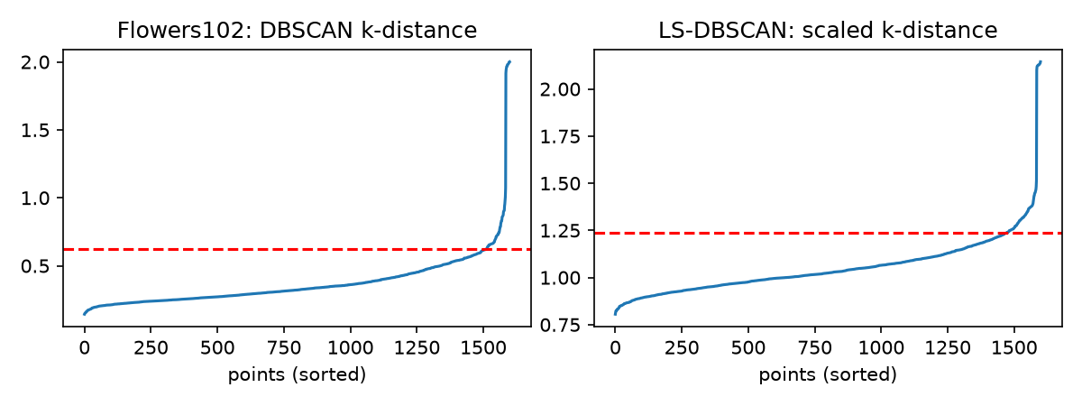
Figure 1. Flowers-102 (seed 0): sorted k-distance for DBSCAN (left) and scaled k-distance for LS-DBSCAN (right). The red line is the elbow ε.
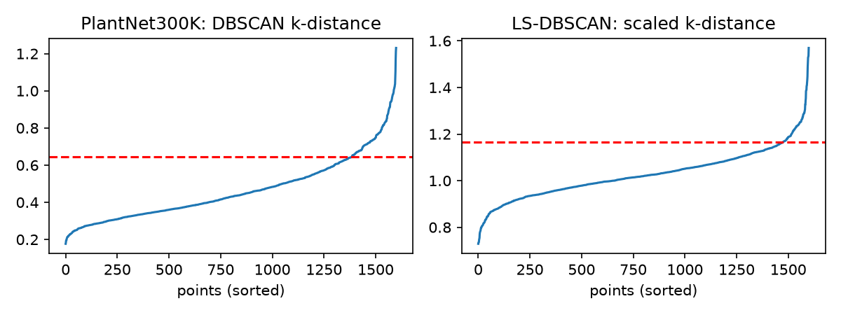
Figure 2. PlantNet-300K (seed 0): sorted k-distance for DBSCAN (left) and scaled k-distance for LS-DBSCAN (right).
To check how much of the result depends on ε, we reran both methods with ε from 0.5× to 1.8× the elbow value (Figure 3). Table 3 compares the ARI at the elbow with the best ARI found in the sweep. The best value is chosen using the true labels, so it is a best case and not a fair score, but it shows what each method could do with a better ε.
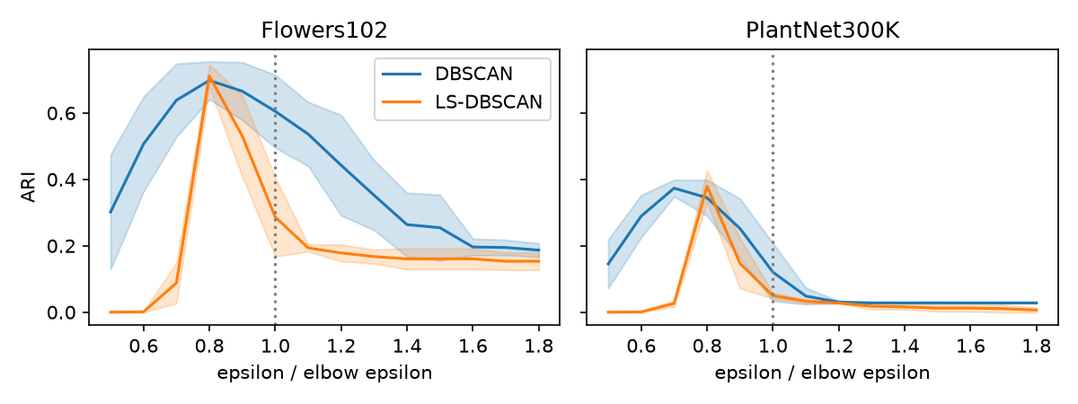
Figure 3. ARI as ε changes (mean over 5 seeds, shaded band = ±1 std). The dotted line at 1.0 is the elbow ε.
Table 3. ARI at the elbow ε compared with the best ARI in the ε sweep (training split).
Dataset | Method | ARI at elbow ε | Best ARI in sweep
Flowers-102 | DBSCAN | 0.605 | 0.729
 | LS-DBSCAN | 0.287 | 0.711
PlantNet-300K | DBSCAN | 0.121 | 0.378
 | LS-DBSCAN | 0.050 | 0.379

For both methods the elbow ε was larger than the best ε: the mean curves peak at about 0.7–0.8× the elbow value. The gap was much bigger for LS-DBSCAN. With a tuned ε it reached 0.711 on Flowers-102 (DBSCAN 0.729) and 0.379 on PlantNet-300K (DBSCAN 0.378), so the two methods were roughly equal at their best. However, the LS-DBSCAN curve is a narrow spike: below 0.7× almost every image becomes noise and above 0.9× the clusters merge, while DBSCAN gives a usable ARI over a much wider range of ε.
4.3 What the Clusters Look Like
Figures 4 and 5 show the seed-0 training images in a 2D UMAP view, coloured by the true species and by each method's clusters (black crosses are noise). On Flowers-102 most species form small, well-separated groups, and k-means, DBSCAN and HDBSCAN recover most of them. LS-DBSCAN joins the groups in the middle of the plot into one large cluster. On PlantNet-300K the true species already overlap in the embedding, and both DBSCAN and LS-DBSCAN put most of the images into one big connected cluster. HDBSCAN splits that region further but marks many of the points between groups as noise.
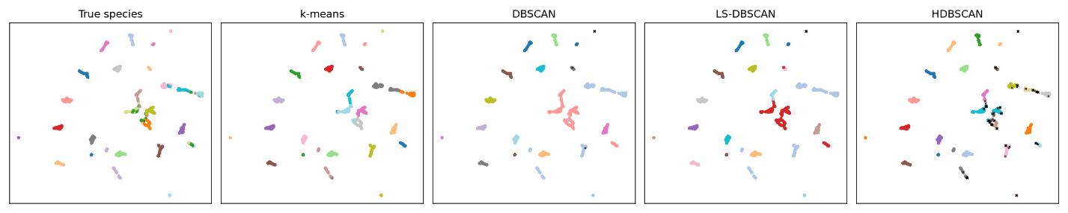
Figure 4. Flowers-102 (seed 0, training split): true species and the clusters found by each method.
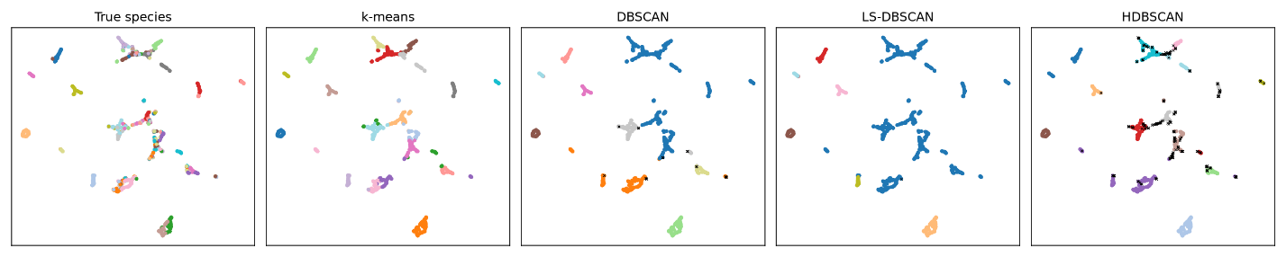
Figure 5. PlantNet-300K (seed 0, training split): true species and the clusters found by each method.
4.4 Which Species Became Noise
For seed 0, noise was concentrated in a single Flowers-102 class: 18.8% of species 13's training images were noise for both DBSCAN and LS-DBSCAN, while no other class had more than 1.2%. On PlantNet-300K, DBSCAN spread its small amount of noise over many species (at most 6.2%, for species 10), and LS-DBSCAN marked only one image as noise (1.2% of species 11). So LS-DBSCAN did keep sparse points in clusters as intended, but because its ε was too large this came from merging clusters rather than from fitting each species better.
5. What Was Learned
Flowers-102 turned out to be much easier than PlantNet-300K for every method. The flower photos are mostly close-ups of a single bloom, and the ImageNet-trained MobileNetV2 features separate the 20 classes well. PlantNet-300K images show different plant organs, backgrounds and growth stages, and many of the randomly chosen species look alike, so their embeddings overlap. When the species are not separated in feature space, no clustering method can fully recover them, which is why even k-means only reached an ARI of 0.438.
Our main hypothesis, that a locally scaled distance would help DBSCAN, was not supported. With automatic ε selection LS-DBSCAN was the weakest method on both datasets, and with a tuned ε it only matched standard DBSCAN. The biggest lesson is that the elbow rule does not carry over to rescaled distances: local scaling makes every point's k-th neighbour distance close to 1, which flattens the k-distance curve and moves the elbow too high. The ε sweep showed that LS-DBSCAN is also very sensitive to ε, which is the opposite of what we hoped a density-adaptive method would do.
HDBSCAN, which also adapts to different densities, gave the cleanest clusters (highest purity and silhouette among the density methods), but its ARI was only slightly better than DBSCAN's and it labelled 8–11% of the images as noise. k-means had the best ARI everywhere, but it was given the true number of classes (20), which is not known in a real unsupervised setting, so its score is an upper reference point rather than a fair comparison.
Finally, the test-split scores were close to the training-split scores, so the nearest-core-point method for labelling new images is a workable way to use DBSCAN-type clusters on unseen photos. For future work, the most promising changes are a different way to pick ε for LS-DBSCAN (for example, a fixed value or a percentile of the scaled distances instead of the elbow), image features trained on plants instead of ImageNet, and another attempt at implementing ADBSCAN for a direct comparison.

References
[1] M. Ester, H. P. Kriegel, J. Sander, and X. Xu, “A Density-Based Algorithm for Discovering Clusters in Large Spatial Databases with Noise,” in Proc. KDD-96, Portland, OR, USA, 1996, pp. 226–231.
[2] E. Schubert, J. Sander, M. Ester, H. P. Kriegel, and X. Xu, “DBSCAN Revisited, Revisited: Why and How You Should (Still) Use DBSCAN,” ACM Trans. Database Syst., 2017.
[3] M. M. R. Khan, M. A. B. Siddique, R. B. Arif, and M. R. Oishe, “ADBSCAN: Adaptive Density-Based Spatial Clustering of Applications with Noise for Identifying Clusters with Varying Densities,” 2018.
[4] R. J. G. B. Campello, D. Moulavi, and J. Sander, “Density-Based Clustering Based on Hierarchical Density Estimates,” in Proc. PAKDD, 2013.
[5] L. McInnes, J. Healy, and J. Melville, “UMAP: Uniform Manifold Approximation and Projection for Dimension Reduction,” arXiv:1802.03426, 2018.
[6] L. Zelnik-Manor and P. Perona, “Self-Tuning Spectral Clustering,” in Advances in Neural Information Processing Systems 17, 2004.
[7] L. Hubert and P. Arabie, “Comparing partitions,” Journal of Classification, vol. 2, pp. 193–218, 1985.
[8] P. J. Rousseeuw, “Silhouettes: a graphical aid to the interpretation and validation of cluster analysis,” J. Comput. Appl. Math., vol. 20, pp. 53–65, 1987.
[9] A. Garcin, A. Joly, P. Bonnet, et al., “Pl@ntNet-300K: a plant image dataset with high label ambiguity and a long-tailed distribution,” NeurIPS Datasets and Benchmarks Track, 2021.
[10] M. Sandler, A. Howard, M. Zhu, A. Zhmoginov, and L.-C. Chen, “MobileNetV2: Inverted Residuals and Linear Bottlenecks,” in Proc. CVPR, 2018.
[11] M.-E. Nilsback and A. Zisserman, “Automated Flower Classification over a Large Number of Classes,” in Proc. ICVGIP, 2008.
[12] F. Pedregosa et al., “Scikit-learn: Machine Learning in Python,” J. Mach. Learn. Res., vol. 12, pp. 2825–2830, 2011.

