CPSC 480 Machine Learning
Team Members : Mike Benko and Logan Cooper
11/8/2026
Phase 3 Code and Experiments

1. What We Did
As stated earlier, the issue that was chosen in Phase 1 for addressing by DBSCAN is that it has one distance metric across all points, which does not fit well when points in different regions are packed and dispersed differently. In this phase, we coded DBSCAN along with its proposed variant, tested it on two plant/flower image datasets and compared results to those of other popular methods such as standard DBSCAN, HDBSCAN and k-means.
All the code was implemented in one file plant_clustering.py. There were several modifications to our Phase 2 plan that we will list below to make sure they are reflected in the report and the code.
- Our datasets are Flowers-102 and PlantNet-3020K, 20 classes with 100 images each.
- Randomly picked (with a fixed seed) the 20 PlantNet species out of those that contain at least 100 training images. Phase 2 planned to pick "visually distinct" species by hand. Random choice is unbiased but may include similar species, while the hand-picked would be easier.
- The images in PlantNet were not restricted to any specific plant organ (leaf, flower etc). Phase 2 said images could be clustered by the organ and not species.
- The UMAP embedding dimension was 15 in one case and 30 in another (and not 15/50 as in Phase 2), while MinPts is 30 and 100 correspondingly (and not 30/100 as in Phase 2, because 2×d in [2] gives 30 for 15 dimensions).
- ADBSCAN [3], which we tried to implement based on the paper failed to be reproduced. We decided to try a simpler variant of DBSCAN called LS-DBSCAN (Section 3.2), which uses standard DBSCAN on locally scaled distances [6]. Thus, it is not ADBSCAN.
We also used HDBSCAN [4] as another known method and provided the actual number of classes (20) to k-means.
Short summary of our findings.
2. The Two Datasets
- Flowers-102 [11]. Photos of 102 different flower types. Three splits were combined to select 20 classes randomly, each having at least 100 pictures, and then 100 pictures were randomly selected for each, totaling 2,000 images.
- PlantNet-300K [9]. More than 300,000 images of different plants captured by the Pl@ntNet app, belonging to more than 1,000 plant species. Majority of the photographs belong to a few species, and many species share high similarity with others making it difficult even for experts to identify them. Images of 20 randomly selected species having at least 100 training images were selected randomly, and 100 pictures per each, summing up to be 2,000 pictures. Rather than downloading the whole dataset file (which takes up 31.7 GB), the selected images are being read from the dataset zip file stored on Zenodo.
The images and plant species have been selected with one random seed set so that the same 4,000 pictures are used in each run.

3. How the Code Works
- The code is divided into five sections: preparing the data, defining helper functions, running the experiment, displaying the results, and creating figures.
- Embeddings creation: Images are resized to 224×224 and processed using MobileNetV2. Every image is transformed to a feature vector of size 1,280, which is stored in a .npz file.
- Data split: 80% of images are used as train and 20% - as test. Each class has the same ratio in train and test datasets. Only train dataset is used for fitting UMAP, determining ε and forming clusters.
- Dimensionality reduction: UMAP reduces 1,280 dimensional feature vectors down to 15, preserving proximity between similar images. Test images are embedded into 15-dimensional space.
- ε determination: Distance to 30-th nearest neighbour is determined for each training point. Distances are sorted and ε is automatically chosen at the elbow point of the diagram without using any class information.
- Clustering: four clustering algorithms were used: DBSCAN, LS-DBSCAN, HDBSCAN, k-means.
- Test set evaluation: As DBSCAN and its modifications can not classify unseen data, each test image is classified as a core point of a cluster of a nearest training point if it is closer than ε, otherwise as noise. k-means assigns clusters to test images according to its predicting process. HDBSCAN is evaluated only on train set since this algorithm implementation is not able to assign labels to new points.
- 3.2 LS-DBSCAN (Our Variant)

- Standard DBSCAN defines neighboring points as those lying at a fixed distance ε one from another. It may become problematic since clusters of a dense group may have to use a smaller ε, and clusters of a spread-out one may require a larger one. Small ε for a spread-out group may result in labeling some points as noise.

- LS-DBSCAN calculates the local scale of each point as the distance to its 30th nearest neighbor. Then distances between the points are rescaled accordingly. In sparse areas, they become smaller to keep clusters connected, and in dense areas, bigger to prevent neighboring clusters from being merged.

- After the rescaling procedure, the standard DBSCAN algorithm is applied with no modifications and ε calculated using the elbow method as before. The inspiration behind the rescaling technique comes from self-tuning spectral clustering.

- Note: LS-DBSCAN differs from the ADBSCAN algorithm published elsewhere. It employs the standard scikit-learn DBSCAN algorithm with the distance matrix rescaled beforehand. We did not make any comparisons between LS-DBSCAN and ADBSCAN.

3.3 Evaluation Metrics

Here are the metrics we used to evaluate clustering performance:

Adjusted Rand Index (ARI): Indicates how similar predicted clusterings and the true image classes are. A perfect value of 1 means that all clusters are found, and 0 means random clustering performance. Noise points reduce the score. It is our main metric.
Noise Rate: Percentage of images assigned to noise cluster.
Purity and Coverage: Each cluster is assigned the class which occurs in it the most frequently. Purity shows the percentage of images in the cluster with this class label, while coverage is the percentage of all images which were assigned to clusters rather than noise.
Silhouette Score: Shows the compactness and separation of the clusters. Since it does not take into account the noise points, it is used as a supplementary metric.

3.4 Procedure

For each dataset, 5 different experiments were performed using seeds 0 to 4. These aused in splitting the dataset into training and test subsets, in UMAP projection, and in the initialization of k-means algorithm
.Results show the average value and standard deviation (±) over the five experiments.

- An additional procedure called ε sweep was performed for each dataset. During this procedure, ε was varied from 0.5 to 1.8 of the elbow-selected value. It gives us the best possible value of ε as it depends on the true labels, but it cannot be used for comparison of algorithms' performances.

- Also, the code logs information about which image classes are the most frequent among noise.
4.Resul,ts (maybe tables of what came like Datasset method clusters noise ari purity coverage === Training split (80%) ===
clusters noise ARI purity coverage silhouette
dataset method
Flowers102 DBSCAN 16.0 0.036 0.605 +/- 0.110 0.753 0.964 0.701
HDBSCAN 18.2 0.111 0.647 +/- 0.067 0.869 0.889 0.778
LS-DBSCAN 11.6 0.006 0.287 +/- 0.119 0.553 0.994 0.516
k-means 20.0 0.0 0.827 +/- 0.022 0.9 1.0 0.715
PlantNet300K DBSCAN 6.2 0.013 0.121 +/- 0.087 0.255 0.987 0.39
HDBSCAN 7.2 0.081 0.136 +/- 0.150 0.31 0.919 0.475
LS-DBSCAN 5.6 0.004 0.050 +/- 0.009 0.227 0.996 0.22
k-means 20.0 0.0 0.438 +/- 0.011 0.599 1.0 0.539

=== Held-out test split (20%) ===
clusters noise ARI purity coverage silhouette
dataset method
Flowers102 DBSCAN 16.0 0.049 0.569 +/- 0.092 0.747 0.951 0.685
LS-DBSCAN 11.6 0.005 0.270 +/- 0.110 0.546 0.995 0.506
k-means 20.0 0.0 0.781 +/- 0.026 0.878 1.0 0.674
PlantNet300K DBSCAN 6.2 0.024 0.112 +/- 0.082 0.255 0.976 0.359
LS-DBSCAN 5.6 0.007 0.045 +/- 0.008 0.224 0.992 0.195
k-means 20.0 0.0 0.389 +/- 0.012 0.568 1.0 0.465

=== ARI at the elbow epsilon vs. best ARI in the sweep (best case) ===
ARI at elbow best in sweep
dataset method
Flowers102 DBSCAN 0.605 0.729
LS-DBSCAN 0.287 0.711
PlantNet300K DBSCAN 0.121 0.378
LS-DBSCAN 0.050 0.379

=== Species with the most noise (seed 0, training split) ===
Flowers102 / DBSCAN:
species images noise
13 80 0.188
14 80 0.012
17 80 0.012
0 80 0.000
3 80 0.000
Flowers102 / LS-DBSCAN:
species images noise
13 80 0.188
0 80 0.000
2 80 0.000
1 80 0.000
3 80 0.000
PlantNet300K / DBSCAN:
species images noise
10 80 0.062
1 80 0.050
4 80 0.050
17 80 0.050
18 80 0.050
PlantNet300K / LS-DBSCAN:
species images noise
11 80 0.012
0 80 0.000
2 80 0.000
1 80 0.000
3 80 0.000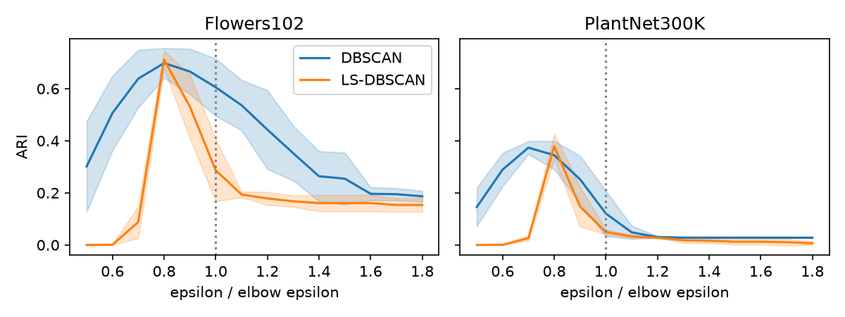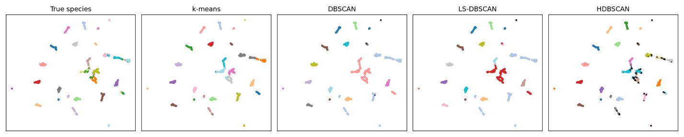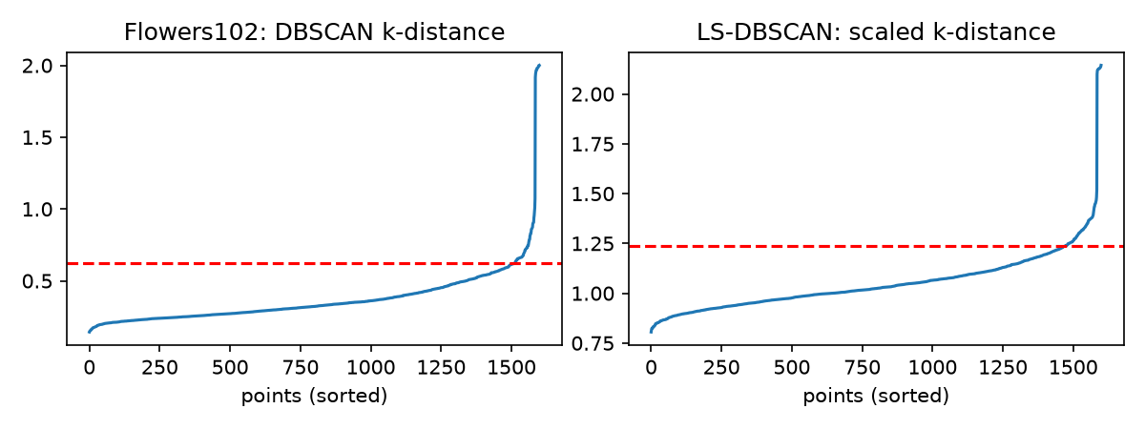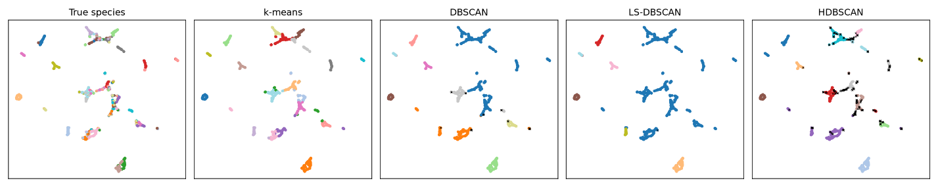
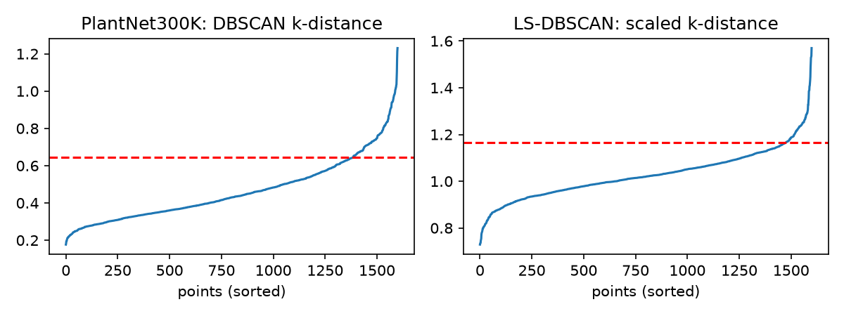

5. What was learned ( what datasets turned out better etc)
References
[1] M. Ester, H. P. Kriegel, J. Sander, and X. Xu, “A Density-Based Algorithm for Discovering Clusters in Large Spatial Databases with Noise,” in Proc. KDD-96, Portland, OR, USA, 1996, pp. 226–231.
[2] E. Schubert, J. Sander, M. Ester, H. P. Kriegel, and X. Xu, “DBSCAN Revisited, Revisited: Why and How You Should (Still) Use DBSCAN,” ACM Trans. Database Syst., 2017.
[3] M. M. R. Khan, M. A. B. Siddique, R. B. Arif, and M. R. Oishe, “ADBSCAN: Adaptive Density-Based Spatial Clustering of Applications with Noise for Identifying Clusters with Varying Densities,” 2018.
[4] R. J. G. B. Campello, D. Moulavi, and J. Sander, “Density-Based Clustering Based on Hierarchical Density Estimates,” in Proc. PAKDD, 2013.
[5] L. McInnes, J. Healy, and J. Melville, “UMAP: Uniform Manifold Approximation and Projection for Dimension Reduction,” arXiv:1802.03426, 2018.
[6] L. Zelnik-Manor and P. Perona, “Self-Tuning Spectral Clustering,” in Advances in Neural Information Processing Systems 17, 2004.
[7] L. Hubert and P. Arabie, “Comparing partitions,” Journal of Classification, vol. 2, pp. 193–218, 1985.
[8] P. J. Rousseeuw, “Silhouettes: a graphical aid to the interpretation and validation of cluster analysis,” J. Comput. Appl. Math., vol. 20, pp. 53–65, 1987.
[9] A. Garcin, A. Joly, P. Bonnet, et al., “Pl@ntNet-300K: a plant image dataset with high label ambiguity and a long-tailed distribution,” NeurIPS Datasets and Benchmarks Track, 2021.
[10] M. Sandler, A. Howard, M. Zhu, A. Zhmoginov, and L.-C. Chen, “MobileNetV2: Inverted Residuals and Linear Bottlenecks,” in Proc. CVPR, 2018.
[11] M.-E. Nilsback and A. Zisserman, “Automated Flower Classification over a Large Number of Classes,” in Proc. ICVGIP, 2008.
[12] F. Pedregosa et al., “Scikit-learn: Machine Learning in Python,” J. Mach. Learn. Res., vol. 12, pp. 2825–2830, 2011.

