
Practical Programming Assignment
Introduction to Programming IY499


Student Id: P296144
Student Name: Muhammed Berk Kilic
Tutor: Marzieh Farahani
Table of Contents
Introduction 1
Requirements 2
Design Flowchart Diagram 3
Testing Guide (User Manual Style) 4
Appendix A (Code listing) 10
Appendix B (ReadMe file) 13

Introduction

The purpose of this program is to collect numerical data from the user,
group it into classes and analyse it statistically.

The program saves user input into a CSV file, creating one automatically
if it does not exist. It calculates and displays statistics such as mean,
median, mode, variance and standard deviation. It also groups the data
into a frequency table based on a class width specified by the user, and
displays a histogram with customisable class width.

The program is split into functions to keep the code organised:
- get_user_data() collects ages from the user and saves them to a CSV file
- read_data() reads the data back from the CSV file
- get_bin_width() gets the class width from the user
- compute_statistics() calculates and displays statistics and the frequency table
- draw_histogram() displays the histogram
- main() shows the menu and handles user choices

The concepts demonstrated in this program include file handling,
error handling, validating user input, data grouping, statistical
calculations and data visualisation using a histogram.

Requirements
1. The program shall prompt the user to input numerical data.
2. The program shall validate user input and display an error message if the input is invalid.
3. The program shall create sampleData-1.csv automatically if it does not already exist.
4. The program shall save the user-entered data into a CSV file named sampleData-1.csv.
5. The program shall read the data back from sampleData-1.csv.
6. The program shall group the data into classes, where the class width is specified by the user.
7. The program shall calculate and display statistics including mean, median, mode,
variance, standard deviation and a grouped frequency table.
8. The program shall save the frequency table results to a CSV file named results.csv.
9. The program shall display a histogram of the data using a class width specified by the user.
10. The program shall provide a menu so the user can choose what to do.

Design Flowchart Diagram

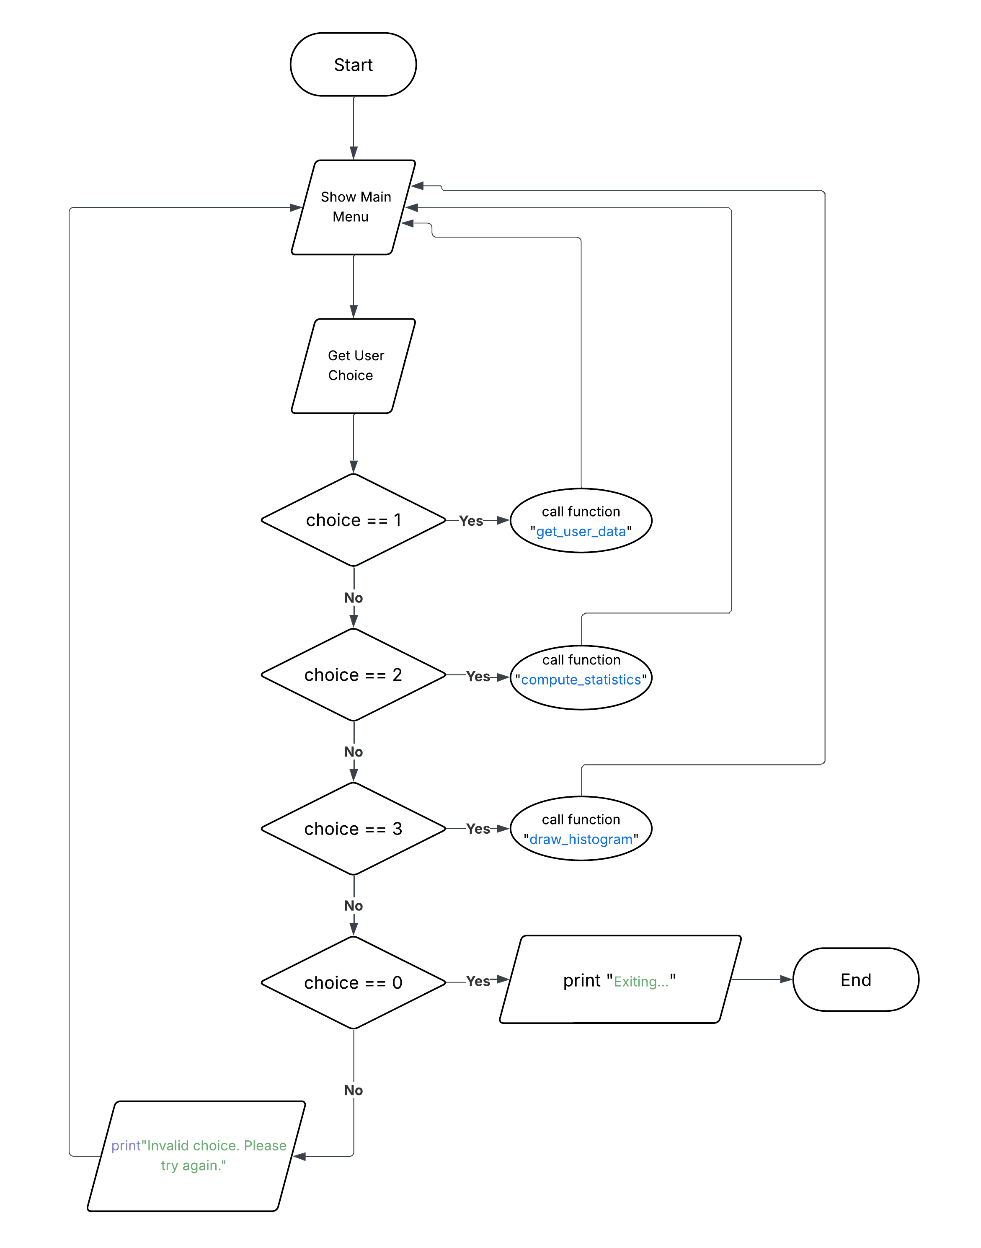

Testing Guide (User Manual Style)
1. Running the Program
Objective: Ensure the program starts correctly.
Steps:

1. Make sure Python is installed on your computer.
2. Save the program file as GroupedDataApp.py
3. Open a terminal (Command Prompt, PowerShell, or Terminal).
4. Navigate to the folder where the file is saved.
5. Type the following command and press Enter:
python GroupedDataApp.py
Expected Result:
The program launches and shows the main menu with 4 options.
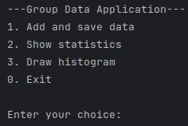

2. Getting Data from the User
Objective: Ensure the program collects numerical data correctly.
Steps:

1. Run the program.
2. Select option 1 from the menu.
3. When prompted enter an age between 1 and 125.
4. Enter 0 to stop adding data.

Expected Result:
* Each age is saved and "Data Saved" is printed after each entry.
* Entering 0 stops the input and returns to the menu.
* Entering a letter or invalid number shows "Wrong input enter a number".

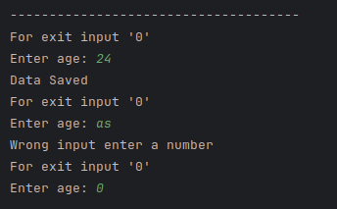

3. Saving Data into a CSV File
Objective: Verify that the program saves the user input to a CSV file.
Steps:

1. Run the program.
2. Select option 1 from the menu.
3. Enter a few ages and then enter 0 to stop.
4. Open the project folder and check for sampleData-1.csv.

Expected Result:
* The file sampleData-1.csv is created in the project folder.
* It contains a header row "Age" and the entered ages underneath.

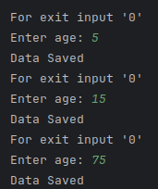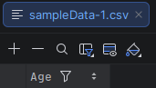
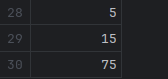
4. Showing Statistics
Objective: Verify that the program calculates and displays statistics correctly.
Steps:

1. Run the program.
2. Make sure there is data in sampleData-1.csv (use option 1 first if needed).
3. Select option 2 from the menu.
4. Enter a class width when prompted (e.g. 10).

Expected Result:
* The program displays mean, median, mode, variance and standard deviation.
* A grouped frequency table is shown with class interval, midpoint,
frequency and cumulative frequency.
* Modal class is displayed.
* Results are saved to results.csv.

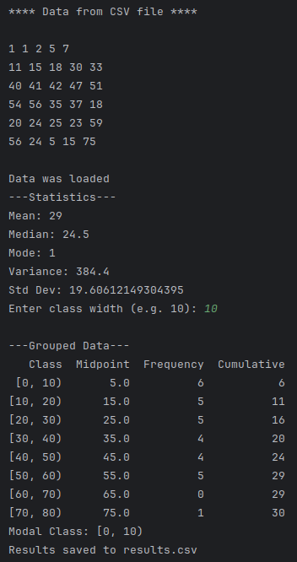

5. Drawing Histogram
Objective: Verify that the program displays a histogram correctly.
Steps:

1. Run the program.
2. Make sure there is data in sampleData-1.csv (use option 1 first if needed).
3. Select option 3 from the menu.
4. Enter a class width when prompted (e.g. 10).

Expected Result:
* A histogram is displayed with age groups on the x-axis and
frequency on the y-axis.
* The bars align with the class width specified by the user.

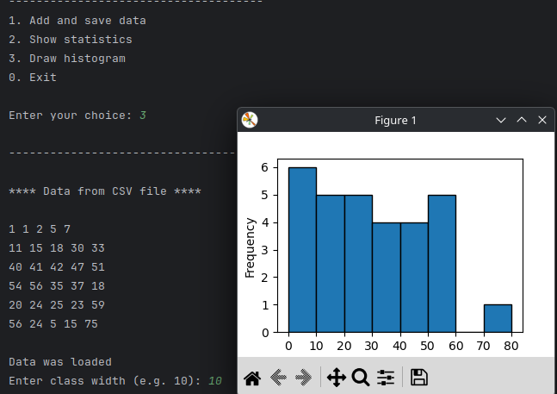

Appendix A (Code listing)
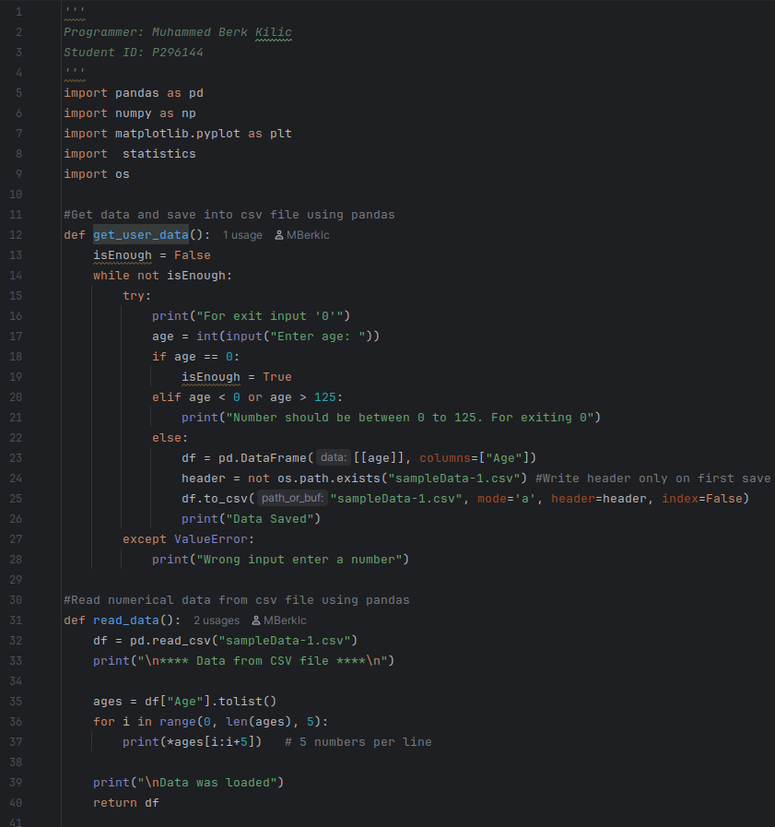

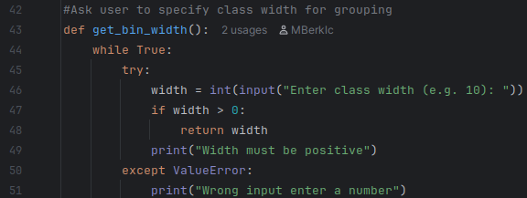
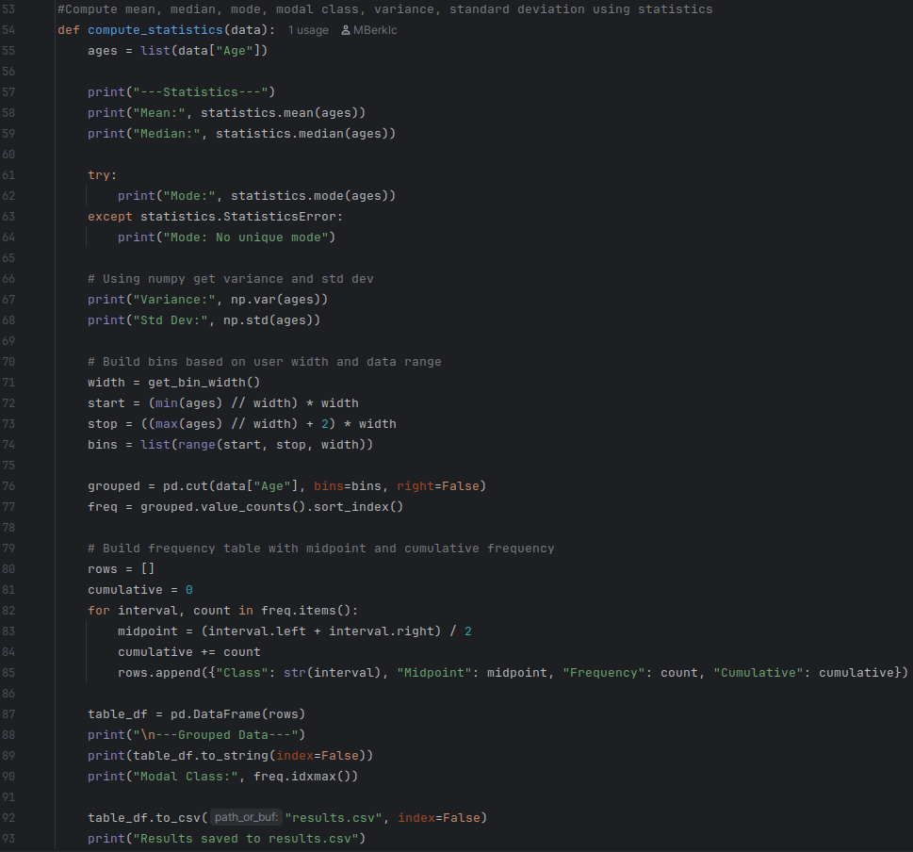
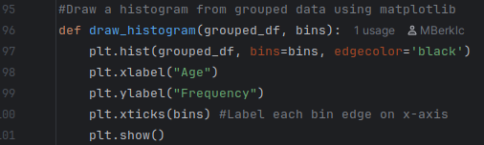
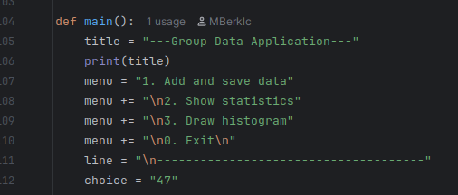
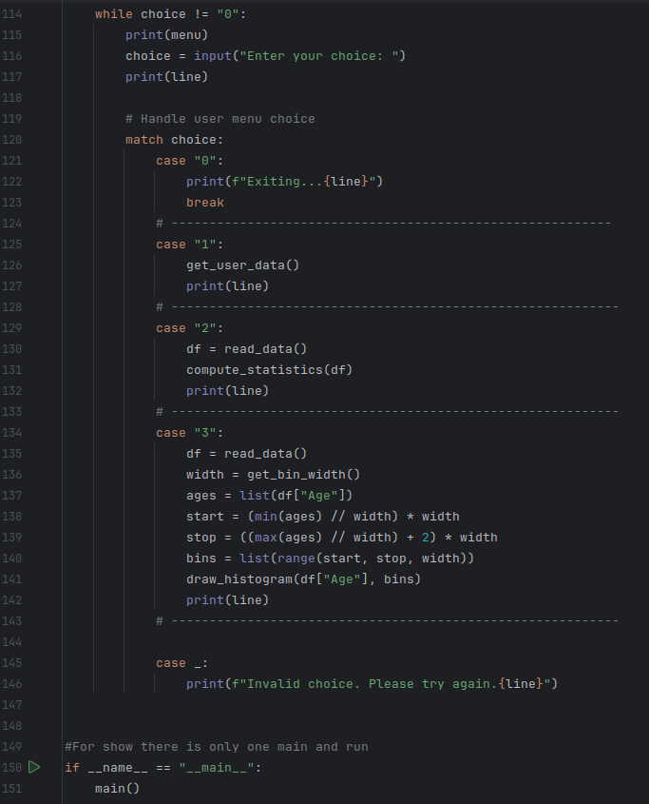

Appendix B (ReadMe file)
Programmer: Muhammed Berk Kilic
P-number: P296144
Course code: IY499
GitHub: https://github.com/MBerklc/IY499-Exam

Declaration: This is my own work.

Description:
This program gets data from the user and saves it into a CSV file (if there
is no CSV file it creates one). It shows statistics of the data and gets
class width from the user to show grouped frequency table, and it shows a
histogram with customisable class width.

Required Libraries:
pandas, numpy, matplotlib, statistics, os

Installation:
pip install pandas numpy matplotlib
(statistics and os are built into Python, no installation needed)

Usage:
Run the program with: python GroupedDataApp.py
1. Add and save data - enter age values one at a time
2. Show statistics - shows mean, median, mode, variance, std dev and frequency table
3. Draw histogram - shows histogram of the data
0. Exit - exits the program

