JavaScript Introduction:

What is JavaScript? Explain the role of JavaScript in web development.

Ans: JavaScript is a high-level, interpreted programming language primarily known for its role in web development. It is a core technology of the World Wide Web, alongside HTML and CSS. JavaScript allows for the creation of dynamic and interactive content on websites, enhancing the user experience.

Role of JavaScript in Web Development:

* **Client-Side Interactivity:**

JavaScript's primary role in web development is to enable client-side interactivity. This means it runs directly within the user's web browser and can manipulate the content, style, and behavior of web pages in real-time. Examples include:

* + Responding to user actions like button clicks, form submissions, and mouse movements.
  + Creating dynamic elements such as image carousels, pop-up menus, and animated content.
  + Validating user input in forms before submission, providing instant feedback.
  + Fetching data from a server without requiring a full page reload (AJAX).
* **DOM Manipulation:**

JavaScript interacts with the Document Object Model (DOM), which is a programming interface for HTML and XML documents. This allows JavaScript to dynamically modify the structure, content, and style of a web page after it has been loaded.

* **Server-Side Development (with Node.js):**

While initially designed for client-side scripting, JavaScript's utility expanded to server-side development with the advent of Node.js. Node.js is a runtime environment that allows JavaScript to be executed outside of a web browser, enabling developers to build entire web applications using a single language for both the front-end and back-end. This facilitates:

* + Building web servers and APIs.
  + Interacting with databases.
  + Performing file system operations.
* **Integration with HTML and CSS:**

JavaScript seamlessly integrates with HTML (which provides the structure of a web page) and CSS (which handles the styling). This triumvirate forms the foundation of modern web development, allowing for rich and engaging user interfaces.

How is JavaScript different from other programming languages like Python or Java?

Ans: JavaScript distinguishes itself from languages like Python or Java in several key aspects:

1. Execution Environment and Purpose:

* **JavaScript:**

Primarily designed for web browsers to create interactive and dynamic web content (front-end development). With Node.js, it can also be used for server-side development (back-end).

* **Python:**

A general-purpose language used in various domains like data science, machine learning, web development (backend), automation, and scripting.

* **Java:**

A robust, object-oriented language for building enterprise-level applications, Android apps, and large-scale systems, often running in a Java Virtual Machine (JVM).

2. Typing and Compilation:

* **JavaScript:**

Dynamically typed and interpreted. Variables do not require explicit type declarations, and the code is interpreted at runtime by the browser or Node.js runtime.

* **Python:**

Dynamically typed and interpreted. Similar to JavaScript, types are inferred at runtime.

* **Java:**

Statically typed and compiled. Variables must have their types declared, and the code is compiled into bytecode before execution by the JVM.

3. Object-Oriented Paradigm:

* **JavaScript:**

Uses a prototype-based object model, where objects inherit properties and methods directly from other objects (prototypes). While it now has class syntax, it's largely syntactic sugar over the underlying prototype system.

* **Python & Java:**

Primarily class-based object-oriented languages, where objects are instances of classes, and inheritance is achieved through class hierarchies.

4. Concurrency Model:

* **JavaScript:**

Single-threaded with an event loop, enabling asynchronous operations through callbacks, Promises, and async/await.

* **Python & Java:**

Support multi-threading for concurrent execution, though Python's Global Interpreter Lock (GIL) can limit true parallelism for CPU-bound tasks.

5. Syntax and Standard Libraries:

* **JavaScript:**

C-style syntax with curly braces and semicolons (optional in many cases). Its standard library focuses on web-related functionalities.

* **Python:**

Emphasizes readability with significant whitespace and a rich standard library for diverse applications.

* **Java:**

C-style syntax with a vast and comprehensive standard library for platform-independent application development.

Discuss the use of <script> tag in HTML. How can you link an external JavaScript file to an HTML document?

Ans: The <script> tag in HTML serves to embed or reference executable code, primarily JavaScript, within an HTML document. This tag allows for dynamic and interactive content on web pages.

Uses of the <script> tag:

* **Embedding inline JavaScript:** JavaScript code can be directly written within the opening and closing <script> tags.

Example:

<script>  
 alert("Hello from inline JavaScript!");  
 </script>

* **Linking external JavaScript files:** The src attribute is used to specify the path to an external JavaScript file, promoting code organization, reusability, and browser caching.

Example:

<script src="path/to/your/script.js"></script>

Linking an External JavaScript File:

To link an external JavaScript file to an HTML document, use the <script> tag with the src attribute.

* **Create a JavaScript file:** Create a separate file with a .js extension (e.g., myscript.js) and place your JavaScript code within it.

*// myscript.js*  
 console.log("This is from an external JavaScript file!");  
 document.getElementById("myElement").textContent = "Content updated!";

* **Reference the file in your HTML:** In your HTML document, typically just before the closing </body> tag (to ensure the DOM is loaded before script execution), add a <script> tag with the src attribute pointing to your JavaScript file.

<!DOCTYPE html>  
 <html>  
 <head>  
 <title>External JavaScript Example</title>  
 </head>  
 <body>  
 <p id="myElement">Original content.</p>  
  
 <script src="myscript.js"></script>  
 </body>  
 </html>

Variables and Data Types:

What are variables in JavaScript? How do you declare a variable using var, let, and const?

Ans: In JavaScript, variables are named containers used to store data values. These values can be of various types, such as numbers, strings, booleans, objects, and more. Variables allow for the storage and manipulation of data within a program.

Variables in JavaScript can be declared using three keywords: var, let, and const.

Declaring a variable using var:

The var keyword is the oldest way to declare variables in JavaScript. Variables declared with var have function-level scope, meaning they are accessible throughout the entire function in which they are declared, regardless of block-level constructs like if statements or for loops. They also exhibit "hoisting," where the declaration is effectively moved to the top of their scope during compilation, though the assignment remains in place.

Example:

var myVar = "Hello";  
myVar = "World"; *// Reassignment is allowed*  
var myVar = "Again"; *// Redeclaration is allowed*  
console.log(myVar); // Output: Again

Declaring a variable using let:

The let keyword was introduced in ECMAScript 6 (ES6) and provides block-level scope. This means let variables are only accessible within the specific block (e.g., if block, for loop, or any curly braces {}) where they are declared.

Example:

let myLet = 10;  
myLet = 20; *// Reassignment is allowed*  
*// let myLet = 30; // This would cause an error (redeclaration not allowed in the same block)*  
console.log(myLet); *// Output: 20*  
  
if (true) {  
 let innerLet = 5;  
 console.log(innerLet); *// Output: 5*  
}

Declaring a variable using const:

The const keyword also introduced in ES6, is used to declare constants. Like let, const variables are block-scoped. The key difference is that const variables must be initialized at the time of declaration and cannot be reassigned or redeclared after their initial assignment.

Example:

const PI = 3.14;  
*// PI = 3.14159; // This would cause an error (reassignment not allowed)*  
*// const PI = 3; // This would cause an error (redeclaration not allowed)*  
console.log(PI); *// Output: 3.14*  
  
const myObject = { name: "Alice" };  
myObject.name = "Bob"; *// Modifying properties of a const object is allowed*  
console.log(myObject);

Explain the different data types in JavaScript. Provide examples for each.

Ans: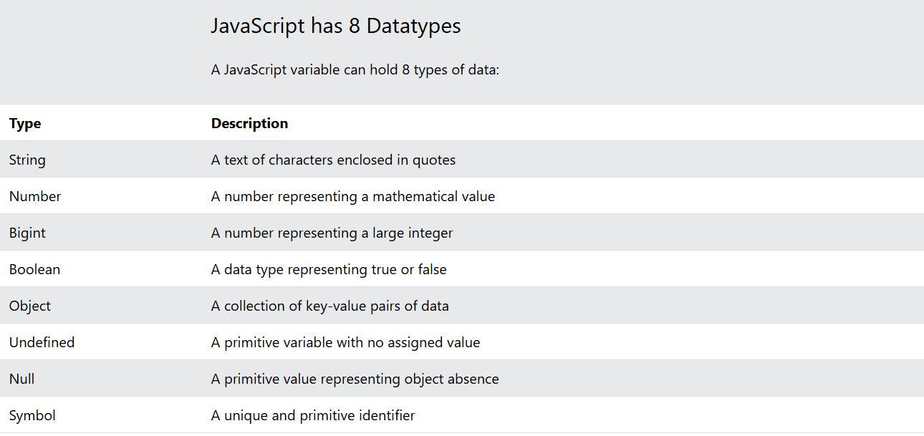

Example:

// Strings  
let color = "Yellow";  
let lastName = "Johnson";  
  
// Number  
let length = 16;  
let weight = 7.5;  
  
// BigInt  
let x = 1234567890123456789012345n;  
let y = BigInt(1234567890123456789012345)  
  
// Boolean  
let x = true;  
let y = false;  
  
// Object  
const person = {firstName:"John", lastName:"Doe"};  
  
// Array object  
const cars = ["Saab", "Volvo", "BMW"];  
  
// Date object  
const date = new Date("2022-03-25");  
  
// Undefined  
let x;  
let y;  
  
// Null  
let x = null;  
let y = null;  
  
// Symbol  
const x = Symbol();  
const y = Symbol();

What is the difference between undefined and null in JavaScript?

Ans: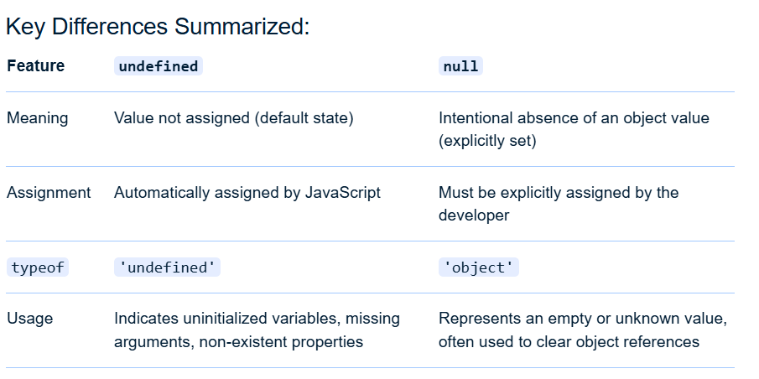

JavaScript Operators:

What are the different types of operators in JavaScript? Explain with examples.

o Arithmetic operators

o Assignment operators

o Comparison operators

o Logical operators

Ans: JavaScript includes various types of operators to perform different operations. The following provides an explanation of arithmetic, assignment, comparison, and logical operators with examples:

1. Arithmetic Operators:

These operators perform mathematical calculations.

* Addition (+): Adds two operands.

Example:

let result = 5 + 3; // result is 8

* Subtraction (-): Subtracts the right operand from the left.

Example:

let result = 10 - 4; // result is 6

* Multiplication (*): Multiplies two operands.

Example:

let result = 6 * 2; // result is 12

* Division (/): Divides the left operand by the right.

Example:

let result = 15 / 3; // result is 5

* Modulus (%): Returns the remainder of a division.

Example:

let result = 10 % 3; // result is 1

* Increment (++): Increases the value of an operand by 1.

Example:

let num = 5;  
 num++; // num is now 6

* Decrement (--): Decreases the value of an operand by 1.

Example:

let num = 5;  
 num--; // num is now 4

2. Assignment Operators:

These operators assign values to variables.

* Assignment (=): Assigns the value of the right operand to the left.

Example:

let x = 10; // x is assigned the value 10

* Addition Assignment (+=): Adds the right operand to the left operand and assigns the result to the left operand.

Example:

let x = 5;  
 x += 3; // Equivalent to x = x + 3; x is now 8

* Subtraction Assignment (-=): Subtracts the right operand from the left and assigns the result to the left.

Example:

let x = 10;  
 x -= 4; // Equivalent to x = x - 4; x is now 6

* Multiplication Assignment (*=): Multiplies the right operand with the left and assigns the result to the left.

Example:

let x = 5;  
 x *= 2; // Equivalent to x = x * 2; x is now 10

* Division Assignment (/=): Divides the left operand by the right and assigns the result to the left.

Example:

let x = 12;  
 x /= 3; // Equivalent to x = x / 3; x is now 4

3. Comparison Operators:

These operators compare two values and return a boolean result (true or false).

* Equal to (==): Checks if two operands are equal in value (type coercion allowed).

Example:

let result = (5 == "5"); // result is true

* Strict Equal to (===): Checks if two operands are equal in value and type.

Example:

let result = (5 === "5"); // result is false

* Not Equal to (!=): Checks if two operands are not equal in value (type coercion allowed).

Example:

let result = (5 != "10"); // result is true

* Strict Not Equal to (!==): Checks if two operands are not equal in value or type.

Example:

let result = (5 !== "5"); // result is true

* Greater than (>): Checks if the left operand is greater than the right.

Example:

let result = (10 > 5); // result is true

* Less than (<): Checks if the left operand is less than the right.

Example:

let result = (3 < 7); // result is true

* Greater than or Equal to (>=): Checks if the left operand is greater than or equal to the right.

Example:

let result = (8 >= 8); // result is true

* Less than or Equal to (<=): Checks if the left operand is less than or equal to the right.

Example:

let result = (4 <= 6); // result is true

4. Logical Operators:

These operators combine or modify boolean expressions.

* Logical AND (&&): Returns true if both operands are true.

Example:

let result = (true && false); // result is false

* Logical OR (||): Returns true if at least one operand is true.

Example:

let result = (true || false); // result is true

* Logical NOT (!): Inverts the boolean value of an operand.

Example:

let result = !true; // result is false .

What is the difference between == and === in JavaScript?

Ans: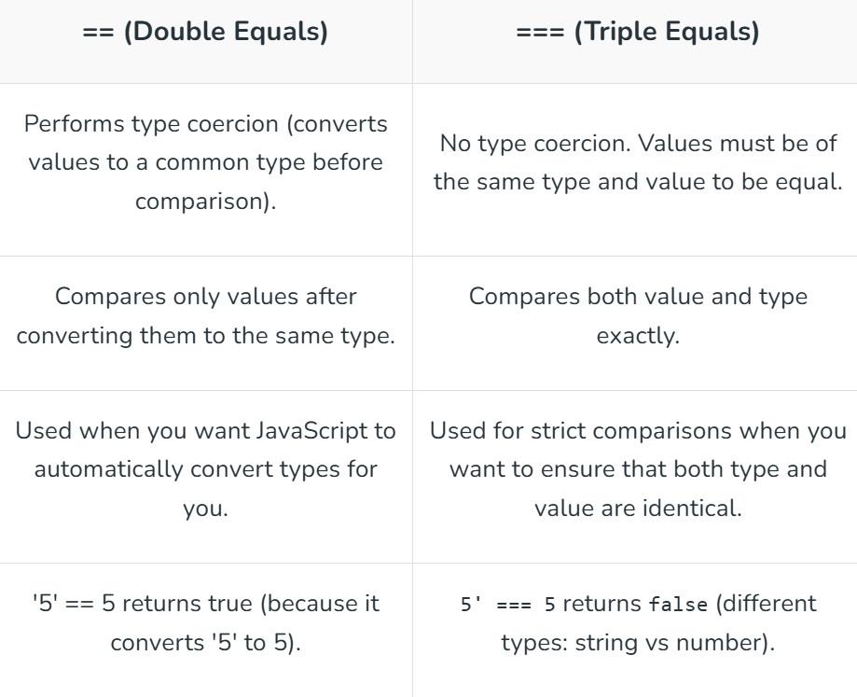

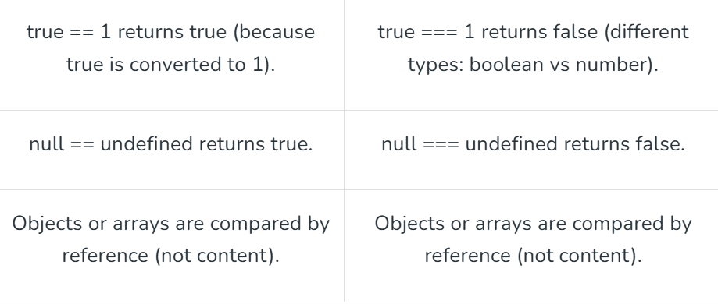

Control Flow (If-Else, Switch):

What is control flow in JavaScript? Explain how if-else statements work with an example.

Ans: Control flow in JavaScript refers to the order in which the statements of a program are executed. By default, JavaScript executes code sequentially from top to bottom. However, control flow statements allow you to alter this default order, enabling your program to make decisions, repeat actions, or jump to different sections of code based on specific conditions.

If-Else Statements

The if-else statement is a fundamental control flow structure used for conditional execution. It allows you to execute one block of code if a specified condition is true, and a different block of code if the condition is false.

How it works:

* if (condition):

The if keyword is followed by a condition enclosed in parentheses. This condition is evaluated to a boolean value (true or false).

* **Code Block (if true):**

If the condition evaluates to true, the code block immediately following the if statement (enclosed in curly braces {}) is executed.

* else:

The else keyword is optional and provides an alternative path. If the condition in the if statement evaluates to false, the code block immediately following the else statement is executed instead.

Example:

let age = 9;  
  
if (age >= 18) {  
 console.log("You are eligible to vote.");  
} else {  
 console.log("You are not yet eligible to vote.");  
}  
  
// Output: You are not yet eligible to vote.

Describe how switch statements work in JavaScript. When should you use a switch statement instead of if-else?

Ans: In JavaScript, a switch statement provides a way to control the flow of execution based on the value of a single expression. It evaluates an expression once and then compares its value against multiple case clauses.

How switch statements work:

* **Expression Evaluation:**

The switch statement begins by evaluating the expression provided within its parentheses.

* **Case Matching:**

The result of this expression is then strictly compared (using ===) with the value of each case clause in sequential order.

* **Code Execution:**

If a match is found, the code block associated with that case is executed.

* break Keyword:

The break keyword is crucial. If present, it terminates the switch statement after a match is found and its corresponding code block is executed, preventing "fall-through" to subsequent case clauses. Without break, execution would continue to the next case's code block, regardless of whether it matches.

* default Clause (Optional):

If no case matches the evaluated expression, the code block within the optional default clause is executed.

Example:

switch (expression) {  
 case value1:  
 *// Code to execute if expression === value1*  
 break;  
 case value2:  
 *// Code to execute if expression === value2*  
 break;  
 default:  
 *// Code to execute if no case matches*  
}

When to use switch instead of if-else:

switch statements are particularly advantageous in scenarios where:

* **Multiple, Discrete Values:**

You need to perform different actions based on a single variable's value having several distinct, fixed possibilities (e.g., days of the week, menu options, status codes).

* **Readability and Clarity:**

For a long series of if-else if-else statements checking for equality, a switch statement can significantly improve code readability and maintainability, making it easier to understand the different execution paths.

* **Performance (in some cases):**

While often similar in performance for a small number of conditions, switch statements can sometimes be optimized by JavaScript engines, especially with a large number of cases, potentially using lookup tables for faster access.

When if-else is more suitable:

* **Complex Conditions:**

When conditions involve relational operators (e.g., >, <, >=, <=), logical operators (e.g., &&, ||), or complex expressions that cannot be simplified to a single value comparison, if-else statements are necessary.

Loops (For, While, Do-While):

Explain the different types of loops in JavaScript (for, while, do-while). Provide a basic example of each.

Ans: JavaScript provides several types of loops to execute a block of code repeatedly. The primary types are for, while, and do-while.

1. for loop:

The for loop is used when the number of iterations is known beforehand. It consists of three optional expressions: initialization, condition, and increment/decrement.

Example:

for (let i = 0; i < 5; i++) {  
 console.log("For loop iteration:", i);  
}

2. while loop:

The while loop executes a block of code as long as a specified condition remains true. The condition is evaluated before each iteration.

Example:

let count = 0;  
while (count < 3) {  
 console.log("While loop iteration:", count);  
 count++;  
}

3. do-while loop:

The do-while loop is a variant of the while loop. It executes the code block at least once, then checks the condition. If the condition is true, it repeats the loop.

Example:

let x = 0;  
do {  
 console.log("Do-while loop iteration:", x);  
 x++;  
} while (x < 2);

What is the difference between a while loop and a do-while loop?

Ans: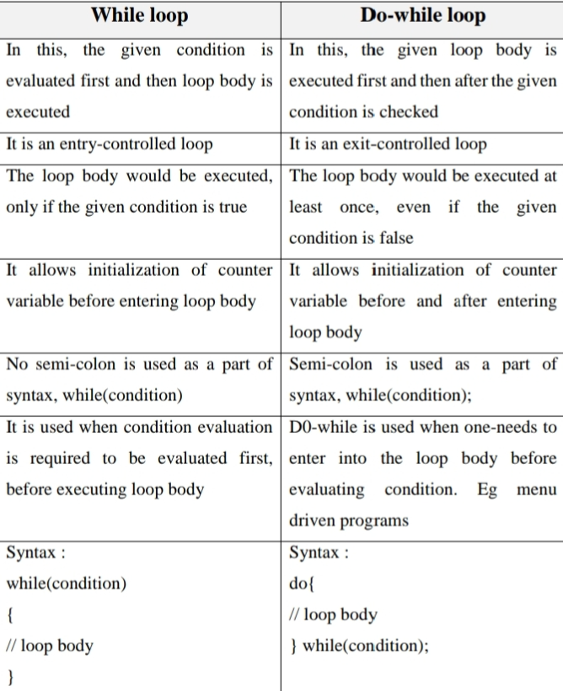

Functions:

What are functions in JavaScript? Explain the syntax for declaring and calling a function.

Ans: In JavaScript, a function is a block of code designed to perform a particular task.

Syntax for Declaring a Function (Function Declaration):

The most common way to declare a function is using the function keyword.

Example:

function functionName(parameter1, parameter2, ...) {  
 *// Code to be executed*  
 return value; *// Optional: returns a value*  
}

* function keyword:

Initiates the function declaration.

* functionName:

The unique name given to the function. This name is used to call the function later.

* (parameter1, parameter2, ...):

A comma-separated list of parameters (optional). These are placeholders for values that will be passed into the function when it is called.

* { ... }:

Curly braces enclose the function's body, which contains the statements to be executed when the function is invoked.

* return value;:

The return statement (optional) specifies the value the function should send back to the caller. If no return statement is present, the function implicitly returns undefined.

Example of Function Declaration:

function greet(name) {  
 console.log("Hello, " + name + "!");  
}

Syntax for Calling a Function:

To execute the code within a function, you need to call or invoke it.

functionName(argument1, argument2, ...);

* functionName: The name of the function you want to call.
* (argument1, argument2, ...): A comma-separated list of arguments (optional). These are the actual values passed to the function's parameters. The order of arguments must match the order of parameters in the function declaration.

Example of Calling a Function:

greet("Alice");

What is the difference between a function declaration and a function expression?

Ans: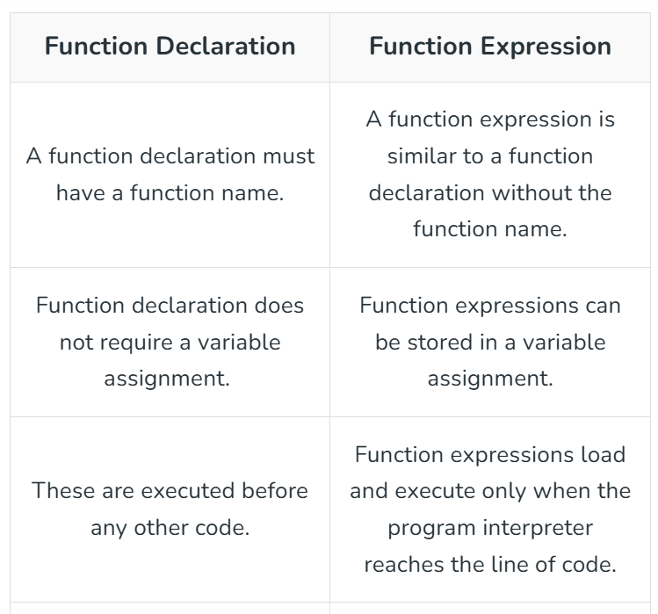

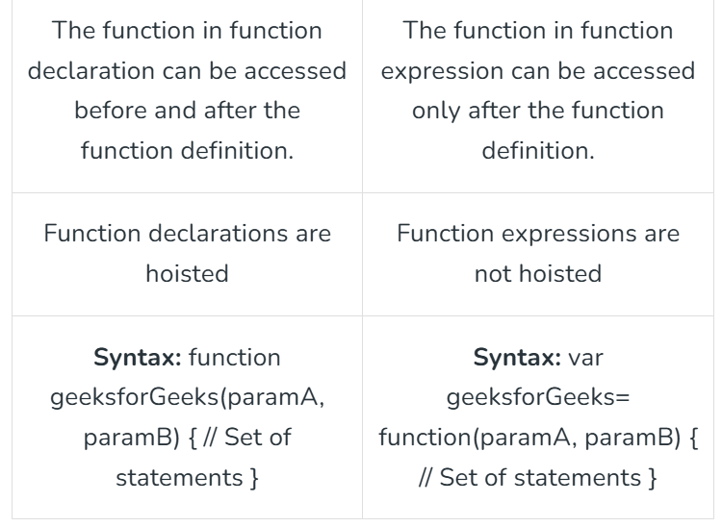

Discuss the concept of parameters and return values in functions.

Ans: In JavaScript, functions utilize parameters to accept input values and return values to provide output.

Parameters:

* **Definition:** Parameters are variables declared within the parentheses of a function's definition. They act as placeholders for the values (arguments) that will be passed into the function when it is called.
* **Purpose:** Parameters enable functions to be dynamic and reusable. They allow a function to perform operations on different data without needing to be rewritten for each specific case.
* **Syntax:**

function functionName(parameter1, parameter2, ...) {  
 *// Function body*  
 }

* **Arguments:**

When a function is invoked, the actual values passed to it are called arguments. These arguments are mapped to the corresponding parameters in the order they are provided.

* **Default Parameters:**

JavaScript allows assigning default values to parameters. If an argument is not provided for a parameter with a default value, the default value is used.

Return Values:

* **Definition:** A return value is the output generated by a function. The return statement is used within the function body to specify the value that the function should send back to the calling code.
* **Purpose:** Return values allow functions to produce a result that can be used in other parts of the program, enabling functions to be building blocks for more complex logic.
* **Syntax:**

function functionName(parameters) {  
 *// Function body*  
 return value; *// 'value' is the data to be returned*  
 }

Arrays:

What is an array in JavaScript? How do you declare and initialize an array?

Ans: In JavaScript, an array is a special type of object used to store an ordered collection of multiple values under a single variable name. These values, known as elements, can be of any data type (numbers, strings, booleans, objects, or even other arrays). Each element in an array is accessed by its numerical index, starting from 0 for the first element.

There are two primary ways to declare and initialize an array in JavaScript:

1. Array Literal Notation (Recommended):

This is the most common and concise way to create arrays. You use square brackets [] to enclose the elements, separated by commas.

Example:

*// Declaring an empty array*  
let emptyArray = [];  
  
*// Declaring and initializing an array with values*  
let colors = ["red", "green", "blue"];  
let numbers = [1, 2, 3, 4, 5];  
let mixedData = ["hello", 123, true, { name: "John" }];

2. Array Constructor:

You can also use the Array constructor function to create arrays.

Example:

*// Declaring an empty array*  
let emptyArrayConstructor = new Array();  
  
*// Declaring and initializing an array with values*  
let fruits = new Array("apple", "banana", "orange");  
  
*// Creating an array with a specified length (elements will be empty/undefined)*  
let sizedArray = new Array(5); // Creates an array with 5 empty slots

Note on const with Arrays:

When you declare an array with const, it means the reference to the array cannot be reassigned. However, the elements within the array are still mutable and can be changed, added, or removed.

Example:

const myArray = [1, 2, 3];  
myArray[0] = 10; *// This is allowed*  
console.log(myArray); *// Output: [10, 2, 3]*  
  
// myArray = [4, 5, 6]; // This would cause an error (reassignment of const)

Explain the methods push(), pop(), shift(), and unshift() used in arrays.

Ans: The methods push(), pop(), shift(), and unshift() are fundamental array manipulation methods used to add or remove elements from either the beginning or the end of an array.

1. push():

* **Purpose:** Adds one or more elements to the end of an array.
* **Return Value:** The new length of the array.
* **Example:**

let fruits = ['apple', 'banana'];  
 fruits.push('orange', 'grape');  
 console.log(fruits); // Output: ['apple', 'banana', 'orange', 'grape']

2. pop():

* **Purpose:** Removes the last element from an array.
* **Return Value:** The removed element.
* **Example:**

let fruits = ['apple', 'banana', 'orange'];  
 let removedFruit = fruits.pop();  
 console.log(fruits); *// Output: ['apple', 'banana']*  
 console.log(removedFruit); // Output: 'orange'

3. shift():

* **Purpose:** Removes the first element from an array.
* **Return Value:** The removed element.
* **Example:**

let fruits = ['apple', 'banana', 'orange'];  
 let removedFruit = fruits.shift();  
 console.log(fruits); *// Output: ['banana', 'orange']*  
 console.log(removedFruit); // Output: 'apple'

4. unshift():

* **Purpose:** Adds one or more elements to the beginning of an array.
* **Return Value:** The new length of the array.
* **Example:**

let fruits = ['banana', 'orange'];  
 fruits.unshift('apple', 'grape');  
 console.log(fruits); // Output: ['apple', 'grape', 'banana', 'orange']

Objects:

What is an object in JavaScript? How are objects different from arrays?

Ans: In JavaScript, an object is a collection of key-value pairs, where each key is a string (or a Symbol) and each value can be any data type, including other objects or functions. Objects are used to represent entities with properties and potentially methods (functions associated with the object). They are declared using curly braces {}.

Here's an example of a JavaScript object:

let person = {  
 name: "Alice",  
 age: 30,  
 occupation: "Engineer",  
 greet: function() {  
 console.log("Hello, my name is " + this.name);  
 }  
};

Objects vs. Arrays in JavaScript:

While both objects and arrays are used to store collections of data, their primary differences lie in how they organize and access that data:

* **Data Organization:**
  + **Objects:** Store data as key-value pairs, allowing you to associate a descriptive string (the key) with a value. This is useful for representing entities with distinct attributes.
  + **Arrays:** Store data as an ordered list of elements, where each element is accessed by its numerical index, starting from 0. This is ideal for collections of similar items where order matters.
* **Syntax:**
  + **Objects:** Declared using curly braces {}.
  + **Arrays:** Declared using square brackets [].
* **Accessing Elements:**
  + **Objects:** Properties are accessed using either dot notation (e.g., person.name) or bracket notation with a string (e.g., person["age"]).
  + **Arrays:** Elements are accessed using bracket notation with a numerical index (e.g., myArray[0]).
* **Order:**
  + **Objects:** The order of properties in an object is not guaranteed in older JavaScript versions, though modern JavaScript engines generally preserve insertion order for string keys.
  + **Arrays:** Elements are inherently ordered and maintain their position based on their index.

Explain how to access and update object properties using dot notation and bracket notation.

Ans: In JavaScript, object properties can be accessed and updated using two primary methods: dot notation and bracket notation.

1. Dot Notation

Dot notation is used when the property name is a valid JavaScript identifier and is known at the time of writing the code (static). Accessing Properties.

Example:

const person = {  
 name: "Alice",  
 age: 30  
 };  
 console.log(person.name); // Output: Alice

Updating Properties.

const person = {  
 name: "Alice",  
 age: 30  
 };  
 person.age = 31;  
 console.log(person.age); // Output: 31

Adding New Properties.

const person = {  
 name: "Alice"  
 };  
 person.city = "New York";  
 console.log(person.city); // Output: New York

2. Bracket Notation

Bracket notation is used when the property name is dynamic (e.g., stored in a variable), contains special characters (like spaces or hyphens), or is not a valid JavaScript identifier. The property name inside the brackets must be a string. Accessing Properties.

Example:

const person = {  
 name: "Bob",  
 "favorite color": "blue"  
 };  
 console.log(person["name"]); *// Output: Bob*  
 console.log(person["favorite color"]); // Output: blue

Updating Properties.

const person = {  
 name: "Bob",  
 "favorite color": "blue"  
 };  
 person["favorite color"] = "green";  
 console.log(person["favorite color"]); // Output: green

Adding New Properties.

const person = {  
 name: "Bob"  
 };  
 const newProp = "occupation";  
 person[newProp] = "Engineer";  
 console.log(person.occupation); // Output: Engineer

JavaScript Events:

What are JavaScript events? Explain the role of event listeners.

Ans: JavaScript events are actions or occurrences that happen in a web browser, often in response to user interactions or browser-generated activities. These events allow for the creation of interactive and dynamic web pages. Examples of common events include:

* **User interactions:**
  + click: When a user clicks an element (e.g., a button, link).
  + mouseover: When the mouse pointer moves over an element.
  + keydown, keyup: When a user presses or releases a key on the keyboard.
  + submit: When a form is submitted.
* **Browser events:**
  + load: When a page or an image finishes loading.
  + resize: When the browser window is resized.

The Role of Event Listeners

Event listeners are functions that "listen" for specific events on a designated HTML element (or the document or window object) and execute a callback function when that event occurs. They are the mechanism by which JavaScript code can react to events.

The primary method for attaching an event listener is addEventListener().

Example:

const button = document.getElementById('myButton');  
  
function handleClick() {  
 console.log('Button was clicked!');  
}  
  
button.addEventListener('click', handleClick);

How does the addEventListener() method work in JavaScript? Provide an example.

Ans: The addEventListener() method in JavaScript attaches an event handler to a specified element without overriding existing event handlers. When the specified event occurs on that element, the associated function (the event handler) is executed. This method allows for a more robust and flexible way to manage event handling compared to traditional onEvent attributes in HTML.

Syntax:

element.addEventListener(event, function, useCapture);

How it works:

* **Select the target element:**

You first need to get a reference to the HTML element or DOM object you want to attach the event listener to.

* **Specify the event type:**

Define the specific event you want to listen for (e.g., a "click").

* **Provide the callback function:**

Write the JavaScript function that will be executed when the event is triggered.

* **Attach the listener:**

Use addEventListener() on the target element, passing the event type and the callback function as arguments.

**Example:**

This example demonstrates how to use addEventListener() to change the text content of a paragraph when a button is clicked.

<!DOCTYPE html>  
<html>  
<head>  
<title>addEventListener Example</title>  
</head>  
<body>  
  
<button id="myButton">Click me!</button>  
<p id="myParagraph">Initial text.</p>  
  
<script>  
 // Get references to the HTML elements  
 const button = document.getElementById('myButton');  
 const paragraph = document.getElementById('myParagraph');  
  
 // Define the function to be executed on click  
 function changeParagraphText() {  
 paragraph.textContent = 'Button was clicked!';  
 }  
  
 // Attach the click event listener to the button  
 button.addEventListener('click', changeParagraphText);  
</script>  
  
</body>  
</html>

DOM Manipulation:

What is the DOM (Document Object Model) in JavaScript? How does JavaScript interact with the DOM?

Ans: When a web page is loaded, the browser creates a **D**ocument **O**bject **M**odel of the page.

The DOM is a W3C (World Wide Web Consortium) standard.

The DOM defines a standard for accessing documents:

*"The W3C Document Object Model (DOM) is a platform and language-neutral interface that allows programs and scripts to dynamically access and update the content, structure, and style of a document."*

The W3C DOM standard is separated into 3 different parts:

* Core DOM - standard model for all document types
* XML DOM - standard model for XML documents
* HTML DOM - standard model for HTML documents

Explain the methods getElementById(), getElementsByClassName(), and querySelector() used to select elements from the DOM.

Ans: The Document Object Model (DOM) provides several methods to select and manipulate HTML elements within a web page. Three commonly used methods are getElementById(), getElementsByClassName(), and querySelector().

getElementById()

The getElementById() method is used to select a single HTML element by its unique id attribute.

* **Purpose:** Retrieves a specific element based on its ID.
* **Return Value:** An Element object representing the element with the specified ID, or null if no such element exists.
* **Usage:**

const myElement = document.getElementById('uniqueId');

This method is efficient for targeting individual elements because IDs are intended to be unique within a document.

getElementsByClassName()

The getElementsByClassName() method is used to select all HTML elements that share a specific class name.

* **Purpose:** Retrieves a collection of elements that have the given class name.
* **Return Value:** A live HTMLCollection object containing all matching elements. This collection automatically updates if elements are added or removed from the document that match the class.
* **Usage:**

const elementsWithClass = document.getElementsByClassName('myClass');  
 *// To access individual elements:*  
 for (let i = 0; i < elementsWithClass.length; i++) {  
 console.log(elementsWithClass[i]);  
 }

querySelector()

The querySelector() method is a more versatile method that allows selecting elements using CSS selectors.

const firstParagraph = document.querySelector('p'); *// Selects the first paragraph*  
 const elementById = document.querySelector('#uniqueId'); *// Selects by ID*  
 const elementByClass = document.querySelector('.myClass'); *// Selects by class*  
 const nestedElement = document.querySelector('div > p.highlight'); // Selects a p with class 'highlight' inside a div

JavaScript Timing Events (setTimeout, setInterval):

Explain the setTimeout() and setInterval() functions in JavaScript. How are they used for timing events?

Ans: In JavaScript, setTimeout() and setInterval() are functions used to schedule the execution of code at specific intervals or after a delay, enabling timing events.

1. setTimeout(function, delay):

* **Purpose:** Executes a specified function once after a designated delay in milliseconds.
* **Usage:**

let timeoutID = setTimeout(function() {  
 console.log("This message appears after 3 seconds.");  
 }, 3000); // 3000 milliseconds = 3 seconds

2. setInterval(function, delay):

* **Purpose:** Executes a specified function repeatedly at a fixed delay in milliseconds between each execution.
* **Usage:**

let intervalID = setInterval(function() {  
 console.log("This message appears every 2 seconds.");  
 }, 2000); // 2000 milliseconds = 2 seconds

Provide an example of how to use setTimeout() to delay an action by 2 seconds.

Ans: Here is an example of how to use setTimeout() to delay an action by 2 seconds in JavaScript:

Example:

function delayedAction() {  
 console.log("This action was delayed by 2 seconds!");  
}  
  
*// Call setTimeout, passing the function to execute and the delay in milliseconds.*  
setTimeout(delayedAction, 2000);  
  
console.log("This message appears immediately.");

JavaScript Error Handling:

What is error handling in JavaScript? Explain the try, catch, and finally blocks with an example.

Ans: Error handling in JavaScript refers to the process of anticipating, detecting, and responding to errors or exceptions that may occur during the execution of a program. It ensures that the program can gracefully handle unexpected situations and continue running or provide meaningful feedback to the user, rather than crashing or producing unpredictable behavior.

JavaScript provides the try...catch...finally statement for structured error handling:

* try block:

This block encloses the code that might potentially throw an error. If an error occurs within the try block, the execution of the try block immediately stops, and control is transferred to the catch block.

* catch block:

This block immediately follows the try block and is executed only if an error occurs in the try block. It takes an error object as a parameter, which contains information about the error (e.g., name, message). The catch block allows for handling the error, such as logging it, displaying a user-friendly message, or attempting to recover from the error.

* finally block:

This optional block follows the try and catch blocks. The code inside the finally block always executes, regardless of whether an error occurred in the try block or was caught by the catch block. It is typically used for cleanup operations, such as closing files, releasing resources, or performing final actions that must happen irrespective of the outcome.

Example:

function divide(numerator, denominator) {  
 try {  
 if (denominator === 0) {  
 throw new Error("Cannot divide by zero."); *// Throws a custom error*  
 }  
 const result = numerator / denominator;  
 console.log("Division result:", result);  
 } catch (error) {  
 console.error("Error caught:", error.message); *// Handles the error*  
 } finally {  
 console.log("Division operation completed."); *// Always executes*  
 }  
}  
  
divide(10, 2); *// No error, prints result and finally block*  
divide(5, 0); // Throws an error, prints error message and finally block

Why is error handling important in JavaScript applications?

Ans: Error handling is crucial in JavaScript applications for several reasons, primarily centered around creating robust, reliable, and user-friendly software.

* **Preventing Application Crashes:**

Unhandled errors can lead to an application crashing, resulting in a poor user experience and potential loss of data. Proper error handling, using constructs like try-catch blocks, allows for graceful recovery from unexpected situations.

* **Improving User Experience:**

Instead of abrupt crashes or cryptic error messages, effective error handling enables applications to provide meaningful feedback to users. This could involve displaying a user-friendly error message, guiding them to resolve an issue, or offering alternative actions.

* **Enhancing Application Stability and Reliability:**

By anticipating and managing potential errors, applications become more stable and reliable in production environments. This ensures consistent functionality and reduces downtime.

* **Facilitating Debugging and Maintenance:**

Well-implemented error handling provides valuable context and information when errors occur, making it significantly easier to debug issues. Logging errors with relevant details (e.g., stack traces, timestamps) helps developers quickly identify and fix problems.

* **Ensuring Resource Cleanup:**

The finally block in try-catch-finally statements guarantees that crucial cleanup operations, such as closing file connections or releasing resources, are executed regardless of whether an error occurred.

* **Building Robust Asynchronous Code:**

In modern JavaScript development, especially with Promises and async/await, proper error handling is vital for managing errors that arise during asynchronous operations. Errors in asynchronous code need to be caught and handled to prevent them from propagating and potentially crashing the application.