HTML Full Stack

**1.HTML Basic:**

1. Define HTML. What is the purpose of HTML in web development?

**Ans:** **Define:** HTML, which stands for HyperText Markup Language, is the standard language used to create and structure web pages. In web development, HTML serves as the foundational language for building the content and layout of websites.

**Purpose of HTML:**

HTML, or HyperText Markup Language, provides the fundamental structure and content for web pages.

* **Structure:**

HTML elements, enclosed in tags, define the different parts of a webpage, such as headings, paragraphs, lists, and links.

* **Content:**

HTML is used to include various types of content, including text, images, videos, and other media elements.

* **Foundation for other technologies:**

HTML forms the foundation upon which CSS (for styling) and JavaScript (for interactivity) are built.

1. Explain the basic structure of an HTML document. Identify the mandatory tags and their purposes.

**Ans:** An HTML document's basic structure includes a <!DOCTYPE html>, <html>, <head>, <title>, and <body> tag. The <!DOCTYPE html> declaration specifies the document type as HTML5. The <html> tag encompasses the entire page, while <head> contains metadata and linked resources. The <title> tag defines the page's title, and <body> holds the visible content. These tags are mandatory for a valid HTML document.

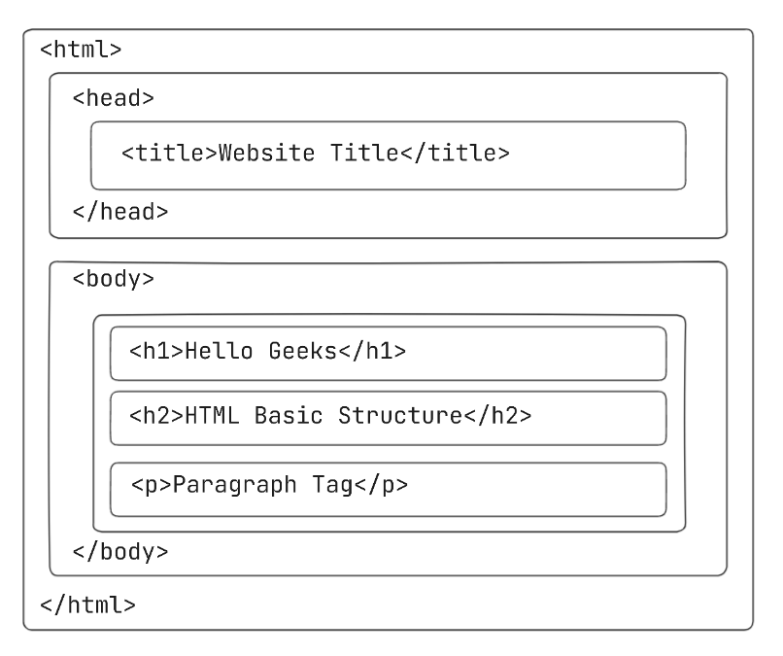

1. <html>:

The root element of the HTML page. It contains all other elements, including the <head> and <body>.

1. <head>:

This section contains meta-information about the HTML document, like the title, character set, links to stylesheets, and scripts. It's not displayed directly on the page.

1. <title>:

This tag, placed within the <head>, defines the title of the HTML page. The title is displayed in the browser's title bar or tab.

1. <body>:

This section contains the visible content of the web page, such as text, images, links, and other elements that users see and interact with.

1. What is the difference between block-level elements and inline elements in HTML? Provide examples of each.

**Ans:** In HTML, block-level elements always start on a new line and take up the full width available, while inline elements do not start on a new line and only take up as much width as necessary.

Block-level elements:

* **Start on a new line:** They force a line break before and after themselves.
* **Take up full width:** They extend to fill the entire width of their parent element.
* **Examples:** <div>, <p>, <h1> to <h6>, <form>, <header>, <footer>, <ul>, <ol>, <li>, <nav>.

Inline elements:

* **Do not start on a new line:** They flow within the existing line of content.
* **Take up only the necessary width:** They only occupy the space required by their content.
* **Examples:** <span>, <a>, <img>, <input>, <button>, <label>, <strong>, <em>.

1. Discuss the role of semantic HTML. Why is it important for accessibility and SEO? Provide examples of semantic elements.

**Ans:** Semantic HTML, which uses meaningful HTML elements to structure content, is crucial for both accessibility and SEO. It helps browsers and assistive technologies understand the content's purpose, improving user experience and making websites easier to navigate, especially for those with disabilities.

Importance for Accessibility:

* **Improved Screen Reader Navigation:** Semantic elements like <header>, <footer>, <nav>, <article>, <aside>, and <section> provide clear structure for screen readers. This allows users to navigate the page more efficiently, skipping to specific sections or content areas.

Importance for SEO:

**Improved Search Engine Understanding:**

Search engines like Google use semantic HTML to understand the structure and content of a webpage.

* **Better Content Indexing:**

Semantic elements like <article> and <section> help search engines understand the hierarchical structure of the page, allowing them to index the content more effectively.

Examples of Semantic Elements:

1. <header>: Defines a header for a document or section.
2. <footer>: Defines a footer for a document or section.
3. <nav>: Defines a navigation section.
4. <article>: Defines a self-contained composition, like a blog post or news article.
5. <aside>: Defines content that is tangentially related to the main content, like sidebars or call-out boxes.
6. <section>: Defines a thematic grouping of content.
7. <table>, <tr>, <th>, <td>: Used for structuring tabular data, rather than for layout purposes.
8. <main>: Specifies the main content of a document.

**2.HTML Form:**

1. What are HTML forms used for? Describe the purpose of the input, textarea, select, and button elements.

Ans: HTML forms are used to collect user input on web pages and transmit that data to a server for processing. The input, textarea, select, and button elements are fundamental components within forms, each serving a distinct purpose in user interaction.

**Purpose of each element:**

* <input>: This element is incredibly versatile and can create a variety of input fields, such as text boxes, password fields, checkboxes, radio buttons, and more. It is the most common element used for capturing user input.
* <textarea>: This element provides a multi-line text input area, allowing users to enter longer text entries, like comments or feedback. It's suitable for scenarios where a single line input field is insufficient.
* <select>: This element creates a dropdown list, enabling users to choose a single option from a predefined list of options.
* <button>: This element defines a clickable button that can be used to submit the form data.

1. Explain the difference between the GET and POST methods in form submission. When should each be used?

Ans:

***HTML GET:***

In GET method we can not send large amount of data rather limited data of some number of characters is sent because the request parameter is appended into the URL.

GET request is comparatively less secure because the data is exposed in the URL bar.

Request made through GET method are stored in Browser history.

**Example:** Fetching a product based on its ID (e.g., example.com/product?id=123).

***HTML POST:***

In POST method large amount of data can be sent because the request parameter is appended into the body.

GET request is comparatively less secure because the data is exposed in the URL bar.  
Request made through POST method is not stored in Browser history.

**Example:** Submitting a form to create a new user account (e.g., example.com/register).

1. What is the purpose of the label element in a form, and how does it improve accessibility?

Ans: The label element in a form associates text with a form control, improving both usability and accessibility. It makes forms easier to use by allowing users to click on the label to activate or focus the associated input field and provides screen reader users with context about the input field's purpose.

How label elements improve accessibility:

**Increased clickable area:**

Clicking on the label focuses or activates the associated form control, making it easier for users to interact with the form, especially those with using touchscreens.

**Context for screen readers:**

Screen readers use the label element to announce the purpose of the form control to users, making it easier to understand what information is expected in each field.

**Improved form navigation:**

By associating labels with input fields, users can quickly understand the purpose of each field, reducing errors and making the form more user-friendly.

**Example:**

<label for="username">Username:</label>  
<input type="text" id="username" name="username">

In this example, the text **"Username:"** is associated with the input field using the for attribute and the id of the input. Clicking on **"Username:"** will focus the text input field.

**3.HTML Table:**

1. Explain the structure of an HTML table and the purpose of each of the following elements:<table>, <tr>, <th>, <td> and <thead>.

Ans: An HTML table is structured using the <table> element, which acts as a container for table rows (<tr>), table header cells (<th>), and table data cells (<td>). The <thead> element groups table header rows, providing semantic meaning and improved accessibility.

**Each purpose of element:**

* <table>: This is the root element of an HTML table.
* <tr>: This element represents a table row. Each <tr> element contains cells (either <th> or <td>) that make up a single row in the table.
* <th>: This element represents a table header cell. It is typically used for column or row headings, and it's often styled with a bold font and centered text by default.
* <td>: This element represents a table data cell. It contains the actual data or content of a table, corresponding to a specific row and column.
* <thead>: This element groups the header content of a table. It's typically used to contain the <tr> elements that define the header row(s) of the table. This helps with accessibility (e.g., screen readers) and potentially with styling. It's not required, but it's good practice for structuring tables.

2. What is the difference between colspan and rowspan in tables? Provide examples.

Ans: In HTML tables, colspan and rowspan are attributes used to merge table cells. colspan merges cells horizontally (across columns), while rowspan merges cells vertically (across rows).

**Colspan:**

The colspan attribute is used within a <td> or <th> tag to specify how many columns a cell should span.

For example, <td colspan="2"> will make the cell occupy the space of two columns.

This is useful for creating headers or labels that span multiple columns.

**For Example:**

<table>  
 <tr>  
 <th colspan="2">Name</th>  
 <th>Age</th>  
 </tr>  
 <tr>  
 <td>John</td>  
 <td>Doe</td>  
 <td>30</td>  
 </tr>  
</table>

**Rowspan:**

The rowspan attribute is also used within a <td> or <th> tag, specifying how many rows a cell should span.

For example, <td rowspan="3"> will make the cell occupy the space of three rows.

This is useful for creating headers or labels that span multiple rows.

**For Example:**

<table>  
 <tr>  
 <th rowspan="2">Name</th>  
 <td>John</td>  
 </tr>  
 <tr>  
 <td>Doe</td>  
 </tr>  
 <tr>  
 <th>Age</th>  
 <td>30</td>  
 </tr>  
</table>

3. Why should tables be used sparingly for layout purposes? What is a better alternative?

Ans: In this article, we will learn why we should avoid using table for layout in HTML. A website can be divided into various sections comprising of header, menus, content, and footer based on which there are many different layout designs available for developers. Different layouts can be created by using an HTML div tag and CSS property to style them.

