**ESTIMATING THE TIME CONSTANT OF MOISTURE SORPTION**

**SENSORS OF RADIOSONDES**

A. M. Bagurov, Μ. B. Fridzon, and A. R. Dozortsev

MeteorologiyaiGidrologiyaNo. 4, pp. 114-117, 1984

UDC 551.508.7:551.508.822

Presented are theoretical calculations of the time constant of moisture sorption-deformation sensors (SDS) of RKZ and MARZ radiosondes. The procedure is described and data from experimental determination of the time constant of SDS are presented. The time constant of SDS increases with increase in relative humidity and drop in temperature. The difference of relative co­efficients of inertia, determined experimentally and theoretically, does not exceed 30%. The values of the time constant of SDS are calculated for stan­dard atmospheric conditions.

One of the constituents of the error of measuring moisture with radiosondes is the error due to sensor inertia. The time constant of moisture sorption-deformation sen­sors (SDS) used in radiosondes of RKZ and MARZ type is a complex function of the original value of moisture, the value and sign of its variation, temperature, pressure, and flow velocity of the measured medium, design parameters of the sensor, geometric and sorption characteristics of the sensitive element, an animal film.

The experimental determination of the value for the entire range of operating conditions of the radiosonde is a fairly complex problem. Its complexity is due to the absence of special equipment for determining λi at different temperatures, pressure, moisture, and airflow velocities.

One of the ways to obtain estimates of the λi value of radiosondes sensors for the operating conditions is theoretical calculation and comparison with available units of test data obtained usually by different methods.

Development of the general theory of inertia of moisture sorption sensors, which considers the sorption characteristics of the sensor, the effect of heat and mass transfer in the boundary layer of the gas flow around the sensor, and also different external factors, is not yet complete.

Thus, in [4] empirical dependences have been obtained for the time constant of capillary sensors of moisture on a series of parameters of the measured medium. One of the main assumptions of the theory developed in [4] is the identification of the mechanisms of transfer of water vapor molecules in the boundary layer and in the pores of the sensor. As further studies of sorption processes have shown [2], this assumption turned out to be invalid with a fairly small pore diameter and led to errors in many of the important conclusions of [4].

In particular, in experimental studies of film sensors of RKZ and MARZ radiosondes [3], it turned out that their time constant increases with increase in moisture and does not decrease, as found in [4]. The form of the dependence of λi on pressure of the medium also differs significantly.

The conclusions of [1], which is devoted to aluminum oxide sensors (ADS), are obtained on the basis of the conjugate problem: combined solution of the equations of mass transfer in the boundary layer and in pores of the sorbing body. These conclusions are confirmed experimentally. The mechanism of mass transfer of water vapor molecules for ADS and film sensors is similar. Therefore, despite the difference in the methods of transformation of the amount of absorbed water vapor into the appropriate output signal, it is worthwhile to use the results of [1] as a first approximation for theoretical estimate of λI of film sensors.

In this paper it is shown that if we determine the value of the time constant of the actual moisture sensor for some initial conditions λi, then for other parameters of the measured medium it may be calculated with the aid of the following relationship:

(1)

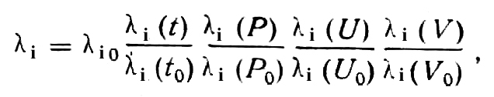

where the subscript 0 indicates initial conditions, t is the temperature, P is the pressure, U is the relative moisture, V is the flow velocity of the measured medium,

(2)

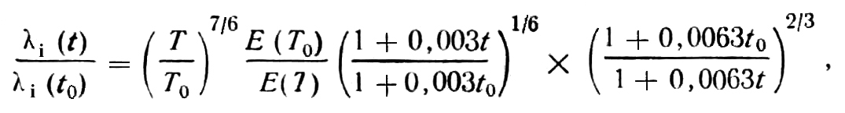

where T = t + 273.15, К, E is the elasticity of the saturated vapor, mb,

(3)

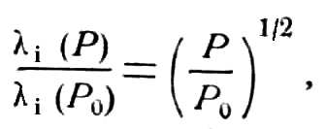

(4)

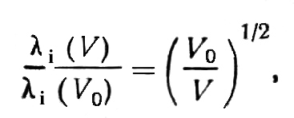

(5)

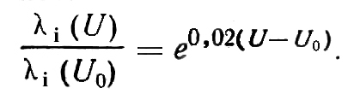

To calculate the time constant of SDS, we transform formula (1) with consideration of dependences (2)-(5) into the form

(6)



For convenience of calculations, formula (6) can be represented as a nomogram (see Fig. 1). Taken for the zero conditions are t0 = 0°C, P0 = 100 gPa, U0 = 50%, V0 = 1 m/sec. The value can be determined approximately from [3]. For the indicated conditions, λi≅ 15 sec.

Thus, it is possible to calculate the value of the time constant of SDS for different conditions of atmospheric sounding.

To refine and verify the obtained theoretical values of li , we investigated the time con­stant of SDS on a device for determining the dynamic characteristics of UPG-110 hygrometers, which was developed by the Tbilisi NPO Analitpribor.

The tests followed the flow chart:

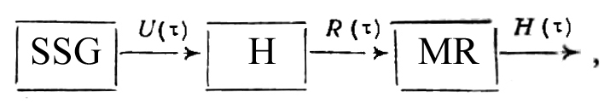

where SSG is the generator of a stepped signal, U (τ) is the stepped signal, H is the hy­grometer, MR is the measurement recorder, Η (τ) is the transitional characteristic, and τ is the time.

Used as the SSG was the UPG-110 combined with the climate chamber Foitron-3001, with whose aid stepped signals are realized according to moisture within limits of 15 to 95% of relative humidity in the temperature range from -10 to +50°C with an airflow rate of 0.2 to 1.5 m/sec and a time constant of not more than 1 sec.

The H-37 constant-current milliammeter combined with the 1-37 constant-current metering amplifier was used as a recording meter. To transform the output parameter of the moisture sensors (active resistance), we used unbalanced bridge of constant current. The initial U1and final U2 values of relative humidity were monitored by the readings of GS-210 hygrometers. The sensor of one of them was installed in the UPG-110 operating chamber, the other, in the operating chamber of the Foitron-3001 climate chamber.

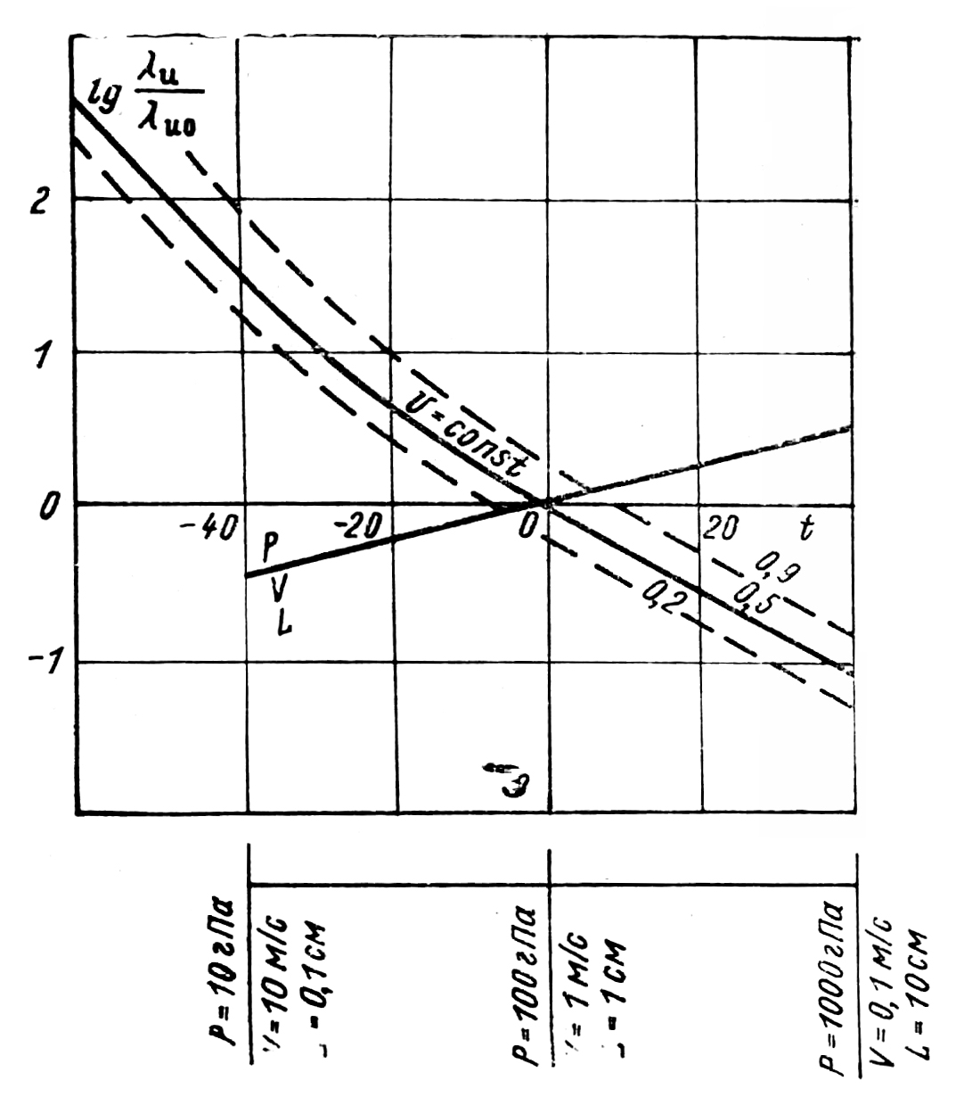

Fig. 1. Nomogram of calculating the inertia coefficient of moisture sorption sensor. λi is the time con­stant, sec; λi is the time constant under normal conditions, sec; t is the temperature, °C; U is the relative humidity; V is the flow velocity, m/sec; P is the pressure, gPa; L is the diameter of the sensitive element of the sensor, cm.

The transitional characteristic was taken in the form of a continuous graphic recording of the process. Recording of the transitional characteristic was done until the readings (output signal) of the investigated SDS reached the established value. Comparison of the variance of inadequacy of the model of the SDS transitional characteristic as a linear dynamic first-order link with the variance of reproducibility of the test data according to the Fischer criterion showed that with a probability of 0.95 the form of the function re­lating the time-variable input U and output R (τ) is expressed by the formula

(7)

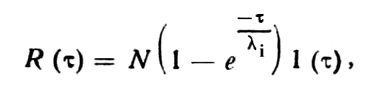

where N is the transmission coefficient of SDS and N is the constant, which corresponds to a linear dependence between U and R (τ), 1 (τ) is the single stepped function.

The time constant λi of the lst-order linear relationship is numerically equal to the time during which the sensor changes its reading by 63% of the value of the variation of the output parameter in the transitional process.

Results of experimental and theoretical determination of the relative inertia coefficients SDS λi/λi0 are presented in Table 1. The analysis of the results shows that the time constant of SDS increases with increase in relative humidity U and with decrease of temperature T, and the mean value of the time constant ‾λi0, defined as ${\overline{λ}}_{i0}=\frac{1}{n}\sum^{n}{λ_{ii}}$ 
 under normal conditions (t0 = 20°C, P0 = 1000 gPa,U1= 37%, U2= 63%, airflow rateV0 = 1.5 m/sec), is equal to 4.65 sec. From Table 1 it is evident that the relative coefficients of inertia, obtained by experimental (λi/λi0)e and theoretical (λi/λi0)t data, differ by no more than 30%.

Table 1

Table 2

Table 2 presents the values of the time constants of SDS, calculated according to the plan outlined, for standard atmospheric conditions. Calculations were carried out for the values of flow velocity of the measured medium V - 5 m/sec (mean velocity of ascent of radiosonde) and relative humidity of 30%.

As evident from Table 2, the value of the time constant of SDS increases from several seconds at the Earth surface to tens of minutes in the tropopause (at elevation of 11 km), and then begins to decrease slowly. This is explained by the prevailing effect of temperature, whose sharp drop in the tropopause decreases the inertia of the sensor. Above 11 km the temperature does not change and with decrease in pressure, the sensor inertia decreases, too.

With relative humidity of 70%, the λi value increased by 2-2.5 times.

The coincidence of experimental and calculation data with a 30% limit in the temperature range from -10 to +20°C allows us to hope that the values of the time constant found in Table 2 are fairly close to actual values and may be used to estimate dynamic errors of moisture measurement in the entire operating range of the radiosonde.

For experimental verification of the λi values, we must create a special device, dynamic generator of moisture, which allows us to create irregular disturbances of the moisture sensor of the radiosonde in terms of moisture in the entire operating range of temperatures, moisture, pressure, and airflow velocities.

**REFERENCES**

1. A. M. Balagurov, "Dynamic characteristics of aluminum oxide moisture sensors", Trudy TsAO, no. 141, 1979·

2. Ya. Burde, Dynamic Nature of Adsorption [in Russian], IL, Moscow, 1962.

3. N. S. Varzhenevskii, "Film sensors of moisture",Trudy NIIGMP, no. 5, 1957·

4. V. D. Reshetov, "Inertia and sensitivity of capillary hygrometer at low temperatures", Trudy TsAO, no. 11, 1953.

1 July 1983 Central Aerological Observatory