Wind uncertainties

Initial assessment

Issued by: UNIVIE / Federico Ambrogi

Date: 19/06/2019

Ref: DC3S311c\_Lot2.2.2.1

Official reference number service contract: 2019/C3S\_311c\_Lot2\_UNIVIE/SC1

This document has been produced in the context of the Copernicus Climate Change Service (C3S).

The activities leading to these results have been contracted by the European Centre for Medium-Range Weather Forecasts, operator of C3S on behalf of the European Union (Delegation Agreement signed on 11/11/2014). All information in this document is provided "as is" and no guarantee or warranty is given that the information is fit for any particular purpose.

The user thereof uses the information at its sole risk and liability. For the avoidance of all doubts, the European Commission

and the European Centre for Medium-Range Weather Forecasts has no liability in respect of this document, which is merely representing the authors view.

Contributors

UNIVIE

F. Ambrogi

M. Blaschek

L. Haimberger

Contents

[Contents 4](#_Toc11407718)

[1. Introduction 4](#_Toc11407719)

[2. Data 4](#_Toc11407720)

[3. Method 5](#_Toc11407721)

[3.1 Outliers Removal 7](#_Toc11407722) [7](#_Toc11407723)

[4. Results 7](#_Toc11407728)

[4.1 Cross Covariance Matrices 7](#_Toc11407729)

[4.2 Distribution and time series of error estimates at the 500 hPa level 9](#_Toc11407730)

[4.3 Dependence of observation error on pressure 11](#_Toc11407731)

[5. Conclusions 12](#_Toc11407732)

[6. References 13](#_Toc11407745)

[7. Introduction 15](#_Toc11407746)

# Introduction

This document extends our effort to estimate uncertainties for early upper air measurements, following the methodology introduced in the deliverable C3S\_C311\_Lot2.2.1.1 (March 2019), with the focus on wind speed and wind direction. The use of observation minus background and observation minus analysis departure statistics, as they are produced by modern climate data assimilation systems such as ERA5 (Hersbach et al. 2018), is an efficient alternative way to estimate observations errors, i.e. measurement plus representation error, whenever these are not available from observations. Early observations for sure and most contemporary observations do not supply observation error estimates. Such information can indeed be directly retrieved only in special networks such as the Global Climate Observing System (GCOS, Daan, 2002) Reference Upper-Air Network (GRUAN, Dirksen et al., 2014), or from the results of radiosonde inter-comparison campaigns (e.g. Yangjiang, Chian, 2010). However, results of such campaigns cannot be easily accessed, and in addition they depend on the types of radiosondes used for the measurements. In contrast, the use of departure statistics for estimating observation errors, according to the method described by Desroziers (2005), is a good general method that is applicable whenever departures are available. In this document we present results of the uncertainty estimation method for wind related observables, namely the wind speed and its decomposition in orthogonal components, and the wind direction.

# Data

For this initial version of the uncertainty assessment we use data from the ERA5 observation database (ODB), provided by the European Centre for Medium-Range Weather Forecasts (ECMWF).

For the following discussion, we will take as an example benchmark for explaining our procedure the Lindenberg observation station (Germany, WMO ID 10393, 2006-2019). It is straightforward to apply this analysis to arbitrary observation stations.

Together with the results presented in this document, we also provide example scripts which allow to reproduce the plots shown.

We include also the temperature files although the error estimation for this variable was discussed previously in the C3S\_C311\_Lot2.2.1.1 (March 2019) deliverable.

The code used to produce the results here presented is available from GitHub at [https://github.com/MBlaschek/CEUAS/tree/develop/CEUAS/wind\_uncertainty](https://github.com/MBlaschek/CEUAS/tree/develop/CEUAS/wind_uncertainty%20) .

The repository includes an extended README file with all the relevant information to allow the user to reproduce the results shown in this document.

During the processing of the ODB files, 16 standard pressure levels are used as a reference for the observations; moreover, all the observations are reported at the 00GMT and 12GMT standard launch times.

# Method

The present analysis is based on the statistical framework, which has already been introduced and explained in some details in the previous uncertainty estimation deliverable C3S\_C311\_Lot2.2.1.1. We will refer to this procedure throughout this document as Desroziers diagnostics. If **dO-B** represents the observation minus background departure and **dO-A** represents the observation minus analysis departure, the error cross covariance matrix **R** can be calculated as:

where the expectation value is calculated over an arbitrary time range. The estimation of R is dependent on the temporal intervals. Here we use 1, 2, 6 months and 1 year. For each pressure level, the quantities **dO-B** and **dO-A**are available and the estimate of the error can be calculated from the time averages.

A useful benchmark to compare the procedure is the result from the WMO inter-comparison campaign performed in Yangjing (2010), and documented in the “Guide to Meteorological Instruments and Methods of Observations (2014)”.

In case of upper-wind measurements, errors stem from the combination of three different sources of uncertainties related to the tracking of the horizontal motion of the target, to the determination of the height of the target, and the difference between the movement of the target and the actual atmospheric motion.

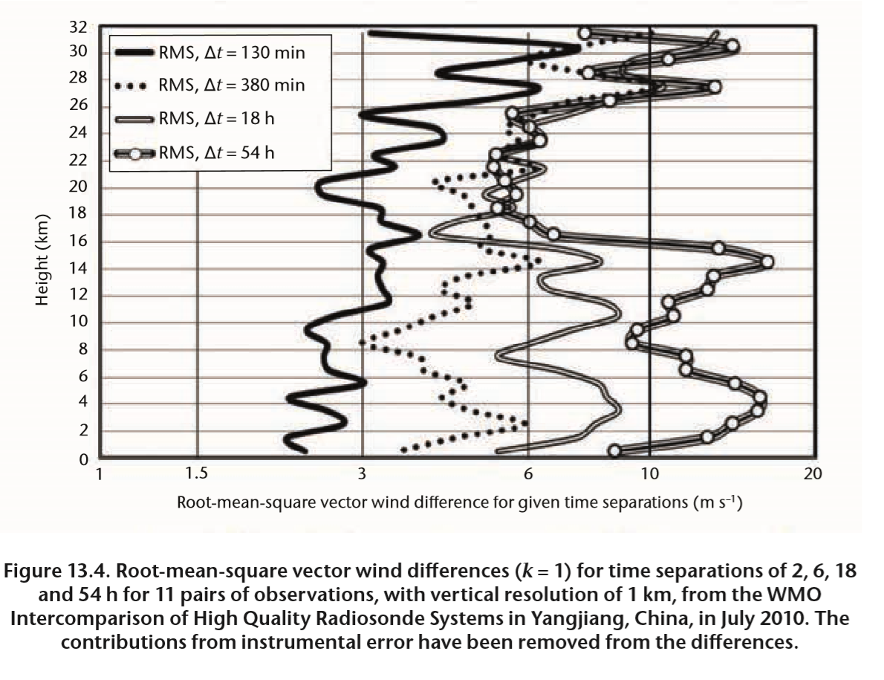

**Figure 1** Root-mean-square vector wind differences for different time separations, for 11 pairs of observation, from the WMO Inter-comparison of High Quality Radiosonde System (Yangjiang, Chian, 2010).

-1.

The ODB files provided by the ECMWF include the observed values as well as the departures for the wind u- and v-components. The wind direction and speed values are then calculated from the orthogonal components, as well as the departures needed for the calculation of the Desroziers diagnostics.

**3.1** **Outlier removal**

Before proceeding to the extraction of the measurement errors, outliers values are removed from the departure data. This is done to ensure better statistical robustness. The Desroziers diagnostics is indeed sensitive to outlier values, especially when averaging over short time intervals, where one single outlier can result in large discrepancies in the error calculation. We use quartiles statistics in the following way. The 25% and 75% percent quartiles, denoted with q25 and q75 respectively, are computed using the original datasets of the analysis and background departures. An arbitrary parameter *cut=1.5* is then employed to calculate a cut\_off value:

The values in the data below the lower value q25-cut\_off and above the upper value q75+cut\_off are disregarded when computing the Desroziers averages and errors. For the case of a normal distribution, this means that 0.7% of data are rejected.

The number of outliers found in each dataset depends largely on the pressure levels, and on the time period considered. Generally the number of outliers does not exceed 3% of the wind speed data. For the temperature, the number is slightly higher, especially for departures in the upper troposphere, settling around 10%. The outliers however are still reasonably close to the lower and upper cuts, and only spurious data is removed from the calculation of the Desroziers average. Thus, given a more robust estimate and circumventing any inclusion of to be rejected values.

# Results

In this section we present the main results of our analysis. In section 4.1 we present the full results of the calculation of the cross-covariance matrices, from which observation errors are calculated. In section 4.2, we present the error time series and distributions for observations at 500 hPa pressure level, comparing the results for different choices of time averaging. In section 4.3 we then compare the results for all the different pressure levels.

## Cross Covariance Matrices

As a starting point, it might be of interest to visualize the cross-covariance matrices defined in eq. (1). We provide some example for the Lindenberg station, for arbitrary observation days as indicated in Fig. 1. The variables shown are the u- and v- component of the wind, the speed of the wind, and the temperature (as a reference, since the estimation of the errors for this variable was the object of the previous report C3S\_C311\_Lot2.2.1.1).

The values are obtained by computing the product of the analysis departure times the background departure for the standard pressure levels as indicated by the axis labels. Note that usually only the diagonal entries are considered, i.e. one should expect no significant correlation between the measurements at different pressure levels. For these matrices, the value shown is calculated by taking the average over a period of 365 days following the chosen date. Null values, for which no data is available, are neglected in the computation of the average.

The correlation matrices are the starting point for the calculation of the uncertainties using Desroziers method, essentially the square root of the correlations averaged over a time interval. Note that the matrices are obtained by evaluating the covariance of the analysis and background departures, hence the presence of negative values.

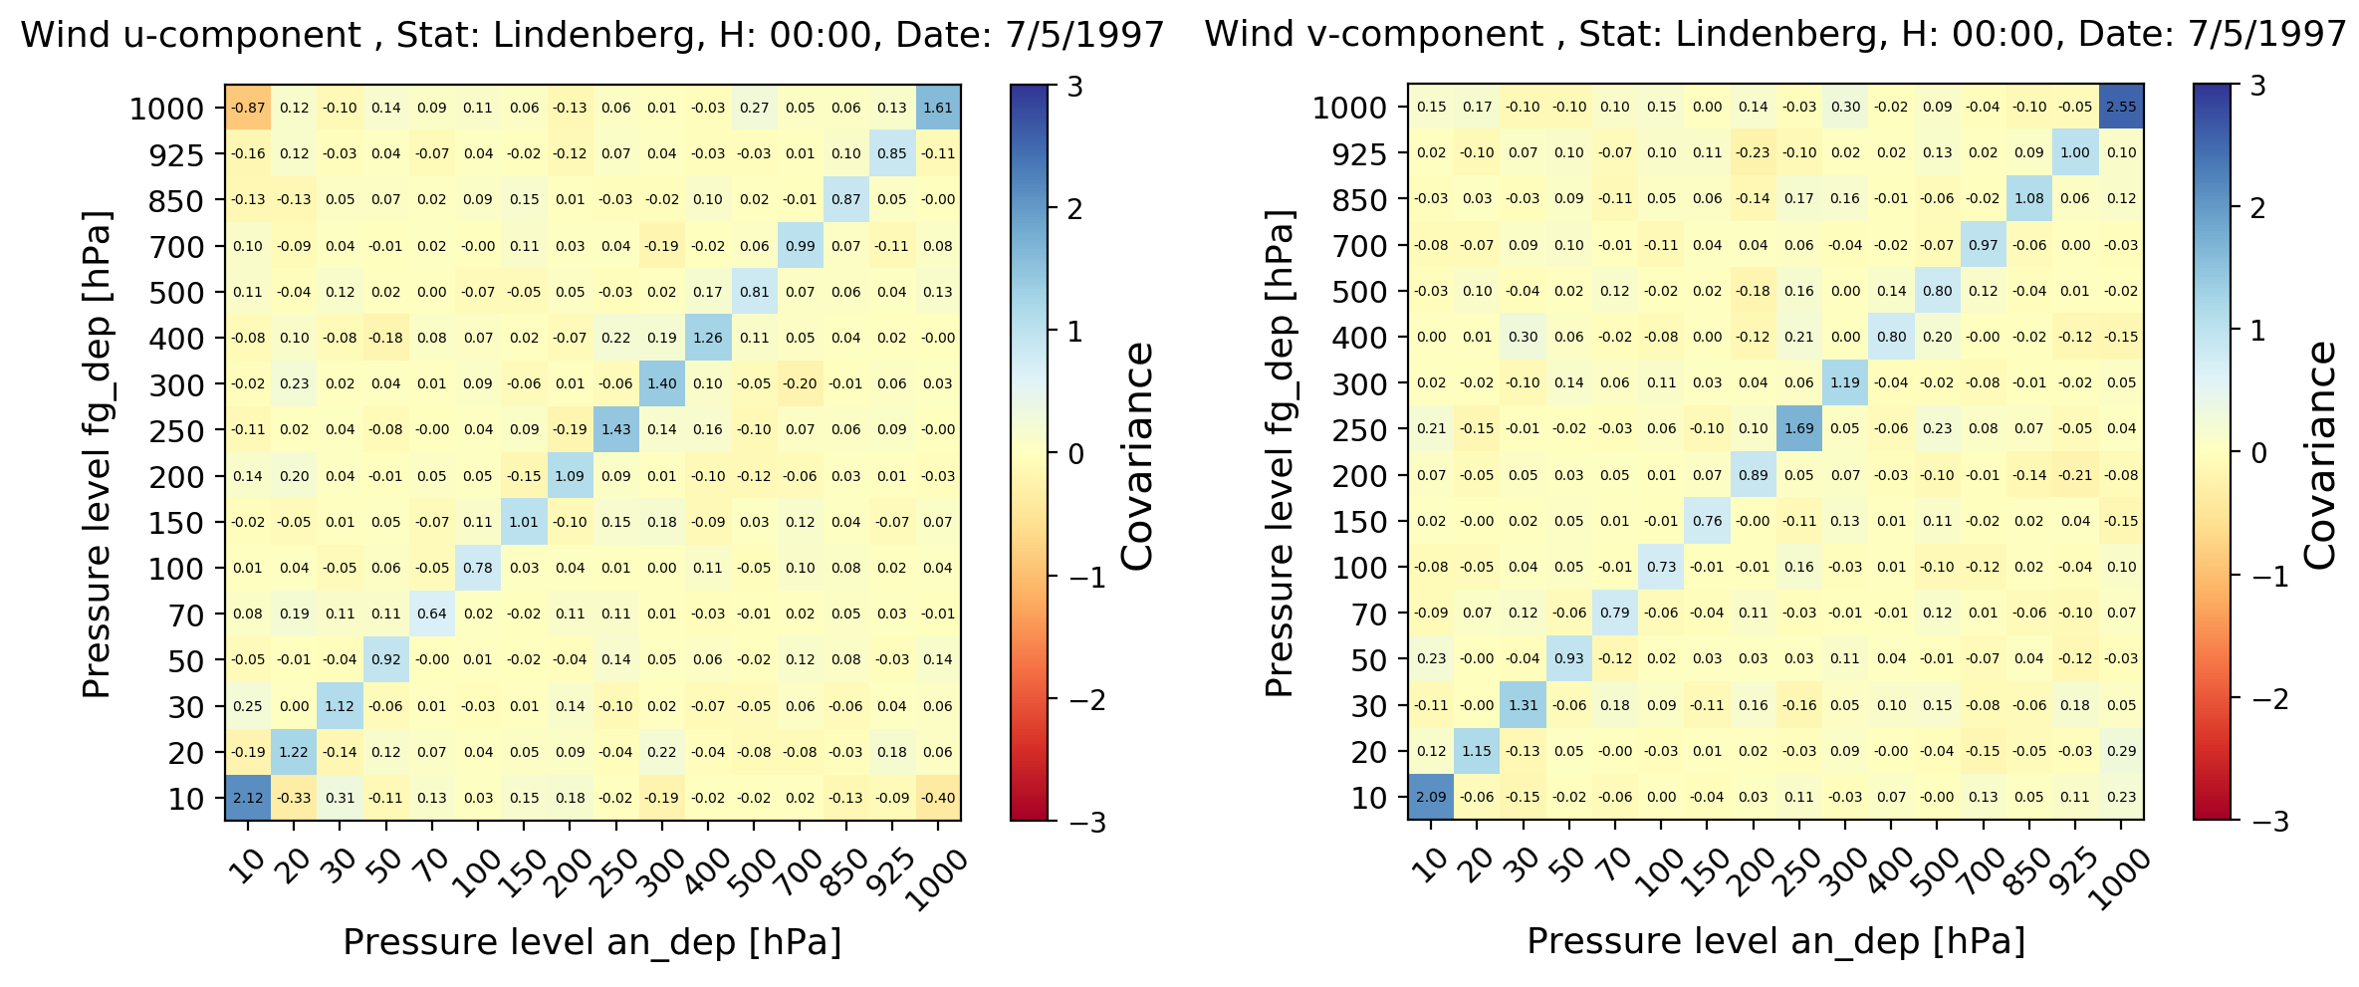

**Figure 2** Example of wind u- and v-components correlation matrix, for the day July 5th, 1997, and measurements reported to 00GMT, Lindenberg station.

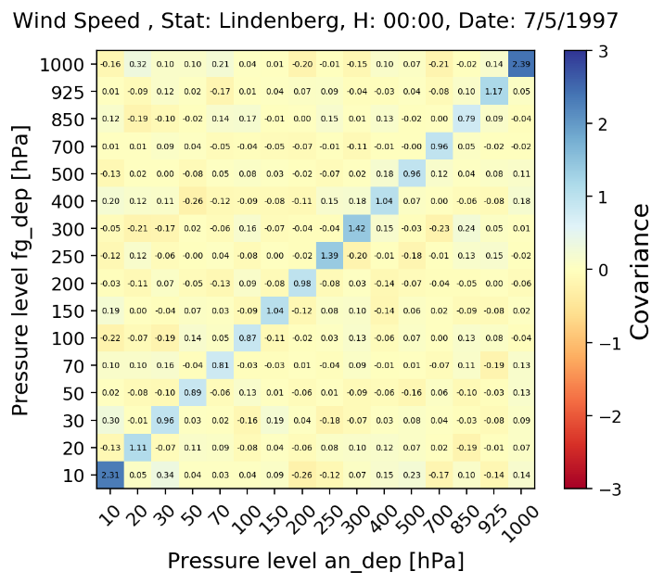

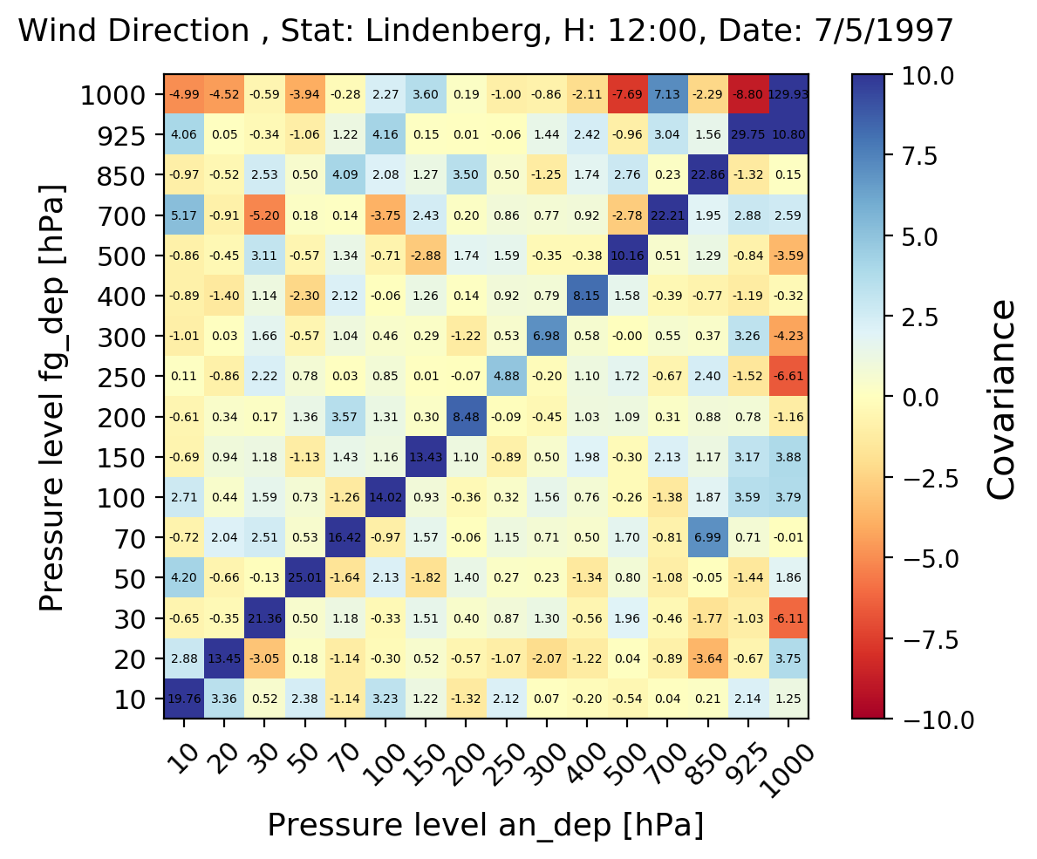

**Figure 3** Same as Fig. 2, but for wind speed and direction.

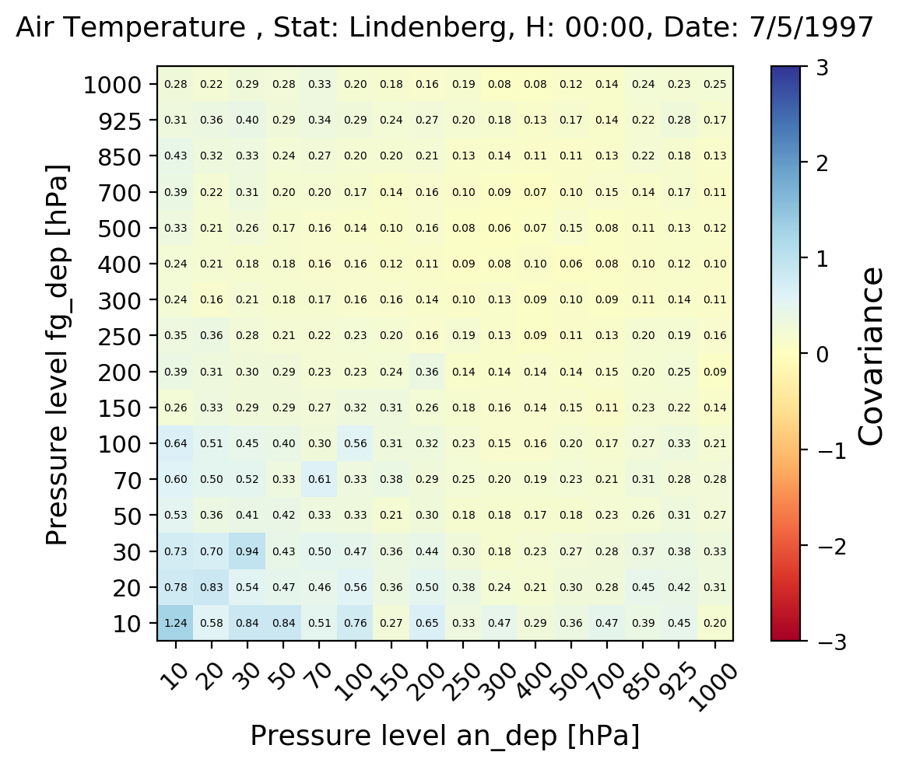

**Figure 4** Same as Fig. 2 and Fig. 3 for the temperature observation.

Overall the correlation seems reasonably small; in particular, it is verified that correlations between measurements at different standard pressure levels are negligible, and at the same time the values along the diagonal are effected by larger uncertainties for measurements in the higher atmosphere (lower pressure levels).

There is to some degree a vertical correlation of wind direction from level to level, driven by the synoptical situation and influenced by the boundary layer. The errors should be vertical independent, but can be impacted by calm winds and therefore strongly varying directions. The wind direction error correlations are thus very noisy and indicate this possibility of vertically strongly changing wind directions, particularly under light wind conditions. Biases near the surface can be larger due to local wind channeling.

## Distribution and time series of error estimates at the 500 hPa level

We present here our estimates for the observation errors obtained using Desroziers’ method. We start with Fig. 5, which shows the time series of the wind-related variables (u- and v-components, speed, direction) for the whole range of data available (1979-2018) for the Lindenberg station. We chose the 500 hPa standard pressure level. By definition, Desroziers statistics is calculated averaging over a time interval, chosen among the values 1,2,3,6 months and 1 year.

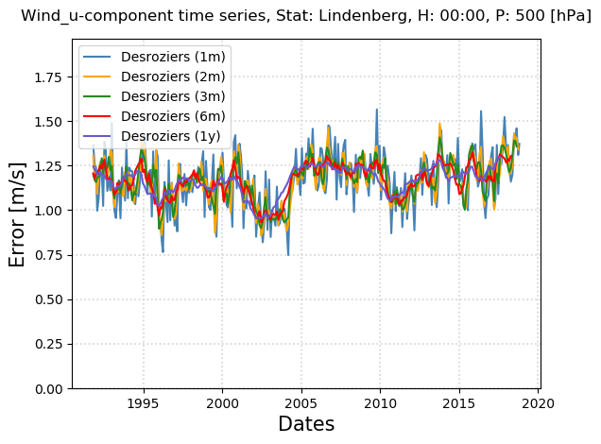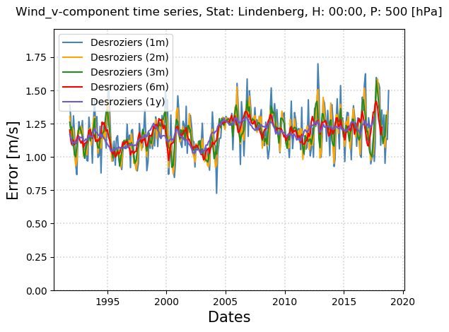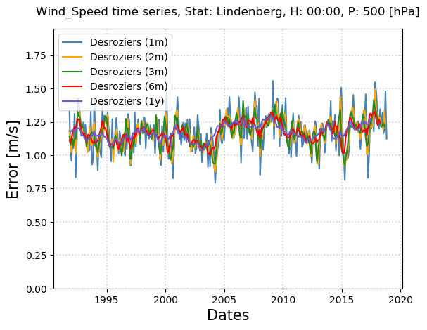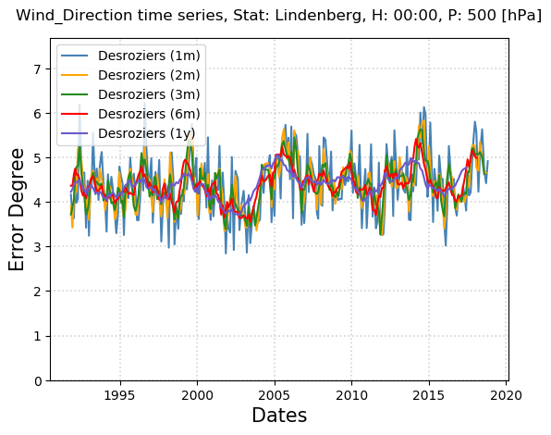

**Figure 5** Time series for the error estimates using Desroziers method, averaging over time intervals of 1,2,3,6 months and 1 year, for the u- and v-component of the wind (upper panels), the wind speed (bottom left) and wind direction (bottom right), for 500 hPa standard pressure level.

For each day in the time series, a running mean is evaluated considering the data of the 1,2,3,6 months and 1 year following the initial date. Outliers in the data were previously removed and not considered in the calculation. In addition, in the case of the wind, data is not always available for all the observation days and pressure levels, so the actual number of measurements considered a fixed time interval is reduced. However, this does not have a great impact in the calculation of the error. In fact the average value of the error is quite stable between 1.1 and 1.2 ms-1 irrespectively of the time interval considered in the evaluation of the average, while the choice of a longer interval results in a smoother distributions of the values. We note also there is no evident trend in the time series, where all the values fluctuates slightly around the median. The same considerations apply also to the estimates of the direction errors, which lies around the 4 degree range.

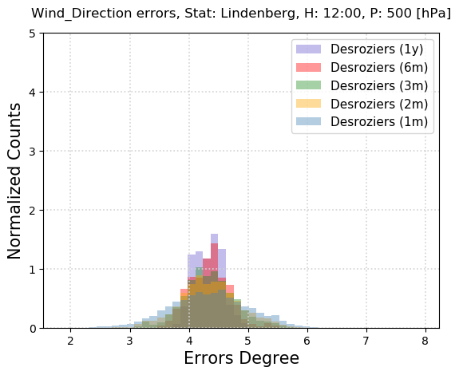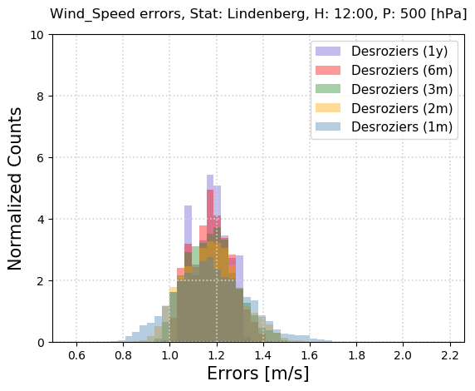

**Figure 6** Diagnosed observation error distribution for the wind direction (left) and wind speed (right), for different temporal averages.

## Dependence of observation error on pressure

In the following we give an estimate of the variation of the errors as a function of the standard pressure levels, focusing on temperature and wind speed only. In Fig. 7 we take as an example the Desroziers means averaged over 2 months, and analyze the distribution of the error estimates.

As expected, both the shape of the distribution and the median depend on the pressure level considered, i.e. for lower pressures the average error estimate is larger of approximately a factor 2 compared to the values in the mid and lower troposphere. At the same time, the distribution spreads over a larger interval, while results are very narrow for larger pressure values. The smallest median values are found for intermediate elevations, between the 250 and 500 hPa pressure levels.

For further analysis, we extracted the mean value and standard deviation for the distributions of the errors, for which some examples are shown in Fig. 7. The complete set of results for all the pressure levels, considering the wind related variables, is shown in Fig. 8.

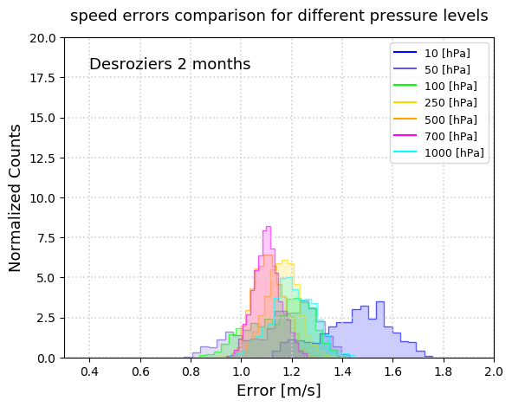

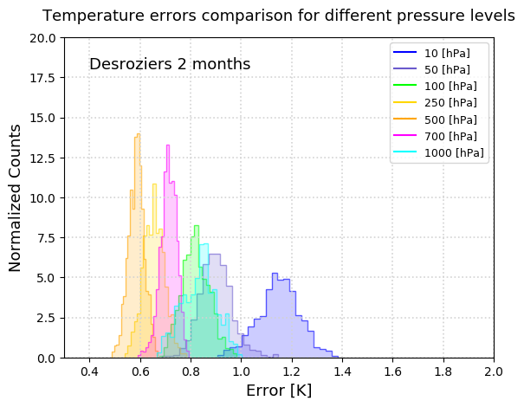

**Figure 7** Distribution of the errors for the temperature (left) and speed (right) for different pressure levels. The Desroziers average was calculated using a time interval of 2 months.

The blue and red lines refer respectively to the errors obtained assuming 1-month and 1-year time averaging. Observation at 00GMT and at 12GMT are plotted with solid and dashed lines respectively. We note that this is a similar representation of the rms error reported in the diagonals of the matrices of Fig. 1, with the difference in the units of the elevation. We find similar values for the estimated error, or more precisely for the mean value of the error assuming a Gaussian distribution, and find a similar vertical distribution with increased error values for higher elevations. The errors show little dependency on the observation hours, with noticeable differences only at low elevations. Finally, the choice of the two extreme values for the time averaging in the Desroziers departure does not affect the mean value of the errors, but it is evident that the choice of the longer time interval reduces the standard deviation of the distribution.

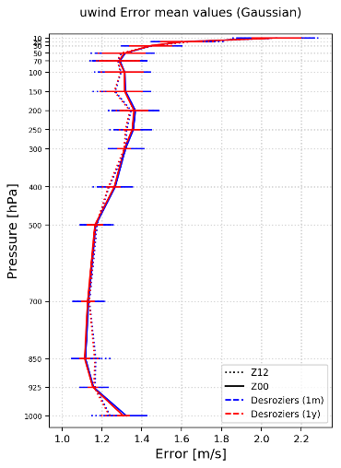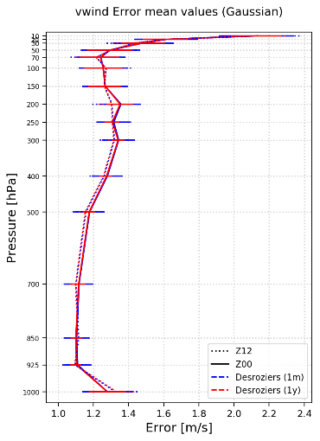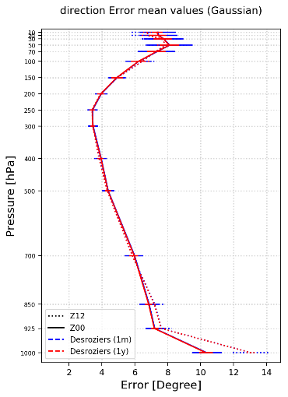

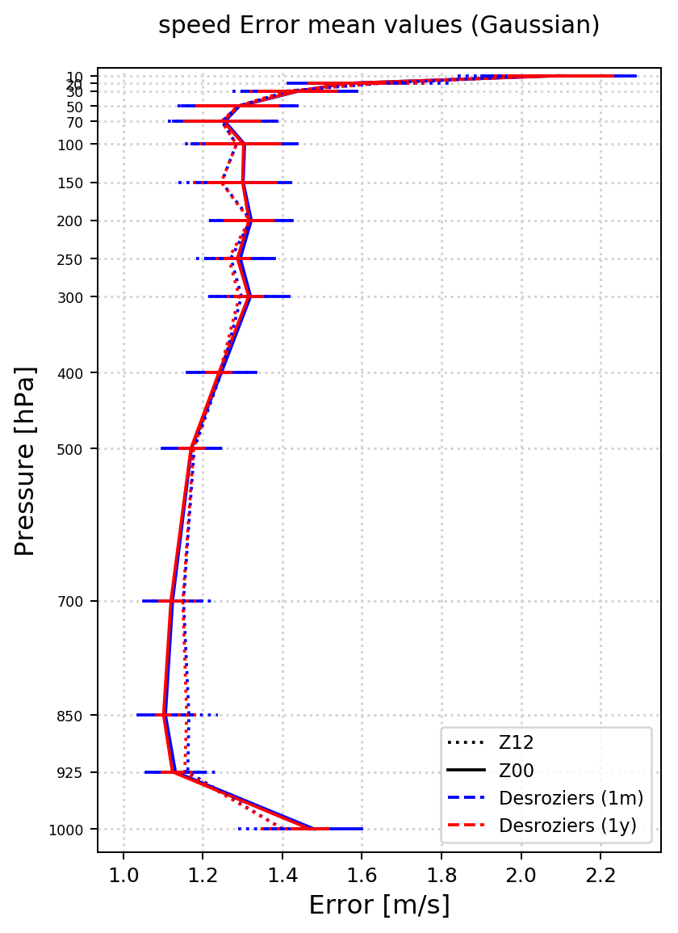

**Figure 8** Error mean values and standard deviation, for the wind speed, u- and v-component, and direction. The blue and red lines show the values obtained assuming a time interval of 1 month and 1 year respectively when applying the Desroziers method. Dotted lines show the results for 00GMT observations, and solid lines refer to 12GMT observations.

# Conclusions

We presented the first estimate of observation errors of the wind related variables (u- and v-components, speed and directions) using the departure statistics methods developed by Desroziers et al. (2005). This method makes use of the ERA5 analysis and forecast departures to estimate observation errors, that include the representation uncertainties related to the ERA5 model. In theory, by making use of higher resolution reanalysis and better representation of observations, the estimated observation error will decrease due to a decrease in representation error. Using JRA-55, one could go back to 1958 and with the completion of ERA5 it will be possible to go back to 1950. For observations before that, one must resort to surface data only reanalysis like CERA20C (Laloyaux et al. 2018). Since these have not assimilated all the observations analyzed here, one has to do the interpolation step offline, which likely results in a larger representation error estimates since the model state is only available at analysis times.

This work extends the previous study of the estimations of the error for air temperature and humidity. We found that the typical order of magnitude of the error standard deviation of the wind speed, as well as the projection onto its orthogonal components, is of order of 1.1-1.5 ms-1, depending on the pressure level considered, while the uncertainty related to the directions is of order 4-8 degree.

Finally, we made all the scripts and input data available on GitHub available at [https://github.com/MBlaschek/CEUAS/tree/develop/CEUAS/wind\_uncertainty](https://github.com/MBlaschek/CEUAS/tree/develop/CEUAS/wind_uncertainty%20). The format of the input files needed, that are available as an example for the Lindenberg station, follows the standard netCDF convention. The README file contains the instructions to allow the user to reproduce the statistical analysis and the results here presented.

# References

Bathmann, K.: Justification for estimating observation-error covariances with the Desroziers diagnostic, Quarterly Journal of the Royal Meteorological Society, 144(715), 1965–1974, doi:10.1002/qj.3395, 2018.

Dee, D. P., Uppala, S. M., Simmons, A. J., Berrisford, P., Poli, P., Kobayashi, S., Andrae, U., Balmaseda, M. A., Balsamo, G., Bauer, P., Bechtold, P., Beljaars, A. C. M., van de Berg, L., Bidlot, J., Bormann, N., Delsol, C., Dragani, R., Fuentes, M., Geer, A. J., Haimberger, L., Healy, S. B., Hersbach, H., Hólm, E. V., Isaksen, L., Kållberg, P., Köhler, M., Matricardi, M., McNally, A. P., Monge-Sanz, B. M., Morcrette, J.-J., Park, B.-K., Peubey, C., de Rosnay, P., Tavolato, C., Thépaut, J.-N. and Vitart, F.: The ERA-Interim reanalysis: configuration and performance of the data assimilation system, Quarterly Journal of the Royal Meteorological Society, 137(656), 553–597, doi:10.1002/qj.828, 2011.

Desroziers, G.: Observation error specification, ECMWF Annual Seminar 2011

[online] Available from: <https://www.ecmwf.int/node/14958>, 2011.

Desroziers, G., Berre, L., Chapnik, B. and Poli, P.: Diagnosis of observation, background and analysis-error statistics in observation space, Quarterly Journal of the Royal Meteorological Society, 131(613), 3385–3396, doi:10.1256/qj.05.108, 2005.

Dirksen, R. J., Sommer, M., Immler, F. J., Hurst, D. F., Kivi, R. and Vömel, H.: Reference quality upper-air measurements: GRUAN data processing for the Vaisala RS92 radiosonde, Atmos. Meas. Tech., 7(12), 4463–4490, doi:10.5194/amt-7-4463-2014, 2014.

Hersbach, H, [de Rosnay, P](https://orcid.org/0000-0002-7374-3820" \t "_blank), Bell, B, Schepers, D, [Simmons, A](https://orcid.org/0000-0002-7327-6310" \t "_blank), Soci, C, Abdalla, S, Alonso-Balmaseda, M, [Balsamo, G](https://orcid.org/0000-0002-1745-3634" \t "_blank), [Bechtold, P](https://orcid.org/0000-0002-1967-3382" \t "_blank), Berrisford, P, Bidlot, J-R, de Boisséson, E, Bonavita, M, Browne, P, Buizza, R, Dahlgren, P, Dee, D, Dragani, R, Diamantakis, M, Flemming, J, [Forbes, R](https://orcid.org/0000-0002-3596-8287" \t "_blank), Geer, AJ, Haiden, T, Hólm, E, Haimberger, L, [Hogan, R](https://orcid.org/0000-0002-3180-5157" \t "_blank), Horányi, A, Janiskova, M, Laloyaux, P, Lopez, P, [Munoz-Sabater, J](https://orcid.org/0000-0002-5997-290X" \t "_blank), Peubey, C, Radu, R, [Richardson, D](https://orcid.org/0000-0002-5182-7898" \t "_blank), Thépaut, J-N, Vitart, F, Yang, X, [Zsótér, E](https://orcid.org/0000-0002-7998-0130" \t "_blank), [Zuo, H.](https://orcid.org/0000-0003-0860-5832" \t "_blank)

2018: Operational global reanalysis: progress, future directions and synergies with NWP

ERA Report Series 27.

Kitchen, M.: Representativeness errors for radiosonde observations, Quarterly Journal of the Royal Meteorological Society, 115(487), 673–700, doi:10.1002/qj.49711548713, 1989.

Laloyaux, P., de Boisseson, E., Balmaseda, M., Bidlot, J.‐R., Broennimann, S., Buizza, R., et al. ( 2018). CERA‐20C: A coupled reanalysis of the twentieth century. Journal of Advances in Modeling Earth Systems, 10, 1172– 1195. <https://doi.org/10.1029/2018MS001273>

Nash, J., Oakkley, T., Vomel, H., Wei Li: WMO INTERCOMPARISON OF HIGH QUALITY RADIOSONDE SYSTEMS, WMO, Instruments and Observing Methods Report No. 107

Waller, J. A., Ballard, S. P., Dance, S. L., Kelly, G., Nichols, N. K. and Simonin, D.: Diagnosing Horizontal and Inter-Channel Observation Error Correlations for SEVIRI Observations Using Observation-Minus-Background and Observation-Minus-Analysis Statistics, Remote Sensing, 8(7), 581, doi:10.3390/rs8070581, 2016.

WMO: Guide to Meteorological Instruments and Methods of Observation (Part I. Measurement of meteorological variables - Chapter 13: Measurements of upper wind); (2014 edition updated in 2017)

[online]: <https://library.wmo.int/doc_num.php?explnum_id=3159>

# Introduction