Proceedings of the Central Aerological Observatory
- Issue 43

P.F. Zaichikov

METHOD OF DETERMINING RADIATION CORRECTIONS TO THE TEMPERATURE READINGS OF RADIOSONDES A-22, RKZ-1 AND RZ-049 ON THE BASIS OF “DAY MINUS NIGHT” DIFFERENCES

The article describes derivation of a basic equation for computing radiation correction to the temperature readings of radiosondes RZ-049, A-22 and RKZ-1 as well as provides determination of the basic parameters of the equation on the basis of “day ─ night” temperature differences resulted from temperature radiosonde measurement of the atmosphere.

The method of determining radiation correction on the basis of “day ─ night” differences remains today the most available and reliable since it is based on processing of actual radio sounding data. Theoretical background for supporting this statistical method results from the elementary equations of heat balance determining the thermal state of a temperature sensor under the steady-state equilibrium. The equation has the following form:

I_{sw} + I_{lwD} – I_{srtsD} – α(T_{D} – T_{aD}) = 0 (for day time)
I_{lwN} – I_{srtsN} – α(T_{N} – T_{aN}) = 0 (for day time), (1)

where I_{sw} and I_{lw} ─ short-wave and long-wave radiation of all types: direct, reflected and scattered, I_{srts} ─ self-radiation of a temperature sensor, α ─ convective heat conductivity factor, T and T_{a} ─ temperature of temperature sensor and air respectively. “D” means “for day time”, “N” means “for night time”.
If in (1) the value “for night time” is subtracted from the value “for day time” and the reminder is solved for the difference between temperature sensor temperature and air temperature the following will be obtained:

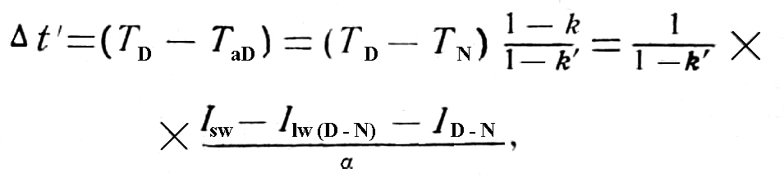 (2)
where
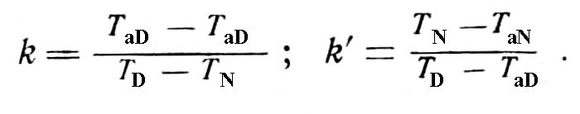

Depending of the rate of ventilation the convective heat conductivity factor
α = α₀ (ρω)^{x}, where ρ ─ air density, ω ─ temperature sensor air blowing rate, ρω ─ ventilation rate, x ─ unknown exponent.
It is not possible to use Equation (2) for computing corrections to radiosonde data in real practice, since the main parameters of the right member of the equation are not yet accessible for direct measurement.
Let’s represent equation (2) in the general form. For that the T_{D} ─ T_{N} difference should be presented in the following way:

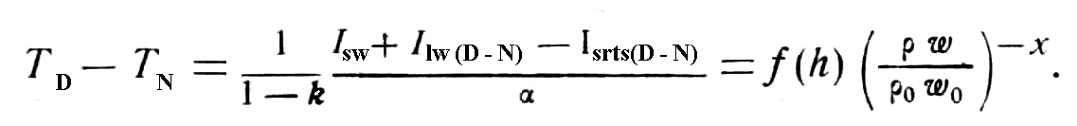 (3)
The equation of temperature sensor overheating relative to the ambient air will have the following form:

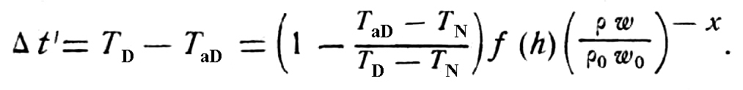 (4)

Determination of the basic parameters of Equation (4)

The specific statistical processing of radio sounding results at a number of upper air stations for several years allows us, as will be shown below, to obtain the functional dependence of the “day ─ night” temperature difference upon solar elevation, the value of the exponent x and the value of temperature sensor overheating relative to the ambient air.
Table 1 provides mean “day ─ night” temperature differences for different solar elevations and at different radiosonde altitudes on the basis of radiosonde data received from the A-22-III radiosonde. It also gives mean values of ventilation rates (ρω) for these differences. The value of ventilation rate was determined through multiplying the mean vertical rate of radiosonde ascent by the relative air density corresponding to the given radiosonder ascent altitude according to the standard atmosphere.

Table 1

If we take the logarithm of Equation (3), we will obtain a linear function of dependence of the “day ─ night” temperature difference logarithm upon the ρω logarithm:

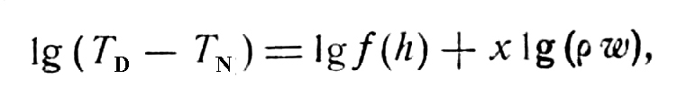 (5)

where lgf (h) = const for h = const. The exponent on the graph of dependence of the lg (T_{D} ─ T_{N}) upon the lg(ρω) will characterize a slope of the straight line relative to the axis along which the values of the lg(ρω) are placed.
Figure 1 shows graphs of dependence of the lg (T_{D} ─ T_{N}) upon the lg(ρω) based on data from Table 1.

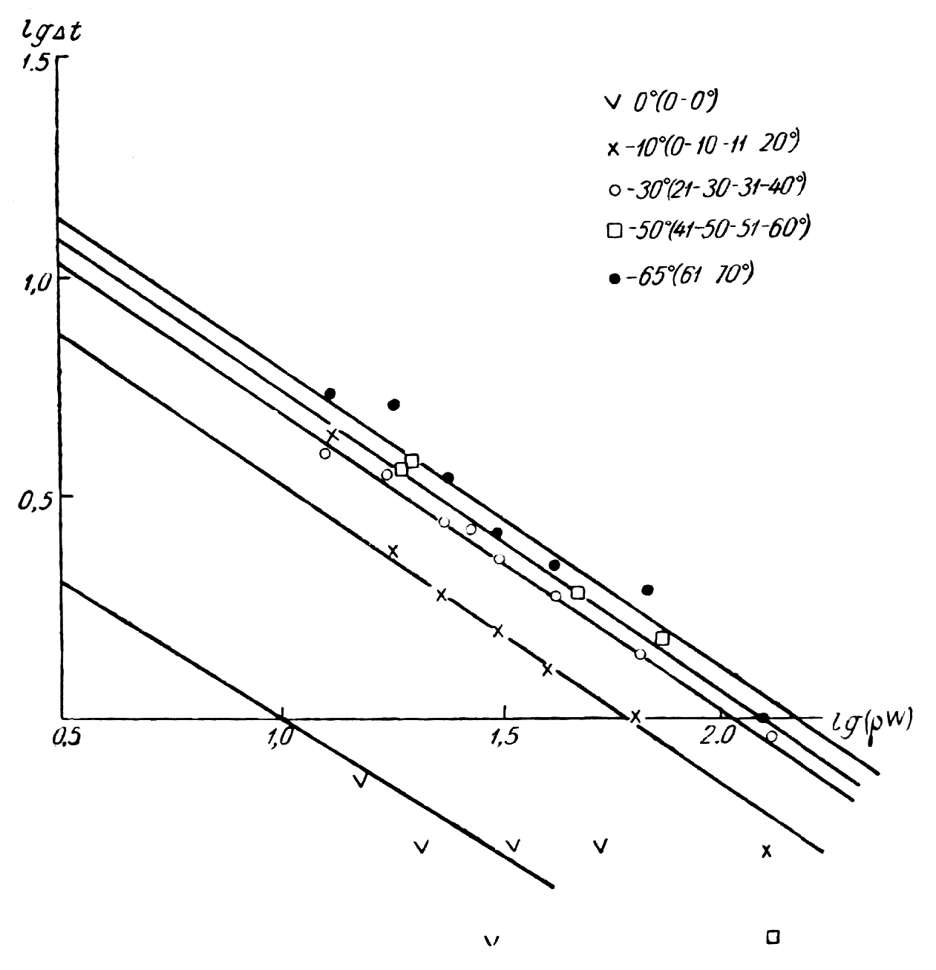

Figure 1. Dependence of the lg∆t upon the lg(ρω) for the A-22-III radiosonde

Location of points on straight lines shows that the general law of the “day ─ night” temperature difference functional relationship, described by Equation 3 is true for altitudes of up to 30 km.
Spread of values appearing for some ranges of solar elevation is explained by deficient number of observations. Due to this it was not possible to exclude the influence of all random effects on the “day ─ night” temperature difference leaving only radiation influence. Sources of other random types of influence are numerous. They include, among others, instrumental errors of an instrument itself and processing errors. For example, errors in pressure measurements results in errors in “day ─ night” temperature difference measurements due to the fact that temperature decreases in each case of erroneous altitudes. Most considerable radiation overheating-induced errors in the “day ─ night” temperature difference may result from the influence of heat and cold advection in the time interval of 6-12 hours between measurements. They may also occur due to the change of sign of air vertical movements, which is extremely important for the formation of the atmosphere temperature stratification.

Table 2

According to Table 1 the “day ─ night” temperature difference mean-root-square deviation from the mean value of this difference is roughly 2.0º. In some cases even negative “day ─ night” temperature differences may occur, i.e. the night time temperature is higher than that in the day time. For more accurate computations a huge amount of observations would be needed. For instance, in order to obtain the “day ─ night” temperature difference mean value to an accuracy of 0.1º it is necessary to process 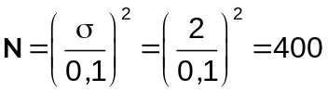 pairs of observations for each range of solar elevations.
The slope of a straight line, determined by the graph in Figure 1 allows us to obtain a value of the unknown exponent x in Equation (3). Therefore one of the parameters of the general Equation (3) was determined empirically. For the
A22-III radiosonde it is 0.68 (x = 0.68).
Formula for the function of the “day ─ night” temperature difference dependence on solar elevation may be obtained on the basis of the graphs in Figure 1 by taking values of (T_{D} ─ T_{N}) for various solar elevations with the constant value of ρω. It is more advantageous to make computations for small values of ρω (ventilation rates), i.e. for large “day ─ night” temperature differences. In fact, if a sufficiently reliable functional dependence of (T_{D} ─ T_{N}) upon solar elevation is observed where the T_{D} ─ T_{N} difference is most considerable, at smaller altitudes all inaccuracies in determining parameters of this function will be automatically reduced accordingly.
In Figure 2 on the ordinate the values of (T_{D} ─ T_{N}) taken from the graph of Figure 2 for ρω = ρ₀ω₀ = 10 m are plotted, solar elevations are plotted on the abscissa. The plotted points are approximated by the following equation of the third order:
(6)
h ─ solar elevation in tens of degrees

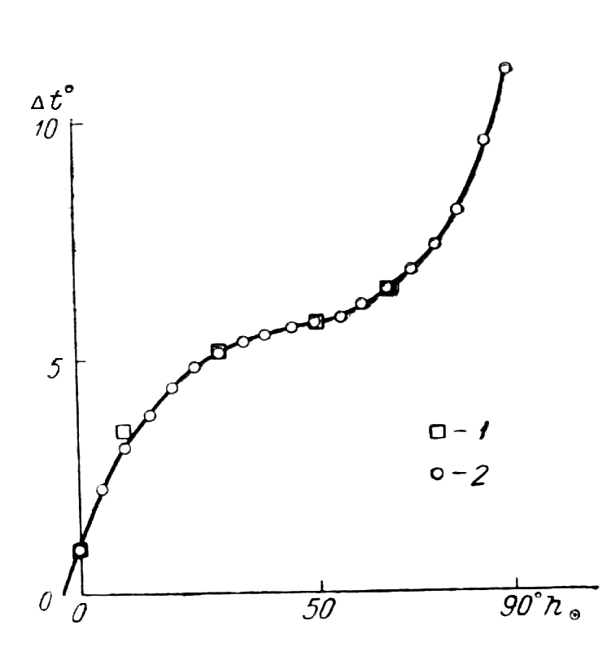
Figure 2. Dependence of ∆t upon solar elevation (h○ ) for the A-22-III radiosonde 1. ─ based on data from the A-22-III, 2.─ computed by Equation (6).

In Figure 2 the curve rise steeply up in the extrapolation section of solar elevation of 70-90º. Laboratory studies of the A-22-III radiosonde shields showed that this steep rise is very realistic. When solar elevation is close to the zenith direct sunlight begins to fall on a temperature sensor. Due to this temperature sensor overheating increases sharply.
In the same way values of exponent x and functional dependencies of (T_{D} ─ T_{N}) upon solar elevations have been determined for the RZ-049 and RKZ-1 radiosondes.
Data for the RZ-049 and RKZ-1 radiosondes are given in Tables 2 and 3 and Figures 3 and 4 respectively.
The approximated (T_{D}─ T_{N}) equation for RZ-049 is as follows:

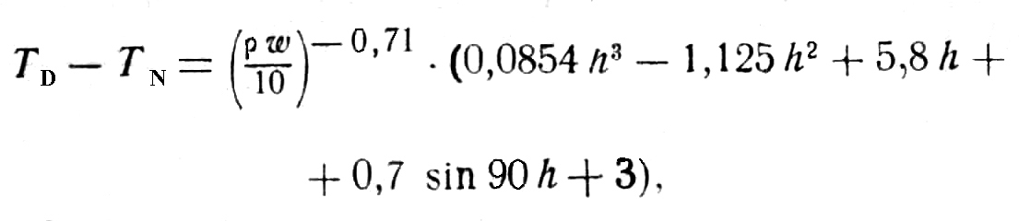 (7)
(where h ─ solar elevation in tens of degrees), and for RKZ it is as follows:

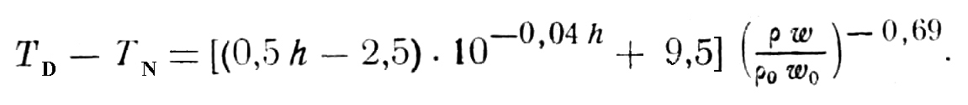 (8)
To move from temperature sensor temperature to air temperature it is necessary to know the temperature range in the period of observation of the air itself, i.e. the diurnal air temperature variation ∆t_{a} = T_{aD} ─ T_{N} in Equation (4). Here we face the most challenging problem of moving from measured temperature of temperature sensor to actual air temperature. To solve this problem we should pay special attention to the issue of the diurnal air temperature variation at various altitudes.

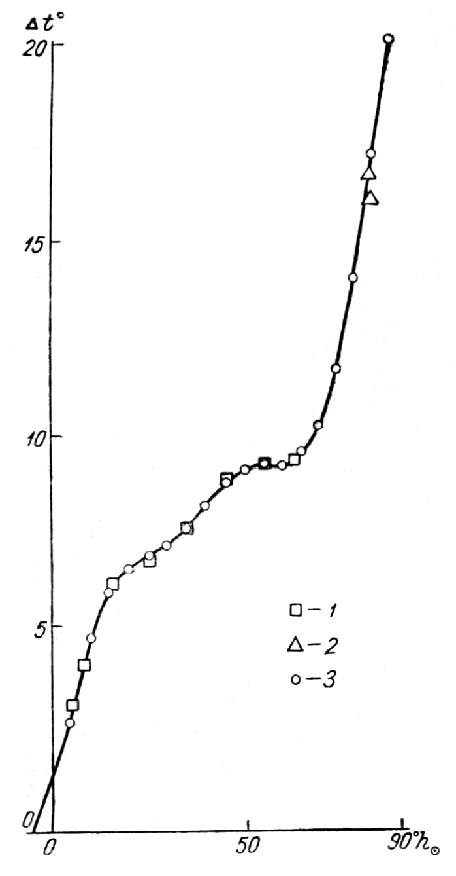 | 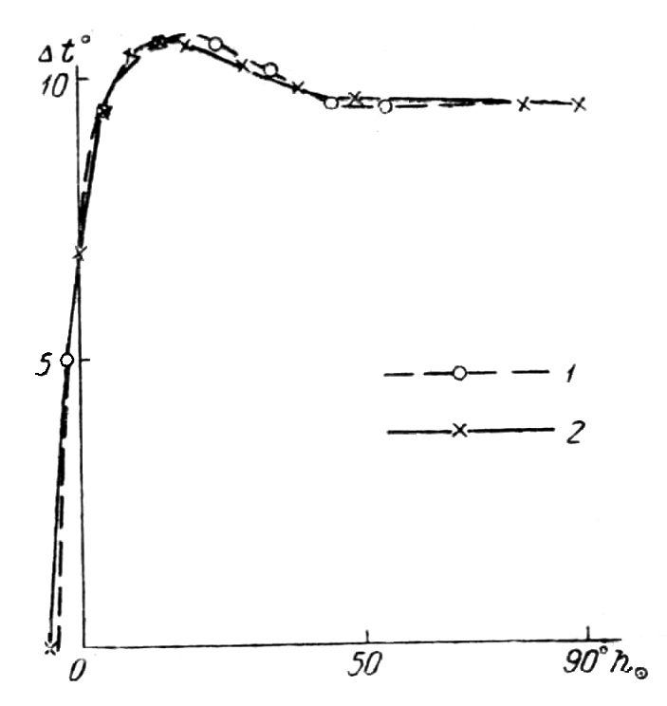
Figure 3. Dependence of ∆t upon solar elevation (h○ ) for the RZ-049 radiosonde 1. ─ mean ∆t for ρω = 10, 2. based on data from diesel-electric ship “Ob”, 3.─ computed by Equation (7). | Figure 4. Dependence of ∆t upon solar elevation (h○ ) for the RKZ-1 radiosonde 1. ─ based on data from the RKZ-1, 2.─ computed by Equation (8).
Table 3

Diurnal air temperature variation in the lower stratosphere

A considerable body of theoretical and experimental works is devoted to the problem of the diurnal air temperature variation in the free atmosphere.
One of the first papers considering the diurnal air temperature variation in the free atmosphere on the basis of radiosonde data was published by E.S. Selezneva in 1945 [2]. According to her findings the amplitude of the diurnal air temperature variation increased with altitude and at the altitudes of 10-12 km it was 2-4ºC. In her work Selezneva used theoretical computations of Gordov, Egorenkov, Shepelevsky and Sokolov [3], where it was argued that the value of radiation error of a comb-type radiosonde does not exceed 1.0 ºC up to the altitude of 10-12 km. All that exceeded this value was attributed to warming of the air.
According to theoretical computations of Malkevich [4] the amplitude of the diurnal air temperature variation does not exceed 0.25 ºC up to the altitude of 3 km and according to experimental aircraft observations performed by V.G. Kastrov it does not exceed 1 ºC. Kastrov concluded that up to the altitude 8-10 km the amplitude of the diurnal air temperature variation remains around 0.2-0.4 ºC, but it was not possible to check this conclusion with the help of direct aircraft observations.
Further studies based on radiosondes ensuring better protection of temperature sensors from solar radiation confirmed that the amplitude of the diurnal air temperature variation in the free atmosphere calculated by E.S. Selezneva is too large. Due to this the radiosonde radiation errors are much larger than those given in the paper of Gordov, Egorenkov, Shepelevsky and Sokolov.
International comparison of radiosondes in Payerne [6] clearly showed that at night temperatures measured by various radiosondes types were similar (within the accuracy). But at daytime systematic temperature differences were demonstrated due to solar radiation. Among other things it was determined that radiation error of the Soviet RZ-049 radisonde reaches 7 ºC at the altitude of 22 km. By 1956 many stations of the Soviet Union launched radiosones to the altitudes of 20 km and higher, and it became clear that radiation correction to readings of a comb-type radiosonde was necessary. By that time several countries (UK, Finland, Japan) have already started to apply radiation corrections to temperature readings of their radiosones.
The method of computing radiation corrections to be applied to radiosonde measurements is still not rigorous enough. It is also not available for experimental verification due to the lack of reference temperature meters, which are not affected by radiation influence. Accurate measurement of radiation heating in each specific ascent is not realistic because the phenomenon itself is complicated and it is not possible to take account of the reflected radiation value, which changes every single time and is connected with albedo of the Earth’s underlying surface, clouds, etc.
Skrez [7] computed radiation correction to the UK radiosonde by using mean values of radiation absorption coefficients for specific mean values of solar radiation intensity. The remaining value of radiosonde overheating at day time Skrez attributed to the diurnal air temperature variation. According to him the diurnal temperature variation at the altitude of 20 km is about 1.5 ºC and at the altitude of 25 km is 3 ºC.
According to Guterman [8] and Rich [9] the amplitude of the diurnal temperature variation at the altitudes of 3-10 km was about 2 ºC. In 1951 Kay [10] analyzed radiosonde data from 5 UK stations for the period of 2 years. He came to the conclusion that at night the air becomes cooler by 0.3-06 ºC in 12 hours at the pressure level of 150-100-80 Mbar.
These data show the existence of the diurnal air temperature variation in the free atmosphere, but its amplitude is not large compared with the earlier data.
V.D. Reshetov determined the amplitude of the diurnal air temperature variation by the indirect method, using variability of thermal wind at the boundary of sun illuminated and non-illuminated areas. According to his computations the amplitude of the diurnal air temperature for the altitudes of 15-16 km is 1.3 ºC.
Kaminer [1] provides the amplitude of the diurnal air temperature variation calculated by absorption of cosmic rays. His amplitude at the altitude of 16 km is about 0.8-1.0 ºC.
Among the papers devoted to the study of the diurnal air temperature variation based on direct radiosonde observations the paper of Wan Chang Chiu [13] is of interest. He used data from US radiosondes.
According to Wan Chang Chiu at the pressure levels of 200 and 150 Mbar the amplitude of the diurnal air temperature variation is 0.15-0.2 ºC, at 100 Mbar it is 0.2-0.25 ºC and at 50 Mbar it is 0.35 ºC. These empirical values of the amplitude of the diurnal variation are the smallest compared with the values provided earlier by other authors. They are close to values resulted from theoretical computations.
Theoretical computations made by L.D. Biryukova and V.G. Kastrov [1] for absorption of solar radiation by water vapour, ozone and cosmic dust resulted in the amplitude of the air temperature variation of 0.4 ºC at the altitude of 20 km.
In the absence of absolute methods of air temperature measurement, the experimental determination of the diurnal air temperature variation is quite complicated. The methods to solve this problem are constantly refined and improved.
In the meantime the confirmation of theoretical computations of the diurnal air temperature variation by actual observations is of great practical interest, since theoretical computations can not adequately cover all sources and regularities of heat absorption directly by the air.
When this paper was under preparation in order to check the warming of the air (diurnal temperature variation) based on radiosonde data B.A. Tardov proposed to process the four-time soundings at upper-air stations in such a way that the temperature differences are determined at the same solar elevation for two radiosondes released before and after the midday, i.e. at solar elevations symmetric relative to the midday. In this case the temperature differences would not include radiation errors of radiosondes.
These requirements were met by the radiosondes at different stations as follows: at Dolgoprudnaya ─ by radiosondes released at 8.5 and 14.5 local time in 30 minutes after the release, when they reached the altitude of 10-11 km; at Riga ─ by radiosondes released at 7.6 local time in 84 minutes after the release, when they reached the altitude of 24 km; at Alma-Ata ─ by radiosondes released at 5.1 and 17.1 local time in 54 minutes, when they reached the altitude of 18 km. Based on data from these stations the mean temperature differences were obtained at the abovementioned altitudes. To reduce the influence of advection and other factors causing inter-diurnal variability of temperature at the altitudes, differences were computed only for radiosondes released on the same day.
The results of processing are given in Table 4 (underlined values).

Table 4

The results make it possible to determine the value of air warming during one hour (coefficient of air warming) as well as the increase of this coefficient depending of air density. It is easy to see that the air warming coefficient follows the law given below:
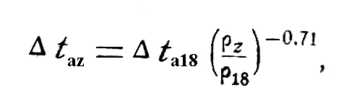
i.e. the same law as the heating of a temperature sensor follows. Indeed in the last line of Table 4 values of ∆t_{a} computed by the given formula are provided. As is seen they are in good agreement with the actual temperature differences. This fact is quite important. It shows that the air in nature is warmed through foreign bodies in the atmosphere. The air with a fairly small heat conductivity coefficient surrounds various foreign bodies and is warmed from them through heat conductivity. Therefore warming of the air is slow and its maximum shifts towards the sunset.
Besides, Table 4 gives temperature differences at other altitudes. They are converted to the altitudes symmetric to solar elevations with the help of radiation corrections to the RZ-049 radiosonde, determined earlier (CAO Guidance, issue 19).
According to Table 4 it turns out that at the altitude of 20-25 km the mean air warming is 0.1º/hour. Therefore maximum temperature increments at these altitudes are 0.8ºC in winter and 1.6 ºC in summer.
As it was already mentioned above, according to the theoretical computations of L.A. Biryukova and V.G. Kastrov [1] the amplitude of the diurnal temperature variation at these altitudes is 0.4 ºC. In the same paper empirical data on temperature decrease at night time are given. These are data from more frequent soundings performed by CAO in 1955, 1956 and 1960. According to these data the night time cooling at the altitude of 18-20 km is about 1.1 ºC. However the night time cooling measured by temperature sensors strictly speaking is not in line with the air temperature decrease, because at night the temperature of all bodies, including a temperature sensor, should be lower that the air temperature, due to their heat emission.

Table 5

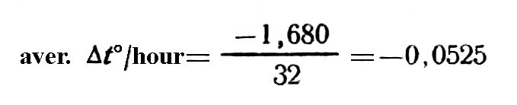
Therefore the findings of [1] do not solve the problem of the diurnal temperature variation, the more so since the disagreement between theoretical computations and experimental data is considerable.
We used the method of V.A. Tardov to additionally process the abovementioned observations at Dolgoprudnaya in 1955, 1956 and 1960. It turned out to be possible to obtain values of temperature differences symmetric relative to the midday for the altitudes of 10-11 km.
Results are given in Table 5.
So, in 8 hours at the altitude 10-11 km the air will be warmer by 0.42 ºC in winter and by 0.83 ºC in summer.
Based on data from Table 5 the weighted mean value of the air warming coefficient was computed. It turned out to be 0.052º/hour, i.e. quite similar to the value based on Table 4 ( 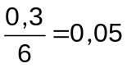º/hrs) for the altitude of 10 km, which was obtained from completely different data.
Therefore by our computations at the altitude of 10-11 km the maximum warming of the air will be 0.4º in winter and 0.8º in summer and at the altitude of 20 km it will be 1.2º and 2.3º respectively. According to V.D. Reshetov at the altitude of 16 km the amplitude of air temperature diurnal variation is 0.9º in May and 1.7º in January. Our findings are close to those of V.D. Reshetov and to empirical data of V.G. Kastrov. However they exceed theoretical computations two or three times.
Data on the diurnal air temperature variation obtained by various researchers are given in Table 6.

Table 6

Computation of coefficient 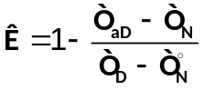 for Equation 4

We refrain from interpreting theoretical and empirical differences in the values of the amplitude of the diurnal air temperature variation due to the fact that empirical data are not sufficient. But we conclude that to compute radiation correction to the A-22-III, RKZ-1 and RZ-049 radiosondes it is necessary to use not theoretical computations, but empirical data, which we give in Table 4.
Avoiding large errors it is possible to determine coefficient 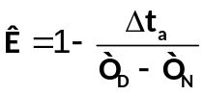 in Equation 4 by values of (T_{D} ─ T_{N}) and ∆t_{a}. For instance for the solar elevation of 35º for the A22-III radisonde at the altitude of 22 km (T_{D} ─ T_{N}) = 2.9º, and air warming (irrespective of a temperature sensor) ∆t_{в} = 1.0 (0.1 ∙ 10 hrs). Substituting these values to the equation for K we will have 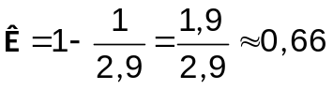.
Hence, the final form of the equation for radiation correction to the A-22-III radiosonde will be:

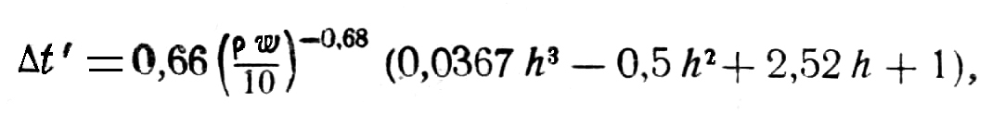 (9)

where h ─ solar angular elevation in tens of degrees.

For RKZ-1 we determine coffecient K substituting (T_{D} ─ T_{N}) = 6.1 (for the altitude of 22 km and solar elevation of h = 35º, Table 2) and ∆t_{a} = 1.0ºC

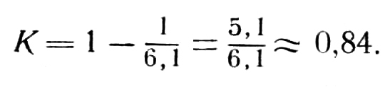

The final equation for radiation correction to RKZ-1 is:

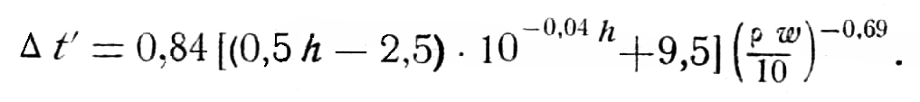 (10)

The equation for radiation correction to the RZ-049 radiosonde is as follows:

(11)

Equation (9), (10) and (11) were used as a basis for computing radiation corrections to the A-22-III, RKZ-1 and RZ-049 in the CAO Guidelines, Issue 25.

REFERENCES

1. Biryukova L.A., Kastrov V.G. The diurnal temperature variation in the lower and middle atmosphere. Manuscript. 1960.

2. Selezneva E.S. The diurnal temperature variation in the troposphere. Preceedings of the USSR Academy of Sciences, Geography and Geophysics Series, Vol. IX, No 2. 1945.

3. Gordov, Egorenkov, Shepelevsky, Sokolov. Proceedings of Research Institutions, Series I, Issue 19.1946.

4. Malkevich. The diurnal temperature variation in the atmosphere. Extended abstract of dissertation. Geophysical Institute of the USSR Academy of Sciences.

5. Kastrov V.G. The diurnal temperature variation in the lower atmosphere. Proceedings of CAO, Issue 23.1958.

6.Zaichikov P.F. Preliminary results international radiosonde comparison. Proceedings of CAO, Issue 22. 1957.

7. Skrez. Radiation and inertia errors of the Meteorological Service’s rediosonde and the diurnal temperature variation in the upper atmosphere. Quart. Journ. Royal Met Soc., v.80 No346. 1954.

8. Guterman I.G. The diurnal air temperature variations on the basis of two series of more frequent upper air observations in 1953. Proceedings of MGO, Issue 56 (118). 1956.

9. Rich L.H. The diurnal pressure and temperature variation in the western Caribbean. Bull. Amer. Met. Soc. v. 28, No7. 1947.

10. Kay K.H. The apparent diurnal temperature variation in the lower stratosphere. Quart. Journ. Meteor. Soc., 77, 1951.

11. Reshetov V.D. The study of the diurnal wind variation in the atmosphere. Proceedings of CAO, Issue 21. 1958.

12. Kaminer N.S. The diurnal temperature variation in the free atmosphere. Proceedings of CAO, Issue 16. 1956.

13. Wan Chang Chiu. The diurnal temperature variation of the lower stratosphere over the United States. Journ. of Met. v. 16, No 4, 1959.

14. Report on the study of radiation errors of the RZ-049, A-22-III and RKZ-1 in 1959. CAO.

15. CAO Guidelines, Issue 25. 1960.

