Proceedings of the Arctic and Antarctic Research Institute
1988 Vol. 409

N.N. Kazakova

COMPARISON OF ATMOSPHERE TEMPERATURE AND WIND SOUNDING DATA OBTAINED BY DIFFERENT SOUNDING SYSTEMS

Due to the fact that beginning from 1982 research vessels (RVs) of the Arctic and Antarctic Research Institute (AARI) have used home produced (Meteorit-RKZ) and Finnish (KORA-RS-21) atmosphere temperature and wind sounding systems, the comparison of these two systems was performed. The comparison was required because the systems use different methods of radio sounding (radio-location and radio-navigation), provide different accuracy of measurement of atmosphere meteorological parameters and apply different methods of information processing to determine differences in results and assess their compatibility. The main objective of the study was to obtain information on reliability of ship-based systems in different meteorological situations. Despite the fact that radiosonde data from different systems were compared many times [4, 8, 9, 10, 11, 28] and the results of the comparison of Soviet and Finnish systems were also compared with data obtained in 1969 (Voeikovo) and in the period of GARP Atlantic Tropical Experiment (GATE-74) [8, 29], there was a lack of statistical significance. So it was possible to make only an approximate assessment of the differences. This is particularly true with respect to wind characteristics [29].
The comparison of the radiosonde systems was started in the 35th cruise of the RV “Professor Zubov” (June-August 1983) and continued in the 44th cruise of the RV “Professor Vise”. RVs “Academician Shuleikin” and “Professor Multanovsky” also took part in the comparisons. The comparisons performed in the 35th cruise of the RV “Professor Zubov” showed, that some differences in temperature and humidity can be reduced if not only sensors themselves are improved, but the method of information processing as well. Finish company “Vaisala”, to which some comments and proposals were submitted during the guaranty repair of vessels in Finland, made a number of significant modifications to the receiving component of equipment. For instance due to improvement of the “Omega” antenna, installed on the vessel, reception of signals from coastal radio-navigation stations was improved (interference resistance) and the quality of wind data accordingly. Some constructional modifications were made to the radiosonde RS-21 (radiation protection was improved, error of barometric boxes P₁ and P₂ was reduced). The results of the comparison obtained in the 44th cruise of the RV “Professor Vise” are more significant statistically than data published earlier [4, 8, 9, 10, 11, 28, 29]. In addition the simultaneous participation in sounding of the atmosphere of two vessels, on which the Finish system was installed, allowed for the more comprehensive and competent analysis of upper air information, guaranteed its accuracy as well as the reliable operation of the KORA-RS-21 system. Since standard but not reference [9, 10, 28] radiosondes were compared, soundings from three vessels simultaneously were particularly important. Basic requirements to the methodology of comparison and information processing were developed jointly by AARI and CAO, taking into account the guidelines and published papers [12-14, 16-27].
For the comparisons basically two methods were used:
- release of radiosondes on a single lifting system (suspension)
- synchronous releases of radiosondes on individual lifting systems with the distance between vessels not longer than two miles; to ensure simultaneousness of releases vessels should be located close or within the sight of each other.
To evaluate the results of the comparison, statistical characteristics (mean and root mean square differences, root mean square deviations of differences) of changes in meteorological parameters were determined for each pair of radiosondes at standard pressure levels and layer by layer as well as separately for day time and night time conditions. Statistical characteristics were computed for seven meteorological parameters (geopotential, temperature, relative humidity, wind direction and speed, orthogonal components of wind speed) at nineteen pressure levels. For the analysis data from nine layers recommended by the Soviet methodology and from six layers recommended by WMO were used. With the first method of comparison (a single lifting system) the mean and root mean square differences were computed in synchronous moments of time with a step of 30 seconds. The mean differences of meteorological elements measured by the RKZ-2 and RS-21 radiosondes, root mean square differences and root mean square deviations of differences were determined from the comparisons conducted in the 44th cruise of RV “Professor Vize” (June – September 1984) for all day time and night time series and for the total number of releases. A comparative evaluation was based on vertical profiles of meteorological elements, taking into account specific layers of each meteorological parameter.
In the 35th cruise of RV “Professor Zubov” one daily series of simultaneous releases of RKZ-2 and PC-21 (seven releases) was conducted at the point with the following coordinates: 64º00’N and 07º30’W. During the comparison of the systems the distance between vessels was less than a mile, but due to unfavourable weather conditions they could not come close to each other and therefore the second method was used. In the 44th cruise of RV “Professor Vise two series of 10 releases each were conducted using the second method and three test releases were conducted on a single suspension. The difficulties in using the first method were also associated with weather conditions (vessels could not come close to each other) as well as with insecurity of balloons No 150. In the period from 18 to 20 July at 61º21’ N and 03º03’ W, together with RV “Academician Shuleikin” synchronous atmosphere soundings were performed with a time step of 3 hours. The distance between the vessels was about 1.5 mile. Brief meteorological characteristics of the area, where soundings were performed, are presented in Table 1. Sounding altitudes were good and this allowed the pressure levels of up to 30-20 hPa to be covered. The second series of observations by RV “Professor Multanovsky” was performed at 64º11’ N and N and 01º17’ W. From 28 to 30 July sounding was also performed by RV “Academician Shuleikin” with a time step of 3 hours and 6 hours. Due to the sea swell of 4-5 grades the vessels could not come close to each other, therefore synchronous soundings were performed. Synchronous releases were made to an accuracy of 1 minute. To eliminate mutual interference in receiving radiosonde signals by the KORA-RS-21 system, receiving frequencies on RVs “Academician Shuleikin” and “Professor Multanovsky” were spaced from 390 to 410 MHz. To compute statistical characteristics upper air information from 28 pairs of the RKZ-2 and RS-21 radiosondes was used.
From 18 to 20 July the weather pattern in area of soundings was determined by the northern periphery of the breaking ridge of the stationary anticyclone with the pressure in the centre of 1030 hPa. Low stratus clouds, fog and mist were observed. On 28 July a cold front brought deep cumulo-nimbus clouds and heavy showers. Similar weather conditions were reported on 11 August, when radiosondes on a single suspension were released. On the one had for atmosphere sounding by Soviet instruments the weather conditions were unfavourable. The fact is that when a thermoresistor passes through the liquid-phase clouds temperature readings are distorted since the sensor spends heat on water evaporation. The same holds true for a humidity sensor, because droplets out of those clouds can freeze in the pores of the sensor and this also leads to the increase of measurement errors. On the other hand the comparison made it possible to determine the probable values of distortions.

Table 1

Table 2 presents average technical characteristics of RKZ-2 and RS-21, some instrumental errors caused by meteorological sensors and converting-encoding devices, systematic errors appearing due to the influence of solar radiation. To reduce variation errors special attention was given to calibration and control of radiosondes. Methodological errors were eliminated by the method of triple computation for the RKZ-2 radiosondes (manual, semi-automated, automated). As is seen from Table 2 the compared sounding systems differ not only in terms of temperature and humidity sensors, but also in terms of methods used to compute altitude and wind characteristics. KORA-PC-21 measures pressure, and geopotential heights are computed by a barometric formula. In the Meteorit-RKZ system pressure is computed by radar-measured heights.

Table 2

O.V. Marfenko analyzed the differences of errors obtained by both methods and came to the conclusion that in the troposphere altitudes measured by the barometric method are more accurate, and in the stratosphere radar-measured altitudes show better accuracy [14, 15]. However to ensure the state-of-the-art accuracy in determining the pressure level altitudes using the direct measurements of pressure, the barometric unit is required, which has an error not exceeding 0.1 hPa across the whole range of pressure [15]. Judging from technical specifications of barometric units of the Finish radiosonde RS-21, in the pressure range of 150-3 hPa an error equals to 0.1 hPa meeting the abovementioned requirements [15]. Hence, comparability of initial information and data of temperature measurements can be taken as a basis in the further analysis of differences between altitudes.

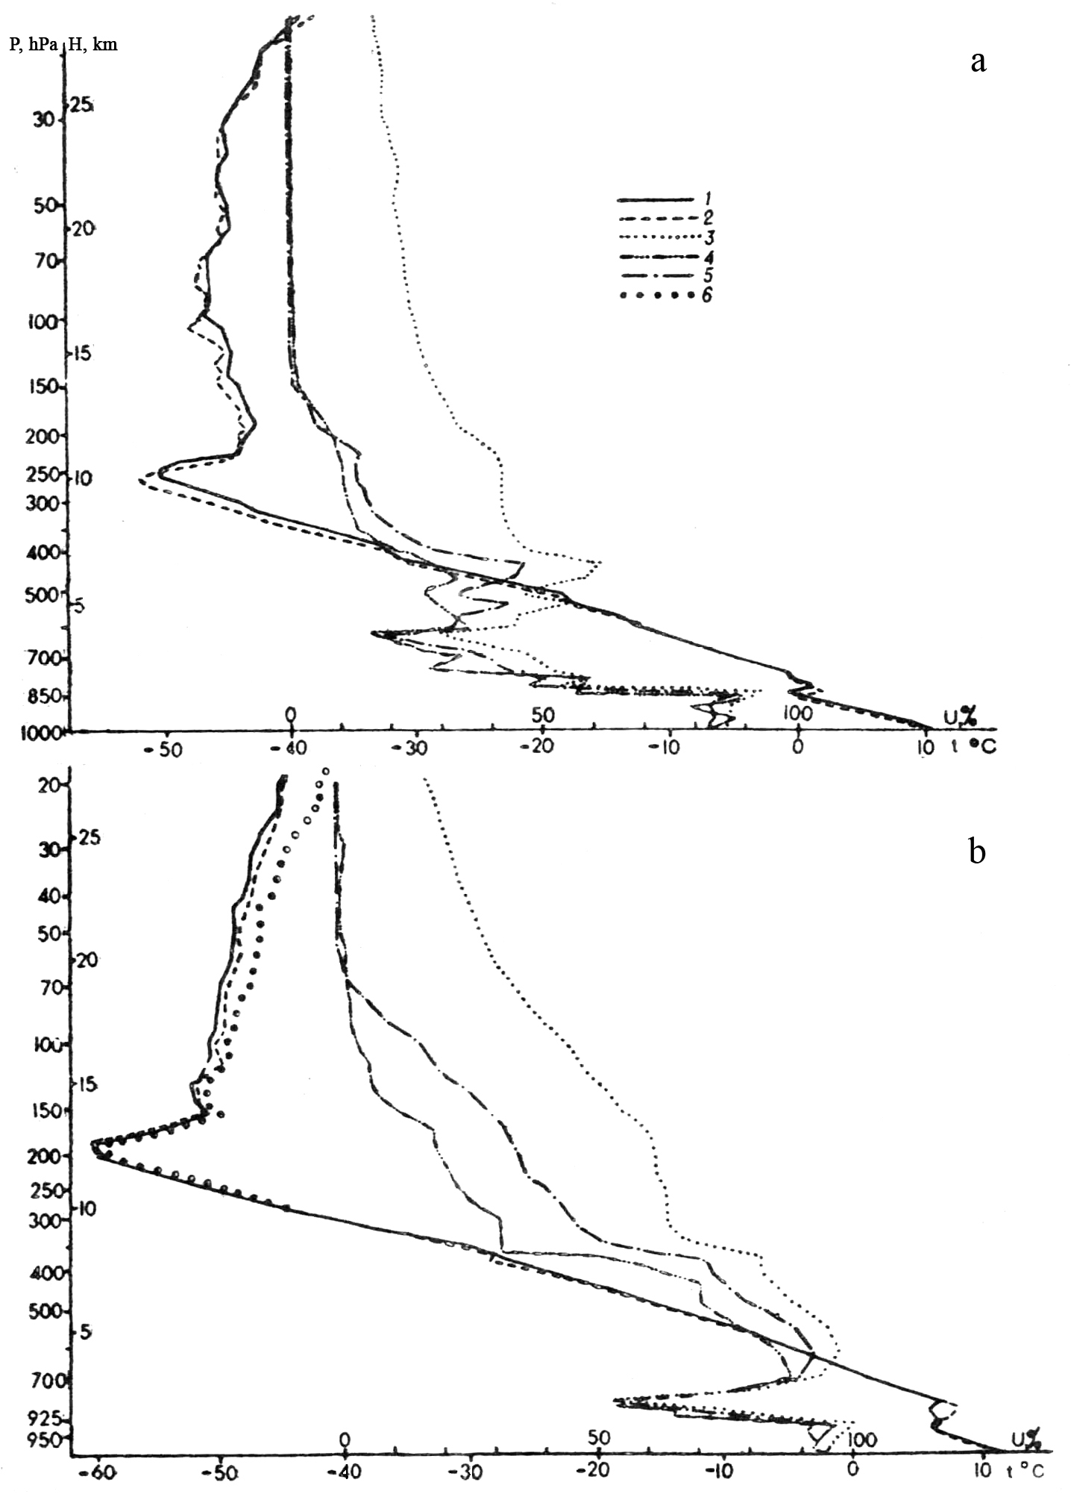

Figure 1. Vertical distribution of temperature t (1, 2, 6) and humidity U (3-5) according to data from RVs “Professor Vise”─”Professor Multanovsky” on 30 July at 00.00 GMT on different suspensions (a) and on a single suspension on 11 August at 14.05 GMT (b): 1,3 ─ RKZ-2; 2,4 ─ RS-21; 5 ─ by formula of A.R. Dozortsev; 6 ─ without radiation correction (RKZ-2).

According to the data of synchronous soundings with the release of RKZ-2 and RS-21 on different lifting systems (Figure 1, a) and on a single system (Figure 1, b) vertical temperature and humidity profiles were obtained. Stratification of the atmosphere (see Figure 1, a) showed that in the 1km-layer both radiosondes passed the liquid-phase clouds at the level of the top boundary of inversion (640 m). As a result due to the wetting the temperature measured by RKZ-2 appeared to be 1.6ºC lower than that measured by PS-21. Only at the altitude of 1.5 km the temperatures measured by the thermoresistor of RKZ-2 and the temperature sensor of RS-21 again became similar. In the troposphere agreement between temperature readings is good, the differences begin from the tropopause level. At the maximum ascent altitude of 21.5 hPa RKZ-2 recorded the temperature 1.8ºC lower than was recorded by PS-21. At night time, when radiation corrections to RKZ-2 were not applied, beginning from the level of 30 hPa at 00.00 GMT of 30 July 1984 the Finish radiosonde RS-21 recorded the temperature about 1ºC higher, than RKZ-2. It might be due to the fact that at altitudes higher than 25 km radiation cooling of the MMT-1 thermoresistor (due to self-radiation) is observed, which increases at the altitudes of 25-30 km, where the absolute ambient temperature begins to grow [26, 27]. When on 11 August at 14.00 GMT RKZ-2 and RS-21 were released on a single suspension, the method of suspension was changed, since the unwinding of a towrope of the RC-21 mechanical commutator proceeds at a rate 1 m per minute and at the maximum altitude of ascent it can reach 120 m. As is seen from the vertical range of temperature values, differences observed higher than the level of 150 hPa were attributed not to the radiation error, since at solar elevation of 26º it is not significant, but rather to the difference in suspension by the end of the ascent. At the 77th minute the distance between the radiosondes was 80 m. It is within the temperature change by 0.6ºC per 100 m of altitude. The comparison of temperatures obtained by different radiosondes indicates that it is necessary not only to apply radiation corrections, requiring further refinement, but also to eliminate other errors of the RKZ-2 radiosondes (heat fluxes, radiation) by improving the temperature sensor and by ensuring its correct location during the radiosonde flight (to eliminate penetration of water). The radiation error determined by RS-21 should also be refined, though from Table 2 it is seen that compared with RKZ-2 it is insignificant (at solar elevation of 60º at the level of 10 hPa the correction of RS-21 is 3.8ºC, the correction of RKZ-2 is 6.5ºC). A mechanical commutator should be removed. It is inconvenient because a towrope often breaks, when a release is made in strong wind, and it provides inaccurate temperature due to unwinding of that towrope during a radiosonde ascent.
From the analysis of temperature comparison data it is clear that clouds have a decisive influence on radiation and temperature conditions of the Earth surface and the atmosphere. Therefore consideration of heat inflows related to phase transitions of water in the atmosphere could considerably improve the quality of pressure, wind and vertical flow forecasts. From here it follows that measurements of water content in the atmosphere are very important [1, 2, 3, 5, 6]. Figure 1, a, b (curves 4, 5) shows that agreement between those data is within the requirements to accuracy of measurements only in the layer up to 5 km. In Soviet radiosondes a film sorption-deformation humidity sensor is used. A detecting element of this sensor is a 20-um thick membrane consisting of muscular protein molecules.
The laboratory analysis [1, 2, 3, 5, 6] consistently showed that sensitivity and response time of film sensors depend on temperature. The time constant λ at the ground level and the temperature of 20ºC is 5-10 sec., at the altitude of 5 km (at the temperature down to ─20ºC) it grows to 1-1.5 min, after that, as noted by A.R. Dozortsev [5, 6], in the troposphere λ continues to grow with altitude and at the tropopause level it reaches 90% of the value of the relative humidity jump. In the troposphere it reduces gradually. This is because temperature influences the RKZ-2 humidity sensors. The sharp decrease of temperature to the level of tropopause bottom boundary results in the increase of the sensor time response by tens of minutes. With the decrease in pressure and subsequent radiation heating in summer or with small drop in temperature in winter the sensor time response decreases [5,6]. In some cases, when a radiosonde passes through the high humidity zone at the temperature of about ─30…─40ºC a film sensor can break down [1]. According to the technical characteristics of the Finish radiosonde the inertia coefficient of a polymer capacitor at the temperature of 20ºC is 1 sec. Other data are not given, except for the standard deviation from measured values which equals to 2%.
Based on RKZ-2 values recalculated by the method of normalization of the generalized function describing the influence of temperature on humidity sensor readings, which was proposed by A.M. Balagurov, M.B. Fridzon and A.R. Dozortsev, relative humidity was determined (see Figure 1, b, curve 5) [2, 3, 5, 6]. The corrected values of humidity for the levels above 100 hPa are close to those measured by the Finish radiosonde. Therefore the relative humidity error of RKZ-2 measurements can be corrected by recalculation according to the following formula:
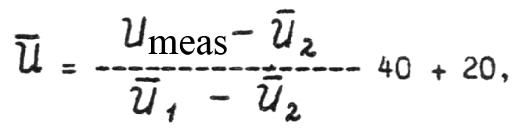

where U_{meas} ─ relative humidity measured under given conditions but determined by the calibration curve obtained at 20ºC (calibration of instrument);
Ū₁, Ū₂─ averaged values by humidity units at the given temperature and relative humidity 60 and 20%, determined by the calibration curve taking into account the ambient temperature; Ū₂ = 28 – 0.4 t; Ū₁ = 66 – 0.25 t – 0.0025 t².
An error resulted from the influence of temperature on the humidity unit will be
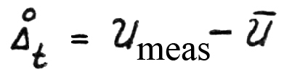
or

Based on the detailed experimental investigations A.R. Dozortsev [6] proposed more complicated formulae for recalculation of relative humidity in different layers of the atmosphere in case of sorption in the lower layers (with the increase of humidity) and desorption (with the decrease of humidity). In practice the best way to correct humidity measurements is to use the computed nomogram rather than the formula. Finish radiosonde readings at the temperature of below ─40º are also open to question, despite the ideas about existence of the so-called “dry” stratosphere emerging in recent years. Values of relative humidity equal to 1% cannot be considered reliable irrespective of the atmosphere stratification and air-mass transport from the tropopause level till the end of radiosonde ascent. The greatest dispersion of the mean differences in measurements of humidity according to the summarized data from RKZ-2 and RS-21 is observed at the level of 850 hPa (the largest sorption of humidity sensors) and in the layer of 400-250 hPa (the largest desorption of humidity sensors).
The comparison of data from Finish radiosondes RS-21, obtained by synchronous soundings from RVs “Academician Shuleikin” and “Professor Multanovsky” showed that at the levels of 850, 700 and 500-300 hPa differences in measurements of relative humidity reached 16%. It seems to be due to either errors caused by calibration of these sensors before release or high sensitivity of receiving surfaces.
Based on the computed statistical characteristics (Table 3) and vertical wind profiles (Figure 2) it is possible to speak about good agreement between wind profiles, particularly wind speed profiles. The largest differences in wind direction were noted in the layer of 100-40 hPa (dispersion from 40 to 80⁰), where wind speed is insignificant, because here in summer a velopause (transition from western to eastern wind directions) is located. In these layers it is possible to observe differences in wind direction, determined by the navigation method with the synchronous soundings from two vessels. This is due to either unreliable operation of the KORA-RS-21 system or inaccuracy in determining wind direction by the navigation methods. As for wind speed, both in absolute value and by orthogonal components differences in wind measurements by radar and navigation systems do not exceed 2 m/s. In general good agreement between wind characteristics gives evidence of a reliable operation of both Soviet and Finish sounding systems in the period of comparisons. Some observations performed by RV “Academician Shuleikin” under standard programmes in the North Atlantic have gaps in wind data, which were caused by unreliable operation of the navigation system.

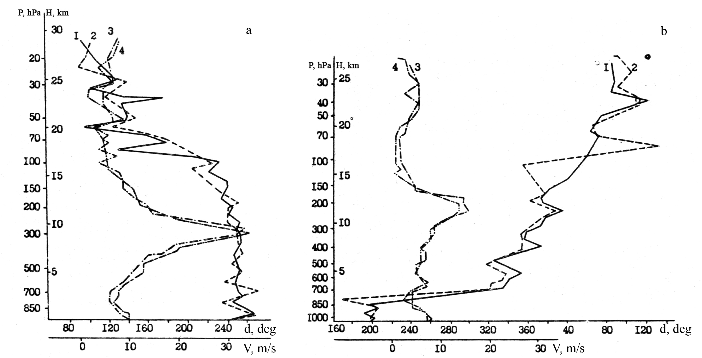
Figure 2. Vertical wind direction d (1.2) and speed (V) (3, 4) from “Meteorit” radar and navigation system “Omega”, 30 July 1984, 00.00 GMT (a) and 11 August 1984, 14.00 GMT (b):
1, 2 – data from radar and navigation systems respectively; 3, 4 – data from “Meteorit” radar and “Omega” system respectively

Table 3

To sum up it is possible to make the following conclusions.
1. The analysis of comparison results of the Soviet and Finish sounding systems shows that the basic differences in temperature measurements are observed in the layer of 1.0 – 1.5 km (when radiosondes RKZ-2 and RS-21 pass through the liquid-phase clouds) and above the level of tropopause: at day time due to the radiation error and at night time due to self radiation of the MMT-1 thermoresistor, as well as due to the differences in the levels of location of the RKZ-2 and RS-2 sensors, which tend to increase due to unwinding of towrope in the Finish radiosonde
2. The results of relative humidity measurements by the RKZ-2 film sensor and the RS-21 polymer capacitor in the lower troposphere of up to 5 – 6 km, meat the requirements to accuracy, above this level data are not comparable. To put into operation improved humidity sensors, it is necessary to correct the measurements made by Soviet radiosondes according to the research that was conducted [5, 6]. For the Finish radiosondes laboratory studies are also needed to determine the measurement accuracy limits.
3. Differences in determining geopotential heights were attributed mainly to errors (wetting, radiation, etc.) in temperature measurements made by the RKZ-2 and RS-21 sensors.
4. The results of wind measurement comparisons, obtained by radiation and navigation methods showed in general good agreement between wind speed characteristics. This gives evidence of a reliable operation of both Soviet and Finish sounding systems in the period of comparisons. Simultaneous synchronous soundings from three vessels made it possible to identify an error in wind direction in the layer of calm winds in the stratosphere in summer. This error is common for both radar and navigation methods. On the basis of the preliminary analysis of the data obtained by the ship-based systems Meteorit-RKZ and KORA-RS-21 the following should be noted:
- temperature and wind obtained by different systems are comparable and
can be used for the joint analysis of the free atmosphere, however radiosounding systems and methods of performing measurements and processing results require metrological certification;
- in Soviet radiosondes it is necessary to improve anti-radiation properties
of temperature sensors, to provide for protection against wetting, to reduce the influence of measuring current, UHF current and heating of batteries on the MMT-I thermoresistor;
- it is necessary to refine radiation corrections to measurements performed
by Soviet and Finish radiosondes RKZ-2 and RS-21;
- it is necessary to change the methodology of processing of relative
humidity data obtained by the RKZ-2 radiosonde;
- in Finish system it is necessary to continue works on improving
interference resistance, to introduce refinements to radiosondes (refusal from mechanical commutator), to conduct laboratory tests of humidity sensors (limits of measurements at low temperature).

To obtain final conclusions it is necessary to continue comparisons. First of all it is recommended to conduct day time and night time releases of RKZ-2 and RS-21 on a single suspension.

References:

1. Balagurov A.M., Gorbatova E.S., Zaichikov B.P., Marfenko O.V., Fridzon M.B. Comparative tests of film and aluminium oxide humidity sensors in radiosounding of the atmosphere. Proceedings of CAO, 1980, Issue 141, pp. 80-85.

2. Balagurov A.M., Fridzon M.B. Investigation of the function of temperature influence on humidity sensors of the RKZ radiosonde and opportunities for its normalization. – Proceedings of CAO, 1993, Issue 151, pp.28-34.

3. Balagurov A.M., Fridzon M.B., Dozortsev A.R. Evaluation of time-constant of radiosonde sorption humidity sensors. – Meteorology & Hydrology, 1984, No 4, pp. 114-116.

4. Goltsova K.I., Marfenko O.V., Petrosyants M.A., Reshetov V.D. Comparison of Soviet and US ship-based systems for radiosounding of the atmosphere. – Meteorology & Hydrology, 1974, No 12, pp. 92-97.

5. Dosortsev A.R. Measurement of humidity of the stratoshere by radiosondes. Meteorology&Hydrology, 1983, No 7, pp. 116-119.

6. Dozortsev A.R. Development of a humid air generator and investigation of dynamic characteristics of upper air humidity sensors. Extended abstract of a dissertation for Candidate in Engineering Science degree. Moscow: 1984. – 14 p.

7. Zaidel A.N. Errors in measurement of physical parameters. Leningrad: Science, 1985. 112 p.

8. Zaitseva N.A. Comparisons of radiosounding data under GATE-74 – Proceedings of TROPEX-74, 1976, pp. 712-726.

9. Kuzenkov A.F., Shlyakhov V.I. Implementation of the programme of international upper air radiosondes comparisons. Proceedings of CAO, 1976, Issue 118, pp. 33-39.

10. Kuzenkov A.F., Shlyakhov V.I. Results of international comparisons or reference-type upper air radiosondes. - Meteorology&Hydrology, 1973, No 4, pp. 94-99.

11. Krechmer M.F., Kuzenkov A.F., Shlyakhov V.I. Some results of upper air radiothermometer comparisons. Meteorology&Hydrology, 1969, No 10, pp. 98 -102.

12. Code for transmission of atmospheric vertical sounding data KN (04) (FM – 35E TEMP, FM – 36E TEMP SHIP). Leningrad: HydroMeteo Publishers, 1971. – 31.

13. Marfenko O.V. Temperature errors of RKZ-2 and methodology of its operation. – Proceedings of CAO, 1971, Issue 102, pp. 11-19.

14. Marfenko O.V. Evaluation of accuracy of radiosounding at the upper air network of the Soviet Union. Meteorology&Hydrology, 1969, No 3, pp. 14-21.

15. Marfenko O.V. Metrological evaluation of the pressure measurement method in the atmosphere radiosounding. Proceedings of CAO, 1983, Issue 147, pp. 3-9.

16. Matveev L.T. Justification of accuracy of temperature and air humidity measurements in the free atmosphere. - Meteorology&Hydrology, 1967, No 6, pp. 21-28.

17. CAO Guidelines. – Moscow, Hydrometeo Publishers, 1968, Issue 38 – 50 p.

18. CAO Guidelines. – Moscow, Hydrometeo Publishers, 1968, Issue 39 – 46 p.

19. CAO Guidelines. – Moscow, Hydrometeo Publishers, 1975, Issue 45 – 36 p.

20. CAO Guidelines. – Moscow, Hydrometeo Publishers, 1977, Issue 47 – 12 p.

21. CAO Guidelines. – Moscow, Hydrometeo Publishers, 1981, Issue 49 – 19 p.

22. Manual for hydrometeorological stations and posts. Ship-based temperature and wind sounding of the atmosphere by the “Meteorit-RKZ” system. – Leningrad: HydroMeteo Publishers, 1974, Issue 4, Part 3b. 127 p.

23. Definition of the “hydrometeorological elements” concept and evaluation of measurement accuracy, Edited by Gorodetsky O.A. – Leningrad, HydroMeteo Publishers, 1970, 90 p.

24. Reshetov V.D. Variability of meteorological elements in the atmosphere. - Leningrad, HydroMeteo Publishers, 1973, 214 p.

25. Reshetov V.D. Requirements to accuracy of atmosphere radiosounding. Proceedings of CAO, 1983, Issue 151, pp. 3-7

26. Fridzon M.B. Shalyakhov B.I. Some specific features of temperature measurements by radiosondes at high altitudes. – Proceedings of CAO, 1971, Issue 102, pp. 130-138.

27. Fridzon M.B. Analysis of metrological support to radiosonde temperature sensors. Proceedings of CAO, 1983, Issue 147, pp. 9-19.

28. Yurchuk V.A. Results of comparative tests of reference thermoradiosondes from the USSR, Finland and Japan. – Proceedings of NIIGMP, 1971, Issue, 1971, Issue 25, pp. 75-81.

29. Mussa D., Reif J. Wind Intercomparison after Phase II of Gate. – Gate Report, 1975, No 14, pp. 51-75.

