Results of studying radiation errors of radiosonde RKZ equipped with thermistor MMT-6 in flying conditions

O.V. Marfenko and K.I. Markelova

Abstract

The paper contains the results of experimental study of radiation overheating and electric current overheating of thermistor MMT-6 in the RKZ radiosonde circuitry in flying conditions.

To determine errors in radiosonde measurements of meteorological elements in flying conditions is no easy task. This accounts for the fact that until very recently, both radiosonde manufacturing specifications of supplier plants and design specifications for new types of radiosondes have indicated permissible values of readings deviations from calibration data under normal conditions only, that are the so-called capital errors. Additional errors are usually not indicated for deviations caused by a number of destabilizing factors affecting a radiosonde in the air. Additional errors of the radiosonde prove to be understudied even following many-years service. However, these errors are often substantially higher than the capital ones.

Most difficult is to determine radiation errors in radiosonde temperature measurements. Theoretical calculations of these errors are known to be difficult, which is connected with the difficulties in making up the heat balance of radiosonde’s temperature receiver. The experience shows that seemingly insignificant changes in the instrument design, sensor position and type of battery power can lead to considerable changes in errors, especially at high altitudes. It is reasonable that the accuracy of theoretical calculations is low not only in determining corrections to the instrument readings, but also in making approximate assessment of errors. To make laboratory conditions close to radiosonde flight natural conditions is not easy; at any rate, we do not know anyone to achieve it. Preference is now given to field experiments, although these are labour consuming and require a large number of observations. All of the aforesaid accounts for studying radiation errors of radiosonde RKZ with thermistor MMT-6, despite the known relationship between radiation characteristics of thermistors MMT-6 and MMT-1.

Before field experiments started, laboratory studies of thermistors MMT-6 had been conducted. These studies showed that stability of calibration data of thermistors MMT-6 under normal conditions is as good as that of calibration data of thermistors MMT-1. In the twelve months of maintenance, none of the ten thermistors under test modified its sensitivity, as compared to initial data of manufacturer. Mean modification of thermistor rating is 0.3°.

The experiment conducted in a thermal vacuum chamber to compare thermistor MMT-1 and thermistor MMT-6 radiosonde temperature readings at surface pressure and at rarefaction to 24 mb with and without ventilation showed no perceptible overheating of thermistor MMT-6 compared with thermistor MMT-1 (Table 1).

Radiosondes calibrated no more than two months ago were used in the field experiments. Calibration was carried out in the CAO experimental workshops.

Table 1

In order to avoid misrepresentation of the major result of investigation, that is the comparative assessment of radiation errors of radiosonde with thermistor MMT-1 and thermistor MMT-6, radiosondes were launched that had three or four different thermistors connected one-by-one in the circuit of the same signal generator of the radiosonde. The position of the thermistors with respect to the radiosonde body and their attachment were identical. Launches were carried out in the day- and night-time. All day-time launches were conducted at approximately the same solar altitude angle. The difference in temperature readings of different thermistors includes differences in their radiation and inertial errors and errors due to current-induced overheating of the thermistors. By neglecting radiosonde radiation errors at night and assuming that inertial errors and errors due to current-induced overheating of the radiosondes are the same in the day- and night-time, we can determine the radiation error of the radiosonde with thermistor MMT-6 based on the following equation:

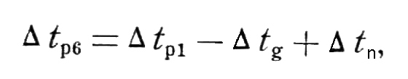 (1)

where Δt _{р6} is the radiation error of the radiosonde with thermistor MMT-6; Δt_{р1} is the known (tabular) error of the radiosonde RKZ with thermistor MMT-1; Δt_{g} is the difference of synchronous temperature measurements by radiosonde with thermistor MMT-1 and thermistor MMT-6 in the day-time; Δt_{n} is the difference of synchronous temperature measurements by radiosonde with thermistor MMT-1 and thermistor MMT-6 in the night-time.

Comparison results of synchronous temperature measurements by radiosonde with thermistors MMT-1 and MMT-6 from day-time and night-time launches are given in Table 2 and Table 3, respectively.

Figure 1 shows the graph of dependency of radiation errors of the radiosonde with thermistor MMT-6, which are derived from (1), on the ventilation rate 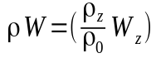on a logarithmic scale. A linear form of the graph points to the exponential law of the change in radiation error depending on the ambient air density. In comparison, this Figure shows the similar graph for radiation errors of the radiosonde with thermistor MMT-1 for the same values of solar altitude.

The power x that characterizes the change in the heat-exchange coefficient of thermistor MMT-6 with height (h=h₀(ρW)^{-x}) proved to be equal to 1.25 in the RKZ radiosonde circuitry, while for thermistor MMT-1, it is 0.69.

The relationship of radiosonde radiation errors for thermistors MMT-1 and MMT-6 is given in Table 4.

The results obtained are indicative of the fact that the efficiency of thermistors of smaller characteristic dimensions, other things being equal, decreases with height.

Table 2
Table 3
Table 4

By using results of night-time experiments, it was attempted to estimate the current-induced overheating of thermistor MMT-6 compared with thermistor MMT-1 under radiosonde flight conditions. By neglecting night-time radiation errors and excluding the difference in errors due to the difference in thermistor inertia coefficients (two seconds), we obtain values of relative current-induced overheating of thermistor MMT-6 that are shown in the last column of Table 3.

In calculating inertial errors, the power x in the empirical formula describing the dependence of inertia coefficient on ventilation rate, 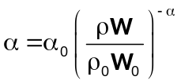, is taken to be equal to 0.69.

It appeared that up to the 30-km height, no perceptible overheating of thermistor MMT-6 was observed, as compared to thermistor MMT-1, while at the 40-km height, the overheating was about 2°.

The efficiency of radiation protection represented as pits was additionally studied.

From the studies conducted in late 1961, the applied radiation protection of thermistor MMT-1 is effective up to the 35-40-km altitude and its effect decreases with height. From the results obtained in 1963, an adverse effect of the pit begins from as low as 20-25 km (Table 5).

Table 5

The irrelevance of the results obtained is very likely to be connected with different values of the solar altitude angle in experiments conducted in 1961 and 1963. In 1961 and 1963, investigations were conducted at solar angles 28-29° and 51-57°, respectively. It is assumed that the black inner face of the pit absorbs direct solar radiation at high solar angles and becomes a powerful source of long-wave radiation. The ascent at the solar angle of 8° confirms this assumption in terms of quality. As seen from Table 5, thermistor MMT-6 placed in the pit shows higher temperature than unprotected thermistor at least from the 20-km height. This Table also presents calculated radiation errors of thermistor MMT-6 in the pit. These errors are larger than those of thermistor MMT-1 in the pit. The reason for this is not clear. In launching radiosondes with the two thermistors being in the same pit and supported by the same bracket arm, thermistor MMT-1 showed nearly the same temperature as thermistor MMT-6 at the altitude to 25 km, while above this level, the temperature according to thermistor MMT-1 was somewhat higher.

We should note a large scatter in quantitative results of the comparison between the readings of different temperature receivers from launch to launch at high altitudes under seemingly identical experimental conditions.

According to the study conducted, temperature measurements at the heights above 25-30 km are complicated. We believe that the problem cannot be solved by applying sensors of small characteristic dimension. The results obtained suggest that in this case, of significance are the so-called indirect inertial and radiation errors caused by the impact of the radiosonde body and the details of temperature node on the sensor. In this connection, in measuring temperature at the heights of more than 25-30 km, the problems of the reduction in heat exchange between a temperature receiver and other components of the instrument are of primary importance.

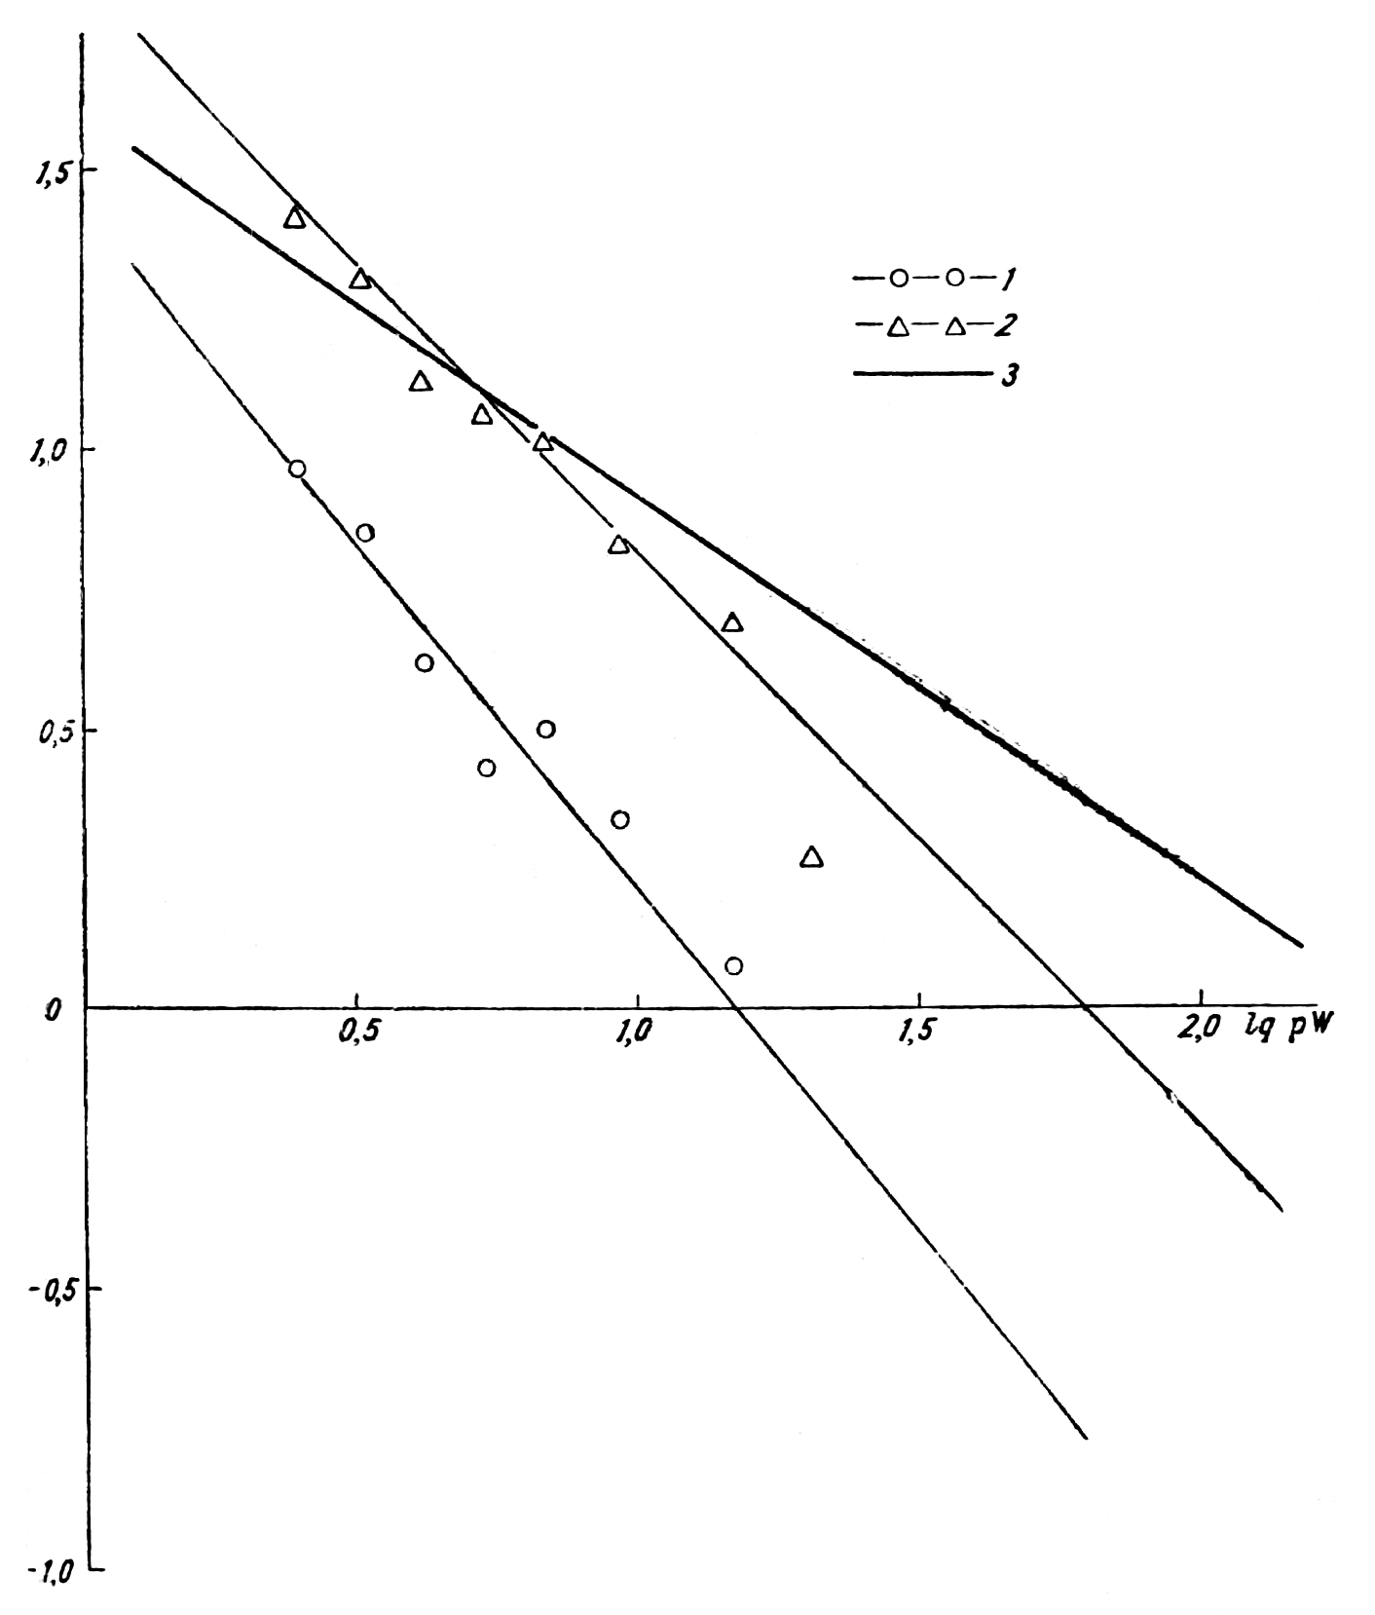
Figure 1. Dependence of radiation errors on the ventilation rate (the value IgΔt is shown on the ordinate axis). 1 – unprotected MMT-6; 2 – MMT-6 in the pit; 3 – unprotected MMT-1.

References

1. Zaichikov, P.F. Procedure of determining radiation corrections to temperature readings of radiosondes A-22-III, RKZ-1 and RZ-049 based on temperature differences “day minus night”. Proc. of CAO, No.43, 1962.

2. Kostyanoi, G.N. Radiation errors in measuring temperature in the free atmosphere by using thermistors of MMT-1 and KMT-1 types. Proc. of CAO, No.45, 1962.

3. CAO Methodical Guidelines, No.25, 1960.

4. Guideline for Instruments and Methods of Observations. WMO. Geneva, 1962.

5. Sheftel, I.T. Thermistors. Fizmatgiz. Moscow, 1958.

6. Shmeter, S.M. Inertial errors in air temperature measurements by radiosondes. Proc. of CAO, No.13, 1954.

