Meteorology and Hydrology
No 3 1969

THE ESTIMATION OF THE RADIOSONDE DATA ACCURACY AT THE UPPER-AIR NETWORK OF THE SOVIET UNION

O.V. Marfenko

The paper presents data on the accuracy of determining geopotential and temperature at pressure levels as well as heights of “specific points” of meteorological elements in sounding the atmosphere with A-22-IV and RKZ-2 type radiosondes. The data are obtained as a result of studying instrumental errors of radiosones and time variability of elements of temperature and pressure fields.

Lack of reference radiosondes makes it rather challenging to estimate the accuracy of upper-air observations. In recent times high-accuracy radiosondes have emerged. It would be more appropriate to call them aerothermometers. Inertia and radiation errors in temperature measurement performed by these aerothermometers are considerably smaller. At present we do not have a radiosonde, which could measure temperature and air pressure in the free atmosphere or a height of ascent to a high accuracy.
It appeared to be possible to estimate the accuracy of radiosounding results with the help of the detailed study of instrumental errors and theoretical expressions of errors of the results depending on instrumental errors [4].
Below are given the approximate expressions of limiting errors of the radiosounding results based on temperature and pressure measurements by a radiosonde.
The error in a pressure level height
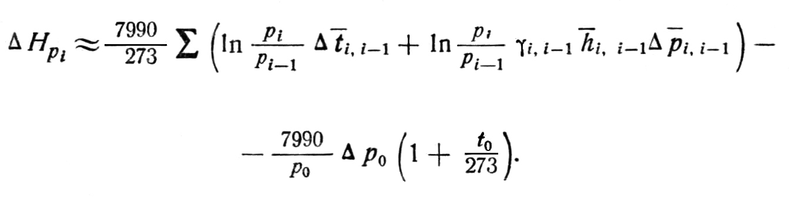 (1)

The error in a height of specific points (a height of radiosonde ascent)

∆H_{i} ≈ h_{i} ∆ p_{i} + h₀ ∆ p₀ ₊ ∆H_{pi} . (2)

The error in temperature at a given level H

∆t'_{H} ≈ ∆t_{H} + γ_{H} + ∆ H_{H} . (3)

Here the following designations are used:
p, ∆ p_{i} – pressure and error in air pressure measurement by a radiosonde, mbar,
∆ p₀ – error in air pressure near land surface measurement by a barometer, mbar,
t, ∆t – temperature and error in temperature measurement by a radiosonde, deg,
H – height, m,
γ – vertical temperature gradient, deg/m,
h – pressure step, m/mbar.

Index i characterizes boundaries of the layer, which is processed. Normally these boundaries are standard pressure levels.
When radar stations are used to supplement radiosondes, a methodology of processing radiosonde ascents is determined by the comparative accuracy of the radiosonde ascent height computed by the barometric formula and radar data, i.e. by comparison of errors defined by expression (2) and the following expression

∆H_{radar} = ∆D sin δ + D cos δ∆ δ, (4)

where D, ∆D – slant range and error in slant range measurement, m,
δ – vertical angle,
∆ δ – error in vertical angle measurement, deg.

The expression for the error of pressure level height, when radar data on radiosonde ascent height are processed, has the following form

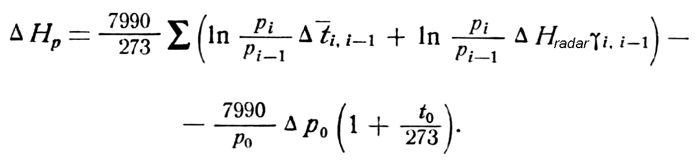 (5)

A relationship between instrumental errors and errors in the sounding results showed that it is reasonable to divide all instrumental errors of radiosondes into three types:
a) systematic errors typical for a specific type of radiosondes;
b) systematic component of a random error of this type of radiosondes;
c) errors random for a single sounding.
Below the results of studying instrumental errors of the A-22-IV and RKZ radiosones used at the upper-air network of the Нydrometeorological Services of the Soviet Union are presented. Random errors of radiosindes were determined both in laboratory conditions based on data of their multiple calibrations at short intervals and in flight conditions by the method of paired releases of radiosondes.
From Table 1 it is seen that to the absolute value of a random error a considerable contribution is made by the component, which is systematic for a specific sounding.
The systematic errors of a radiosonde are attributed to the fact that under real-life conditions its weather sensors are influenced by permanent factors. These conditions differ considerably from conditions, under which radiosonde calibration is performed. The permanent factors are primarily solar radiation and movement of a radiosonde when measuring variable parameters of the environment. These factors are responsible for radiation and inertia errors. Owing to a lack of a reliable and truly reference aerothermometer, radiation errors are determined by comparison of radiosonde data obtained at day time and at night time and at ascent and descent. To ensure reliable data, both methods require long time series of observations, to say nothing of their fundamental deficiencies.

Table 1

Radiation errors of A-22-IV and RKZ-2 are given in Table 2. Errors derived by the above method are average errors corresponding to average weather conditions and average characteristic of underlying surface. The undeterminable value of a radiation error can reach 30% (on average it is 10%) of the total value of the error. In terms of the influence of the thermobaric field on parameters, this component of a radiation error should be considered as random for a given type of radiosonde (type b).
Inertia corrections are not applied to radiosondes. Sounding-to-sounding variability of the temperature vertical gradient and vertical speed as well as inadequate accuracy of their determining in a separate sounding makes it inadvisable at the standard network of observations. Inertia errors of radiosondes of the A-22-IV and RKZ type are given in Table 3.
The calculated data on the accuracy of standard pressure level heights, temperature at pressure levels and heights of specific points including that of the tropopause, when sounding by the A-22-IV and RKZ, are given in Table 4. The processing of the A-22-IV ascent was based on temperature and pressure measured by the radiosonde, The processing of the RKZ ascent was based on temperature measured by the radiosonde and height calculated on the basis of radar data.
Errors are calculated for conditions of the standard atmosphere, i.e. for the temperature vertical gradient, which is equal to 0.0065 deg/m in the layer from the land surface to 10 km, to 0.00 deg/m in the layer from 10 to 25 km, and to 0.003 deg/m in the layer above 25 km. Calculation were made by formulae (1) – (3), (5) using the values of errors given in Table 1. The undeterminable radiation error was considered to be 10% of the values given in Table 2.

Table 2
Table 3
Table 4

Errors of RKZ-2 ascent height and the associated components of errors in surface pressure heights were calculated for the vertical angles of 10 and 20º with the error in measurement of slant range equal to 60 m and with the error in measurement of vertical angle equal to 0.18º. The condition, under which the vertical angle during the whole period of sounding is equal to 10 or 20º corresponds to the condition, under which the wind is constant at all heights and its speed of 18 and 37 m/s respectively, i.e. the condition, which is pretty much exceptional.
The total result error was calculated as the square root of the sum of the squares of errors resulting from errors in the measurement of individual elements.
As is known a random error of a method of observations can be estimated on the basis of data on the statistical variability of thermobaric field elements [1, 2]. So if the static field of element f is characterized by the time structural function σf²(∆τ), the mean root square value of an error will be determined as

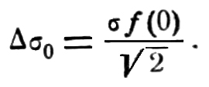

In July 1966 at the upper-air facility of CAO in Rylsk, Kursk Region, we conducted a monthly series of more frequent radiosoundings (every two hours). Observations were performed with the help of the radiosonde A-60 – radar “Meteor” system. According to the calculated data the accuracy of A-60 determined by the height measured by the radar approximately is the same as that of RKZ-2.
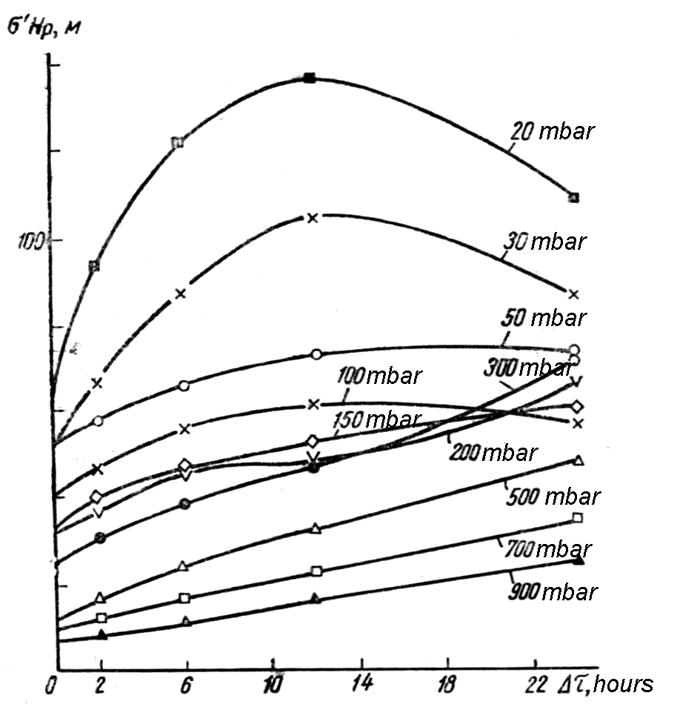 | 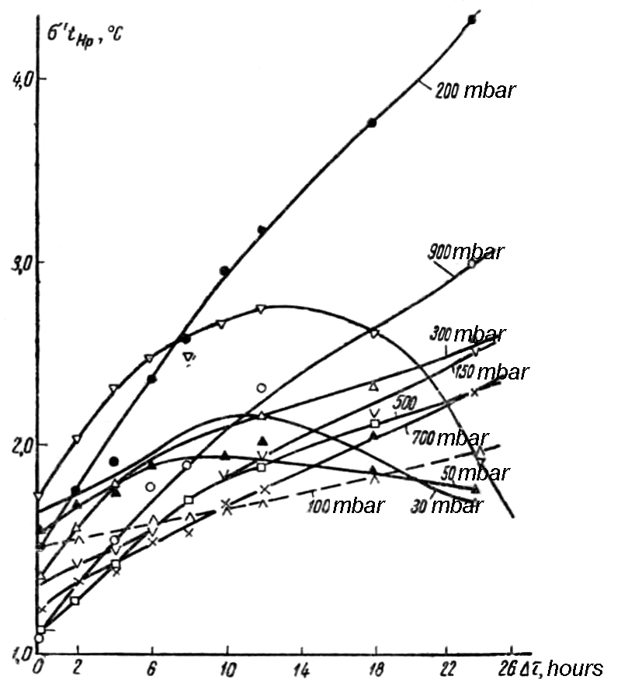
Figure 1 | Figure 2

Figures 1 and 2 give the curves of the mean root square variability of pressure level heights (σ’H_{p}) and temperature (σ’tH_{p}) at theses heights distorted due to the errors of the method. In Table 5 the values of errors of the method obtained with the help of these curves are presented. Comparison of the errors calculated with the help of data on instrumental errors, and the errors calculated with the help of data on variability show that they are in good agreement up to the level of 100 mbar. The analysis of the variability curves show that the height of pressure levels of 50 mbar and above and the temperature at these levels are distorted by considerable systematic errors, which have a diurnal variation. When radiation corrections amended in 1967 were applied, the graphs of the mean root square values of temperature variability at the pressure levels of 30 and 20 mbar against the time interval between observations have the form of straight lines. It seems clear that the accuracy of determining temperature at the levels of 30 and 20 mbar is lower than its diurnal variation.
One of the aspects of using statistical data on variability of meteorological elements is related to the issue of requirements to the accuracy of observations.
In recent years it has become clear that it is appropriate to address the issue of accuracy only when specific requirements are formulated, i.e. the purpose, for which data of observations are used, is specified. For climate-related purposes the requirements to random errors of observations are determined by the length of observation records sufficient to calculate the mean values of elements over a certain time interval to a given accuracy. These requirements are not very strict. Climate scientists impose more strict requirements to systematic errors of a method.
For meteorological purposes requirements to accuracy of upper air information are determined by what values of changes in elements of the thermobaric field should be detected to objectively assess the change of this field. It is natural that meteorologists should impose more strict requirements to random errors.
Data on values of change in the thermobaric field elements, which need to be detected (qualitatively or quantitatively) may, for instance be derived from statistical data on variability of these elements. The fact that a value of variability of an element functionally depends on a distance between points of observations and time between observations shows that in the atmosphere regular processes occur, and this makes forecasting of this element possible. A value of change, which is random in a large set of observations performed during sufficiently long time, in specific observations between forecast intervals is the value that should be determined. For this the accuracy of a method must be higher than characteristic values of variability. If a random error of determining an element is larger than the same statistical characteristic of its variability, the analysis of the field and hence the forecast of its state are normally not possible.
The mean root square errors in determining geopotential and temperature of pressure levels were compared to the mean root square values of their variability over 12 hours, i.e. over the period between two synoptic hours. The ratios resulted from the comparison are given Table 5.

Table 5

It should be noted that weather conditions during the series of more frequent radiosoundings were medium-variable. As for the temperature stratification of the atmosphere it was favourable in terms of its impact on the method accuracy: vertical temperature gradients in the stratosphere were close to zero. Due to this the component of the error in determining geopotential and temperature of pressure levels, which depends on the error in determining the height of radiosonde ascent, was small.
In analyzing the values of variability it was noted that variability of geopotential of pressure levels increases with height: in the troposphere it increases faster and in the stratosphere it increases more slowly. Variability of temperature increases with height in the troposphere. A specific feature of temperature variability in the troposphere is its minimum at the level of 700 mbar (more correctly it is strong influence of the land surface right up to the level of 900 mbar). In the stratosphere temperature variability sharply decreases compared with that in the troposphere.
Errors in the results of sounding unavoidably increase with height. The ratio of errors in the results of sounding to the corresponding statistical characteristics of variability is not less than 0.3 at all levels and reaches 0.8 at levels of about 50 mbar. It is reasonable to assume that at the levels of 30 mbar and above the values of errors on average are larger than values of variability. As for temperature this assumption may be considered to be proved.
Based on the data obtained it can be affirmed that for analysis of synoptic processes to produce short range (daily) forecasts an adequate accuracy of upper-air data is observed only in the lower troposphere.
To improve the accuracy in determining geopotential and temperature of pressure levels it is first necessary to decrease the averaged over the height of ascent total systematic error in temperature measurement by a radiosonde. The temperature measurement error permissible for obtaining the required accuracy of pressure level geopotential (∆H_{p}) can be calculated by the approximate formula

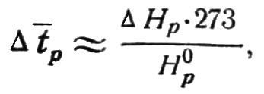

where H⁰_{p} – hypsometric height of geopotential. The accuracy of temperature measurement can be improved by reducing systematic errors in temperature measurement (radiation and inertia errors) and by increasing stability of calibration data of radiosonde temperature unit.
To improve the accuracy of determining the heights of specific points, for example the tropopause it is necessary to increase the accuracy of pressure measurement by a radiosonde (when the radiosonde ascent is processed by the barometric height) or the accuracy of slant range and vertical angle measurement (when the radiosonde ascent is processed by the radar height). The pressure measurement error permissible for obtaining the required accuracy of height ∆H_{i} can be calculated by the approximate formula

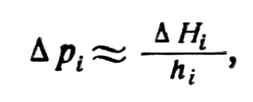

where h_{i} – pressure step.

References

1. Gandin L.S. Objective analysis of meteorological fields. HydroMeteo Publishers, 1963.

2. Zavarina M.V. Study of the free atmosphere thermal field based on data of upper-air observations over the European territory of the USSR and Germany. – Proceedings of the Research Centre. Meteorology. Series I, issue 21, 1936.

3. Zaichikov P.F. Method of determining radiation corrections to the temperature readings of radiosondes A-22-III, RZ-049 on the basis of “day minus night” differences. – Proceedings of CAO, Issue 43, 1962.

4. Marfenko O.V. Accuracy of temperature-wind sounding. – Proceedings of the All-Union scientific meteorological meeting, Volume IX. HydroMeteo Publishers, 1963.

5. Reshetov V.D. Study of the variability of meteorological elements in time. – Proceedings of CAO, Issue 62, 1965.

