Results of international reference radiosonde comparison

Shlyakhov V.I. and Kuzenkov A.F.

Abstract

The paper discusses results of comparison of the Soviet, Finnish and Japanese reference radiosondes. The comparison was conducted in accordance with the WMO international comparison programme. The USSR reference radiosonde is compared with the Soviet commercial radiosondes RKZ-2 and RKZ-3.

It is shown that the accuracy of reference radiosondes is sufficient for them to be used as reference standards in estimating errors of domestic upper-air sounding devices.

To control the accuracy of radiosonde measurements, it is necessary to create sounding devices of reference type that allow atmospheric radiosounding to be conducted with invariably insignificant errors.

The ever increasing requirements applied to the present-day radiosonde [6] and the need to compare the results of measurements in the free atmosphere in different parts of the world made it necessary to perform reference measurements on an international scale. The WMO Commission for Instruments and Methods of Observation elaborated the comparison programme for radiosondes of the countries whose upper-air instruments were most widely used in routine sounding. In 1968 and 1969, the USSR-Japan and USSR-Finland joint tests of radiosondes were carried out to compare the results of temperature sounding.

Air temperature is one of the most significant atmospheric parameters, since it is the original element in describing the potential state of the air mass.

According to the WMO requirements, in the range between +50 and –90°C, the air temperature measurement error is not to be higher than 0.5°C. However, present-day commercial radiosondes show significant errors, particularly in stratospheric measurements. These measurement errors are largely connected with short- and long-wave heat radiation-induced heating of a temperature sensor, gauge currents, impact of the entire raised system on the temperature sensor, and inertia of measuring elements. The errors are also caused by the insufficiently accurate measurement of the temperature sensor state due to the effect of destabilizing factors on radiosonde converter units. It is not easy to estimate and take into account these phenomena in each individual case in order to apply temperature corrections to the readings of the specific instrument. Suffice it to say that the root-mean-square value of the random error in temperature measurement, which is inherent in domestic radiosondes RKZ-2, is 0.7°C. In this case the difference between instrumental readings and the true temperature in the stratosphere at the 20–30-km height can exceed 5°C [2].

Brief description of radiosonde devices compared

Soviet radiosondes made temperature measurements by precision telemetering device (PTD) described in [7]. The PTD sensitive element is represented by platinum wire of diameter 20 mym with 400-ohm resistance at the temperature of +20°C. The sensitive element is included in the equilibrium bridge. The bridge set-off is represented by rheochord (slide wire) with discrete spooling, along which a slider moves cyclically. The measurement bridge is powered by pulse voltage that is applied at the moments when the slider is on the rheochord turn.

Each voltage impulse causes a discrepancy pulse. When the slider moves along the rheochord, the amplitude of discrepancy pulses decreases and at the bridge equilibrium point, the amplitude is equal to zero. Thus, the measured resistance of the platinum wire will be proportional to the number of pulses fed to the bridge circuit from the beginning of the measuring cycle to the moment of offsetting. The measuring cycle duration is no more than five seconds. The rheochord spooling has 100 discrete leads.

The temperature range between +40° and –80°, which is measured by PTD, is divided into four sub-ranges that are automatically selected by a special switch key. The sensitive element overheating is not higher than 0.04°C.

The time constant of such a thermometer is no more than 40 seconds at 5-mb pressure and blowing rate of 5 m/s. Solar radiation-induced overheating at the flow of 1 cal/(cm²·min) is no more than 0.5°C [2]. Sensitivity of the thermal probe is 0.15°C.

The sensitive element in the Finnish radiosonde RS-16 [4] is represented by the aluminum alloy wire of diameter 130 mym and 130 mm in length. As the temperature changes, so does the length of the wire and thus its pull-up that is transmitted to the measuring capacitor through linkage. The change in capacitance gives rise to the change in oscillator frequency.

The temperature sensor of the Japanese reference radiosonde RS11TR67A is made of wire (alloy of Ni (70%) and Fe (30%), 20 mym in diameter and 1.2 m in length) exposed to artificial aging. Its heat capacity is 1.2·10⁻³ J/km. The reflecting power of the surface (25% at 0.2-mym wavelength, 53% at 0.5-mym wavelength, 63% at 1-mym wavelength) gradually increases to 90% at 7-mym wavelength.

The wire wound sensor is a zigzag string attached to a rectangular bent with a low-conductivity wire ring to minimize heat transfer from the bent and to prevent the wire resistance from pull-up-related changing. The metallic material of the yoke (cross-bar of the bent) was chosen in the way that its expansion factor is the same as that of the sensor.

The sensitive element is horizontally attached to the radiosonde case at a distance of 21 cm.

The conversion system comprises a bridge with a resistance wire wound sensor, an enhancer and a voltage-to-frequency convertor [8]. Output voltage of the bridge is enhanced to be converted into the impulse signal in the voltage-to-frequency convertor. This impulse signal, whose frequency is in proportion to the enhanced voltage of the signal from the bridge, is received by the second stage of the enhancer whose output end is connected to the transmitter.

The duration of pilot impulses is about 50 mys and the frequency changes from 10 to 100 Hz.

The temperature domain from +40° to –80° is divided into three ranges. The radiosonde ranges are automatically switched over by using two switch keys connected with a small mercury thermometer with platinum terminals that are set at the levels corresponding to temperature limits of the ranges.

The radiosonde has a baroswitch with about 30 contact segments from surface pressure to 2–3-mb pressure. The baroswitch puts two benchmark resistances in series. Duration of these signals is about ten seconds. Sensitivity of the Japanese radiosonde is 0.1°C.

Experimental technique and comparison results

Comparisons of Soviet and Japanese reference radiosondes were conducted in December 1968 in the Tateno Upper-Air Observatory. Comparisons of Soviet and Finnish radiosondes took place in August 1969 at the Voyeikovo upper-air station.

The research programme provided for five diurnal and five nocturnal launches of twinned radiosondes. For each minute of rise, the difference in temperature readings of the instruments compared was calculated. In processing of Finnish sounding results, radiation corrections to thermometer readings were applied. Their magnitudes at different atmospheric layers are presented in Table 1.

Table 1

Temperature differences Δt_{ij} were classified into time intervals during which the pair of instruments crossed the definite pressure layer. For each group of differences in layers, mean differences in instrumental temperature readings and standard deviation were calculated from the formulas
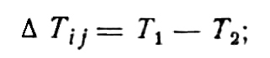 (1)

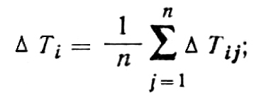 (2)

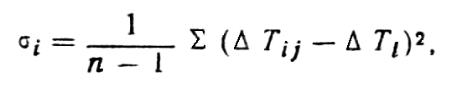 (3)

where T₁ and T₂ are the radiosonde temperature readings, n is the number of readouts in the given pressure layer, i is the launch number.

Then mean differences were calculated in the layers in all N launches:
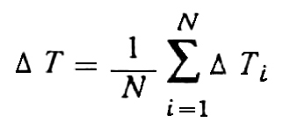 (4)
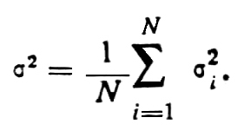 (5)

Averaged results of radiosonde comparisons that were obtained for nocturnal and diurnal launches are presented in Table 2.

Table 2

It is easy to see that the readings of the radiosondes compared coincide well enough. There is no perceptible trend in variation of temperature differences between the two radiosondes. In individual launches, the differences in temperature readings of Japanese and Soviet radiosondes were close to 1°C; however, no regularity is recorded in this kind of values. These large values are likely to be the effect of random instrumental errors. From comparing Finnish and Soviet radiosondes, it was found that maximum values of temperature differences did not exceed 0.5°C in all the launches. Low values of mean temperature differences in the radiosondes compared point to the absence of systematic errors in temperature measurement by these radiosondes.

Close radiosonde readings in nocturnal launches are to be expected, since sensitive elements are made of metal wire, are characterized by low emissivity and their temperatures are almost the same as environmental temperature.

As for diurnal launches, one might expect greater differences in the compared radiosonde readings because of solar radiation. However, the calculations below show that radiation corrections of these radiosondes are small and their dissimilarity is insignificant.

Let us estimate the contribution Δt_{R} of direct solar radiation to the wire thermometers heating that is determined as a difference between the bulb fluid temperature t_{T} and the environmental air temperature t_{A}. To this end, we estimate roughly the overheating of direct solar radiation temperature detectors for the 20-km height, at blowing rate of 5 m/s and perpendicular position of the sensor with respect to a solar beam. According to [5],

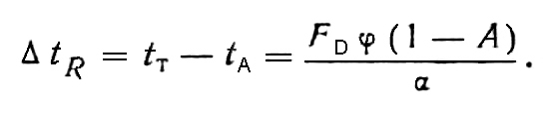 (6)

Here F_{D} = 1.831 cal/(cm²·min) is the quantity of direct solar radiation energy, φ is the radiation factor of direct solar radiation sensors.
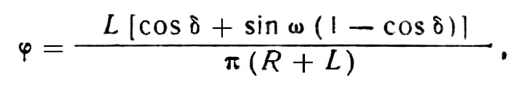 (7)

where L is the wire length, ω is the angle between cylinder axis directions and projection of the solar beam on a horizontal plane, R is the cylinder radius, δ is the zenith angle, A is the albedo (A_{A} = 0.85, A_{pt} = 0.6).

The convective heat-exchange coefficient α is determined from the following dimensionless equations:

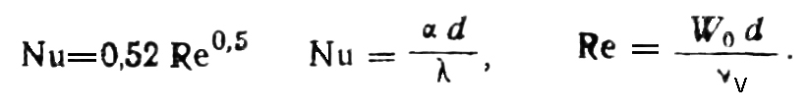 (8)

Here d is the sensitive element diameter ((for aluminum d = 130 mym, for platinum
d = 20 mym, ν_{v} are the kinematic air viscosity coefficients, ν_{v} = 1.6 · 10⁻⁴ m²/s, λ is the heat conductivity coefficient, λ = 4.745 · 10⁻⁵ cal/(cm·s·°C)).

By substituting the values into relations (6) – (8) and by making calculations, we find that overheating of aluminum and platinum sensitive elements is ΔT_{R} = 0.38°C and Δt_{R} = –0.125°C, respectively.

For comparison, Table 2 presents the results of the comparison between radiosonde PTD, improved accuracy radiosonde RKZ-3 [1] and commercial radiosonde RKZ-2. The comparisons were conducted in summer in the CAO experimental site. According to the results, radiosonde RKZ-2 is the “warmest” of the instruments compared. Systematic differences in temperatures of RKZ-3 – PTD and RKZ-2 – PTD radiosonde pairs increase with altitude and reach maximum values at the 20-mb pressure levels. It is likely that this effect is to a considerable extent the result of the overall relative overheating of heat resistors of radiosondes RKZ-3 and RKZ-2 that is related to gauge currents and atmospheric radiation flows. It should be noted that in these launches, the sensors of radiosonde RKZ-3 were not covered with anti-radiation coating. The data obtained make it possible to estimate experimentally the magnitude of heat corrections to the readings of radiosondes RKZ-3 and RKZ-2 and to provide a procedure of their application.

When making observations, it is now recommended to apply the so-called radiation corrections to radiosonde readings, which allows taking into account systematic errors related to sensor heating by solar radiation. In this case the root-mean-square value of the absolute error in applying commercial radiosondes of RKZ-2 type is less than 0.52°C [3].

The comparison of reference and commercial radiosondes and the analysis of comparison results make it possible to obtain information on the actual accuracy of the instruments developed for temperature sounding of the atmosphere.

References

1. Bogdanov R.I., Krechmer M.V., Shlyakhov V.I., and Kuzenkov A.F. Improved accuracy radiosonde RKZ-3. Proc. of CAO, No.102, 1971.

2. Krechmer M.V., Shlyakhov V.I., et al. Results of comparisons of upper-air radio thermometers. Meteorol. And Hydrol., No.10, 1969.

3. Marfenko O.V. Estimating the accuracy of radiosounding results obtained at the upper-air network of the Soviet Union. Meteorol. And Hydrol., No.3, 1969.

4. Talvinen T. Finnish radiosonde with reference signals. Proceedings of the Fifth Session of the Commission for Instruments and Methods of Observation. Paris, 1969.

5. Fridzon M.B. Research into anti-radiation coatings as applied to a procedure of radiosonde temperature measurements. Thesis, MGO, Leningrad, 1968.

6. Shlyakhov V.I. State-of-the-art and future development of temperature-wind and special sounding. Proc. of CAO, No.90, 1969.

7. Yurchuk V.A. Switched power supply bridge circuits as an analog-to-number converter in telemetry systems. Proc of NII GMP, No.16, 1966.

8. Shlyakhov V.I. and Arisumi. The USSR–Japan Reference Radiosonde Comparison. Upper–Air Instruments and Observations. WMO, 1969.

