INSTRUMENTS, OBSERVATIONS, AND PROCESSING RESULTS OF COMPARISONS OF SOVIET AND FINNISH RADIOSONDES
N. A. Zaitseva, R. K. Akhmet 'yanov, and P. Karhunen
Meteorologiya i Gidrologiya,
No. 1, pp. 105-110, 1989
UDC 551.508.822
Results of comparative products of Soviet RKZ-2 and Finnish RS-80-15N radiosondes from the R/V Passat in November-December 1985 are analyzed. The results of measurement of temperature, height of ascent, and wind characteristics are well compared, the data on humidity in the lower troposphere agree satisfactorily, and there are no systematic deviations.
To analyze and use aerological data, it is very important to compare the results of observations obtained by different observation systems. In accordance with the agreement between the Hydrometeorological Services of the USSR and Finland in November-December 1985, tests were conducted on the Finnish automated container for MikroKora shipboard aerological measurements (ASAP program) on the 47th voyage of the R/V Passat. In the course of the voyage we compared the results of sounding by the Finnish system with the data from the Soviet Meteorit-RKS system. The 47th expeditionary voyage of the R/V Passat in the North Atlantic from 20 October through 30 December 1985 took the following route: Kalipeda, Helsinki, Helsinger, St. Johns, Las Palmas, Odessa. The main observations and accordingly the deployments of radiosondes were made in the region bounded by 30 and 50° N and 5 and 45° W. A total of 99 Finnish and 74 Soviet radiosondes were deployed, including 50 comparative deployments.
The goal of this work was to test the equipment of the Finnish complex on board the Soviet R/V and simultaneously to obtain statistically reliable data on the comparability of the results of measuring various characteristics of the free atmosphere made by Soviet and Finnish radiosonde systems under different geographic and weather conditions. To verify the method of considering the effect of solar radiation, deployments were made equally in the night and day periods. For greater coverage of different regions, the comparative deployments were distributed evenly along the entire route of the voyage, due to which we obtained data on the comparability of results under different weather conditions and different regimes of ship movement.
Comparative deployments were made in two ways: in one ascent system and synchronously in different casings. In the first case the both radiosondes were deployed on the Soviet casing no. 150, and they were reinforced on the two sides by a horizontal rod 1.3 m long, which was mounted on the casing at a distance of 10 m; the radiosondes were mounted in series in several deployments. In the latter case both radiosondes were launched separately, each in its own casing, and we only deployed the both sondes synchronously. The tracking and recording equipment was switched on separately, since the Soviet system is switched to a tracking regime manually, and the Finnish automatically, according to the tendency of pressure to rise. In processing it was established that less than strictly synchronous switching did not impair the comparison results.
The Soviet Meteorit radar, RKZ-2 radiosondes, and processing facilities have been prepared for work in accordance with the existing manuals, methodological directions, and operating instructions, the Finnish system has been prepared in accordance with technical regulation and directions of the Vaisala company representative.
In order to obtain comparative characteristics of the both systems during the voyage, we made 50 comparative deployments of six which were unsuccessful. Thus, the entire mass of the obtained data in the course of analysis was grouped according to deployment conditions in the following manner: 1) complete mass of data (44 deployments); 2) deployments in one ascent system (20); 3) deployments in different ascent systems (18); 4) daytime deployments (10); 5) night deployments (15); 6) normal weather conditions (wave height to 3 m) (13); 7) storm conditions (wave height > 3.5 m) (27).

Table 1

The comparison results were processed by the method adopted for analyzing results of comparisons of Soviet and Finnish radiosondes in Minsk in October 1984 [3]. Differences in the values of meteorological elements were calculated for the atmospheric layers between isobaric surfaces: 1000-850, 850-500, 500-300, 300-100, 100-30, 30-10 hPa. The following parameters were subjected to statistical processing: altitude of isobaric surfaces, pressure at standard altitudes, temperature, relative humidity, wind direction and speed. For each group of meteorological values in the layer for each deployment and for each mass of deployments in the group, we calculated the mean arithmetic (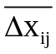) and mean square differences (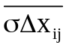) in each enumerated layer of the atmosphere. We also calculated the coefficients of mutual correlation of series of meteorological values in each layer which were not examined later since almost all of them, except humidity, are close to one.
Table 1 presents statistical characteristics of the differences in the radiosonde readings for the entire body of data. This table shows that the results of sounding by the both systems are well compared. The mean square deviation of temperature differences (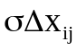) does not exceed 1.5 °C in the layers of 300-100 (1.5 °C) and 30-10 (1.2 °C) hPa; in the other layers it is equal to or smaller than 1 °C. Deviations of the differences in altitudes to the level of 100 hPa do not exceed 19.8 geopotential meters, and for pressure in all layers is 0.5 hPa or smaller. Data on relative humidity in the lower troposphere and wind direction and speed at almost all levels agree satisfactorily. The results of these comparisons coincide largely with the results of similar comparisons made on the ground in Minsk in October 1984.

Table 2

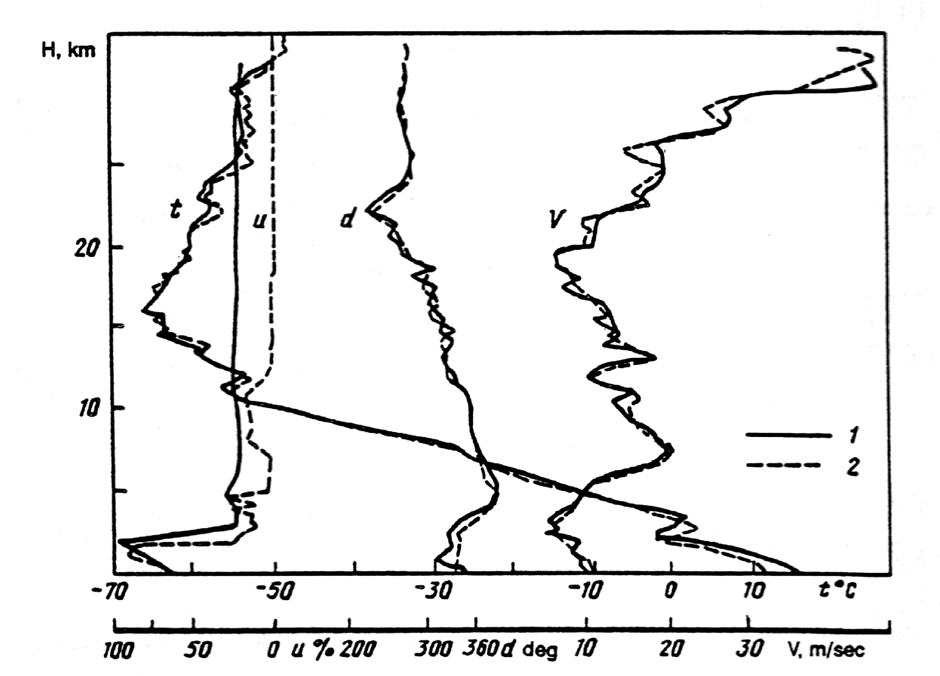
Fig. 1. Vertical profiles of atmospheric parameters according to Soviet (1) and Finnish (2) radiosondes.
t is the temperature; u is the relative humidity; d is the wind direction;
V is the wind speed. Deployment no. 11, 8
November 1985, 00:00 GMT, 37°25' N, 35°00' W.

To confirm this, we recall that for the troposphere, the average value of the mean square deviation of the error in determining geopotential altitudes for the Meteorit-RKZ system is equal to about 14 gp m [4]. The mean square deviation of the instrument error of measuring temperature by RKZ radiosonde in the layer of 1000-100 hPa is 0.5-0.7 °C.
The mean temperature differences in our case are maximal in the layer of 500-100 mbar; above 100 mbar, they are close to zero. The values of relative humidity (=2.1-13.3) agree well only to the level of 300 hPa. This fact is well known, and the divergence in the subjacent layers is systematic and caused by the fact that humidity values above 300 hPa, according to the Finnish radiosonde data, invariably decrease to several percent. These divergences do not provide grounds to consider the Soviet humidity sensor poor; it would be more correct to measure humidity in the upper troposphere over the sea by some other more reliable method (e.g., by dew point method from airplane).

Table 3

Systematic errors in the determination of wind direction do not exceed 1.5° with maximal mean square deviation of 23.1° (100-300 hPa). The greatest differences in determining the direction are observed in the layers with minimal wind speeds. We should stress here that under marine conditions, the wind measurement errors grow substantially due to the roll of the ship and the oscillations of the stable platforms.
In the course of the analysis, we made additional grading of the materials; as a result the data from 11 deployments were considered to be doubtful because of the significant divergences in the ground data (pressure). The results of calculations using the selected data are shown in Table 2.

Table 4

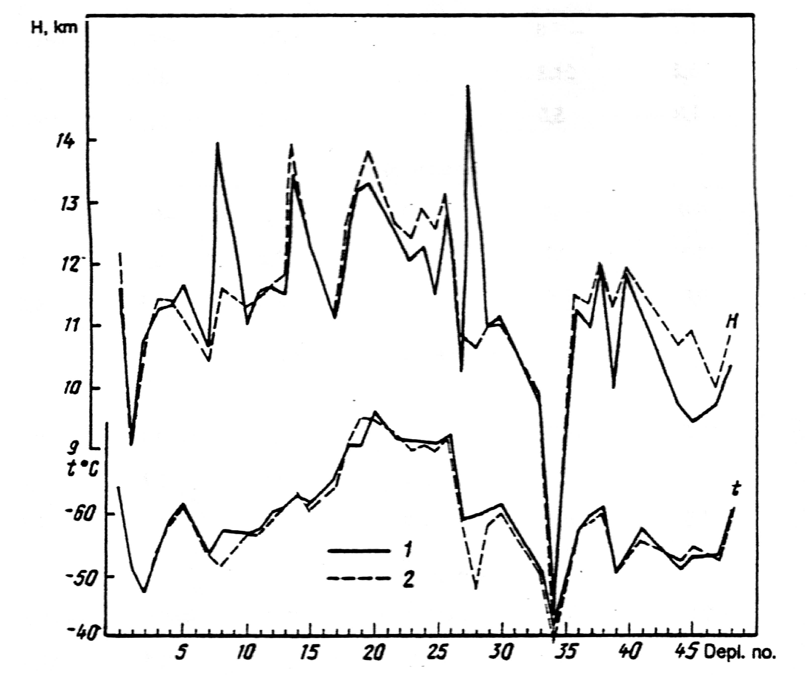
Fig. 2. Variation of altitude (H) and temperature (t) of the tropopause according to data of comparative deployments of Soviet (1) and Finnish (2) radiosondes.
Table 3 shows the results of data processing separately with respect to groups of deployments for the same and different ascent systems. It is obvious that the convergence of radiosonde readings from a single ascent system is much better.
Separate comparison of day and night ascents establishes systematic deviations of temperature measurements by different sensors during the day and at night and differences in methods of considering thermistor heating by solar radiation. Judging by the results obtained, the mean square deviations differ substantially only in the layers above 100 hPa. The mean differences show that the RKZ radiosonde yields higher temperature readings day and night in the troposphere and the lower ones in the day in the stratosphere than the Finnish system (Table 4). We should note here that the solar elevation in the 47th voyage was small (maximum of 35°); with these solar elevations, the radiation corrections to the RKZ radiosonde are small. When comparisons were made in the tropics, the daytime divergences in temperature between the Soviet and foreign radiosondes were greater [1, 2].
As we might expect, under storm conditions the divergences of the radiosonde readings grew substantially. It is quite understandable that with the growth of waves there is a sharp increase in divergence in determining the heights, primarily due to the increase in the errors of leveling the stabilized platform on which the Meteorit radar antenna is installed. The increase in divergence under storm conditions is also due to significant deviations in ground values of pressure because of the impossibility of correctly determining this value under rolling conditions. In stormy weather, the Finnish standard barometer measured the pressure difference of up to 1.5 hPa with variation of the ship's position on the wave (crest and trough).
It was very hard to compare the results of selection of special levels; the altitudes of special points usually do not coincide, although their deviations with respect to altitude are small. The number also differs negligibly, although on the average the Finnish system "finds" more special levels in the atmosphere than the Soviet system. For clarity, Fig. 1 presents an example of vertical profiles of all parameters according to the data of Soviet and Finnish radiosondes. The main special level in the atmosphere is the tropopause; comparison of the altitude and temperature of the tropopause according to the data of all paired deployments is shown in Fig. 2. It is evident that significant divergences were noted only in the deployments which were marked as unsuitable for analysis. The observed deviations are caused by the asynchronous nature of the sensor sampling, the errors in measuring altitude, the different inertia of the sensors, and possibly by different criteria for selecting special levels.
Thus, the analysis of the results of comparative deployments of the Soviet RKZ-2 and Finnish RS-80-15N radiosondes points to the lack of notable systematic divergence in the sounding results and allows us to conclude that they are well compared and these sounding systems correspond well. The comparison made in the 47th voyage of the R/V Passat yielded better results than those conducted earlier (TROPEX, ATE).

REFERENCES
1. K. I. Gol’tsova, O. V. Marfenko, M. A. Petrosyants, and V. D. Reshetov, “Comparison of Soviet and American systems of shipboard radiosounding of the atmosphere”, Meteorologiya i Gidrologiya [Soviet Meteorology and Hydrology], no. 12, 1974.
2. N. A. Zaitseva, “Comparisons of radiosounding data in the ATE”, in: Proceedings of the Interdisciplinary Expedition According to the Program of the International Atlantic Experiment. Vol. 1. The Atmosphere Russian], Gidrometeoizdat, Leningrad, 1976 .
3. P. Karhunen, G. P. Trifonov, and V. A. Yurmanov, “Comparison of data of the Soviet atmospheric radiosounding system of Meteorit-2, MARZ-2, and OKA-3 with the Finnish MikroKora system”, Meteorologiya i Cidrologiya [Soviet Meteorology and Hydrology], no. 11, 1987.
4. Determination of Concepts of Hydrometeorological Elements and Evaluation of the Accuracy of Observations [In Russian], Gidrometeoizdat, Leningrad, 1970.

