ESTIMATE OF ERRORS OF RADIOSONDE MEASUREMENTS OF TEMPERATURE AND HUMIDITY IN THE AEROLOGICAL NETWORK OF THE USSR

M.B. Fridzon
Meteorologiya i Gidrologiya, No. 5, pp. 114- 118, 1989
UDC 551.501.7:551.508.822(47+57)

Reported are the results of developing and implementing a method for estimating errors which is based on metrological analysis of measurement processes in the system of radiosounding, identification and adjustment of metrological characteristics of the mad or functional units of the system, experimental rocket estimation of the elements of the constituents of measurement error, their statistical summation, consideration of the laws of distribution, and subsequent verification of the obtained results using a limited body of independent experimental material. The mad of characteristics of the developed model equipment is reported, and the obtained mathematical models of the temperature and humidity measurement error and the estimates of systematic, random, and summary errors of radiosounding are presented.
The main source of information on the parameters of the free atmosphere is radiosounding. Therefore, estimates of the accuracy of radiosonde measurements are of great interest to many branches of the economy, including the weather forecasting service, agroclimatology, aviation, engineering, medicine, etc.
Evaluation of radiosonde accuracy is a traditional problem of aerology. The most complete and widely used estimates of the accuracy of radiosonde results are presented in [4, 6, 7].
At the same time, these estimates are obtained only for random constituents of the error. They are greatly outdated with respect to the methodology and equipment for which they were obtained. Systematic errors for a sonde system as a type have not been evaluated.
This paper reports the results of developing and implementing a method for estimating errors which is based on metrological analysis of measurement processes in the system of radiosounding, identification, and adjustment of metrological characteristics of the major functional units of the system, experimental rocket estimation of the elements of the constituents of measurement error, their statistical summation, consideration of the laws of distribution, and subsequent verification of the obtained results using a limited body of independent experimental material. Constructed in this way, the estimate of the temperature and humidity measurement errors satisfy modern requirements for metrological security of the measurement since they not only have definite reliability, but they are also guaranteed by adjustment of the metrological characteristics (MC) of radiosondes for production and by the regulation of the rules of' exploitation of the sonde system in the Measurement Procedure (MP) in Radiosounding of the Atmosphere Rd. 52. 11. 60—85. Estimates are obtained by the modern Titan (Meteorit-2) miniaturized radiosonde system.
The MC of radiosondes subjected to investigation and adjustment are determined in this work by analyzing the typical features of the measurement method, its procedure, and the radiosonde calibration technique. In particular, the empirical and individual character of calibration requires adjustment of the function of transformation, the limits of its occurrence, the basic error of radiosondes Δ_{bas} , and the error due to variation Δ_{v} Different conditions of the adjustment of' sensors and secondary transformers from the radiosonde operating conditions require investigation of the function of influence of various influencing factors or uninformative parameters on the measurement errors. Examples of these factors are radiation factors (B) for the temperature sensor T_{sr} , temperature difference between sensor and environment ΔT_{ϕ} , influence of casing Δ_{L} and battery Δ_{b} for the humidity sensor. The use of electrical transformers leads to the need to investigate the impedance errors (Δl_{ω} due to radiation of the UHF transmitter and Δl_{N} due to error of the operating current), and the dynamic character of the measurements leads to determination and adjustment of the dynamic characteristics and dynamic errors of the sonde system Δ_{τ}

Table 1

The radiosonde system is a one-channel radio-telemetric measurement system for which we must determine such specific constituents of error as the error of quantization of meteorological parameters Δ_{q}, the errors of telemetry Δ_{R} and processing Δ_{pr} of sonde data.
The information result of sounding is the value of the meteorological parameter at a certain level in the atmosphere. This leads to the need to consider errors in measurement of the slant range and vertical angle for radar systems (RS) of sounding, which lead to errors in determining the radiosonde altitude Δ_{H}. The latter error is the methodological error typical of the radiosonde method proper. Other errors, such as radiation error in measuring temperature or temperature error in measuring humidity, are the result of the effect of external conditions on the sensors.
The random nature of the linkage of a given radiosonde and RS and the main goal of estimating errors, i.e. determining the spread of data on maps of baric topography, require examination of MC not of an individual radiosonde, but of their entire aggregate, i.e. the radiosonde as a type.
For experimental determination of the indicated MC of radiosondes, a set of special measurement equipment has been developed and metrologically certified; this equipment links the sonde equipment to the corresponding state standards and state inspection schemes. Thus, investigation of the metrological characteristics of temperature sensors are carried out by a model Gradus air thermostat with a temperature range from -55 to 50 °C and a maximal error of 0.1 °C [1]. Lower temperatures are obtained by realization of the reference point of sublimation of carbon dioxide at low pressure.
To reproduce the unit of relative humidity in the radiosonde operating range at different temperatures and pressures, the model Oblako Humid Air Generator has been created [8] which is based on the combined method of two temperatures and two pressures. The operating range of the generator with respect to relative humidity is 5 to 95%, and with respect to temperature it is -50 to 30 °C. The limit of permissible value of the error of reproducing relative humidity is 1% (at temperature from 0 to 30 °C), 3% (at temperature from -20 to 0 °C), and 5% (at temperature from -50 to -20 °C) .

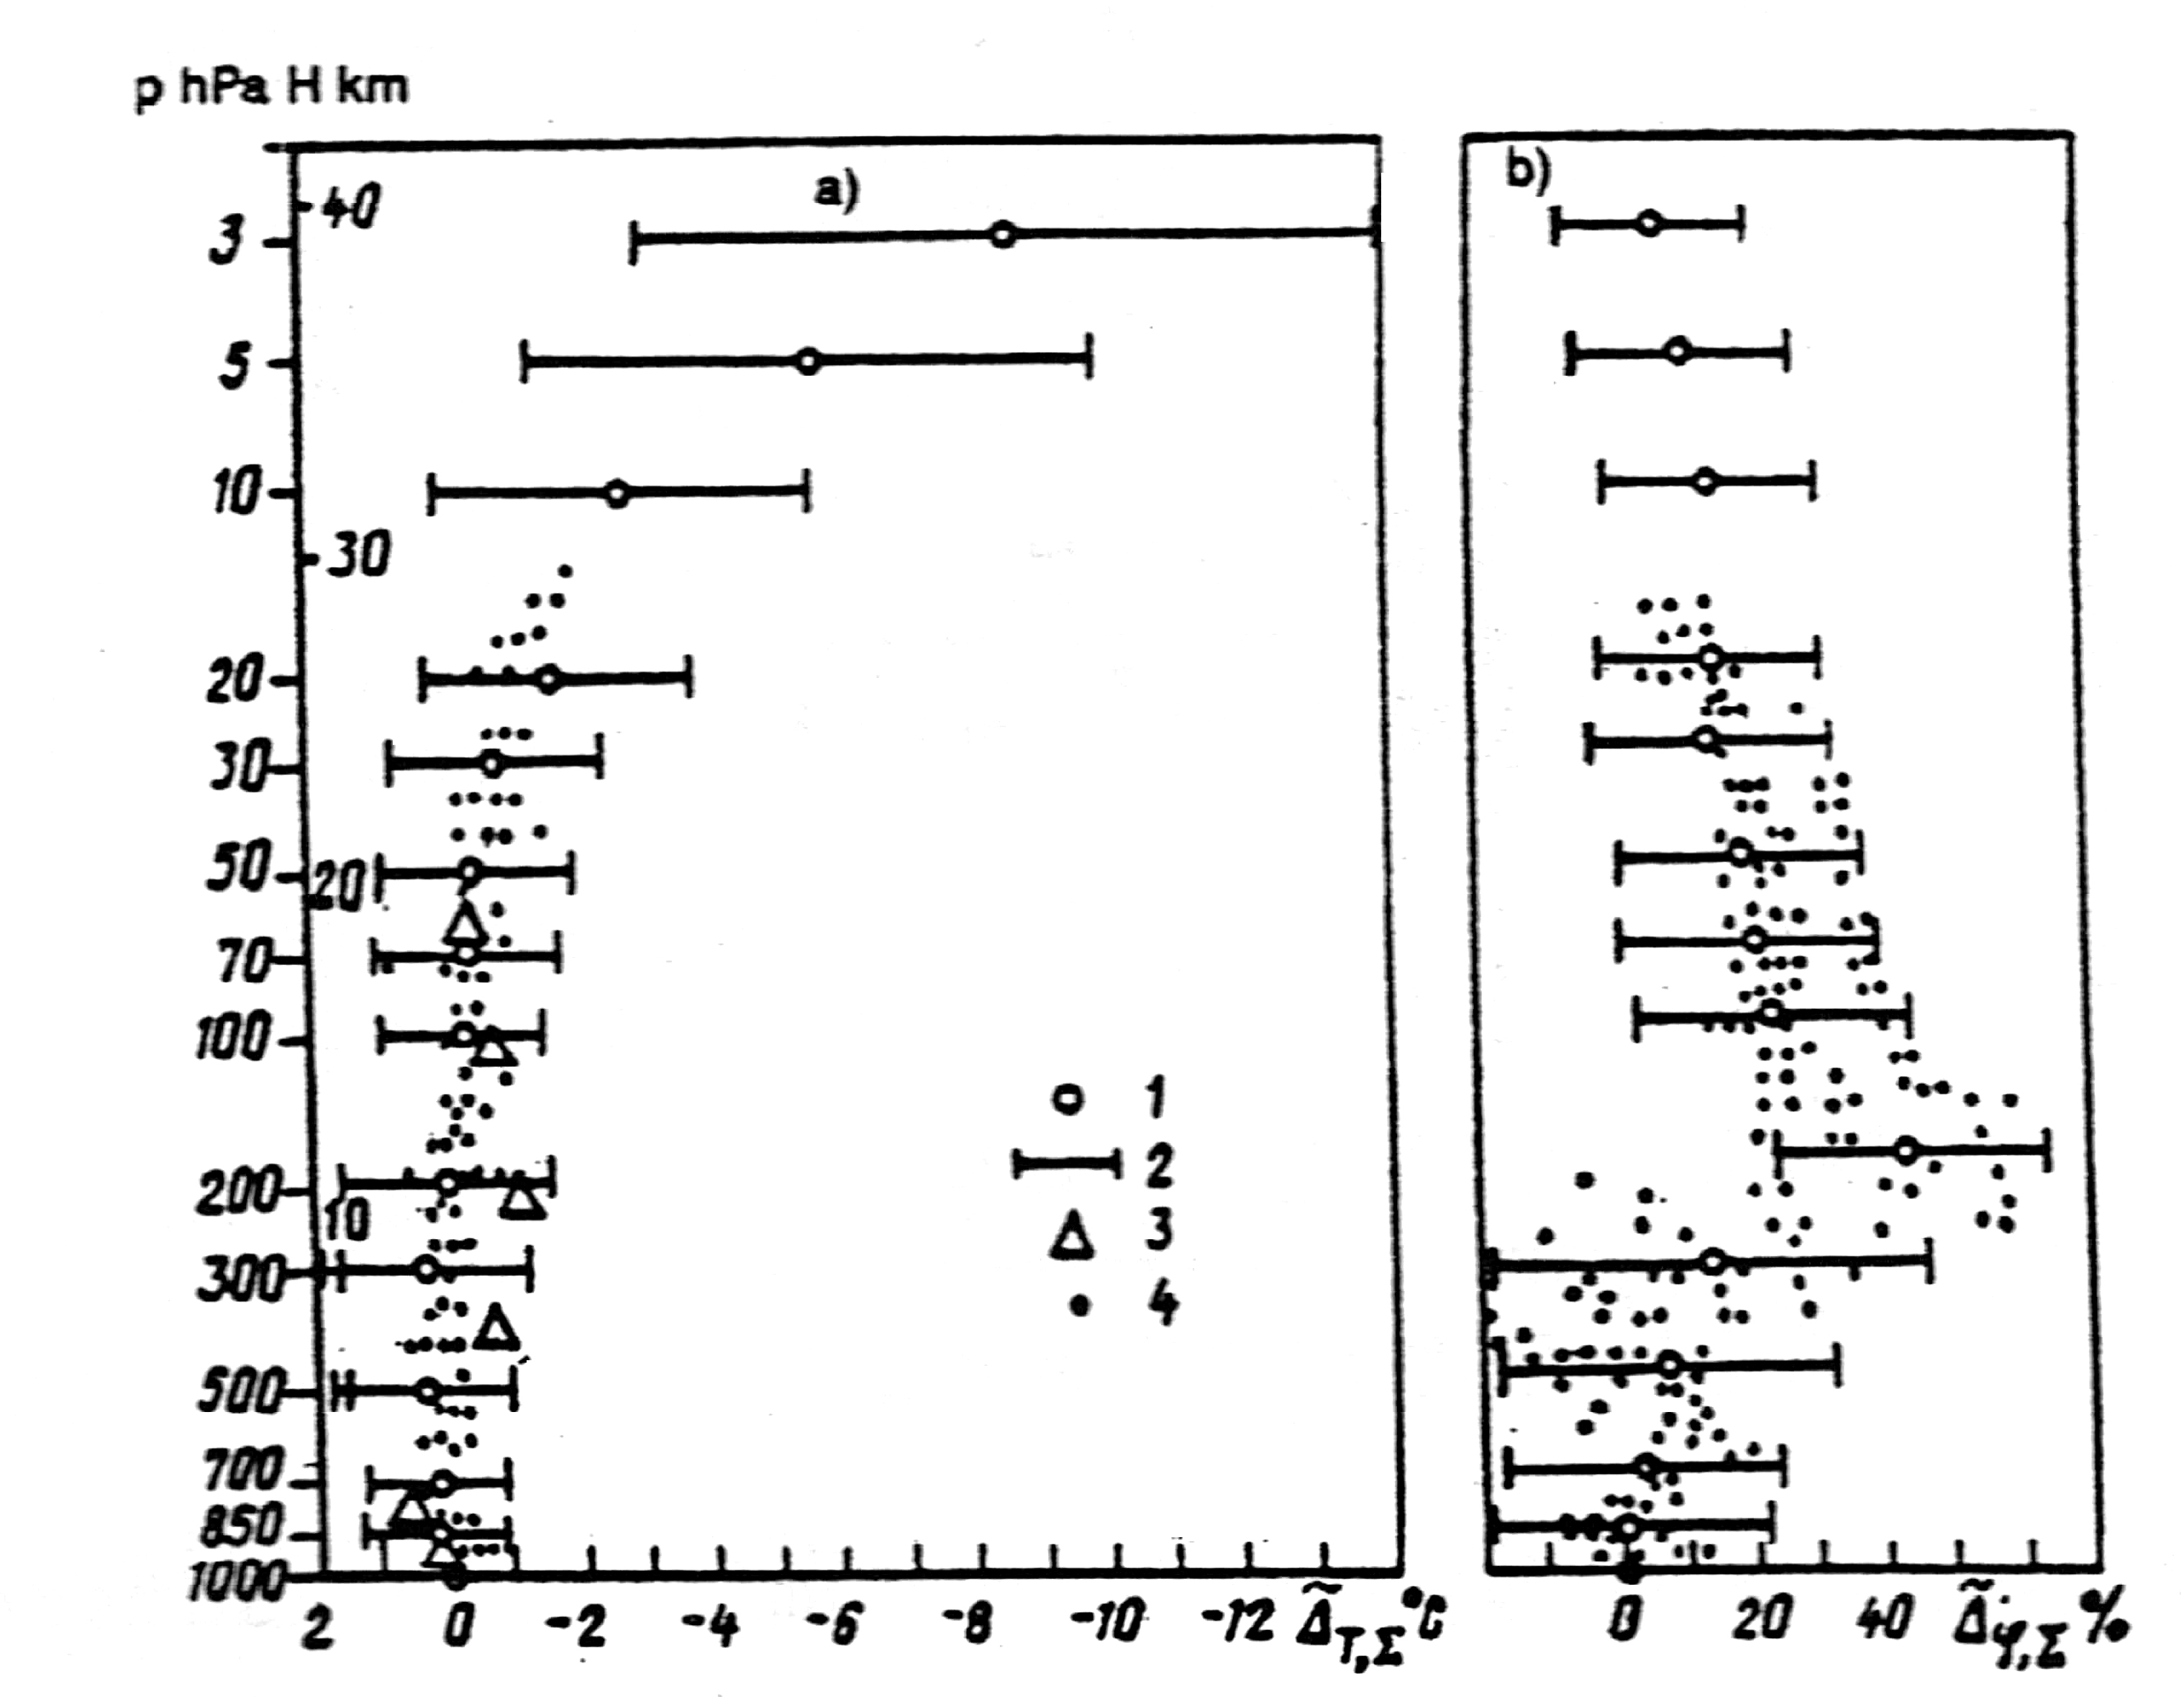
Fig. 1. Summary errors of atmospheric radiosounding.
a) Temperature, b) humidity. 1) Calculated values of systematic errors, 2) confidence interval of error for probability α = 0.95,
3) experiment data from comparing radiosondes and PTT under daytime conditions, 4) experiment data on comparison of radiosondes and PTS (a) or Toros CH (b). (Ryl’sk, summer 1982-1986).
The Kaskad step signal generator (for normal conditions), the Dipol dynamic humidity generator, and the Solntse chamber (in the range of radiosonde operating conditions) were developed and certified for investigating the dynamic characteristics of the temperature and humidity sensors [1].
The developed methods of determining the MC of sensors, e. g. the Method of Determining Basic Error of Radiosonde Temperature and Humidity Sensors, the Method of Determining the Function of Temperature Influence on the SKhP of the Radiosonde Humidity Sensors, the Method of Estimating Indicator of Thermal Inertia and Dynamic Error of Radiosonde Temperature Measurement, etc., have been analyzed and are coordinated with the appropriate institutes of the ALL-Union State Standard of the USSR.
The methodological errors introduced by the initial radiosonde transformers are estimated by theoretical investigation of the processes of their interaction with the environment [9], the methodological error due to the RS by means of experimental rockets with the involvement of high-accuracy means for determining angles and distances (theodolites, quantum range finders, etc.).
As shown by the investigations, the major constituents of the errors have a near-normal distribution.
The adjusted metrological characteristics and estimates of other constituents of measurement error are obtained in the form which allows formulation of the following mathematical models of temperature measurement error:
- for systematic constituent of error:
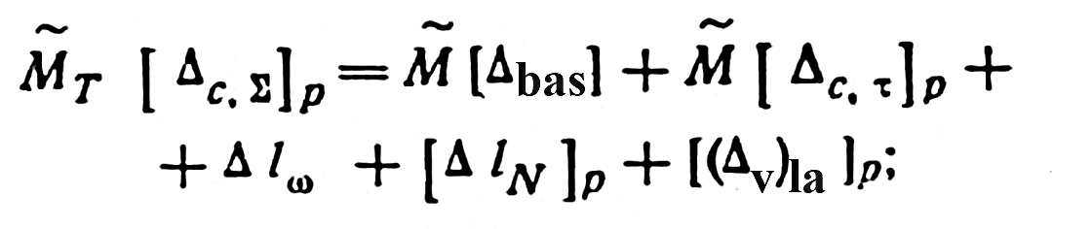 (1)
- for rms deviation of error, random for the type, but systematic in an individual launch:
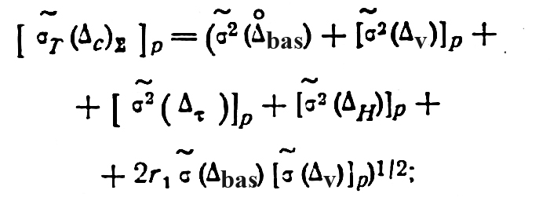 (2)
- for rms deviation of random error in an individual launch:
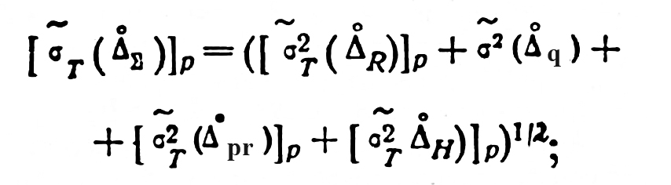 (3)
- for rms deviation of total error;
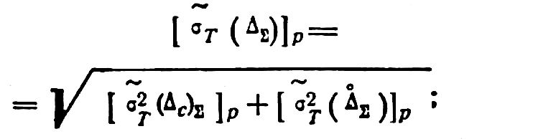 (4)
- for confidence interval of summary error:
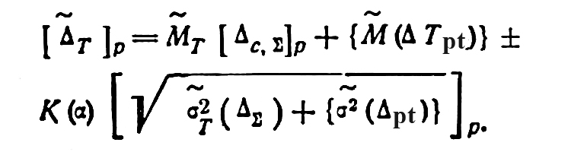 (5)
The following models are for the corresponding humidity measurement errors:
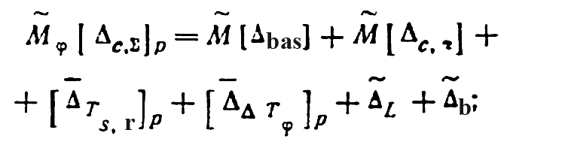 (6)
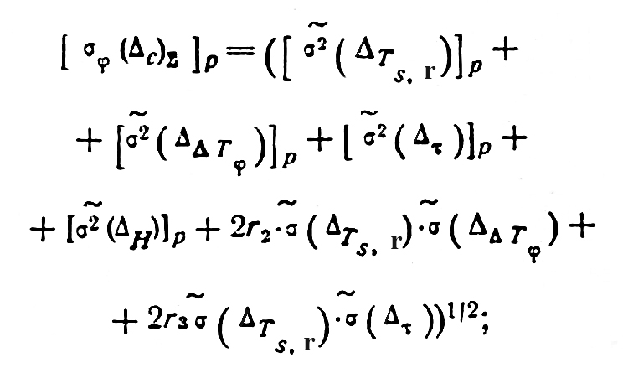 (7)
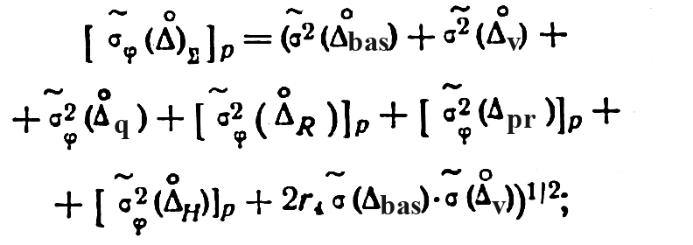 (8)
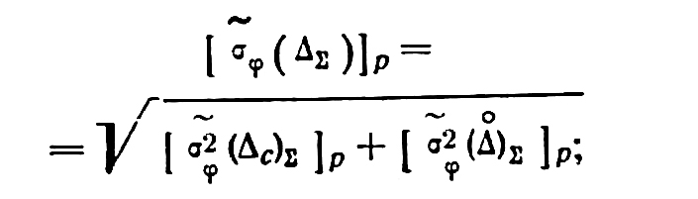 (9)
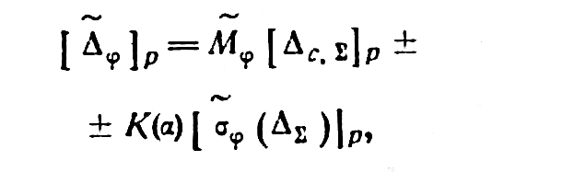 (10)
where M̃[•] is the symbol of selective estimate of mathematical expectation, σ̃ [•] is the symbol of selective estimate of rms deviation, r_{i} is the coefficient of mutual correlation between corresponding error constituents,
K(α) is the adjusted quantile of normal distribution for specified probability α, [Δ_{v}]_{ia} is the difference between the introduced and actual radiation correction, and [ΔT_{pt}] is the error due to phase transformations of water at the sensor surface, which has a sporadic character.
The discrepancy between the form of expressions (2) and (7) is due to the fact that the thermistors, unlike the humidity sensors, do not have random error.
The main results of calculations using models (1)-(10) are presented in Table 1 and Fig. 1.
For experimental verification of the obtained results, special model equipment was created which includes a PTS thin-wire platinum thermometer (wire diameter 5 um) and a Toros condensation hygrometer [2]. Experimental data from comparisons of radiosondes and model equipment are presented in Fig. 1, and data from comparisons of RKZ-2 radiosonde and PTT are used [10]. As we see in the figure, the experimental data fully confirm the results of calculations by models (5) and (10).
As evident from Table 1 and Fig. 1a, to an altitude of 25 km, the temperature measurement errors are relatively small, i.e. the systematic constituents do not exceed 1°C and the confidence intervals of the random constituents (with probability α = 0.95) range from 1 to 1.5°C, which is almost completely determined by the basic radiosonde error. At high altitudes, the temperature measurement errors rapidly increase: the systematic displacement at an altitude of 40 km reaches 9 °C. An important role here is played by the overestimated radiation corrections introduced now.
The uncertainty of the measurement results also increases substantially: the confidence interval of the random error at this altitude is about 5 °C.
Humidity measurements are made with significant errors, especially increasing in the region of the tropopause (to 44%). The confidence intervals of random errors are of the order of 20% in the troposphere and from 13 to 20% in the stratosphere.
The comparison of the obtained estimates of radiosonde errors using the Titan (Meteorit-2) miniature radiosonde system that meets the WMO requirements [11] shows that the accuracy of the sounding system does not exceed the limits which determine the practical value of data on temperature and humidity for studying and forecasting atmospheric processes on medium and synoptic scales. At the same time, it is still very far from the requirements. We must improve both the equipment, particularly temperature and humidity sensors, and also the method of automatic processing of sounding results. In particular, only consideration of the actual measurement conditions (sensor temperature proper, temperature and humidity gradients) will allow a decrease in both systematic and random radiosonde errors by almost 50%.

REFERENCES

1. A. M. Balagurov, A. R. Dozortsev, B. P. Zaichikov, and M: B. Frldzon, “Equipment for investigating dynamic characteristics of aerological sensors under radiosonde operating conditions”, in: Abstracts of 2nd All-Union Seminar “Equipment for GSKP”, [in Russian], Obninsk, part 1, 12-14 October 1983.
2. A. M. Balagurov, A. R. Dozortsev, B. P. Zaichikov, I. B. Nemlrovskii, and M. B. Fridzon, “Comprehensive experiment on Investigating temperature and humidity measurement errors by standard radiosonde”, in: Abstracts of 2nd All-Union Seminar “Equipment for GSKP”, [in Russian], Obninsk, part 1, 12-14 October 1983.
3. COST 8.009-84 “GSI. Adjusted metrological characteristics of measurement equipment”, [in Russian], Izd-vo Standartov, 1985.
4. O. V. Marfenko, “Estimate of the accuracy of radiosonde results in the aerological network of the USSR”, Meteorologiay i Gidrologiya, no. 3, 1969.
5. V. A. Matvienko, M. B. Fridzon, and Kh. N. Gainanov, “Metrological characteristics of temperature measurement transformer of an aerological radiosonde”, Metrologiya, no. 1, 1984.
6. O. A. Gorodetskii, Editor, Observations on the Hydrometeorological Network of the USSR (Definition of Concepts of Hydrometeorological Elements and Estimates of Observation Accuracy) [in Russian], Gidrometeoizdat, Leningrad, 1970.
7. M. A. Petrosyants and V. D. Reshetov, Editors, Composition of the Accuracy and Space-Time Resolution of Data Needed Hydrometeorological Support of the Economy and the Hydrometeorological Forecast Service [in Russian], Gidrometeoizdat, Leningrad, 1975.
8. M. B. Fridzon, “Model equipment for simulating atmospheric conditions”, Meteorologiya i Gidrologlya [Soviet Meteorology and Hydrology], no. 3, 1979.
9. M. B. Fridzon, “Physical model of temperature and humidity measurement error in atmospheric radiosounding”, Trudy NIIP, no. 48, 1985.
10. V. A. Yurchuk, “Thermometers for aerological measurement”, Trudy NII GMP, no. 32, 1975.
11. “Guide to meteorological instrument and observing practices”, WMO, no. 6, 1984.

