Research into the function of temperature effect on humidity sensors
of RKZ radiosonde and capabilities of its normalization

Balagurov A.M. and Fridzon M.B.

One of the main problems in atmospheric radiosounding is a metrological support of humidity measurements. Specifically, in accordance with State Standard 8.009-72, Normalized Metrological Characteristics of Measuring Means, it is necessary to determine and normalize the function of temperature effect on humidity sensor readings, ψ(t). To determine ψ(t), special instruments are required, i.e. humidity generators that operate over a wide temperature range. At present, the standard humidity generator Cloud [2, 5, 6] is developed and certified by the State Standard. This generator makes it possible to produce air at relative humidity of 5 to 95% and temperature from -50°C to 30°C.

This paper presents some of the results of research into the function of temperature effect on humidity sensor readings. The results are obtained by humidity generator Cloud.

The humidity sensor proper of radiosonde RKZ is an animal-film membrane embodied in the secular skeleton and strained with a pullback spring and a cylinder-shaped resistor placed in the protective cover [1]. The membrane 20 μm thick, a sensing element of the sensor, mainly consists of muscle protein molecules. It contains pores of diameter 10÷40 Å that form due to removal of fat inclusions in the course of processing.

While humidity decreases, the membrane tightens up. According to modern outlooks, this process is both due to surface forces and sorption interaction at molecular level. The increase in surface forces is connected with the reduction in curvature radius of water menisci in cone-type pores as long as these move towards the pore bases. The sorption interaction of water molecules with hydrophilic residues of spiral protein molecules reduces to curling of spirals and decrease in their linear dimensions as long as desorption of water molecules occurs.

Since at negative temperatures the film stays responsive to humidity change, the water in the sensor pores is expected to remain in a liquid state at temperatures below zero, too. This is due to a more profound effect of molecular forces under high surface curvature of water adsorbed in the pores.

In this case as the temperature falls, the water first freezes in the larger pores and these stop contributing to the change in linear dimensions of the film. Thus, at negative temperatures, the film humidity sensor is to become less sensitive. This conclusion was made in [3] as applied to hair hygrometer. The decrease in sensitivity of film humidity sensor of radiosonde RKZ at lower temperatures was experimentally supported in [4].

To conduct research, according to predetermined calibration in humidistat PO-34, four humidity sensors with maximum approximation of a calibration curve to a straight line were selected out of 40 instruments. These four sensors were placed in the working chamber of Cloud generator, where different temperature and humidity conditions were assigned. Sensor resistance was measured by digital multimeter FZOK with access to digital print (resistance measuring error is ±0.1 kO).

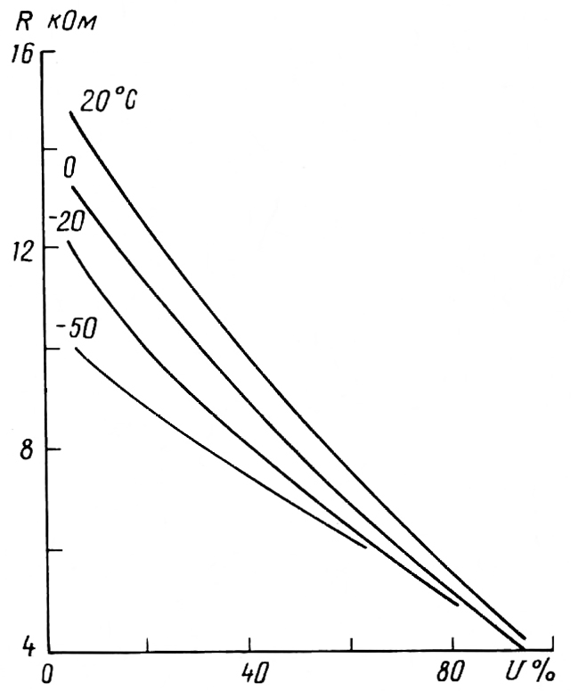
Thermal humidity characteristic of humidity sensor No.45826

In the course of experiments, the following major conditions were sustained in the working chamber of the generator:
- for temperature: 20, 10, 0, -10, -20, -30, -50°C;
- for relative humidity: from 10% up to the maximum possible value every 10%.

Three-fold measurements of humidity nodes resistance were made at the conditions set.

From measurement results, calibration curves of each of the humidity nodes were plotted at fixed temperatures of 20, 0, -20 and -50°C.

As seen from the results presented, the target medium temperature has a significant effect on radiosonde readings of humidity nodes. Absolute measuring errors, with data processed from the calibration curve derived at t=20°C, attain 30-35% of relative humidity at the temperature of -50°C and humidity below 40% (see Figure at R=10 kO). As an example, the Figure shows calibration curves of the humidity sensor for the temperatures indicated, which are graphical representation of the function of temperature effect.

Of interest is evaluating the error of this graphical manner of normalization.

Table 1 shows systematic components of humidity sensors errors ∆Ū and standard deviations of the random component of the error σ̃(∆). As is seen, the systematic component of the error with the graphical normalization of the function of temperature effect on humidity sensor readings is largely no higher than 1-2% of relative humidity.

Table 1

The random error σ̃(∆) increases from 1-3% at 20°C to 5-7% at -50°C. The maximum overall error does not exceed 9% (at -50°C humidity node is No.04202), with its mean value being 3-4%.

Thus, the function of temperature effect can be graphically normalized quite well. However, with regard to automation of radiosonde data processing, it seems advisable to normalize the temperature effect function ‾ψ (t) analytically, for example, by the formula

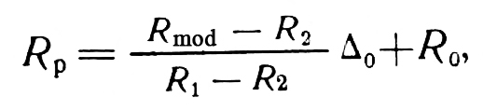 (1)
where R_{p} is the computed resistance of the humidity node for the calibration curve at 20°C; R_{mod} is the measured resistance of the humidity node at the given target medium temperature t; R₁ and R₂ are the resistances of humidity nodes at the given temperature and relative humidity of 20 and 60%, respectively; ∆₀ is the difference between humidity node resistances at relative humidity of 20 and 60%, respectively, at the temperature of 20°C; R₀ is the humidity node resistance at 20°C and relative humidity of 60%.

Table 2 gives calculation results of the errors ∆Ū and σ(∆) for the analytical manner of approximation of the temperature effect function. As seen from the comparison of data in Tables 1 and 2, a systematic component of the error with analytical normalization of the temperature effect function largely increases by 1-2% and attains 4% of relative humidity; σ̃(∆) does not undergo noticeable changes and sometimes even decreases by 1-2%. In this case the maximum overall error is no higher than 10% (at -50°C humidity node is No.04202). On the average, this is about 5% of relative humidity.

Thus, the above analytical method of normalizing the function of temperature effect on humidity sensor readings is sufficiently accurate and efficient. At the same time, derivation of R₁ and R₂ in formula (1) is related to the individual calibrations of humidity sensors over the entire temperature range indicated above. This makes it necessary for the manufacturer of humidity sensors to acquire sophisticated and expensive apparatus that is as effective as Cloud generator and to take considerable time and efforts to perform calibration.

Table 2

In this connection, we suggest normalization of the generalized function of the temperature effect on humidity sensor readings.

With regard to the temperature effect according to formula (1), relative humidity of the target medium, Ū, is to be determined by the formula
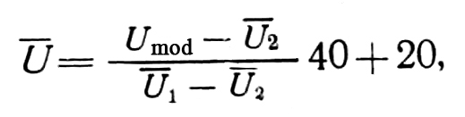 (2)
where U_{mod} is the relative humidity measured under given conditions and determined from calibration curve derived at 20°C (%); Ū₁ and Ū₂ are the average readings of humidity nodes at the given temperature and relative humidity of 60 and 20% which were determined from calibration curve derived at 20°C (%).

Table 3 shows experimental values U₁ and U₂ for each of the humidity nodes studied.

Table 3

From approximation of these dependencies, the following expressions are derived for Ū₁ and Ū₂:
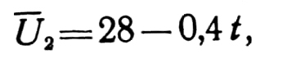 (3)

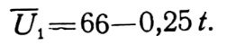 (4)

Based on the measured values U_{mod} and the target medium temperature t°C, relative humidity of the target medium can be determined from equations (2) – (4) with regard to the temperature effect. Deviations of the computed relative humidity U from experimental values at fixed temperatures are shown in Table 4 for each of the sensors studied. Again, this method was used to determine systematic errors and standard deviations of random errors in measuring relative humidity.

Table 4

As seen from the comparison of data in Tables 1, 2 and 4, the values ∆U and σ̃(∆) vary in a manner similar to data in Table 2. The maximum overall error with normalization of the generalized function of temperature effect does not exceed 9% (at -50°C humidity node is No.18161). On the average, this is about 5% of relative humidity.

Thus, the method of introduction of the generalized function of normalization from equations (2) – (4) can be considered the most reasonable one, since despite a slightly higher error in determining actual humidity, as compared to a graphical method, it allows taking into account the temperature effect on humidity sensor readings almost at no extra cost. In this case the manufacturer can introduce no changes in the technological process of humidity sensor production and calibration. In the processing of humidity sensor readings, following the routine determination of U_{mod} (according to manufacturer’s calibration), it is required to calculate the actual value of relative humidity from equations (2) – (4) with regard to the target medium temperature.

In conclusion, it should be noted that formulas (3) and (4), as well as the estimated error of the method, are only derived for linear humidity sensors. It is obvious that the coefficients in formulas (3) and (4) will be different for humidity sensors of other type of calibration curves. Therefore, from now on it is necessary to divide humidity nodes into certain classes according to the type of calibration curve and to determine the coefficients in equations (3) and (4) for these classes. Again, the function of the temperature effect on humidity sensor readings at relative humidity below 10% is likely to need refinement.

References

1. Varzhenevsky, N.S. Film humidity sensors. In: Proc. of NIIGMP, 1967, No.5, pp.79-97.

2. Kondrashov, G.N., Sokov, I.K., Fridzon, M.B., Balagurov, A.M. et al. Calibration certification of multipurpose moist air generator Cloud. In: Measurement Technology, 1979, No.4, pp.52-55.

3. Reshetov, V.D. On inertia and sensitivity of hair hygrometer at low temperatures. In: Proc. of CAO, 1953, No.11, pp.63-70.

4. Fridzon, M.B., Zaichikov, B.P., Balagurov, A.M., and Talanov, V.D. Temperature dependence of RKZ radiosonde’s humidity node. Information materials on hydrometeorological instruments and observation methods. In: Proc. of NIIGMP, 1978, No.74, pp.12-14.

