Radiation protection of thermal detectors of radiosondes
RZ-049, A-22-III and RKZ-1

The paper presents quantitative systematic and random values of radiosondes’ thermal detectors overheating due to reflected and Earth radiation. Appropriate measures of radiation protection are proposed and tested.

Radiation protection of RZ-049 radiosonde’s thermal detector is unsatisfactory. However, no improvements of it were proposed.

A quantitative value of radiation overheating of RZ-049 thermal detector was specified rather well following the International Comparisons of Radiosondes in Payerne in 1956. The comparison results allowed scientists to settle their dispute over the magnitude of daily air temperature variation in the free atmosphere. The advantage in the dispute was gained by those who argued that the daily range of air temperature up to 30 – 35-km altitudes is rather small. This allowed V.D. Reshetov to derive empirical formulas to calculate radiation corrections to radiosonde RZ-049 based on temperature difference “day minus night”.

Technical capabilities available in 1959 allowed CAO, by using four different types of radiosondes raised together, to determine relative values of radiosondes’ radiation corrections and also to check up and propose different ways of radiation protection of thermal detectors: blackening of internal surfaces of pits and louver protection against direct radiation from below.

Four radiosondes were raised with the help of 15 hydrogen-filled latex shells. Radiosonde signals were received by different radars using thoroughly adjusted timers that were turned on by command at the start time.

For each of the radiosondes, the readings of the major meteorological elements were taken for the same point of time from the diagram of their complete processing. The flight altitude was determined from one radiosonde. The altitude calculated from A-22-III radiosonde data was preferable since it was the most accurate.

Major types of radiosondes RZ-049, A-22-III and RKZ-1, as well as improved radiosondes RZ-049₂, RZ-049₃ and RKZ-1₂ were put to comparison testing. The upgrading was largely connected with the improvement of radiation protection of thermal detectors of radiosondes RZ-049 and RKZ-1.

Radiosonde RZ-049₂ was different from RZ-049 in that internal surfaces of its pits were sut and a louver frame made of white writing paper was put in the pit from the bottom (Fig.1). The function of the louver headband was to protect the thermal detector against reflected radiation coming from below.

Radiosonde RZ-049₃ was only different from RZ-049 in that internal surfaces of its pits were sut. A thermal detector of RKZ-1₂, by analogy to that of RZ-049, was placed in the protective cylinder shown in Fig.2.

Statistical processing of comparison results

Table 1 presents mean and root-mean-square differences in the readings of the two radiosondes involved in the same flight. The first three lines in Table 1 characterize the protection efficiency of type RZ-049₂. A systematic value of overheating of the thermal detector of RZ-049, in relation to RZ-049₂, is 2.5°C at the 15-km height and 4.5°C at the 24-km height. The increase in random differences (σ) of pairs RZ-049 – RZ-049₂, as compared with differences of the pairs in lines 2 and 1, is also indicative of the fact that the louver in one of the two radiosondes cuts off quite a variable amount of radiation coming to the thermal detector of RZ-049₂ from below.

Table 1

As seen from Table 1, temperature readings of A-22-III are always lower than those of RZ-049 and RKZ-1, while temperature readings of RZ-049₂ and RKZ-1₂ are close to those of A-22-III. Systematic differences up to the 20-km altitude are within the range of ±0.1°C. Random differences are decreased significantly.

This made it necessary to upgrade radiosondes RZ-049 and RKZ-1 by the example of RZ-049₂ and RKZ-1₂, on which the appropriate recommendations were given.

By analogy with RZ-049₂ and RKZ-1₂ protection, radiation protection of A-22-III do not meet the requirements for the complete radiation protection despite the fact that this protection is substantially better than the one of RZ-049 and RKZ-1.

To find the simplest and best protection of thermal detectors of A-22-III and RKZ-1, different types of protection were tested by comparison method. These will be denoted by the following indices:

A-22₂ – radiosonde A-22-III with a blackened internal surface of the outside pit and with additional protection against reflected radiation from below that looks like a paper disk glued on the spokes of the impeller with the blackened surface at the top;
A-22_{2a} – the same as A-22₂ except that the paper disk is cut up to form four large impeller blades;
A-22₃ – the same as A-22₂ except that it has a white disk;
A-22₄ – conventional radiosonde A-22-III with the outside pit blackened from the interior;
A-22₅ – A-22-III with the disk blackened at the top;
A-22₆ – A-22-III with the outside metallic pit of radiosonde A-22-IV that is polished from outside and blackened from the interior;
A-22₇ – A-22-III with the outside metallic pit blackened from the interior that is made of aluminum foil rather than cardboard. The internal pit remains unchanged;
A-22₈ – the same as A-22₄ with denudation of bimetal from the internal pit (20-mm strip is cut off in its middle part).

To provide a fact-based analysis of comparative results of radiosonde launches, we consider it necessary to present complete data on temperature differences for each of the pairs. The summary data in each of the tables represent mean differences denoted as “actual” and mean radiation corrections denoted as “tabular”. The percentage ratio between actual and tabular differences points to the effectiveness of the protection applied to the radiosonde pair. These data will help to better understand the physics of the phenomenon and will provide useful information that makes it possible to estimate efficiency proposals concerning this issue.

Table 2 presents mean temperature differences between conventional radiosonde A-22-III and radiosonde A-22₂ (with blackened pit and disk), A-22-III and A-22_{2a} (with blackened pit and cut disk), as well as between A-22-III and A-22₄. As seen from Table 2, the A-22₄ blackened pit has a clear advantage.

Table 2

The temperature from radiosonde A-22₄ is lower than that from radiosonde A-22-III by nearly the A-22-III radiation correction value.

The results of special experiments to determine the disk contributions are shown in Table 3.

Two identical radiosondes, one of which had black-disk protection, were compared.

As seen from Table 3, disk protection of A-22-III thermal detectors against reflected radiation failed to deliver the expected results. It is evident that the disk rotating together with the impeller is the main source of radiation heating regardless of whether it is painted black or white.

Table 3

Thus, it should be considered that the internal pit of radiosonde A-22-III and the aligning arrangement of the bimetallic thermal detector provide the effective protection of the thermal detector against radiation from below. Blackening of the internal surface of the outside cardboard pit most efficiently contributes to and improves radiation protection of the A-22₄ thermal detector, at least to the 20-km altitudes.

Table 4 presents temperature differences between A-22-III, A-22₆ and A-22₇ to prove the practicality of using metallic pits.
Table 4

As seen from Table 4, no advantages of metallic pits over the cardboard ones are found.

Table 5 presents the results of the experiments with cutting off the middle part of internal protection of the A-22-III thermal detector. A relatively small piece was cut off in the wall of the inside pit thereby denuding bimetal so that the venting air flow moving along the pit wall was slightly discontinued in the boundary layer. As seen from Table 5, the insignificant effect achieved can only be accounted for by blackening of the internal surface of the cardboard pit rather than the cut-off in the internal protection.

Table 5

On the initiative of GMP Research Institute (M. Usoltsev and S. Nepomnyashchy), funnel-shape protection was tested. They believe that the funnel shape is to increase considerably the flow rate in the pit and it is thought that due to this, radiation effect on the thermal detector readings is to be reduced greatly. The comparison results presented in Table 6 show that none of the pits proposed produces any observable effect of decrease in radiation correction as compared with conventional pit blackening (Table 2).

Table 6

Along with research on protection of RKZ-1₂ type, anti-radiation white coatings of thermistors and tin-foil wrapping were tested. Laboratory and field tests of the coatings proposed gave the worst results compared with the conventional thermistor.

Figure 3 shows the curves of the temperature difference logarithm “day-night” Δt as a function of the ventilation rate logarithm ρw. The curves were obtained from RKZ-1 radiosonde sounding.

The first curve refers to radiosonde RKZ-1 with radiation protection, while the second one to RKZ-1 with the unprotected thermistor. In the both cases the temperature differences refer to solar angles 31 – 40°.

As seen from Fig.3, the values Δt for RKZ-1 with protection always remain lower than those of the unprotected thermistor. As ρw decreases, i.e. with the altitude increase, the protection significance always decreases, and at about 35 – 40-km height, where ventilation rate in the pit will be as low as about 2 m/min., the cylinder pit becomes almost useless.

To summarize all types of radiation protection tested, the following conclusions can be made.

1) Blackening of the internal wall of the A-22 cardboard pit is the best way of reducing radiation correction to radiosonde A-22-III.
2) Up to the 20-km height, the introduction of radiation corrections to temperature readings of radiosonde A-22₄ is not required.
3) Compared with foil, white cardboard is the best material for radiation protection of A-22-III thermal detectors.
4) Protection of RKZ-1₂ type is so far the best solution of the problem of reducing radiation error of radiosonde RKZ-1.

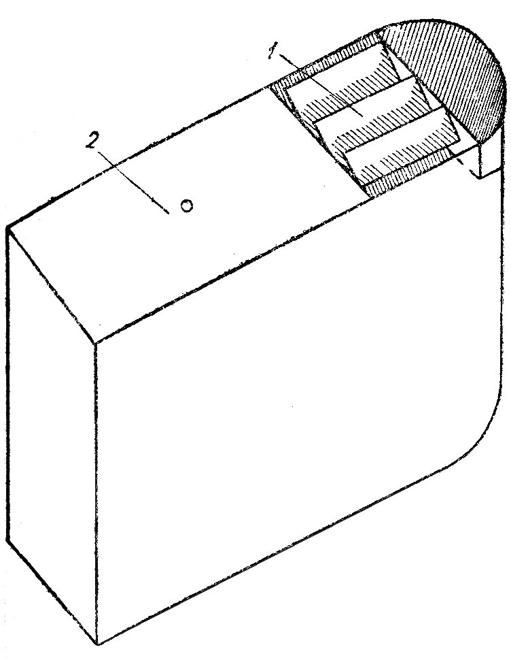 | 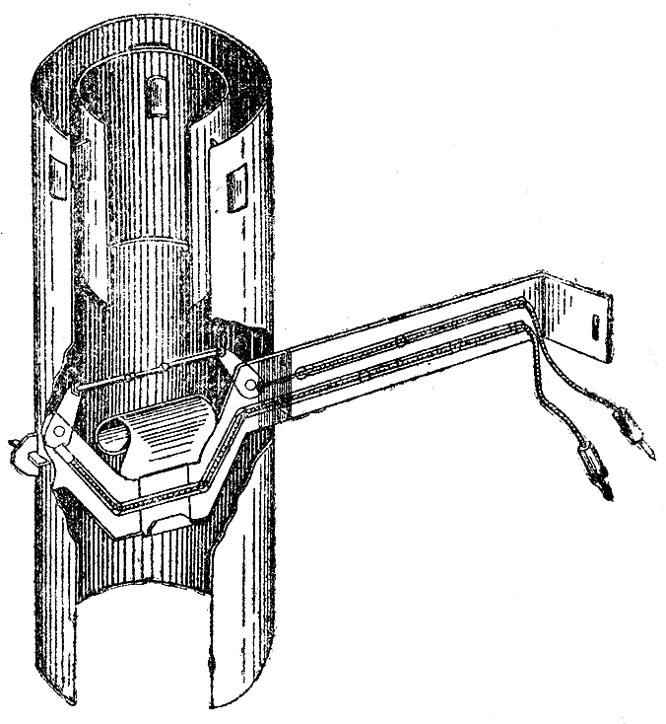
Figure 1. Louver protection for RZ-049. 1 – louver headband, 2 – lower panel | Figure 2. Protection of RKZ-1 thermal detector
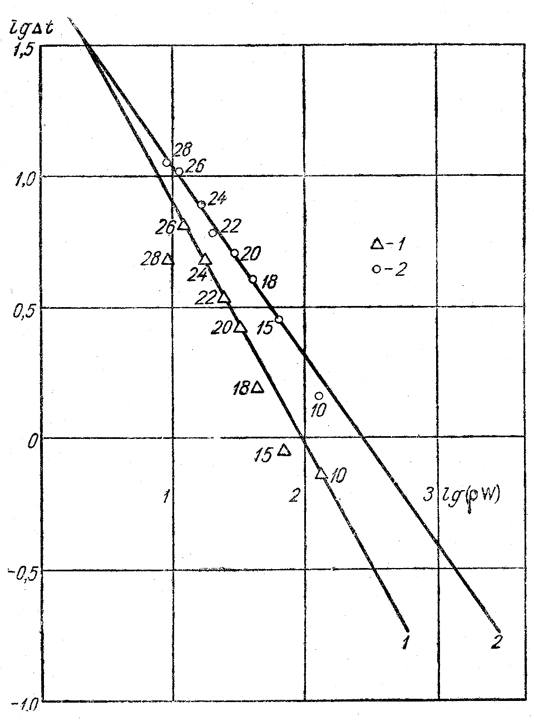
Figure 3. Dependence of lg Δt on lg (ρw). 1 – RKZ₂ (protected), 2 – RKZ₁ (unprotected).

