Metrological research into pressure measuring method
in atmospheric radiosounding

O.V. Marfenko

In atmospheric radiosounding, pressure at different heights (standard heights, singularity levels, heights of standard isobaric surfaces) is calculated by barometric formula rather than being measured directly by the system RKZ – Meteorite. The following formulas for the isothermal atmosphere are applied:
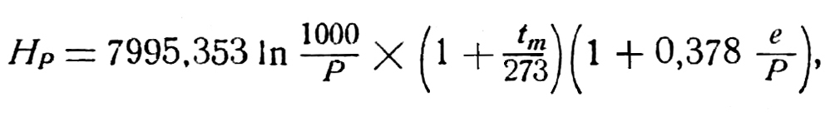 (1)
or
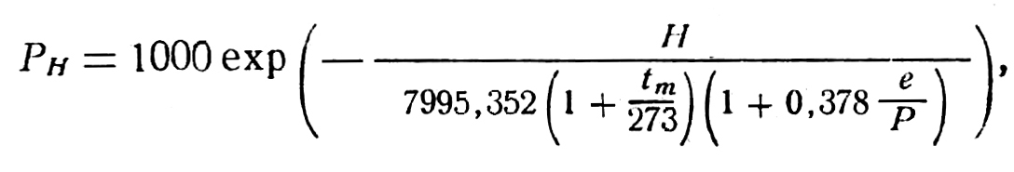 (2)
where H_{p} is the height of the pressure P in geopotential meters; t_{m} is the mean temperature of the layer from 1000 hPa to P°C; e is the water vapour pressure (hPa). Numerical coefficient 7995.352 (barometric constant) is derived from the relation 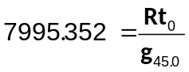, where R is the specific gas constant of dry air which is equal to 287.039 m²/(°C · c); t₀ = 273.15 K; g_{45.0} is the free-fall acceleration at the sea level and 45° latitude that is equal to 9.80665 m/s². Numerical values of constants and parameters that are adopted in the above formulas correspond to State Standard 4401-73.

A possibility of using the formulas for the non-isothermal atmosphere is connected with the division of the entire layer under sounding into separate layers, which allows the mean temperature of each layer (that is taken constant) to be calculated with required accuracy.

The application of dynamic heights, which makes unnecessary taking into account the dependence of free-fall acceleration on the actual height z and the latitude φ, is the requirement of the weather reporting service, since constant pressure maps are plotted on its basis. By convention, the geopotential 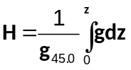; therefore, the z dependence of H is described by the expression

(3)

In developing a procedure of measurements by a definite radiosounding system, specifically, in solving the problems of its metrological support, the issues arise that are related to the practical application of barometric formulas. These issues include: selection of initial data to calculate the height pressure, possibility of using approximation formulas, requirements for a set of metrological characteristics of measuring instruments of the sounding system that are related to the application of barometric formulas, etc. Below are the procedure and results of research into a number of the most urgent issues of the pressure processing procedure that are related to the application of barometric formulas.

As seen from expressions (1) – (3), initial data to calculate the values of the geopotential of isobaric surfaces and pressure at the assigned levels can be represented by the measured values of pressure, temperature and humidity or the measured values of the radiosonde flight actual height, temperature and humidity that are used to calculate pressure at the assigned levels.

If a sounding system makes it possible to measure pressure and radiosonde flight height independently, the question arises as to selection of the processing method. It is clear that the question is settled by considering the accuracy of the both methods.

The expression of the geopotential limiting error is found as a differential of (1) at P=const. According to [3], this expression written as a finite-difference equation has the following form, if calculated from the measured values P and t_{V}:
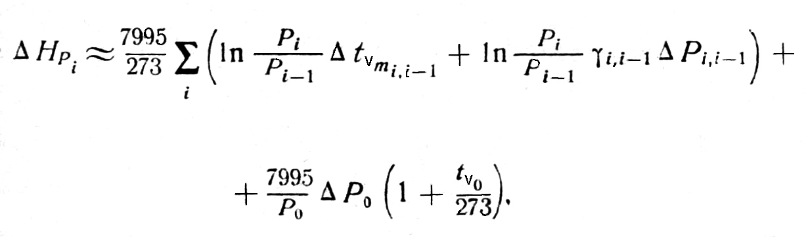 (4)
and the following form, if calculated from the measured values H and t_{B}:
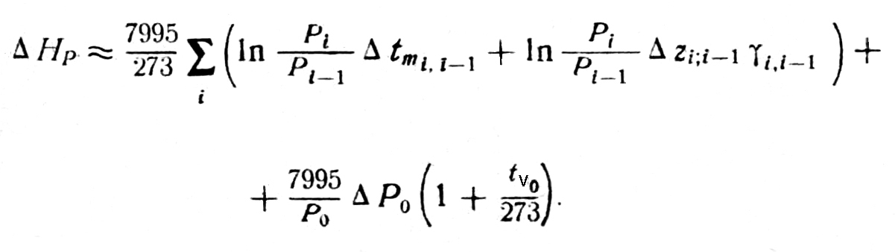 (5)
Here P₀ and t_{V0} are the ground pressure and virtual temperature, respectively (hPa, °C); t_{Vm} is the mean virtual temperature (°C); ΔP is the pressure measurement error (hPa); γ is the temperature lapse rate (°C/m); Δz is the radiosonde flight error determined from data on elevation angle and slant range distance measured by radar (m); h is the pressure step (m/hPa); the index i characterizes the processing layer.

From comparing (4) and (5) it is seen that the difference between the errors obtained by the two processing methods is determined by the difference between hΔP and Δz that are included in the second terms of the equations; hΔP is the radiosonde flight elevation error caused by the error in the pressure measurement performed by the radiosonde barometric node. Taking into account the fact that the overall elevation error is described by the expression ΔH≈ hΔP+h₀ΔP₀+ ΔH_{P} [3], it is evident that hΔP is a determining term.

It follows that the selection of the pressure processing method (selection of initial data), as well as the problem of the necessity of the radiosonde barometric unit, other things being equal, are solved by the comparison of the accuracy in determining the radiosonde flight elevation by barometric and radar methods in each specific sounding system.

Table 1 shows limiting values of standard errors in determining the radiosonde flight elevation (radiosonde of type RKZ), σ (Δz), from radar measurements of slant range distance D and elevation angle δ at σ (Δ δ) = 0.18° and σ (ΔD) = 60m. The Table also presents errors in measuring pressure by barometric node which yield errors in elevation measurement by barometric method that are found from the relation 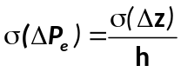.
Table 1

If it is remembered that standard errors of barometric nodes of modern radiosondes are at the best case no less than 1.5 – 2 hPa, it is seen from the data given that stratospheric heights determined from radar measurements will be sufficiently more accurate than those determined by barometric method, while in the troposphere, the heights determined by barometric method will be more accurate. From the data presented it is also seen that in the stratosphere, the radar method of elevation measurements will remain prevailing in the near future, too. In the troposphere, to improve the elevation measurement accuracy, it is reasonable to use a barometric node.

As for the system Meteorite – RKZ, taking into account the fact that standard errors of pressure measurements by barometric node of RKZ-1A radiosonde are 8 to 4 hPa [2], the radiosonde flight elevation determined from radar data is more accurate than that determined from barometric data both in the stratosphere and troposphere. Therefore, it was decided to remove barometric nodes from radiosondes of type RKZ.

As to the selection of the method of calculating pressure distribution over heights, it is reasonable to consider the possibility of the direct pressure measurement, provided that independent measurements of radiosonde flight elevation and pressure (dynamic pressure) are available.

In this case the limiting error of pressure surface heights is described by the expression 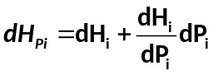 or by the finite-difference equation ΔH_{Pi} = ΔH_{i} + h_{i}ΔP_{i} .

The column σ (ΔHP_{dune}) in Table 1 shows errors in determining pressure surface heights by direct method. These errors are calculated for the case when the standard error of pressure measurement by barometric node is equal to
2 hPa and the error in determining the radiosonde flight elevation is indicated in the column σ (Δz).

From the comparison between σ (ΔHP_{dune}) and σ (ΔH_{P}) it follows that to provide a present-day accuracy in determining the pressure surface heights with direct pressure measurements, it is required to have: (1) barometric node whose error is not higher than 0.1 hPa over the entire range of pressure measurements and (2) radiosonde flight elevation measurement to an accuracy of not higher than 0.5 m in the lower atmosphere and 50 m at the 30-km height. This is hardly feasible in the near future.

In the radiosounding practice, particularly with manual data processing, of no small importance is the application of approximation barometric formulas that allow the time required for the primary results processing to be reduced. It is clear that the problem of using one or another approximation is solved from estimating the error added by the approximation to the overall error in determining pressure surface heights by the radiosounding system considered.

With sounding by radiosonde RZ-049, a barometric formula for dry air was applied to pressure processing. This was rightful, since errors in air temperature measurements by radiosonde RZ-049 were at least twice as high as those obtained by radiosondes of RKZ and A-22 types [1, 6]. Depending on the height, standard errors varied from 1.2 to 4.0°, with these being systematic for the individual sounding. Again, before 1957, no radiation corrections had been applied to radiosonde temperature measurements. As a result, because of ignoring air humidity, errors in determining pressure surface heights were significantly lower than those due to inaccurate air temperature measurements.

With measurements made by systems Meteorite – RKZ and Malakhit – A-22, errors in determining pressure surface heights, due to ignoring air humidity, attain 100% of the method error, which requires application of a more accurate barometric formula that would take air humidity into account [4].

In sounding by system Meteorite – RKZ, primary measurement data, as was mentioned above, are represented by the actual height of radiosonde flight, air temperature and air humidity. To calculate the heightwise pressure in accordance with (2), we are to know the dynamic height connected with the actual height by relationship (3), rather than the actual height. Naturally, the conversion of the actual height into the dynamic one requires additional time, which is not desirable with manual data processing.

Evaluate the error that is to be added to the calculation of heightwise pressure because of ignoring the difference between actual and dynamic heights. According to (4), this error is determined by the following expression:
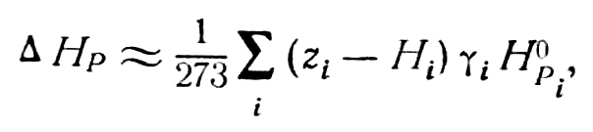(10),
where 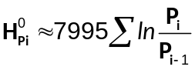 is the hypsometric height of the pressure P_{i}.

Table 2

These errors at different levels are presented in Table 2. If we compare these values with standard errors in determining pressure surface heights that are caused by errors in measuring air temperature and radiosonde flight elevation σ (ΔH_{P}) (see Table 1), these will prove to be an order of magnitude less; thus, this error can be neglected. Processing from dynamic height is recommended for equatorial latitudes only [5], taking into account a weak variability of meteorological parameters in these regions.

The introduction of the new standard atmosphere (State Standard 4401-73) also made it necessary to specify the pressure processing method. Since 1950, pressure surface heights have been calculated by using hypsometric tables calculated by Bergun from barometric formula based on the barometric constant equal to 8000 (R=287.04 m²/(°C·c); T=273.16 K; g_{45.0}=9.8). This constant was also used to construct the circle A-57. State Standard 4401-73 established new values of constants, which also gave rise to the change in barometric constant that is now equal to 7995.352. The calculation showed that processing from the previous barometric constant causes systematic geopotential errors equal to 4 m at the 500-hPa level, 12 m at the 100-hPa level, 25 m at the 10-hPa level, and 48 m at the 5-hPa level, which is 50 to 35% of the method error. In this connection, it was required to re-calculate hypsometric tables and develop the new logarithmic circle A-57M to compute heightwise pressure.

Application of barometric formulas to calculate heightwise pressure sets a number of general requirements for metrological characteristics of measuring means of the sounding system. As is known, one of the major requirements for metrological support of measurements is a possibility of reliable assessment of their accuracy. In atmospheric radiosounding, we are to estimate the information results of sounding that are incorporated in aerological telegrams, including the estimate of accuracy in determining pressure surface heights from expression (4). From analyzing this expression it follows that the accuracy in determining pressure surface heights is largely affected by systematic errors in measuring air temperature and radiosonde flight elevation. The effect of random errors is removed by dividing the layer under sounding into a sufficiently large number of subsequently processed layers.

If it is also remembered that the aerological information is used by the World Weather Watch and the information obtained by national meteorological services requires convergence assessment, to estimate the accuracy in determining pressure surface heights, the set of the rated metrological characteristics of the radiosounding system should include maximum permissible values, mathematical expectations, and standard deviations of systematic errors of radiosonde air temperature and humidity measurements and radiosonde flight elevation measurements.

The estimates presented above allow the following conclusions to be made: (1) to determine pressure geopotential in atmospheric radiosounding by systems Meteorite – RKZ, the barometric formula can satisfactorily be applied to the isothermal atmosphere and humid air by using the actual height of the radiosonde flight that is determined from radar data, as well as values of the constants according to State Standard 4401-73; and (2) to improve the geopotential accuracy, it is necessary to develop a radiosonde with a barometric node and to use the integrated pressure processing method (calculation of geopotential from air temperature, air humidity and air pressure radiosonde measurements in the troposphere, from air temperature and air humidity radiosonde measurements and from radiosonde flight elevation determined from radar data in the stratosphere).

References

1. Marfenko, O.V. Random errors of radiosonde RZ-049. In: Proc. of CAO, 1954, No.22, pp.35-39.

2. Marfenko, O.V. Random errors of meteorological elements measurements in the free atmosphere by radiosondes A-22-III and RKZ-IA. In: Proc. of CAO, 1962, No.43, pp.35-41.

3. Marfenko, O.V. Estimating the accuracy of radiosounding results in the upper-air network of the Soviet Union. In: Meteorol. and Hydrol., 1969, No.3, pp.14-21.

4. CAO Guidelines. Moscow, Gidrometeoizdat, 1968, No.39, pp.3-5.

5. CAO Guidelines. Moscow, Gidrometeoizdat, 1977, No.47, pp.4-8.

6. USSR hydrometeorological network observations. In: Definition of Concepts of Hydrometeorological Elements. Estimating Observation Accuracy. Ed. O.A. Gorodetsky. Moscow, Gidrometeoizdat, 1970, pp.26-37.

