Proceedings of the Central Aerological Observatory
- Issue 102

Some specific features of temperature measurements by radiosondes at high altitudes.

M.B Fridzon, V.I. Shlyakhov

Temperature sensors, used in the current-day radiosondes to measure air temperature, have a number of deficiencies, the most significant of which is the existence of radiation errors. At high radiosounding altitudes it is necessary to consider more seriously radiation processes occurring when air temperature is measured by thermometer.
In the lower atmosphere with the intensive convective heat exchange, differences between the temperature of thermometer and the temperature of the ambient air are not considerable. But at the altitudes higher than 25-30 km, where there is almost no influence of convection and radiation heat exchange plays a vital role, these differences increase significantly.
Due to this when considering the equation of heat balance of a radiosonde temperature sensor it is necessary to determine and strictly take into account the radiation members of the equation
The thermal state of thermoresistor (TR) moving in the atmosphere can be described by the following equation:

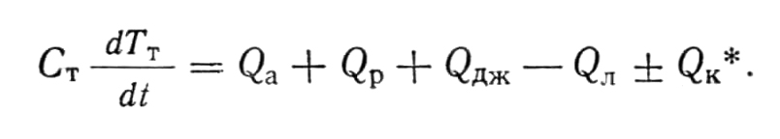 (1)

* C_{T} ─ total heat capacity of TR; Т_{Т} ─ temperature of TR; Т_{a} ─ air temperature away from TR; t ─ time; Q_{hcf} ─ heat convective flux toward TR; Q_{rhf} ─ radiation heat flux, absorbed by TR; Q_{j} ─ Joule heat, released when current passes through TR; Q_{hfs} ─ heat flux from the surface of TR; Q_{hfcw} ─ heat flux through contact wires of TR (current-conducting wires); F_{dr}, F_{grr}, F_{lwr} ─ fluxes of direct solar radiation, ground-reflected solar radiation and long-wave ground radiation respectively; F_{drb}, F_{grb}, F_{lwb}, ─ fluxes of direct radiation, ground-reflected radiation and long-wave radiation reflected from radiosonde body respectively; α_{Т} ─ coefficient of convective heat exchange of TR; φ_{Т,dr}, φ_{Т,lwg}, φ_{Т,lwb} ─ coefficient of irradiance of TR by direct solar radiation, long-wave ground radiation and long-wave radiation reflected from radiosonde body respectively; ε_{Т} ─ emissivity of TR surface; ε_{λ} ─ spectral emissivity of TR surface; А_{Т,dr}, А_{Т,grr}, А_{Т,lwr} ─ albedo of TR surface (cover) with respect to direct, reflected and long-wave radiation; А_{Т,drb} , А_{Т,rb}, А_{Т,lwi} ─ albedo of TR surface (cover) with respect to reflected from radiosonde body direct and reflected radiation and to long-wave irradiance of radiosonde body respectively; U_{Т} ─ voltage across TR; R_{Т} ─ electric resistance of TR; S_{Т} ─ surface area of TR; σ_{o}─ 5.67 ∙ 10⁻⁸ W/m²: ºK⁴ ─ Stefan-Boltzmann constant; r ─ radius and l ─ length of a respective component of temperature sensor; h ─ thermal conductivity of the material; Re, Nu and Pr – criteria of Reynolds, Nusselt and Prandtl respectively; W_{λ} ─ distribution of spectral energy emitted into hemisphere by Planckian emitter with unit surface area; H_{c} ─ absorbing capacity of cover with respect to solar radiation.

Solution of Equation (1) with respect to air temperature T_{а} after appropriate evaluation of values of some members can be written as follows.
- For the temperature measurement unit of the RKZ-2 radiosonde (Figure 1).

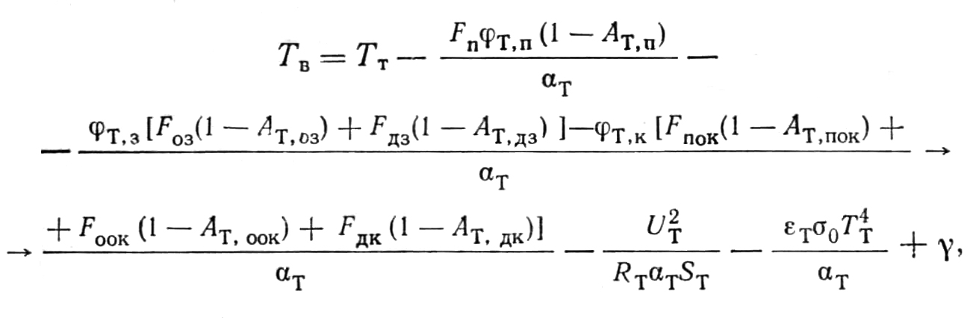 , (2)

where

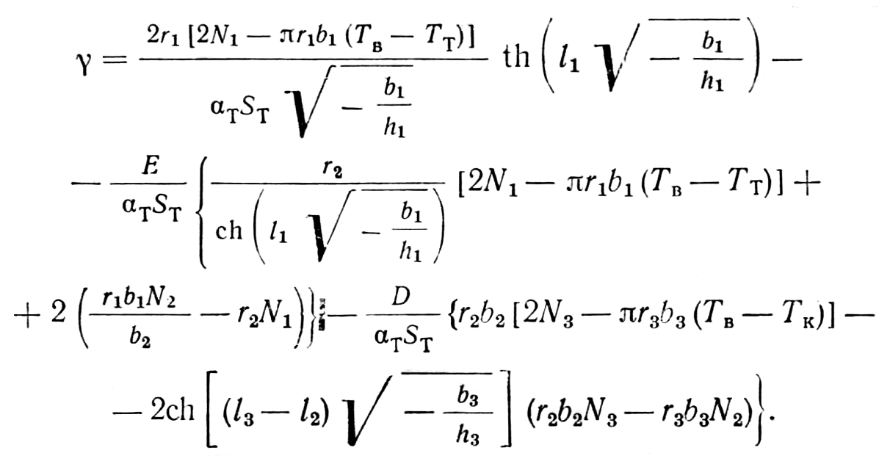 . (3)

Further,

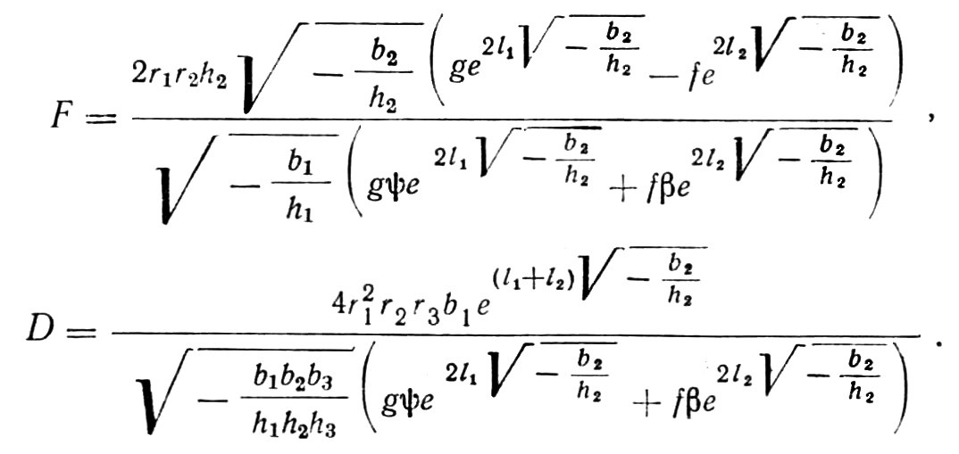 . (4)

Values Ni are equal to

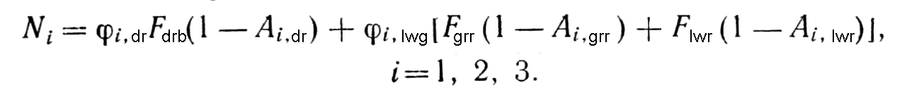 . (1)

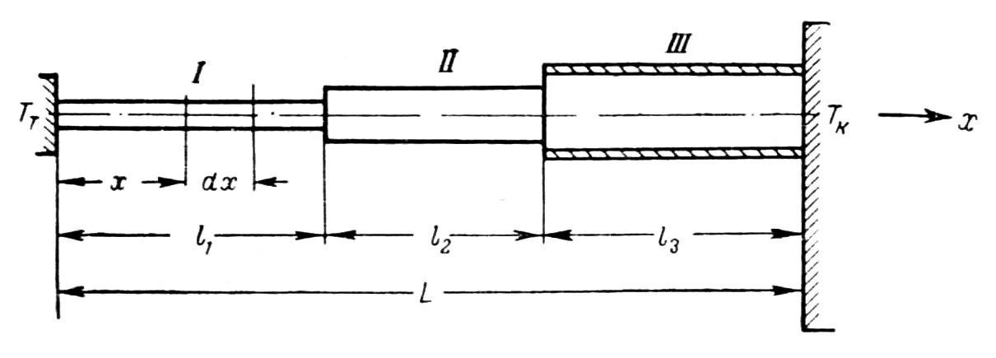
Figure 1. Heat balance diagram of the RKZ-2 radiosonde temperature sensor.
I ─ current-conducting wire of TR; II ─ armature of temperature sensor; III ─ covered electric wires running to armature from the radiosonde body.

Parameters g, f, ψ and β are expressed as follows:

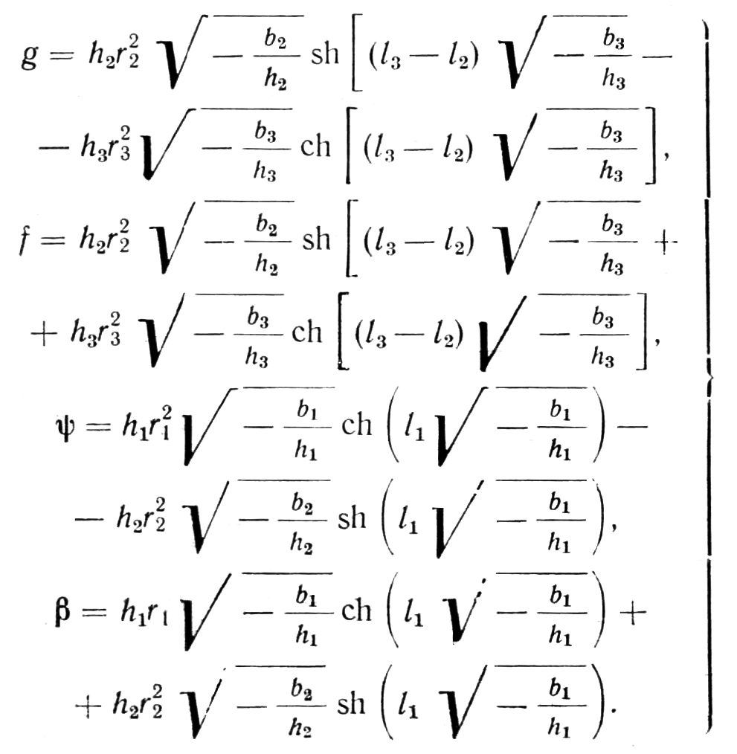 . (5)

And finally,

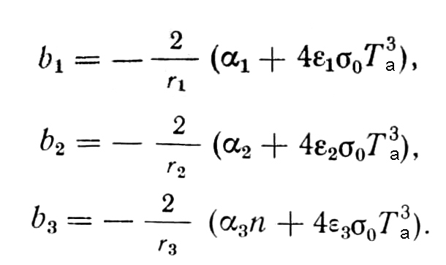 . (6)

Factor n, which is included in coefficient b₃, characterizes the influence of electric wires cover on heat transfer. It is determined by solution of the equation of heat conductivity of cylinder-shaped wall and equals to

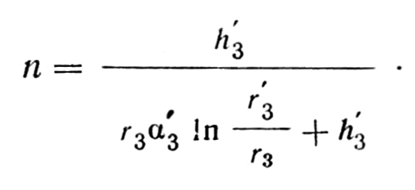 . (7)

B. For 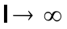

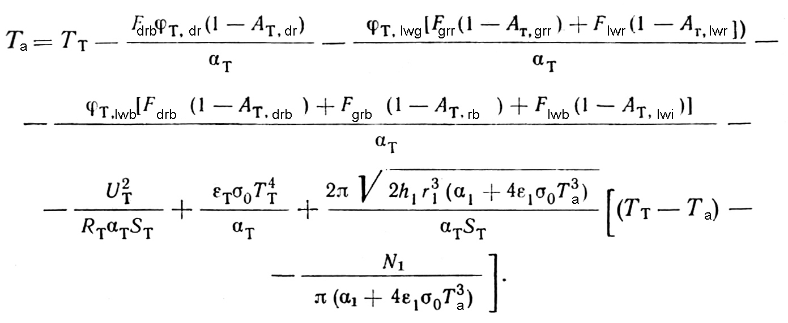 . (8)

С. For Q_{hfcw} = 0

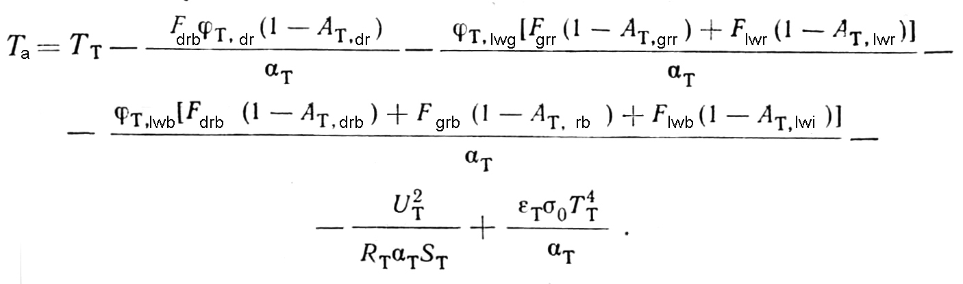 . (9)

At that, index «т» shows that this value relates to TR. Indices «1», «2» and «3» show that the value under consideration relates to the appropriate component of a temperature sensor.
These expressions include coefficients of convective heat exchange α. Usually they are computed by the well-know criterion equations connecting parameters of Nusselt, Reynolds and Prandtl [1]:

with

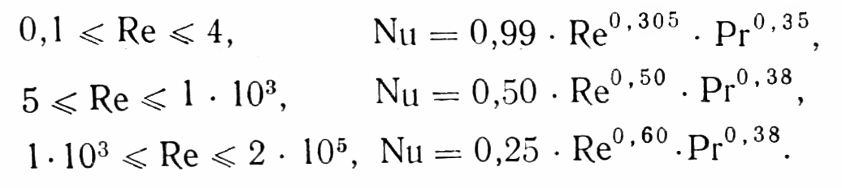 . (10)

The applicability of criterion equations (10) for computing coefficients of heat exchange for TR of MMT-1 and MMT-6 type used in radiosondes of the USSR Hydrometeorological Service was investigated by two ways: 1) by high vacuum wind-tunnel test of TR in transverse air flow, and 2) with the help of special rotation device [2], which allows the airflow over TR during radiosonde ascent to be simulated. It was shown that in the range of Reynolds numbers 4÷1∙10³ coefficients of heat exchange for TR of MMT-1 and MMT-6 type can be obtained from Equations (10) with the largest relative error, which does not exceed 10%. To compute coefficients of irradiance of TR φ from radiosonde body, graphical calculations were applied on the basis of the “cylinder-shaped illumination at a point” concept used in illumination engineering [3].
The values of reflectivity (albedo) A and emissivity ε in Equations (2), (8) and (9) defining the thermal state of termoresistor in measurement of temperature at high altitudes have not been determined previously for most of materials and covers used in aerology.
To compute these values efforts have been taken to study diffused spectral reflectivity of some materials and covers in the spectral range of 0.25÷15.0 um and to summarize data available in literature on the spectral structure of radiation fluxes affecting thermoresistor of radiosonde.
Coefficients of diffused reflection of materials in the spectral range of 0.25÷1.40 um were measured by the spectrophotometer SF-4 with an attachment in the form of ellipsoid. In the spectral range of 0.7÷15.0 um measurement were made by IR spectrometer IKS with an attachment in the form of hemisphere [4]. Direct solar radiation was considered in the range of 0.25÷7.0 um, reflected radiation ─ in the range of 0.29÷3.0 um and long-wave ground radiation ─ in the range of 5.0÷15.0 um.

Results of computations are presented in [5].
The total emissivity ε was computed by the following formula

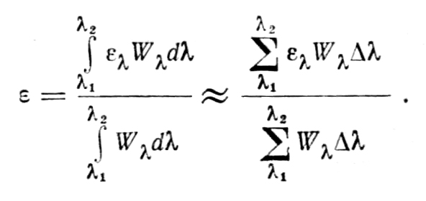 . (11)

It is reasonable to analyze the state of radiosonde TR by the example of the most simple case, when Q _{hfcw} = 0, i.e. when there is no heat loss to conductors. This case, with the least labour intensity of computations, allows us to obtain the dependence of TR thermal state on conditions of measurement with various radiation properties of its surface. Computations by equation (9) have been made under the following conditions: rate of airflow over TR ─ 4.5 m/s; underlying surface ─ solid cloud cover with the mean albedo; altitude temperature variation ─ standard atmosphere scale (USSR State Standard 4401-64); position of TR MMT-1 ─ horizontal, across the airflow; power in TR generated by operating current ─ 360 mcW (radiosonde RKZ-2).

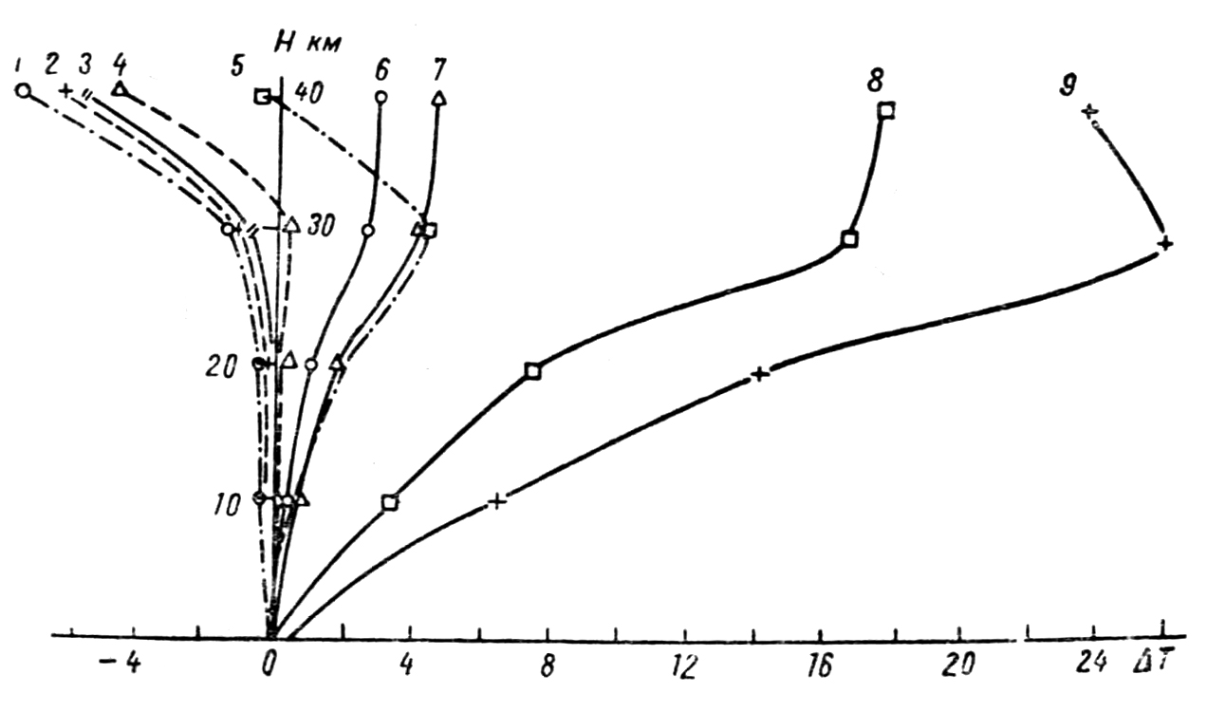
Figure 2. Dependence of the overheating value (∆T = T_{T} ─ T_{a}) of TR MMT-1 (Q_{hfcw} = 0) with various covers on the altitude above sea level at day time under average radiation conditions.
TR cover: 1 ─ magnesium oxide; 2 ─ barium sulphate; 3 ─ white enamel VL-548; barium sulphate covered with celluloid film; 5 ─ white enamel NTs-25; 6 ─ silver; 7 ─ aluminium; 8 ─ chromium; 9 ─ black enamel 1519.

Results of TR overheating (∆T = T_{T} ─ T_{a}) computations under day-time conditions and at solar elevation of 45º are presented in Figure 2. From Figure 2 first of all we see that the thermal state of TR depends considerably on radiation properties of its surface (cover). For instance at the altitude of 30 km the difference in overheating of TRs covered with magnesium oxide and black enamel is as large as 27ºC, and at the altitude of 40 km it is 32ºC.
It is interesting to see how curves of overheating of TRs with different covers change with altitude. Whereas up to altitudes of 20-25 km the difference in overheating of TRs is still possible to explain only by the difference in absorbing capacity of their covers, at higher altitudes it is not possible. At altitudes higher than 25-30 km the intensity of solar radiation falling on TR remains almost unchanged and changes in convection heat transfer driven almost entirely by pure conduction [6] are very small. Against this background a rapid increase of the absolute ambient temperature is observed. Hence, right here such property of TR surface as emissivity begins to play the most important role in generating TR thermal balance. In Figure 2 we can see that beginning from heights of 25-30 km the value of overheating of metal-coated TRs (emissivity is close to zero) becomes nearly constant. For TRs with dielectric cover (emissivity is about 1) a considerable increase of heat transfer is observed as well as reduction of overheating transforming into cooling.
The quantitative ratio between absorbing capacity (with respect to solar radiation) H_{a} and emissivity (ε) of TR cover determines the altitude in the atmosphere, at which radiation heating of TR reverses the sign. For instance for the magnesium oxide cover (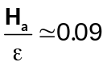) radiation cooling already near the Earth surface is typical, while for white enamel NTs-25 the value of overheating crosses zero at the altitude of about 40 km. To this effect in sounding the atmosphere with radiosondes it would be well to have several temperature sensors with different covers for accurate measurement of temperature at various altitudes.
It should be noted that for the first time radiation heating of MMT-1 TR up to the altitude of 30 km was computed in [7]. Moreover when initial data were similar, the results were in good agreement. However, addressing this problem with consideration to spectral characteristics of reflectivity and emissivity of covers as well as spectral properties of downward radiation resulted in significant clarification of characteristics of physical processes occurring in sounding of the atmosphere with thermoresistors.
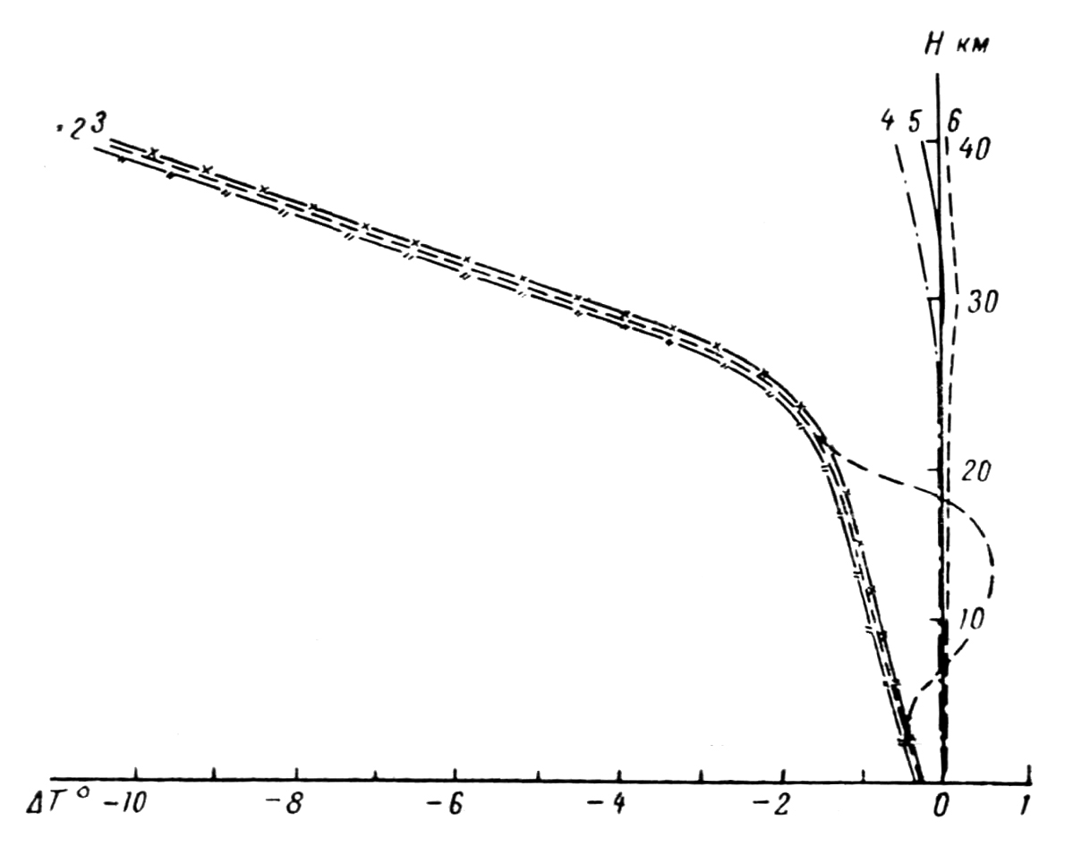

Figure 3. Radiation overheating (cooling) (∆T = T_{T} ─ T_{a}) of MMT-1 TR (Q_{hfcw} = 0) at night time.
TR cover: 1 ─ magnesium oxide; 2 ─ white enamel VL-548; 3 ─ barium sulphate, enamel NTs-25 and enamel 1519; 4 ─ chromium; 5 ─ aluminium; 6 ─ silver.

Radiation overheating (cooling) of TR at night time is presented in Figure 3. Computations were made under conditions similar to those mentioned above. From Figure 3 it is seen that curves of overheating for metal-coated TRs are grouped around zero. Moreover for such metal as chromium (ε ≈ 0.07) even overcooling is observed at the altitude of 40 km amounting to 0.5ºC.
For TRs with dielectric covers considerable cooling due to their self-radiation is observed. As at day time overcooling is increased considerably at altitudes of 25-30 km, just where the increase of an absolute ambient temperature begins. At the altitude of 40 km overcooling can reach 10ºC and at the altitude of 30 km ─ 5ºC. In [8] similar results were obtained for the US TR.
Considering the above and taking into account specific features of manufacturing sensors, when sounding is performed at altitude of up to 40 km it is recommended to use white enamel VL-548 as anti-radiation cover at day time and aluminium at night time. For altitudes higher than 40 km metal cover for TRs must be used.

References

1. Zhukauskas A.A. Cylinder cross-flow heat transfer. “Heat transfer and heat modelling”. Academy of Sciences of the USSR, 1959, pp. 201-212.

2. Fridzon M.B., Shlyakhov V.I. Yurchuk V.A. Device for rotation of thermoresistors without interruption in the measuring circuit. Proceedings of CAO, Issue 84, 1968.

3. Gutorov M.M. Graphical method of determining average cylinder-shaped illumination from large luminous surfaces. Illumination Engineering, No 3, 1964.

4. Kozyrev B.P., Vershinin O.E. Determination of spectral coefficients of infrared radiation diffused reflection from blackened surfaces. Optics and Spectromentry, Vol. 6, Issue 4, 1959, pp. 542-549/\.

5. Fridzon M.B., Shlyakhov V.I., Ilyasov C.G. Albedo of some materials and covers. Meteorology and Hydrology, No 8, 1969, pp. 100-106.

6. Yakob M. Issues of heat transfer. IL, M. 1960.

7. Kostyanoy G.N. Radiation errors in measurement of temperature in free atmosphere by thermoresistors of MMT-1 and KMT-1 type. Proceedings of CAO, Issue 45, 1962.

8. Ney E.P., Maas R.W., Huch W.F. The measurement of atmospheric temperature. Journ. Meteorol. 1961, Vol. 18, No 1, pp. 60-80.

