Proceedings of the Central Aerological Observatory
- Issue 60

Some additions to the “triple check” method. Accuracy of independent methods of determining the altitude of the radiosonde ascending system

P.F. Zaichikov

The article describes derivation of the general equation to check the systematic differences between pairs of methods generated from the combination of N>3 simultaneous methods of measurement of one and the same parameter. The accuracy of determining altitudes by five methods under consideration showed that barometric altitudes determined with the help of RZ-049 and A-22-III radiosondes are less accurate than the altitude determined by the radar technique. It also showed that barometric altitudes have a systematic overestimation error. The ways to identify the reasons of the systematic differences are considered.

In [1] the equation is given, which determines the value of variance (squared value of root mean square error) of each of N methods of simultaneous measurements or determination of one and the same parameter.
The equation is as follows:

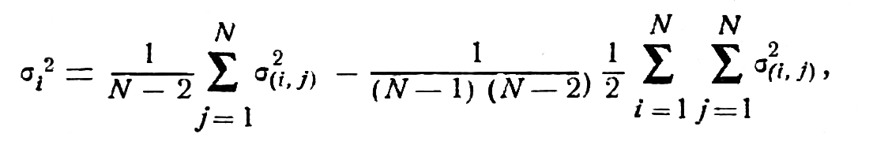 (1)

where σ_{(i, f)} ─ mean square differences of simultaneous measurements by two methods.
In the second member of the right hand side of Equation (1) by the half-sum of differences of a pair of observation methods taken from N and arranged in pairs, the actual and necessary combination of methods in pairs taken from N is represented, since the number of arrangements A_{N}² is twice the number of combinations C_{N}². Hence it can be written as

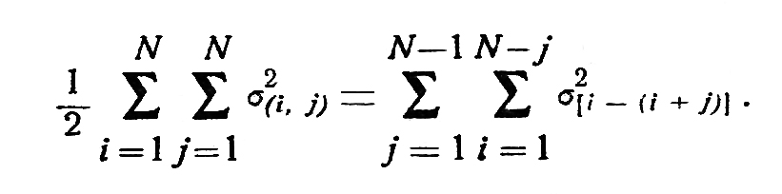

In this case Equation (1) will take the following form

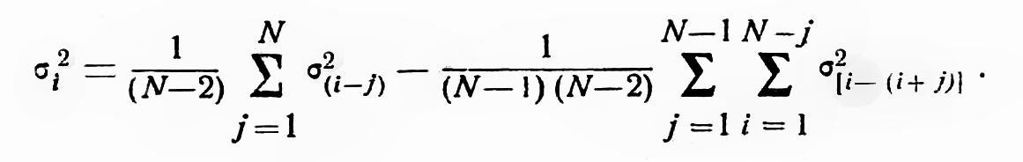 (2)

The essence of extending the “triple check” method from N=3 to N>3 of the compared methods participating in simultaneous measurements of one and the same meteorological parameter is that all of N>3 methods are divided into m groups of three generated from N and arranged in threes:

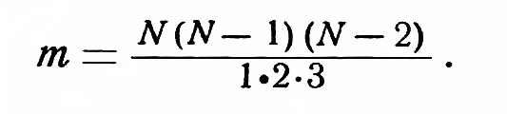

Then in each group we determine the value of error variance σ_{i}² of each method of measurement. It is known that one and the same method participates in several
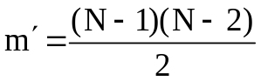 groups and gets m' different values of variances due to insufficient number of comparisons.
After that the mean variance is taken 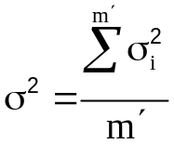 by which the root mean square error of the sought-for value is determined.
Equation (2) allows us to determine the sought-for variance directly omitting all complicated computations mentioned above.
Correctness of computing systematic differences for pairs, generated from combination two out of three, is checked in each group of threes by fulfillment of the equality

K_{(1─2)} + K_{(2─3)} ─ K_{(1─3)} = 0. (3)

This equality allows us to determine more exactly the systematic value of each pair if it is for any reason has been obtained on the basis of less number of comparisons than the other two pairs.
Due to the fact that with Equation 2 there is no longer any necessity to generate groups of threes from N, the need arises to give the general rule to determine correctness of determining systematic differences for individual pairs in case N>3.
To fulfill this task let’s consider some examples for cases N=4, N=5 and N=6.
For N=4 the number of groups of threes is

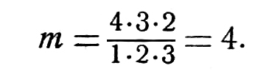
In each group the sums of systematic differences equal to zero. Therefore when adding systematic differences of all groups we should also obtain the sum equal to zero. We will write this in the indexed form only:

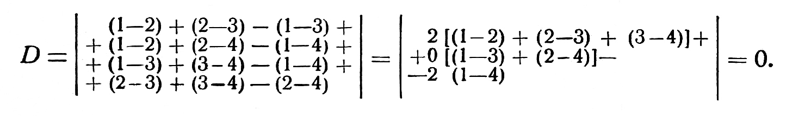
Obtaining in this way the sums of systematic differences in pairs for N=5, N=6, etc. we arrive at the general law of formulating an equation, which has the following form

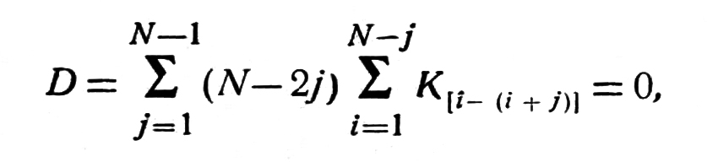 (4)

It is easily decomposed into lines j and columns i:

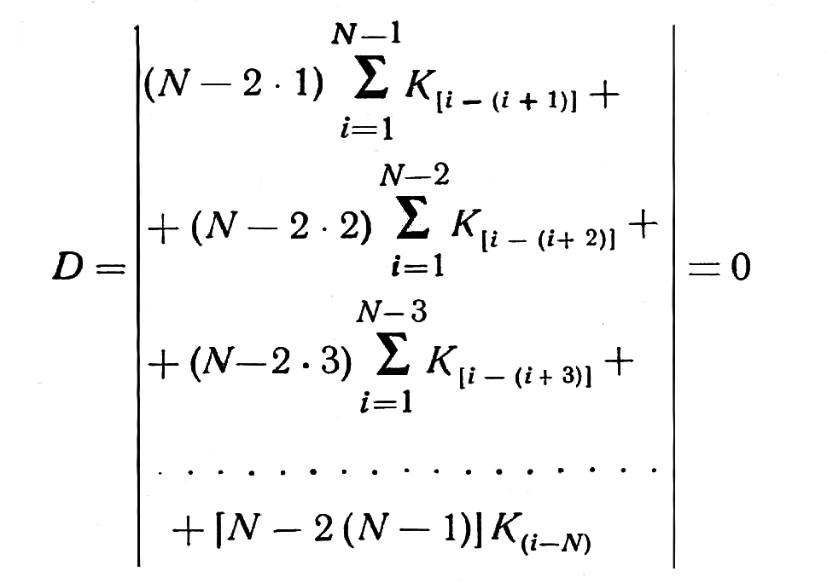
In the specific example for N=6 Equation 4 in the decomposed form will be as follows

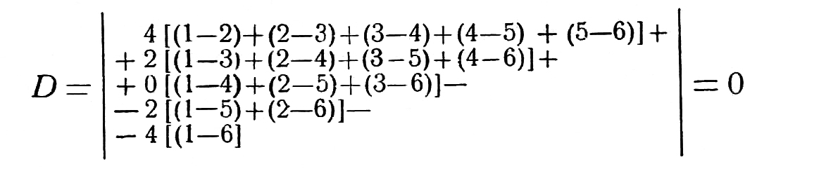
K is omitted everywhere

Systematic differences of all pairs, methods of measurement obtained in simultaneous measurements of one and the same parameter with a similar number of measurements should always satisfy Equation (4). Cases of unequal number of observations for some of pairs require further studies.

Accuracy of various methods of determining radiosone altitudes

In 1959 CAO conducted ascents of four radiosondes with one radiosonde ascending system consisting of 15 balloons No 159 fill with hydrogen and distributed over a 35-50-meter long suspension.
To this system a detachable parachute was suspended and to the parachute a light-weight crossed construction made of two 2-meter long arms (2.0 x 1,5 cm in section) was attached with the help of a twine trapezium. To the ends of the arms four radiosondes ─ A-22-III, RZ-049, RZ-049₂ and RKZ-1 ─ were fixed rigidly. All instruments therefore were at the same level relative to each other. The distance between the parachute and the instruments was about 15-20 m.
Signals were received from four radars: “Meteor”, Malakhit”, “Neptun” and “Son-2”. The process was timed by a stopwatch timer adjusted in advance.
This system ascending four radiosondes allowed us to determine one and the same altitude by five different methods simultaneously, i.e. by barometric method based on readings of the radiosondes A-22-III (1), RZ-049 (2), RZ-049₂(3), RKZ-1 (4) and by radar method (5). Hereinafter, figures 1, 2, 3, 4 and 5 will be used to specify these five methods.
The values of altitude simultaneous measurements by five methods taken from the appropriate data processing graphs are recorded into separate tables for altitude of 1, 5, 10, 15 and 20 km. To each table a sequence number and an appropriate level of altitudes were given. By way of example here only the tables for the level of 20 km are presented. These tables have numbers 1-20, 2-20, etc.
To increase a number of comparisons at each level, from each ascent of the system ascending four radiosondes, altitudes for three minutes were taken, for instance, the altitude close to 20 km was taken for the 58th , 60th , and 62nd minutes.
The total amount of the processed data included into the tables for the altitudes of 1, 5. 10, 15 and 20 km is 12, 13, 14, 10 and 8 ascents and 26, 39, 38, 28 and 24 measurements respectively.
Table 1-20 gives the values of simultaneous measurements of altitude by five methods at the level close to 20 km.
Table 2-20 gives differences between altitudes simultaneously measured by two methods combined by two out of five.

Table 1-20
Table 2-20

At the bottom of the table the arithmetic mean (systematic) differences between altitudes measured by two methods are computed.
By Equation (4) correctness of determining systematic differences for N=5 methods is checked. Decomposing Equation (4) by line j and columns i, we will obtain

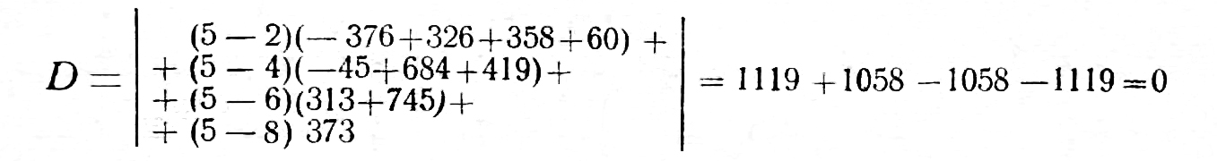
Mean differences between pairs are computed correctly.
Having excluded the systematic value from each difference of a given pair, we obtain random deviations from means, which are given in Table 3-20. At the bottom of Table 3-20 mean absolute values of random differences of pairs are given as well as their squared values η².

Table 3-20
Table 4-20

Table 4-20 gives squared values of random deviations of differences from mean values and at the bottom of the table squared values of root mean square deviations of paired differences from their mean values.
So the material for the triple check processing was prepared, which allows us to move from random difference of a given pair to random error of each method of measurement.
Computation is made with the help of the basic Equation (2). The first summand of the right hand side of Equation (2) equals to one third of the sum of squared values of random differences of pairs, comprising given pairs σ_{i f}² in the last but one line of Table 4-20 with indexes i = 1, and j = from 1 to 4, i.e. pairs 1─2, 1─3, 1─4, 1─5. The subtrahend in the right hand side of Equation (2) is the sum of all squared values of differences of pairs, presented in the last but one line of Table 4-20, divided by 12. This member, as seen from the equation, is common for all values of i.
Here is the computation of the value of root mean square errors in altitudes for each method of measurement according to data from Table 4-20:
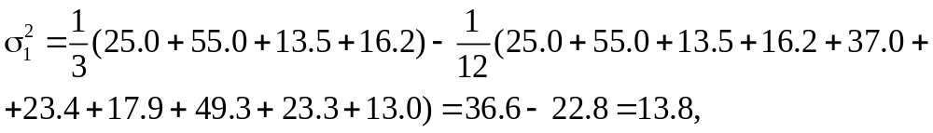

etc 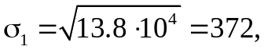

In the last line of Table 4-20 values are given, which characterize validity of mean or root mean differences. The value ∆²_{(i – j)} is determined by the following equation

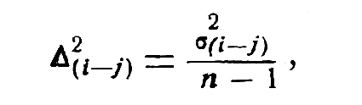
where n ─ number of comparisons.

The maximum error of mean ∆∆H_{i} is determined by solution of equations

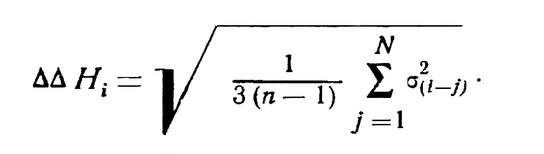
The systematic value of the error of each method of observation is determined by mean values given in Table 2-20. At that one of the methods is conditionally considered as a reference.

Table 5-20

In our case the altitudes measured by radar may be considered as a reference. This choice is justified by two considerations: the lowest value of random error (σ), independence of the radar-measured altitude from such constant factors as radiation overheating of temperature sensors contributing to overestimation of barometric altitudes. In processing of data radiation corrections to radiosondes were not applied.

Table 6-20

If the systematic error of the radar-measured latitude is taken as zero, inaccuracy will be smaller than if the mean latitude of five methods is taken as a reference, since it can be expected that measurements by the above methods are not free from systematic errors.
In Table 5 the final result of processing by triple check method is presented. It characterizes accuracy of altitudes measured by each method (altitudes of radiosonde ascents measured by each of five methods).
The table gives two main characteristics: 1) the systematic error of the method, the random value of deviation from the true altitudes; 2) the value of ∆∆H, characterizing validity of the results in view of the insufficient number of measurements.
As seen from Table 5 the radar (the radar “Meteor” was used) method appeared to be most accurate for determining altitudes of radiosonde ascents. Among barometric methods, the most accurate performance was demonstrated by RKZ-1, A-22-III ranked second and RZ-049 was the least accurate in all of its versions.
Relative to the radar-measured altitude all barometric altitudes have an increasing systematic overestimation error. Five methods of determining one and same altitude of the radiosonde ascending system allow for more robust analysis of the main sources of radiosonde errors. They also show the way of bringing barometric and radar-measured altitudes closer to each other and therefore making radiosonde data, used for constant pressure maps, more homogeneous. First it is necessary to determine what share in the overestimation of baromentric latitudes, compared with that measured by radar, is attributed to overheating of radiosonde temperature sensors, and what ─ to errors in barometric measurement of atmospheric pressure.
Table 6-20 gives values of air pressure for each synchronous point in time taken from the appropriate curves of pressure in the function of altitude and temperature P_{i} = f (H_{i} t_{i}). Pressure for the radar-measured altitude is taken from the curve P₁f(H₁t₁), i.e. the curve for the A-22-III radiosonde, which has the smallest radiation error (for the altitudes of 20 km it is about 1.5º). Therefore the mean temperature of the whole layer from the Earth surface to the altitude of 20 km will be overestimated by no more than 1ºC, or an error in altitude (∆H_{t}) will be 70 m.
Hence the difference between the А-22-III altitude and radar altitude will be determined only by difference in pressure.
The data given in Table 6-20 have also been processed by the triple check method and are presented in Table 7-20.

Table 7-20

Comparing mean errors in pressure with mean errors in altitudes for each method of computation we feel free to compute only altitude overestimation ∆H for radiozondes.
Hence we have an actual overestimation of barometric altitudes compared with radar-measured altitude. Accordingly we have systematic errors of the A-22-III, RZ-049, RZ-049₂ and RKZ-1 barometric units, and we know that systematic overestimation of altitude by A-22-III compared with radar altitude is caused only by systematic error of the barometric unit. Consequently it is possible to determine the mean value of barometric coefficients for the level of 20 km. It will be

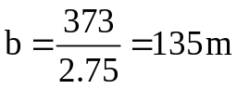

For RZ-049, RZ-049₂ and RKZ-1 it is possible to determine altitude overestimation using both error in pressure and systematic error in temperature in the middle of the layer from the Earth surface to the altitude of 20 km, i.e.

∆H = ∆H_{p} + ∆H_{t} ,
where
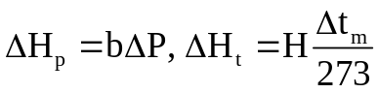

Table 8-20

Results of computation are presented in Table 8-20.
As is seen from data in Table 8-20 values of pressure measured by A-22-III and RZ-049 are systematically underestimated. This leads to overestimation of barometric altitudes compared with those measured by radar. Overestimation of barometric altitudes largely depends on errors in pressure measured by radiosondes.
There is an assumption (so far it has not been thoroughly checked) that the source of systematic underestimation of pressure by membrane pressure meter is connected with the absence of massing of a barometric unit before the lunch of instruments. This assumption requires further urgent investigation.

CONCLUSIONS

1. The triple check method used to study systematic and random errors in altitude measurement performed simultaneously by five different methods: barometric method with the help of four radiosondes and radar method with the help of the “Meteor” radar, showed that the “Meteor” radar had the smallest random error. At the level of about 20 km the random root mean square error of altitude measurements is ± 70 m with reliability of ± 100 m.
2. RKZ-1 showed the smallest random errors in barometric altitude compared with A-22-III and RZ-049.
3. Random errors in altitudes computed by the barometric method have a tendency for a considerable growth with altitude. This is in good agreement with the theory of errors related to barometric altitudes. The radar-measured altitude does not show such growth.
4. The systematic overestimation of barometric altitudes mentioned above go beyond the influence of temperature sensor overheating. Partly it is the result of systematic errors in measuring pressure by barometric units of radiosindes. But this issue requires further detailed and urgent investigation.

REFERENCES

1. Zaichikov P.F. Preliminary results of the 2nd International comparisons of radiosondes. Proceedings of CAO, issue 22, 1957.

