Preliminary results of processing of observations within the framework of the Second International Intercomparison of Radiosondes

P.F. Zaichikov

Introduction

Data of radiosonde readings from all countries of the world are used in synoptic practice. Radiosounding is conducted by different types of instruments with a different accuracy of measuring atmospheric parameters (pressure, air temperature and air humidity). To make the comparison of measurement results possible, the international comparisons of the readings of different types of radiosondes were conducted in 1950 and 1956 in Payerne, Switzerland. Examination of errors of each type of radiosondes also allows proposing new ways to further improve a method of atmospheric radiosounding.

The following countries participated in the Second International Intercomparison of Radiosondes that took place in May-June 1956: Belgium, West Germany, East Germany, the USA, Finland, France, Japan, India, England, Holland, Switzerland, and the USSR.

A procedure of comparison consisted in a simultaneous launch of four and more radiosondes of different types which were fastened to several hydrogen-filled balloons.

The amount of the data processed during this international intercomparison of radiosondes is shown in Table 1.

Table 1

In this Table, figures 1, 2, 3 … 12 stand for different types of radiosondes from different countries: 1 – Belgium, 2 – West Germany, 3 – East Germany, 4 – USA, 5 – Finland, 7 – Japan, 9 – Great Britain, 11 – Switzerland, and 12 – USSR.

Figures in the column-line crossing show the number of “meetings” of radiosondes from the two countries during twinned flights. For each pair, the number of diurnal and nocturnal flights is approximately the same. All the radiosondes reached the 100-mb height and about 90% of them, the 50-mb height.

It should be noted that the participants from Great Britain, Japan and Finland introduced corrections for radiation and inertia effects into the readings of radiosonde temperature detectors. The rest of the countries introduced no corrections into the readings of their instruments.

1. Procedure for processing of radiosonde readings under comparison

The problem of processing of radiosonde readings reduces to determining the type of the instrument that is distinguished by the highest accuracy of measurements. Taking the radiosonde that shows the smallest measurement errors as a reference instrument, you can estimate merits and demerits of the remaining types of radiosondes.

The accuracy of readings can be determined by triple control method¹ that allows objective determination of random errors of each type of radiosondes from the known errors of three radiosonde pairs comprising a combination of two types out of three.

The main point of the method is as follows.

Assume that true values of a meteorological element t₁, t₂ ...t_{n} are simultaneously measured by three types of radiosondes (1, 2, 3) with different measurement accuracy. In this case, the following radiosonde readouts are obtained:

by radiosonde of type 1 – A_{1,} A₂ … A_{n}
by radiosonde of type 2 – B₁, B₂ … B_{n} (1)
by radiosonde of type 3 – C₁, C₂ … C_{n}.

Each of the readouts contains a true value and a measurement error

A_{i} = t_{i} + a_{i}
B_{i} = t_{i} + b_{i}
C_{i} = t_{i} + c_{i}.

Series in (2) comprised of readouts (1), being differences of simultaneous pair readouts, represent measurement errors made by the appropriate pair

a_{i} – b_{i} a₂ – b₂ … a_{n} – b_{n}

b₁ – c₁ b₂ – c₂ … b_{n} – c_{n} (2)

c₁ – a₁ c₂ – a₂ … c_{n} – a_{n}.

The series in (2) can be classified from random and systematic differences of each pair.

__________
¹P.F. Zaichikov. Triple control method and its application to study radiosonde accuracy. Pro. of CAO, No.16, 1956.

For example,
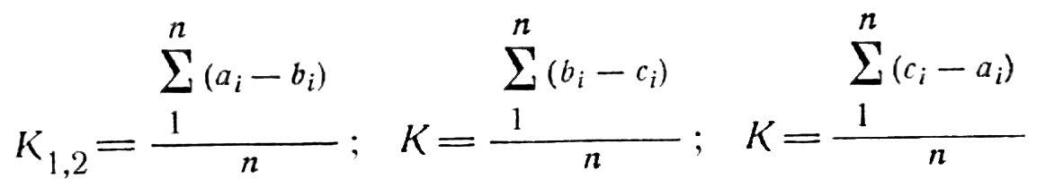

represent systematic differences of the pair indicated in the index of the value K.

Eliminating systematic differences from (2), we obtain random differences, after which it is easy to find their root-mean-square values σ_{1,2}, σ_{1,3} and σ_{2,3} or mean absolute values η_{1,2}, η_{1,3} and η_{2,3}. Then by applying the well-known statistical law to the random differences, we obtain three equations in three unknowns:

σ²_{1,2} = σ²₁ + σ²₂,

σ²_{2,3} = σ²₂ + σ²₃ and (3)

σ²_{3,1} = σ²₃ + σ²₁.

The solutions of equation (3) take the following forms:

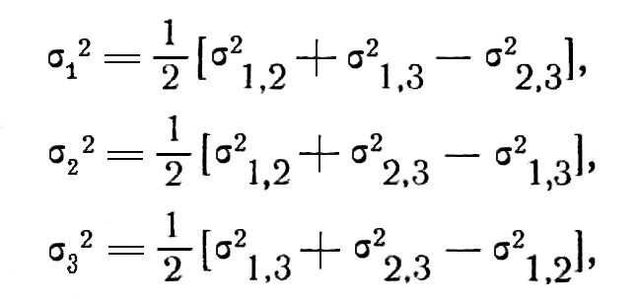 (4)

where σ₁, σ₂ and σ₃ are the root-mean-square random errors of radiosondes of types 1, 2 and 3. If the differences in square brackets are adjoined and subtracted by
σ²_{1,2} + σ²_{1,3}, σ²_{1,2} + σ²_{2,3} and σ²_{1,3} + σ²_{2,3}, respectively, expanded equation (4) can be written in the general form as follows:

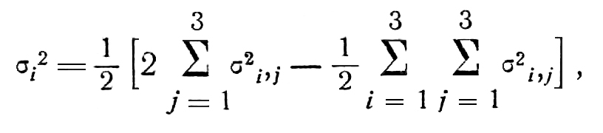 (5)

where i is the radiosonde type 1, 2 and 3.

The same equation can also be written for the mean absolute difference η that is known to be connected with σ by the relation

σ = 1.25 η.

If N radiosondes of different types, rather than three, are compared, to be processed by triple control method, these are to be divided into groups including three types and to solve each group separately. In this case, each radiosonde type is determined from 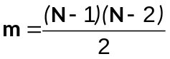 of individual equations of type 5. The most accurate value η_{i}² will be represented by ‾η_{i}² , the mean of their m different values that deduces the following formula:

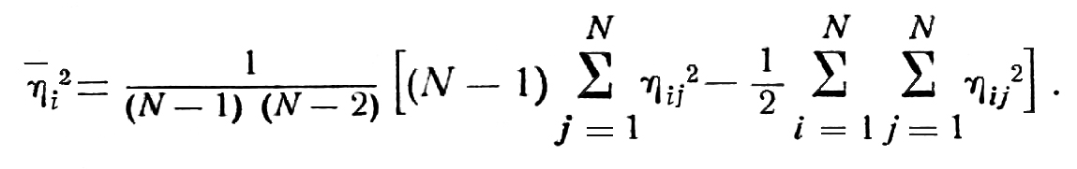 (6)

By using equation (6), you can reduce time-consuming intermediate calculations of η₁² in each group.

2. On reliability of determining errors of different types of radiosondes

Reliability of determining radiosonde errors depends on the accuracy in determining root-mean-square and mean absolute differences of the two radiosondes of different type.

The accuracy in determining the differences of the errors of radiosonde pairs depends on the number of observations included in calculations of the means of each pair. With a fairly large number of twinned observations, there is no point in making simultaneous observations by using all instruments.

The error in the mean that can somewhat distort the random value η is described by the equation

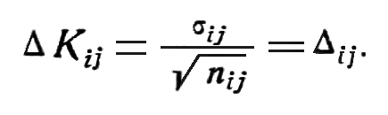 (7)

The error in the mean absolute error of the radiosonde pair affects the mean absolute error of each type of the instrument, as seen from the equation similar to (6)

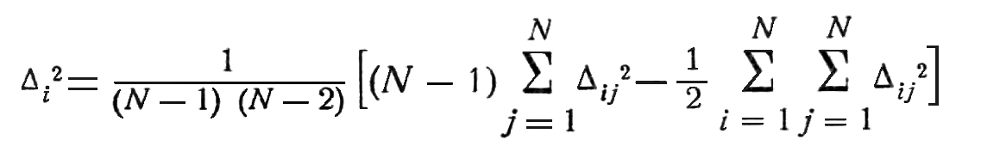 (8)

or

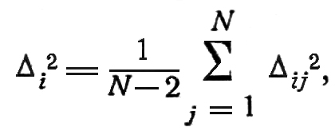 since 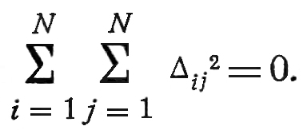

As seen from formula (8), the accuracy of the random error also depends on the number of the radiosonde types compared.

3. Accuracy of pressure level determination

We have applied a triple control method to determine a random error in determining pressure levels without separating diurnal and nocturnal observations.

Radiosonde comparisons based on pressure levels are desirable for the following reasons:

1. Pressure levels are used in synoptic practice. They do not directly depend on the errors of the radiosonde barometric node. They only depend on the errors in measuring the mean temperature of the layer in determining which of some significance is the accuracy of the air pressure measurement.

2. Pressure levels do not depend on the radiosonde position in the system of the radiosondes launched.

Inertial and radiation errors of temperature detectors are the major factors that determine both random and systematic errors of pressure levels. Therefore, it would appear reasonable that the radiosonde type with minimum random errors in pressure level measurements is to some extent deprived of an additional source of systematic errors, as well as the associated random errors, in air temperature measurements.

Results of application of the triple control method are presented in Table 2.

Table 2

It is seen from Table 2 that the least random errors are inherent in the radiosondes of the USA and West Germany. Radiosondes of the USSR, Switzerland, Belgium, Finland, East Germany and Great Britain have larger random errors in pressure levels determination and these increase with height. If we take the USA radiosonde as a reference instrument, we will see that systematic errors in pressure level measurement, which are presented in Table 3, characterize the effect of inertial and radiation errors of each radiosonde type in air temperature measurements with respect to this radiosonde.

Table 3

Systematic overestimation of pressure levels by radiosondes of the USSR, Finland, Japan and East Germany is indicative of the fact that temperature detectors of radiosondes of these countries are affected by radiation and inertia. It should be noted that radiosondes of Belgium and Great Britain show very small systematic errors, although random errors are significant.

4. Accuracy of air temperature measurements by different radiosondes

Table 4 shows mean temperature deviations of USSR, West Germany, Belgium and Switzerland radiosonde readings from those of the USA instrument (every five minutes of the radiosonde rise) for diurnal (D) and nocturnal (N) observation hours separately.

Table 4

As seen from the Table, the USSR tooth-comb-type radiosonde has the largest radiation and inertial errors. If the mean radiation error due to the composite metal nocturnal radiation is taken to be –0.5° for the USSR radiosonde, by subtracting it from the mean data for nocturnal launches, we obtain the inertial error for the temperature detector of this radiosonde.

The results of calculations are presented in Table 5.

Table 5

The values in Table 5 are in good agreement with the data obtained by Shmeter¹.

____________
¹S.M. Shmeter. Inertial errors in air temperature measurements by radiosondes. Proc. CAO, No.13, 1954.

Table 6 presents radiation errors for the USSR radiosonde that are obtained by eliminating the inertial error from diurnal differences of the USSR and USA radiosonde pairs.

Table 6

The end line of Table 6 contains radiation errors calculated by Scrase method². Radiation errors of the USSR radiosondes are in good agreement with radiation errors calculated from Scrase tables. They are also supported by comparisons of mean temperature differences based on simultaneous diurnal radio and aircraft soundings in the Central Aerological Observatory (CAO) in the summer of 1955. For 1-, 2- and 4-km altitudes, these are equal to 1.2, 1.0, and 1.2 for clear days and 0.7, 0.7 and 0.6 for dull days, respectively.

Radiation corrections introduced into the readings of Japanese and Finnish radiosondes are likely to insufficiently offset radiation effects, so pressure levels prove to be overestimated.

It is supposed that apart from radiation errors, the Swiss radiosonde also has errors caused by calibration procedure. Diurnal and nocturnal temperature deviations from the USA radiosonde readings grow with height; these are negative in the troposphere and positive in the stratosphere in the daytime (Table 4).

5. On introduction of corrections for inertial and radiation effects into the USSR radiosonde readings

Inertial and radiation corrections with regard to the solar altitude were introduced into the temperature data obtained by the USSR radiosonde. Inertial correction values are taken from Shmeter’s article and radiation correction values, from Scrase tables. Then random and systematic errors in determining pressure levels (Tables 2 and 3) were recalculated to obtain the values presented in Table 7.

__________
²F.I. Scrase. The Metor. Mag. Vol. 85, No. 1.005, Moscow, 1956

Table 7

It is seen from this Table that systematic errors decreased to 1 – 2 m. Random errors also decreased considerably, but these remained slightly greater, as compared with the USA and West Germany radiosondes. This is accounted for by the poorer accuracy of the USSR radiosonde of type RZ-049 in temperature and air pressure measurements, as compared with the USA radiosonde. This is supported by the data in Table 8 that presents random errors in temperature and pressure measurements which are obtained by triple control method for radiosondes of individual countries.

Table 8

From comparison of Tables 2 and 7, it follows that recalculation of data of the USSR tooth-comb-type radiosonde made no significant changes in the characteristics of radiosondes of the other countries.

Conclusions

1. Comparative measurements data processing by triple control method makes it possible to determine error magnitudes in measurements by different types of radiosondes.

2. Systematic errors in determining pressure levels by the USSR radiosonde of type RZ-049 can be almost completely eliminated and random errors can be reduced by introducing radiation and inertia corrections into temperature detector readings.

3. Of the existing radiosonde types, the USA and West Germany radiosondes are likely to be most accurate.

Preliminary recommendations for IGY from radiosonde comparison results

The following recommendations can be made from preliminary results of radiosonde comparison.

1. It is desirable to consider the possibility of introducing inertia and radiation corrections to temperature from radiosounding data.

2. It is desirable that the countries introducing these corrections should make correction values more specific by using the 1956 comparison results.

Recommendations to be used in the future comparisons

In the forthcoming comparisons it is necessary to:
1) determine the accuracy of measuring coordinates, altitudes and slant range, as well as wind speed and wind direction obtained by radars;
2) determine the accuracy of barometric, radar and trigonometric methods in measuring altitudes;
3) use in practice launches of as many types of radiosondes as possible;
4) consider the possibility of unification of the radiosonde calibration procedure;
5) study the accuracy of readings of humidity sensors of different radiosondes and to identify the most reliable instruments;
6) take more efforts to test different types of radiosonde cover envelopes.

