Michael Borowski

Geovisualization

12/16/2019

Final Project

Philadelphia Beverage Tax Locations Workbook

**Introduction:**

The beverage tax began in 2017 and placed a tax of 1.5 cents per ounce on sugary and artificially sweetened non-alcoholic drinks (Bomey, 2019). In order for a business to participate in the beverage tax, the business must become registered with the city of Philadelphia. Opendataphilly provides records for all the registered dealers that gave consent to publicly release its information. The beverage tax has brought a deal of backlash as the prices of drinks rose. Analyzing the points spatially can provide insight of which locations are most and least effective. Areas can be identified where a new beverage tax dealer should be located, as well as areas that contain too many registered dealers.

**Data and Methods:**

# The beverage tax data used in this analysis was acquired from *OpenDataPhilly* under ‘Philadelphia Beverage Tax Registered Distributors and Dealers.’ The data was downloaded as a .csv file. The dataset contained 1,028 rows of all businesses participating in the beverage tax. The downloaded beverage tax .csv file has the address of the businesses listed, but requires geocoding for coordinate data.

The ‘[Census Geocoder](https://geocoding.geo.census.gov/geocoder/locations/addressbatch?form)’ made it possible to geocode an address batch easily. The Census Geocoder has parameters for its input files that needs to be met. A new excel file was created and copied the ‘street_address’, ‘city’, ‘state’, and ‘zipcode’ fields from the downloaded .csv file in that order. An id field was added to the beginning of the table. To create a numeric id field, typing in the numbers 1, 2, 3, and 4 in rows 2, 3, 4, and 5 respectively will create a pattern recognized by excel. The first column in the table will be acting as a header and will not need to be numbered. Selecting the filled fields of numbers 1, 2, 3, and 4 will create the pattern. A box in the bottom right of the lastly selected cell (typed number 4, cell number 5) will allow for the selection to be expanded down to the bottom of the table and automatically generate an ordered numeric id field. This table can then be added to the Census Geocoder.

The file will take a minute or two to download. The resulting file will combine the input ‘address’, ‘city’, ‘state’, and ‘zipcode’ fields under one field. Two new fields will follow this column that label if the address was matched or not and if it was an exact or partial match. The next field will be the address that it was matched to, followed by x and y coordinates in a single field separated by a comma. Two other fields result at the end of the table that were not used for this analysis.

The coordinate’s field needs to be split into separate columns. To do so, selecting the column will allow for the tool ‘text to columns’ to be used. The parameters were ‘Delimited’ by ‘Comma’. This breaks the initial field into two separate columns containing the x and y data.

Two other layers were downloaded to better analyze the data. From *OpenDataPhilly,* the ‘Census Block Groups (2010)’ shapefile was downloaded and from American FactFinder, the ‘Demographic Characteristics for Occupied Housing Units 2013-2017 American Community Survey 5-year Estimates’ was downloaded as a .csv.

To get the data into a sql client, QGIS was used. The sql client that I used was DBeaver. In DBeaver, a new database connection was made followed by the creation of a new schema with a meaningful name. The database type used was PostgreSql. In QGIS’s browser window, right clicking Postgres allows for a new connection to be added using the same login credentials as in the DBeaver creation. Other sql clients can be used but may vary slightly according to these directions. Once the connections are made, the three files can be added to QGIS and dragged to the schema found in the QGIS browser window. The data should then be available in DBeaver.

Kepler.gl needs specific parameters to be met in order to get the data uploaded to the environment. Sql queries made in easy for the data to conform to the parameters. The income data was joined to the block group’s layer. The sql script read:

**select** "HD01_VD01" **as** median_household_income, b.geom, b."NAMELSAD10" **as** block_id, a."GEO.id"

**from** "ACS_17_5YR_B19013_with_ann" a

**join** "Census_Block_Groups_2010" b

**on** a."GEO.id2" = b."GEOID10" ;

# ‘ACS_17_5YR_B19013_with_ann’ was the name of the income data. This was joined with the block groups table using similar fields of GEOid. The select phrase limited some data to better be accepted by kepler.gl. The HD01_VD01 field was the medium household income field. In the Census Block Group table, the ‘NAMELSAD10’ field represented the block group and was preserved as well as with the geom field. This query result was exported as a .csv and then added to kepler.gl.

# The beverage tax data was queried to meet the parameters of kepler.gl as well. This query wrote:

**select** field_5 **as** address, field_6 **as** city, field_7 **as** state, field_8 **as** zip, field_10 **as** longitude, field_11 **as** latitude

**from** "Geocode_join"

# where field_6 ilike '%PHILADELPHIA%';

# The table was saved under the name Geocode_join and the field numbers were aliased accordingly. The ‘where’ statement limited the location to Philadelphia only as there were approximately 300 locations outside of Philadelphia. This analysis focused on Philadelphia only. With the data in Kepler.gl, the final step was altering properties and style to get the resulting map.

# For the static map, the shapefile of block groups was added to ArcMap. The .csv of beverage tax locations was also added. The beverage tax locations required the ‘Display X and Y data’ tool to be used in or to create points from a .csv file. The inputs were set to the matching fields and the coordinate system mimicked that of the block group’s layer. Again, the process ended with style and property altercations. The results were uploaded to GitHub using Git Bash

# Results:

# The map outputs visually showed the location of participating beverage tax locations. The interactive map included median household income and better communicated the data. The interactive map allowed for the data of points and census block groups to be displayed upon hovering over the locations.

# Conclusions:

# The two maps provided different ways of looking at the data. The interactive map was more appealing and informative. I experienced an issue with joining the income data in the static map and was not able to develop a map to convey the income data. Instead the static map held as a spatial map only showing locations. The interactive map provides an adjustable extent level that is better suited to analyze individual points especially in a map with data as clustered as this one. One limitation would be with the census block data. *OpenDataPhilly* only provided 2010 as its most recent data. There is a possibility that the boundaries could have changed in the past ten years. An improved analysis would acquire the most recent data if possible. I chose to produce the map with Kepler.gl instead of writing an html code from scratch. While it was more user-friendly, it was limiting in term of all the possible options that are possible within a full code. Kepler created a large html file that cannot be viewed in GitHub and requires being downloaded. The map looks visually pleasing and contains the desired data, but lacked some of the potential as would be displayed in a hand-typed html code.

**Static Map:**

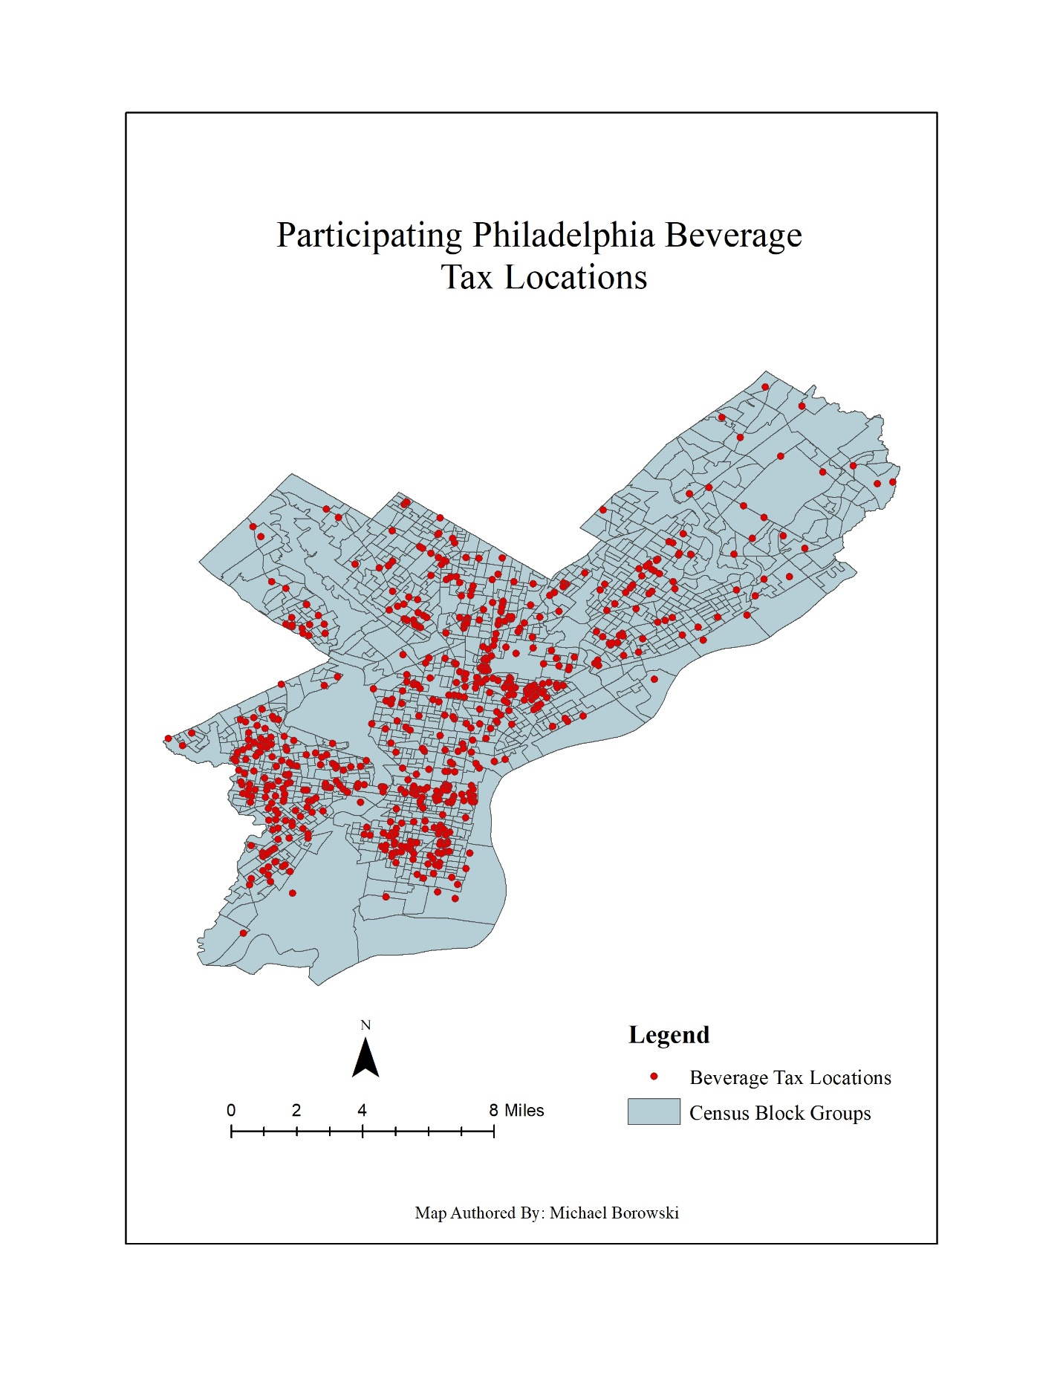

**Bibliography:**

(n.d.). Retrieved from <https://geocoding.geo.census.gov/geocoder/locations/addressbatch?form>.

Bomey, N. (2019, May 17). Philadelphia soda tax caused 'substantial decline' in soda sales, study finds. Retrieved from <https://www.usatoday.com/story/money/2019/05/15/philadelphia-soda-tax-sales-study/3677713002/>.

Data Access and Dissemination Systems (DADS). (2010, October 5). American FactFinder - Results. Retrieved from <https://factfinder.census.gov/faces/tableservices/jsf/pages/productview.xhtml?pid=ACS_17_5YR_S2502&prodType=table>.

Philadelphia Beverage Tax (PBT): Service. (n.d.). Retrieved from <https://www.phila.gov/services/payments-assistance-taxes/business-taxes/philadelphia-beverage-tax/>.

Philadelphia Beverage Tax Registered Distributors and Dealers. (2019, October 8). Retrieved from <https://www.opendataphilly.org/dataset/philadelphia-beverage-tax-registered-distributors-and-dealers>.