Name: Matthieu Broisin IP-LAB-4

Question 1.1
Insert the image of kernel (sx=40, sy=20)
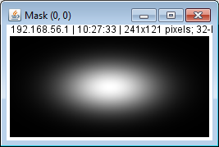
Insert the image of kernel (sx=10, sy=20)
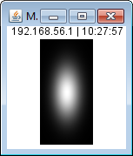

Question 1.2
Insert the image of kernel (sx=30, sy=10)
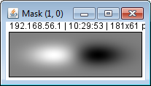
Insert the image of kernel (sx=20, sy=10)
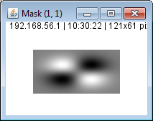
Insert the image of kernel (sx=5, sy=20)
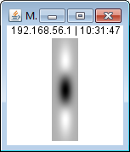
Insert the image of kernel (sx=30, sy=30)
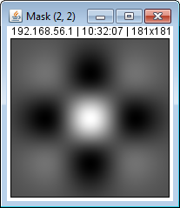

Question 1.3
Insert the resulting image (s=3)
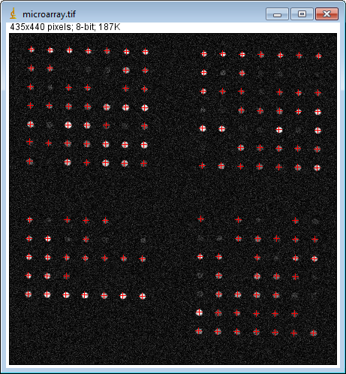
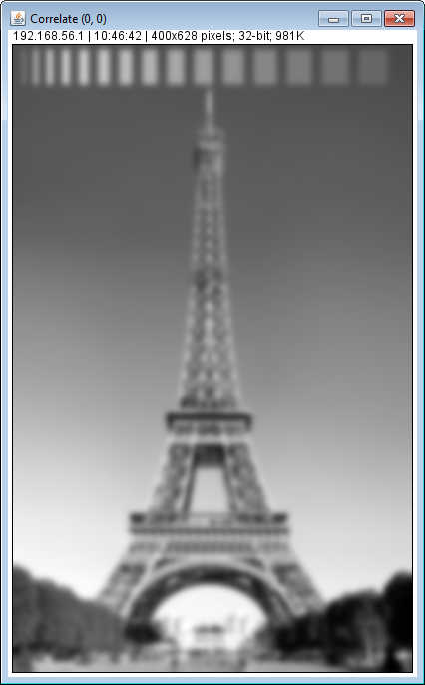

Insert the resulting kernel (s=0.5)
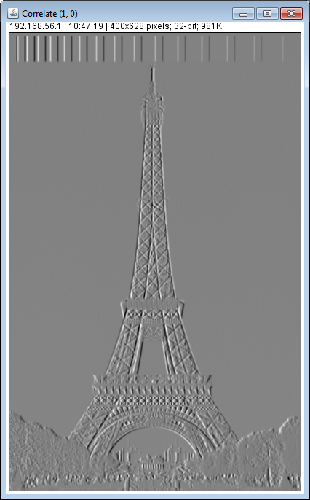

Insert the resulting kernel (s=5)
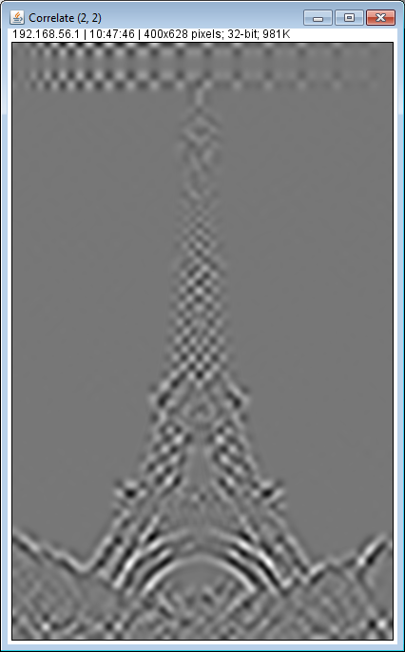

Question 2
Insert the output image
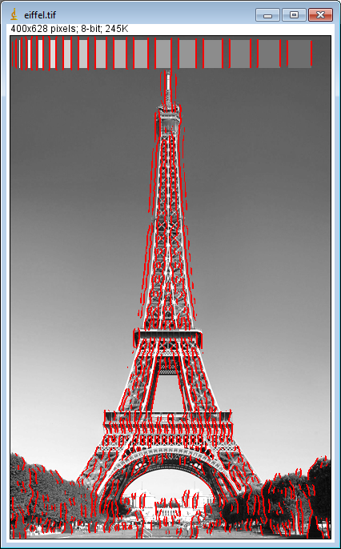
sigma=3.0
TL = 1
TH = 2

Question 3
Insert the output image
sigma=
T =

Question 4.1
Insert the module image

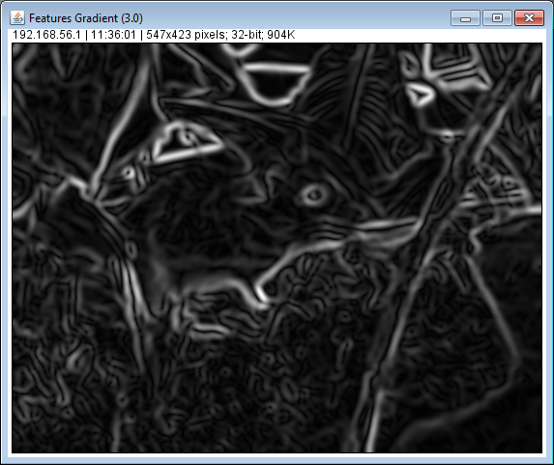

Insert the ux image

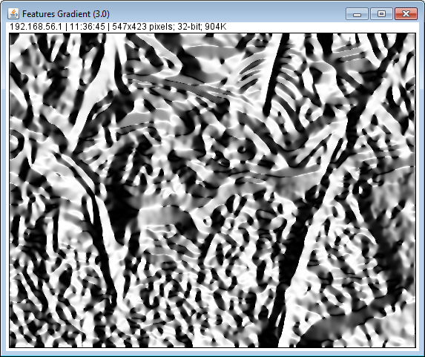

Insert the uy image
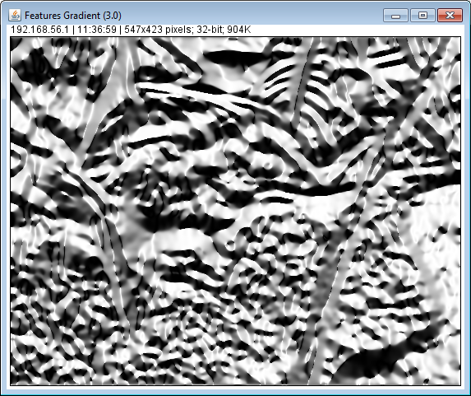

Question 4.2
Insert the output image
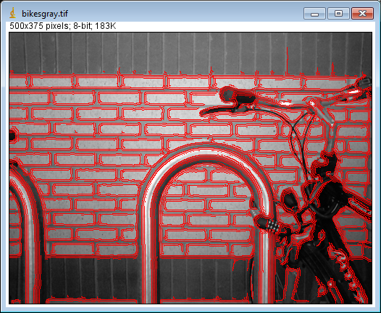
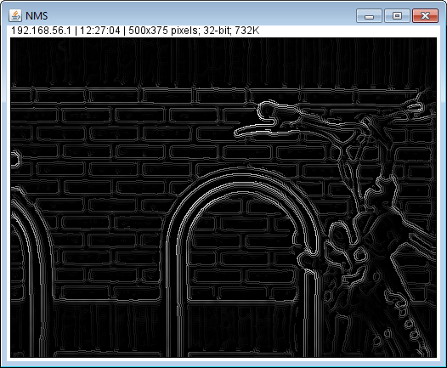
sigma=2.5
TL = 3
TH = 6

Question 5.1
Expression of Lambda_Max
Lambda_Max = (fxx+fyy + sqrt((fxx-fyy)^2+4*fxy^2)) /2

Expression of Lambda_Min
Lambda_Min = (fxx+fyy - sqrt((fxx-fyy)^2+4*fxy^2)) /2

Question 5.2
Insert the merit image
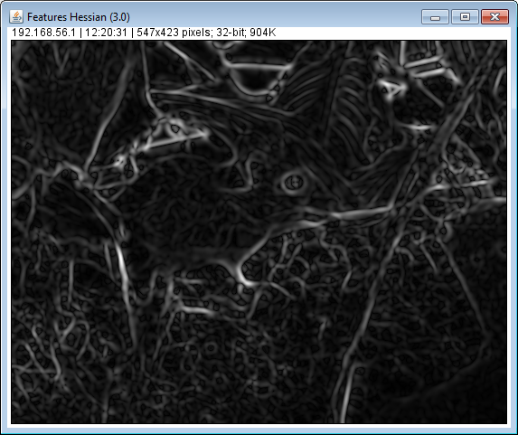

Insert the ux image
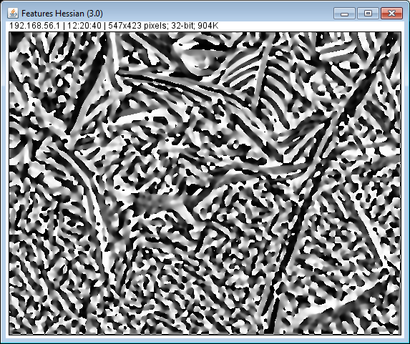

Insert the uy image
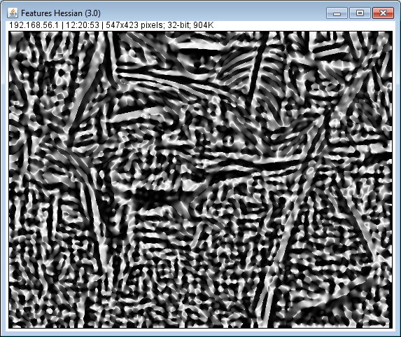

Question 5.3
Insert the output image
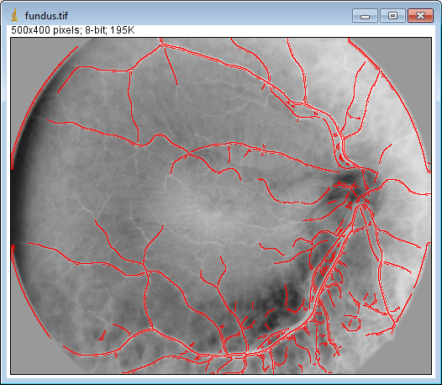
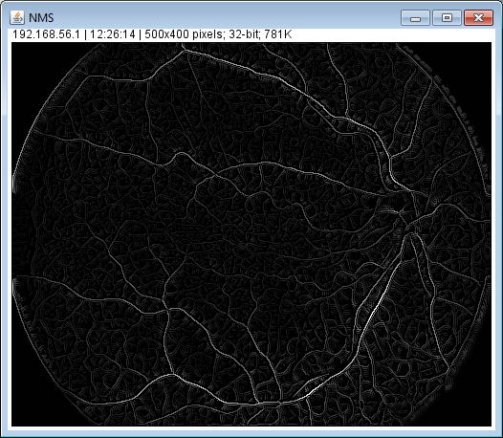
sigma= 2
TL = 2
TH = 3

