Name: Broisin Matthieu IP-LAB-6

report.doc Wavelets

Question 1
Insert the filtered image with testConvolution()
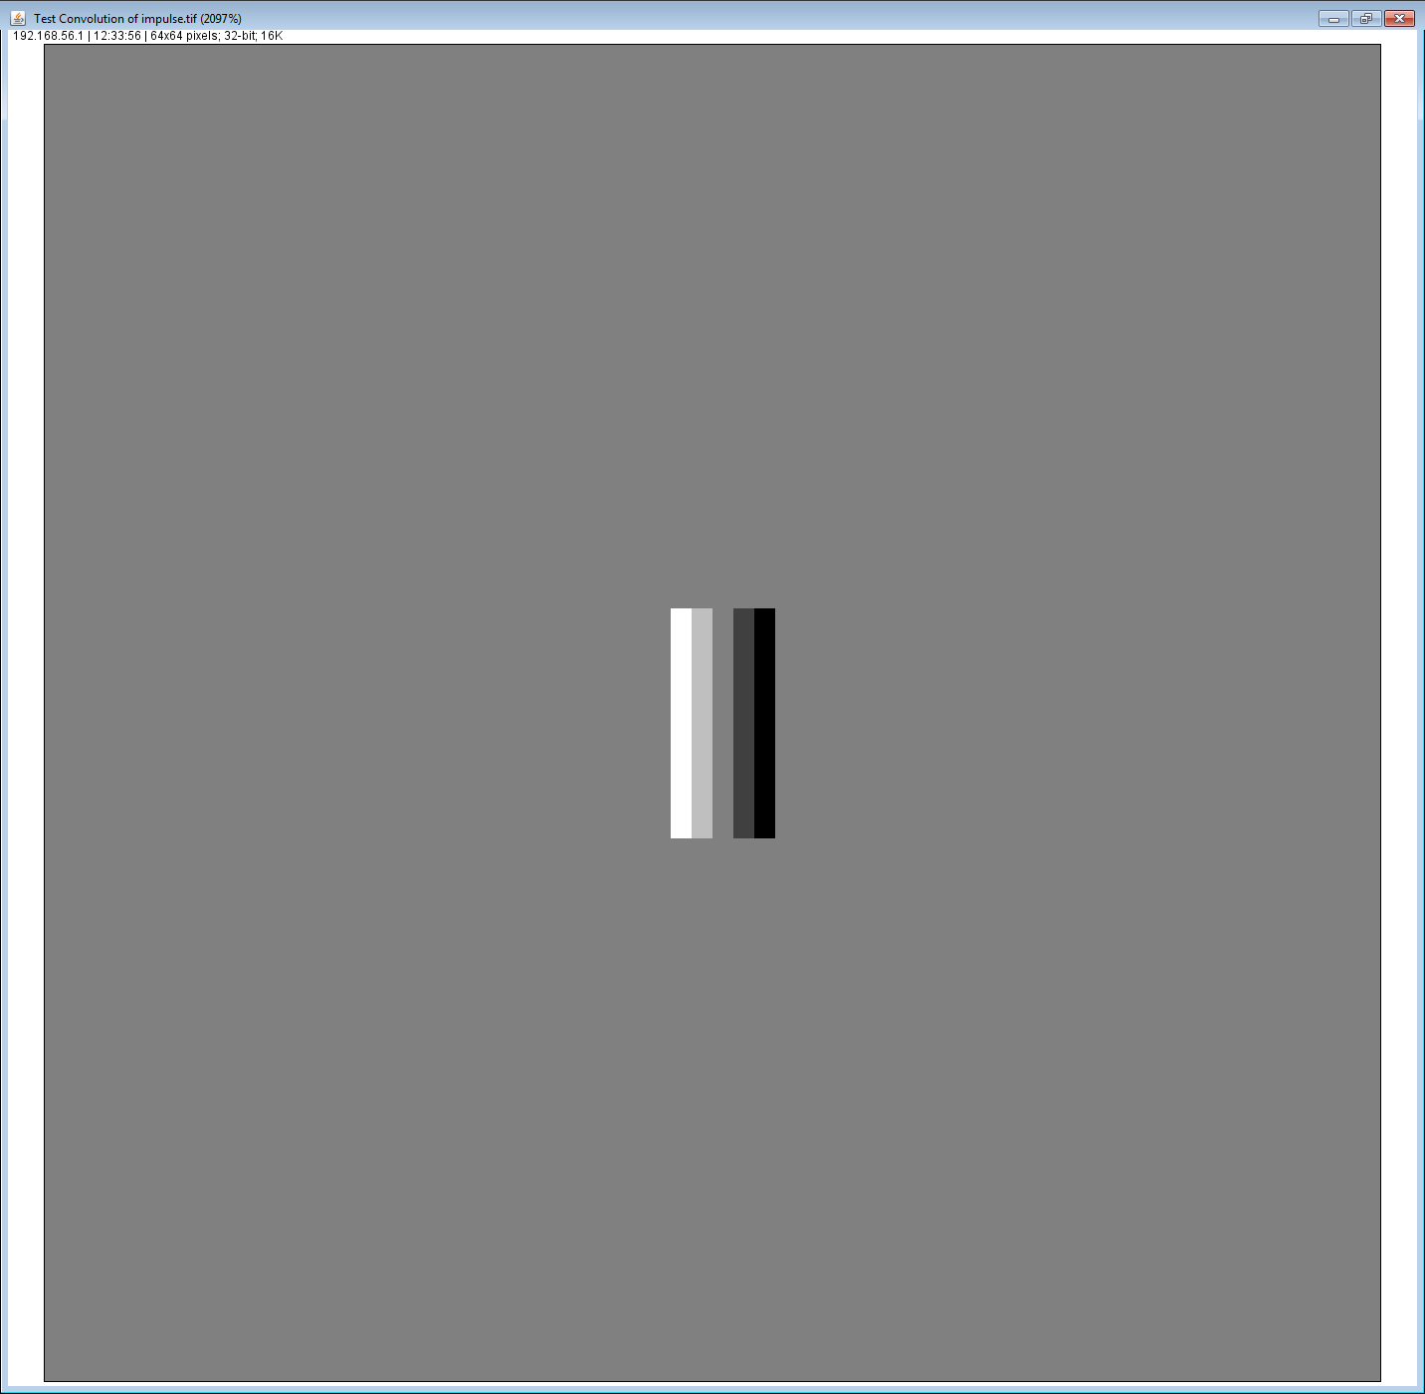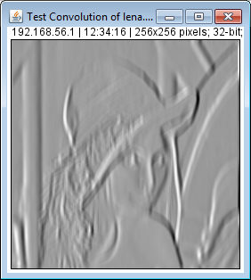

Question 2.c
Insert the filtered image, Daubechies, order 2

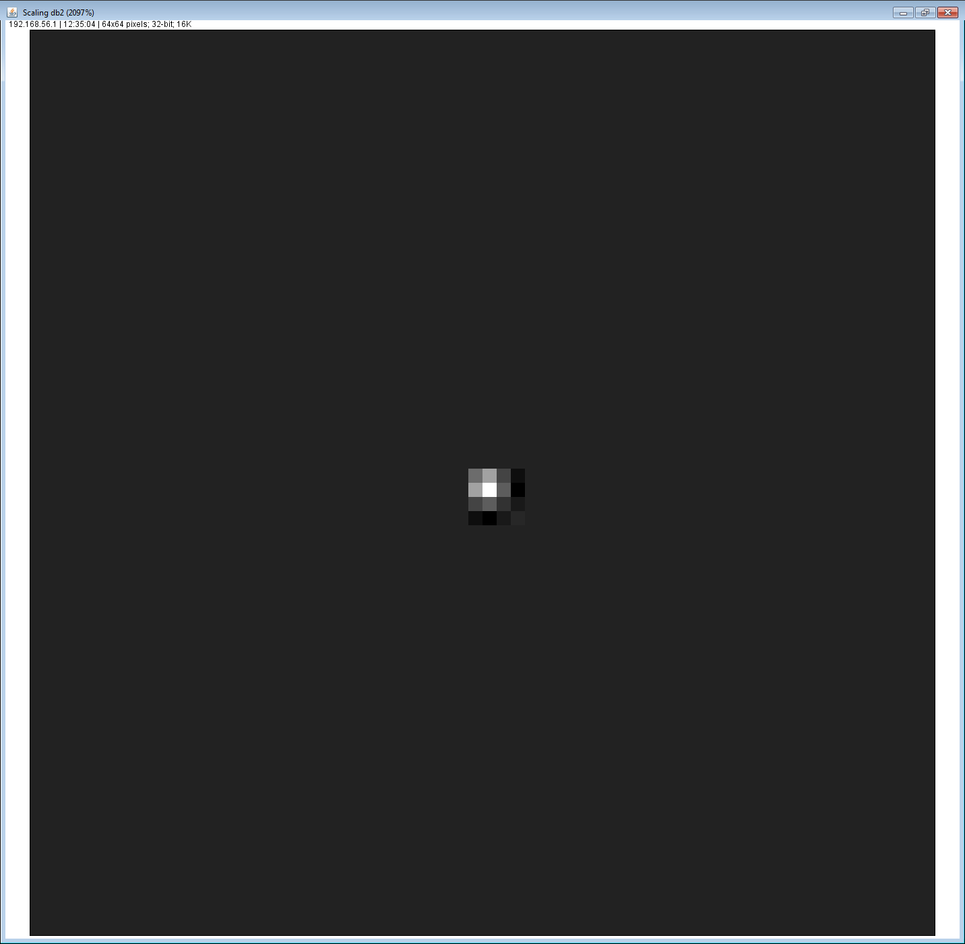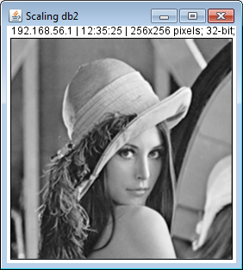
What type of filter is it?
This a low pass filter

Question 2.d
Insert the filtered image, Daubechies, order 1

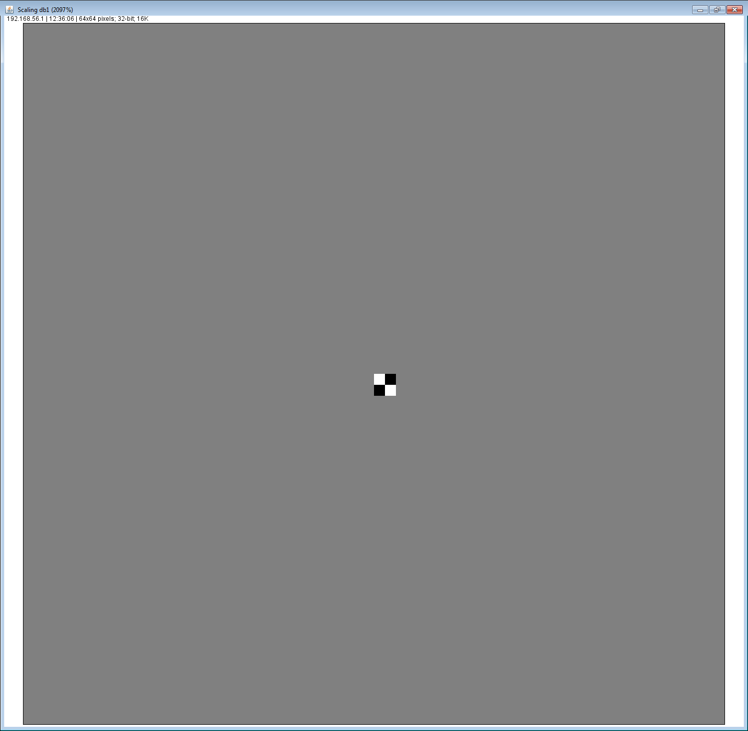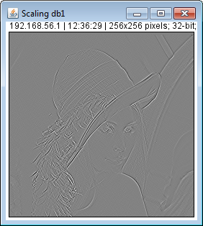
What type of filter is it?
This is a high pass filter

Question 3.c
Insert the resulting image
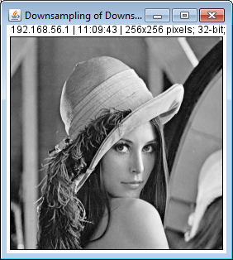

Question 3.d
Insert the resulting image
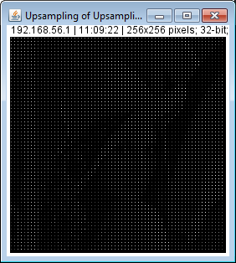

Question 4
Insert the resulting image, Daubechies, order 2, 1 scale
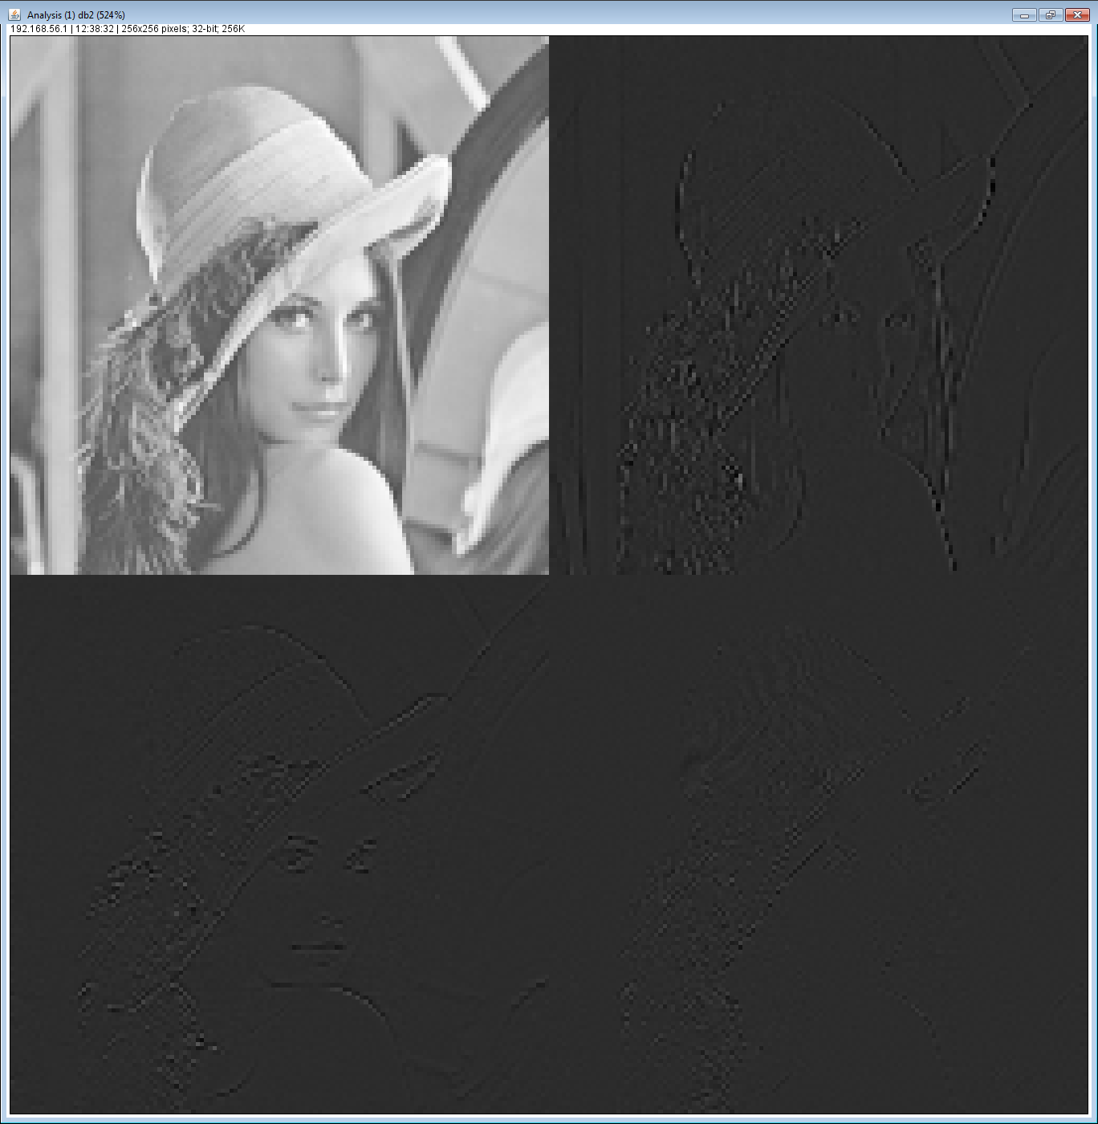

Question 5
Insert the resulting images, Daubechies, order 2, 1 scale
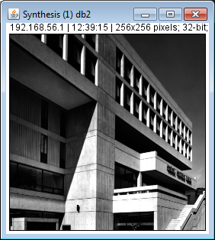

Question 6
Insert the reconstruction of doisneau, “Keep Lowpass Band”, Daubechies, order 1, 5 scales
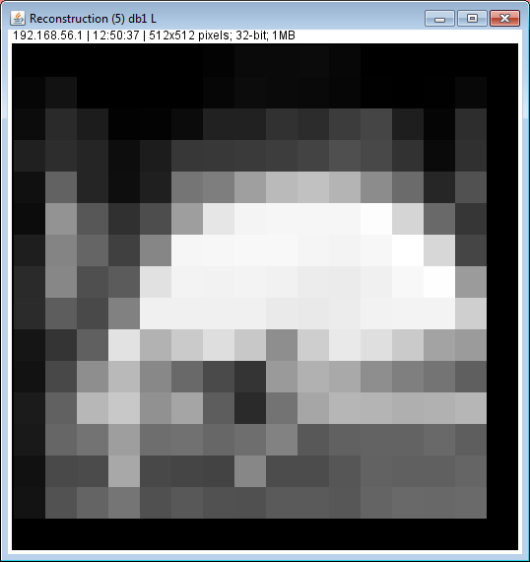

Insert the reconstruction of doisneau, “Keep Lowpass Band”, Daubechies, order 2, 5 scales

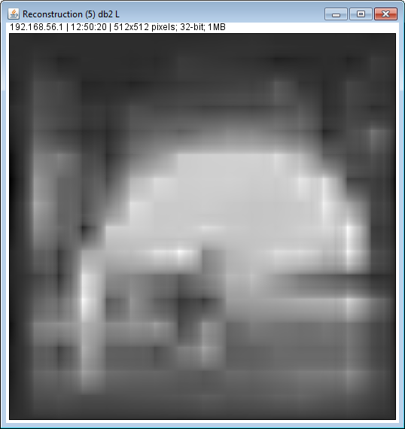

Insert the reconstruction of doisneau, “Soft Threshold”, Daubechies, order 2, 3 scales, T=10
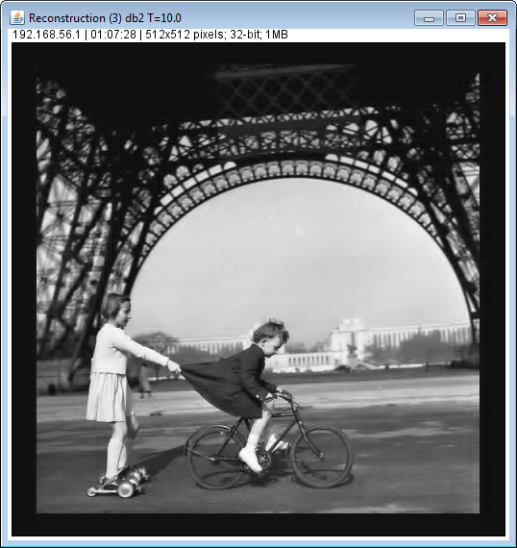

Question 7
Insert the automatic denoised cells
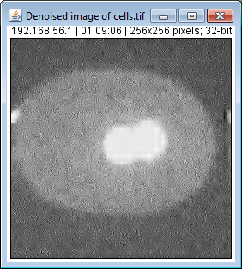
Insert the automatic denoised lowlight
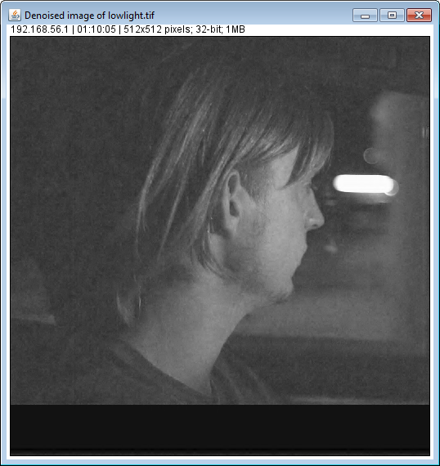

Image | T
Doisneau-noise | 15.69
Doisneau | 4.29
cells | 52.91
lowlight | 3.97

