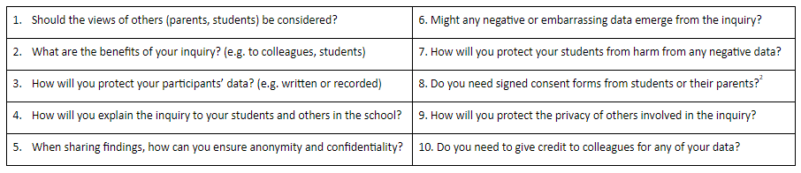

**Part g. Research ethics**

**Making sure you carry out an ethical inquiry**

The T-SEDA professional learning pack is intended to support teachers' reflective inquiry, with the aim of enhancing classroom dialogue.  As in any form of professional activitythere are some general ethical considerations for using T-SEDA to investigate dialogue. Note that educational researchers in Britain are expected to abide by ethical guidelines issued by the British Educational Research Association and these offer useful guidance for others too: <http://bit.ly/BERAethics2018>.

The Principles of Research Ethics:

• Minimising the risk of harm and maximising benefits

• Obtaining informed consent

• Protecting anonymity and confidentiality

• Avoiding deceptive practices

• Providing the right to withdraw from research

What does the risk of harm mean?

• Physical harm or discomfort to participants

• Psychological distress and discomfort, including participants feeling pressure to participate

• Social or educational disadvantage

• Lack of privacy and anonymity

To follow the principles of research ethics, it is important to consider these points before, during and after your inquiry. You might choose to discuss these issues with colleagues or to make your own notes on any of these points:

[**Video 8: Ethics in educational inquiry**](https://www.edudialogue.org/resources/introductory-video-series/)

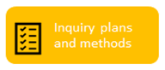

**About coding and rating**

**Part h. Analysing classroom talk: systematic observation and coding**

*Section of inquiry cycle*

When you plan your inquiry, you need to think about how you will actually carry out the inquiry in your setting in order to be able to answer your research question. Consider how much observation you want to do and when; how feasible is it to repeat your observations over time in order to look at change? This section gives an introduction to coding in educational settings, and there is more information, as well as coding templates, to help you in Sections 1 and 2.

There are a number of T-SEDA video guides that can provide useful guidance on this as you start to think about the planning and methods stage. This video will give you an overview of how to carry out coding and the positive and negative aspects of different types of coding:

[Video 12: Recording dialogue and coding in your classroom](https://www.edudialogue.org/tools-resources/introductory-video-series/)

**What is coding?**

Coding means breaking down classroom dialogue into chunks and systematically putting each chunk into a category. This is often done by ‘turn’ (Person A...Person B...etc).

**Why is coding important?**

It’s easy to miss dialogue in a busy classroom or to assume that it’s happening when it might not be. Coding is a way of focusing in on particular types of dialogue and recording it in some way. This allows you to go back over the dialogue and spot patterns or missed opportunities to probe students. It also helps you notice change over time

**How do I code?**

The T-SEDA pack offers several resources to support your coding: there is more information about this on the following page about this

**What is rating?**

In addition to coding dialogue, you might want to rate student participation. For example, you could rate students who took part a lot as a ‘1’, who took part less as a ‘2’ and who didn’t take part much as a ‘3’. There are also resources to help you rate aspects of classroom dialogue (see templates 2C and 2D for group work and 2E and 2F for whole-class participation)





**About coding: planning your inquiry**

**Reflection point:** Coding can seem tricky if you are new to it. Here are some tips to help you plan your coding for your inquiry:

• Decide on one or two dialogue codes to look at for any one inquiry, then you won’t be trying to focus on too much in the classroom

• Look at the templates in Section 2. Think about how you could use them in your classroom to record dialogue

• Consider the way that you will record dialogue, and what this entails. Will you have to source recording equipment? Do you have other adults in your setting to help out while you are coding in person (live coding)?

Using Sections 1 and 2 and the video guides to help you, jot down some of your ideas to these questions. These noes will help you to decide on a plan for your inquiry.

One key tip for coding during your inquiry is to get some practise at it beforehand. The T-SEDA videos on coding have activities so that you can practice coding some recorded dialogue.

Video 13: Identifying productive dialogue: ‘building on’ and ‘challenging’ ideas

Video 14: Practising coding: whole class dialogue

Video 16: Coding and rating the quality of small group dialogue

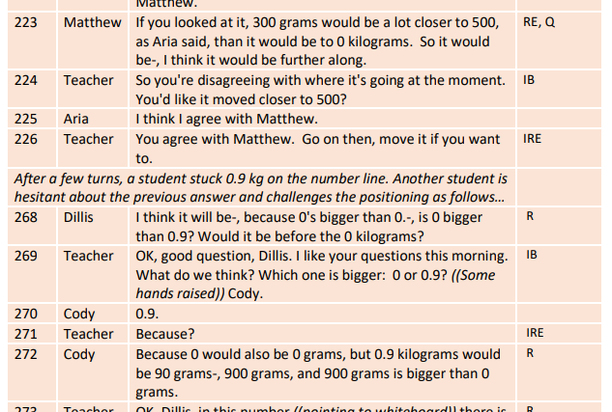

Here you can see an example of a section of dialogue that has been coded by ‘turn’: each time a different person speaks, look at the coding framework to see if one (or more than one) of the codes could be applied to what has been said. In this example, the dialogue has been recorded and then transcribed.

Each different turn is given a different number for easy identification

The name of each speaker is recorded

Each turn is added in a separate line

You can identify the code by checking what has been said against the coding framework in Section 1.

**Gathering data in your inquiries: baseline data**

**What is baseline data?**

Baseline data means making observations and gathering information before you make any changes in your learning setting.

Why should I collect baseline data?

Knowing what sort of dialogue is taking place in your classroom at the start of your inquiry can:

• Give you more information about your assumptions (students might be better or worse than you think)

• Help you to understand changes over time. You can compare your baseline data with data that you gather later to see if anything changes

• Give you an indication if any interventions that you are putting in place are making a positive difference

Consider the two sections of dialogue on the right. They are the same group of children before and after an intervention. The children are taking part in a group activity where they are solving multiple choice non-verbal reasoning problems. In the first example, you can see that there is not a lot of reasoning taking place: children aren’t spending much time discussing the activity or giving reasons to others. In the second example, interactions are longer and there is much more reasoning (the word ‘because’ is used often).

This indicates that children are engaging in dialogue more following the intervention, particularly showing reasoning.

**Example 1: Baseline data before the intervention**

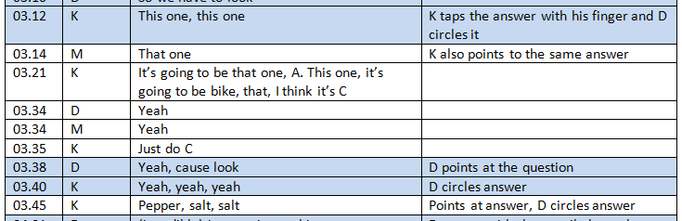

**Example 2: Data gathered after the intervention showing positive changes**

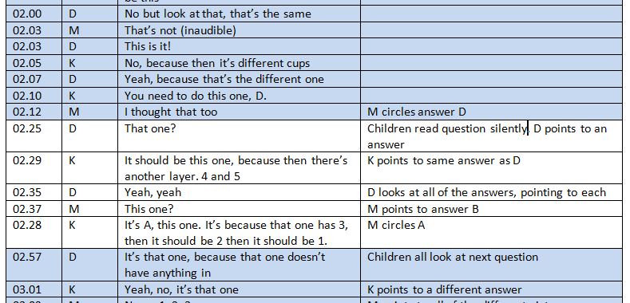

**TEACHER SCHEME FOR EDUCATIONAL DIALOGUE ANALYSIS**

**(T-SEDA): Supporting Resources**

• [**SECTION** **1: Detailed Coding framework**](https://docs.google.com/document/d/1VfrY9Uy7vPnnvQyLnho9B4g8NLoZG2aY3mhK7gCtO0Y/edit#heading=h.z337ya) A list and explanation of dialogue categories illustrated with sample prompts and contributions, plus more general dialogic classroom practices.

• **SECTION 2: Templates for observing and coding** Includes lesson observation (time-sampling; checklist; rating scales).

**The following resources are available online, including separately downloadable templates for printing or editing; look out for the** **icon**

• **SECTION 3: Technical guidance for recording and transcribing**

• **SECTION 4: Case studies** Illustrates teachers’ coding and interpretation of dialogue in different contexts; includes teachers’ findings and next steps.

• **SECTION 5: Resources and activities:** Ideas to implement dialogue in your classroom, references to other research on dialogue and links to related resources

**Section 1: Detailed coding framework**

This coding scheme is a more detailed version of the one that you saw in Part B. These codes will help you to identify the dialogue that is taking place in your learning setting. You can apply a dialogue code to each ‘turn’ by a different speaker, whether you record and transcribe what is said or you do live coding as students are talking. Guidance about how the framework can be used follows in the next sections of this resource.

|  |  |  |  |  |
| --- | --- | --- | --- | --- |
| CODING CATEGORIES | | CONTRIBUTIONS AND STRATEGIES | | WHAT DO WE HEAR? |
| **B – Build on ideas**  *build on, elaborate, clarify or comment on own or others’ ideas expressed on previous turns or other contributions to the learning activity (oral/written/other)* | | • build on own or another’s previous ideas /contributions by adding something new    • clarify, elaborate, extend, reformulate own or another’s previous ideas / contributions    • comment on previous ideas / contributions | | **Possible Key Words to look for:**  ‘it’s also’, ‘that makes me think’, ‘I mean’, ‘she meant’  **Examples:**  Kate’s idea made me think about why the character would do that.  I’ve got an idea that no-one has mentioned yet…  What I meant earlier was…  Ahmed’s story had a lot of detailed description  My idea was similar to Jose, I wrote that flowers would make the best present |
| **IB – Invite to build on ideas**  *Invite building on, elaboration, clarifying or commenting on own or others’ ideas / contributions to learning activity (oral / written / other)* | | • invite others to build on own or others’ ideas    • invite others to clarify a contribution    • invite others to comment on others’ ideas or views (including invitations to agree/disagree or evaluate)    • invite others to refine/improve ideas | | **Possible Key Words to look for:**   ‘What?’ ‘Tell me’, ‘Can you rephrase this?’ ‘Do you think?’ ‘Do you agree?’ Can you add to…?’  **Examples:**  What do you mean? Tell me more…  Can anyone add to that?   Can you give an example of what you said?  Is your idea similar to Manuel’s?  What do you think about Maria’s idea? Do you agree with what Chris just said?  What other information do we need?  How can you improve Sanjay’s group’s poster/concept map? |
| CODING CATEGORIES | CONTRIBUTIONS AND STRATEGIES | | WHAT DO WE HEAR? | |
| **CH – Challenge**  *Questioning, disagreeing with or challenging an idea* | • Stating full or partial disagreement    • Doubting an idea    • Challenging an idea    • Rejecting an idea    • Indicating that two or more ideas that have been expressed are in disagreement | | **Possible Key Words to look for:**  ‘I disagree’, ‘No’, ‘But’, ‘Are you sure…?’ ‘…different idea’  **Examples:**  I’m not sure it will float actually  I don’t think that’s right, I think.... or ‘I have a different idea…’  Are you sure these angles are the same?  But then that wouldn’t happen if…  That’s partially true, but not when…  I don’t agree with that at all  It’s not Victorian London though  No, I think that other one | |
| **R – Make reasoning explicit**  *Explain, justify and/or use possibility thinking relating to own or another’s ideas* | • explain, justify, draw on evidence, make analogies, make distinctions    • predict, hypothesise    • speculate, explore different possibilities | | **Possible Key Words to look for:**  ‘I think’, ‘because’, ‘so’, ‘therefore’, ‘thus,’ ‘in order to’, ‘if...then’, ‘not...unless’, ‘it’s like...’, ‘imagine if...’, ‘would’, ‘could’ or ‘might’  **Examples:**   I think the wood will float but not the metal.  The ice caps melting by 10% supports the global warming theory.  If children don’t have to go to school, they wouldn’t learn maths properly.  If I chose the first alternative I would be safer, but if I choose the second one I could eventually have greater gains.  I think the author might be referring to feelings when he writes about water. | |

|  |  |  |
| --- | --- | --- |
| CODING CATEGORIES | CONTRIBUTIONS AND STRATEGIES | WHAT DO WE HEAR? |
| **IRE – Invite reasoning**  *Invite explaining, justifying, and/or using possibility thinking relating to their own or another’s ideas* | • invite others to explain, justify, draw on evidence, make analogies, make distinctions    • invite others to predict, hypothesise    • invite others to speculate, explore different possibilities | **Possible Key Words to look for:**  ‘Why?’, ‘How?, ‘Do you think?’, ‘explain further’  **Examples:**  How did you arrive at that solution/conclusion/evaluation?  I don’t quite understand. Can you explain further?  Group X/Classmate Y said that it is because of... what do you think about their explanation?  What would/could/might happen if...?  Which objects do you think might float?  Why do you think that was? (in relation to a statement/observation)  Why do you think that would be? (in relation to a statement/observation)  How do you know that? |
| **CA - Coordination of ideas and agreement**  *Contrast and synthesise ideas, express agreement and consensus, or invite others to do this* | • come to a consensus view    • evaluate at least two different ideas by comparing / contrasting / critiquing them    • judge the value of an idea / artefact    • confirm agreement/consensus    • propose to resolve differences and/or agree a solution    • synthesise, generalise    • **invite** consensus, evaluation, summary | **Possible Key Words to look for:**  ‘I agree’, ‘to sum up…’, ‘So, we all think that…’, ‘summarise’, ‘similar and different’  **Examples:**  So we agree with Jason… because…  Elaine came up with more evidence than Tim, she was more convincing.  I think all we agree that a suspension bridge would work best.  I agree with Maria and not with Andy because the pebble is too heavy to float  We agree that these ideas can’t be reconciled.  I see what you mean, Option C is probably right, not B.  They are both saying the same thing because… |

|  |  |  |
| --- | --- | --- |
| CODING CATEGORIES | CONTRIBUTIONS AND STRATEGIES | WHAT DO WE HEAR? |
| **RD –** **Reflect on dialogue or activity**  *Evaluate or reflect “metacognitively” on processes of dialogue or learning activity; invite others to do so* | • talk about talk rules / ground rules    • reflect (or invite to reflect) about the processes/ value/ impact of dialogue    • reflect (or invite to reflect) on value/ impact of learning activity    • explicitly acknowledge a shift of position | **Possible Key Words to look for:**  ‘dialogue’, ‘talking’, ‘sharing’, ‘work together in the group/pair, ‘task’, ‘activity’, ‘what you have learned’, ‘I changed my mind’, changed your mind’, ‘listening’, ‘talk rules’  **Examples:**  I like sharing ideas because it can give us new ideas for our writing.  They (talking and listening) kind of go together, don’t they?  It (dialogue) works when everyone is talking about the right thing  So, thinking about our ground rules for talking in the classroom...  In your group can you think about what makes dialogue work?  Do you think we need new talk rules for next time?  I can see you were listening to each other carefully; did that help your learning?  What have you learned in today’s lesson? Have you changed what you think?  What / whose argument helped you change your mind, and why?  How did you feel about being a group leader today?  As the ‘note-taker’ in your group did you feel you participated in the dialogue? |

|  |  |  |
| --- | --- | --- |
| CODING CATEGORIES | CONTRIBUTIONS AND STRATEGIES | WHAT DO WE HEAR? |
| **C – Connect**  *Make pathway of learning explicit by linking to contributions / knowledge / experiences beyond the immediate dialogue* | • refer back to earlier contributions or flag up forthcoming requests  • refer forward or back to relevant activity or artefacts  • refer to wider contexts beyond the classroom or to prior knowledge / experiences | **Possible Key Words to look for:**  ‘last lesson, ‘earlier’, ‘reminds me of’, ‘next lesson’ ‘related to’, ‘in your home’  **Examples:**  It’s like when we did/learnt…  How is today’s lesson related to last lesson?  Who remembers the experiment we did with keeping plants in the dark?   At the end of the lesson I'm going to ask you to write down what you think happened and why.  Who has visited the science museum and can tell us what they’ve seen?  I know a lot about horse riding because I have my own horse.  Do you think you might find similar creatures in the soil in your own garden?  Have you seen anything on the news that refers to weather or climate?  Is there any information in earlier chapters that is useful? |
| **G – Guide direction of dialogue or activity**  *Take responsibility for shaping activity or focusing the dialogue in a desired direction or use other scaffolding strategies to support dialogue or learning*  **(This general category captures contributions that support the flow of dialogue and may enhance student participation)** | • encourage student-student dialogue  • offer thinking time  • propose possible courses of action or inquiry  • | **Possible Key Words to look for:**  ‘How about’, ‘focus’, ‘concentrate on’, ‘Let’s try’, ‘no hurry’  **Examples:**  So, in answer to the question, what have you found out?  Are you thinking about...?  Don’t worry, have a go...  Let’s try adding up instead!  Take your time and let me know when you’ve thought of anything.  Why don’t you explain to Kelly what we are doing?  In pairs can you discuss which of these sources you think is the most reliable account of the battle?  What would Newton say? |

|  |  |  |
| --- | --- | --- |
| CODING CATEGORIES | CONTRIBUTIONS AND STRATEGIES | WHAT DO WE HEAR? |
| **E – Express or invite ideas**  *Offer or invite relevant contributions to initiate or further a dialogue* ***(ones not covered by other categories)*** | • invite opinions, ideas, beliefs or examples without referring back or  building on prior contributions, typically by open, general questions, or by drawing more people into the exchange without explicitly inviting them to build/reason/coordinate/query    • make a relevant contribution, including short responses to closed questions; plenary reporting; extended ideas not explicitly linked to previous contributions | **Possible Key Words to look for:**  ‘What do you think about…?’, ‘Tell me’, ‘your thoughts’, ‘my opinion is…’, ‘your ideas’  **Examples:**  What do you think, Maria?  What do you think is really important in this text? Can you identify some key words and underline them on the board?  Are there any more ideas on that?  How many four-legged animals can you name?  What do you know about how electricity works?  Let’s brainstorm… |

**Section 2: Systematically observing and coding dialogue**

This section covers two important aspects of carrying out your inquiry: which sort of observations you will make and which template you will use to record your observation. These observation fact files provide more information about different types of observation

**Type of observation:** Live Coding

**What is it?** You can live code in your learning setting, for example by sitting with a group and recording their dialogue onto one of the coding templates.

**What are the advantages?**

• You can see how the group is interacting and pick up on non-verbal clues such as body language

• It is more practical, and doesn’t need any special equipment, so it can be used more often

• It’s easier to capture normal behaviour because you’re not filming students

**What are the disadvantages?**

• As you’re not recording the dialogue, if you miss anything you can’t go back and check what was said

• It can be demanding as you have to listen, think and code at the same time

• Your focus has to be on only one or two codes so it is manageable

**Best for:** Capturing dialogue in group work; rating students participation or dialogue; short and/or multiple periods of observation,

**Can be used with templates:** 2B; 2C; 2D

**Type of observation:** Audio recording with transcribing

**What is it?** You record what is said in your learning setting (audio only) and then later on transcribe it so that you can code the transcription. See Part H for an example of a coding transcript.

**What are the advantages?**

• You can code in more detail and with more precision

• You can make more connections between the dialogue ‘turns’ because you can revisit the transcript and recording

• It gives you more thinking time

• It’s a more subtle way of recording than with a video camera

**What are the disadvantages?**

• It’s more time consuming as you have to take the time to transcribe the recording

• You have no visual observation so you cant pick up on non-verbal aspects of dialogue and interaction

• You need to obtain consent from guardians to record, so it requires advance planning

**Best for:** If you want to examine one episode of dialogue in more detail; if you want to look at several codes at once

**Can be used with templates:** 2A; 2C; 2E

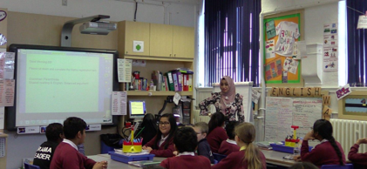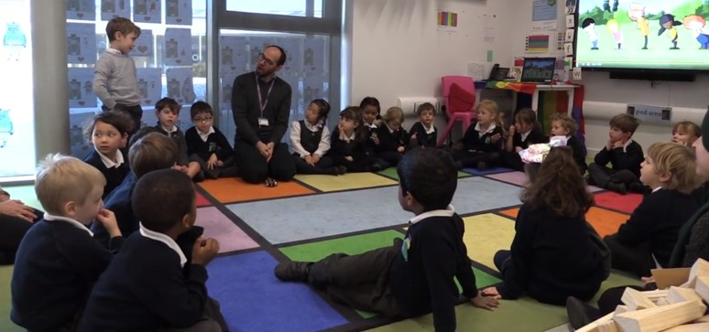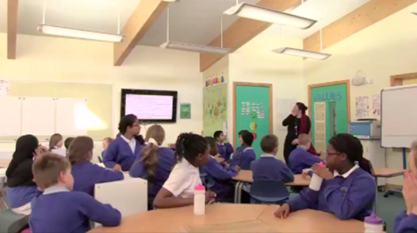

**Type of observation:** Video recording with transcription

**What is it?** You record what it said in your learning setting and then transcribe it later

**What are the advantages?**

• You can code in a greater level of detail and with more precision

• It gives a more accurate representation of classroom events because you have audio and visual data

• You can make connections between ‘turns’ because you can revisit the data

• You can record student interaction and non-verbal dialogue

**What are the disadvantages?**

• It might take time for students to get used to being video recorded and their behaviour might be different in the presence of a camera

• You need to get consent from guardians so you need to plan in advance

• Transcribing is time consuming so you need to make sure that the amount of dialogue you plan to transcribe is manageable

**Best for:** If you want to examine one longer episode of dialogue in a lot of detail; if you want to look at non-verbal interaction; if you want to look at several codes at once

**Can be used with templates:** 2A; 2C; 2E

**When to use the different coding and rating templates**

This diagram shows when particular templates that you will find on the following pages are particularly useful.

Some tools are more suited to whole class teaching and others to group work. You can also use different tools depending on whether you want to focus on turns in dialogue or on wider practices such as participation and classroom cultures of dialogue.

Looking at these templates can help you to decide how you will carry out your inquiry.

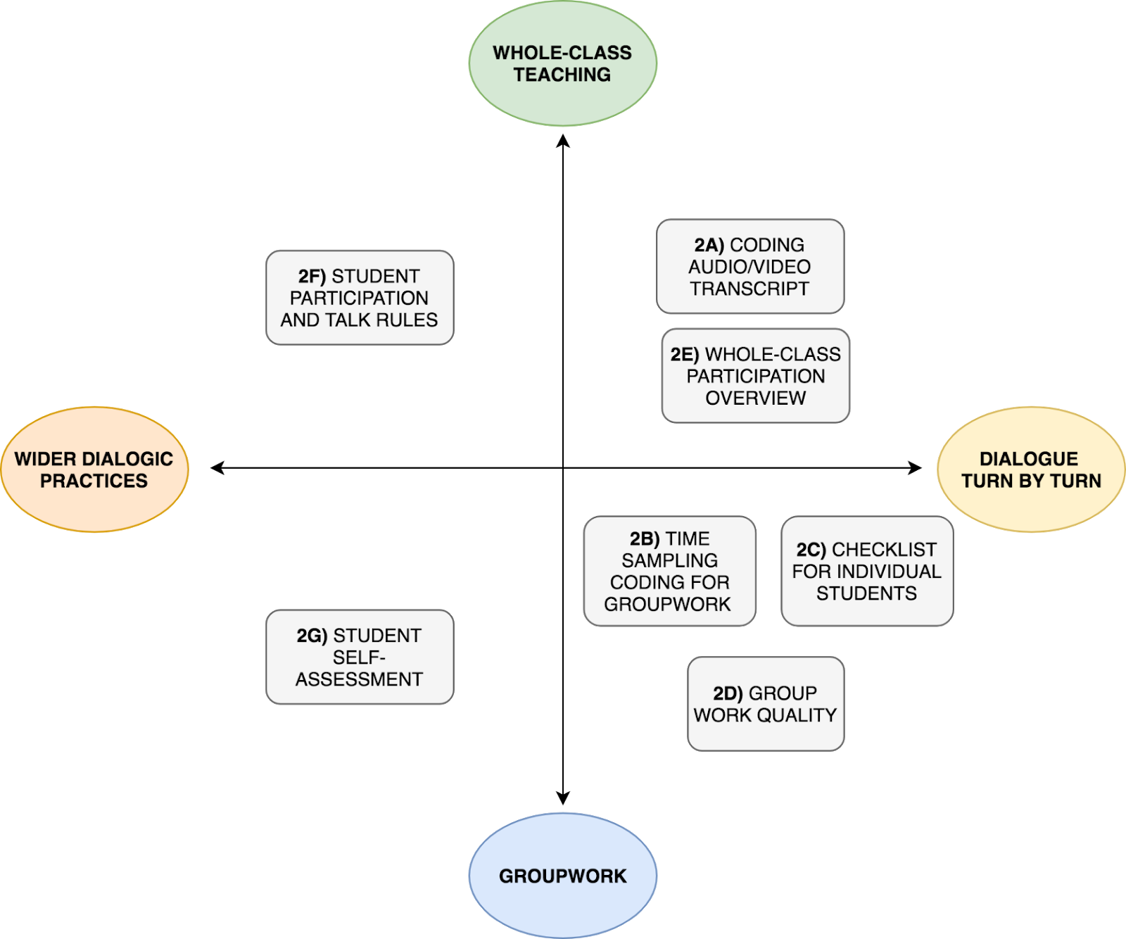

**2A: Template for coding an audio/video transcript**

You can use this template to apply T-SEDA codes to individual speaker’s turns.

**Guidance notes:**

• Create your transcript into a table like this one, adding as many rows as you need

• Numbering the terms makes them easily identifiable

• You can choose one or two codes to look for, or use many categories, depending on what the focus of your inquiry is

• Some turns might be left uncoded because none of the categories apply

• Alternatively, some speakers’ turns might have more than one code applied to them

• You could also add a comments category to each row to record your thoughts about how the dialogue is unfolding

**A downloadable transcript coding** **template** is available from our website**.**

On the next page you can see an example of a completed template

|  |  |  |  |
| --- | --- | --- | --- |
| **Line no.** | **Speaker** | **Turn** | **Code** |
|  |  |  |  |
|  |  |  |  |
|  |  |  |  |
|  |  |  |  |
|  |  |  |  |

yCb_-vS_V8SGWBz8OvBnaGag9OflhJKvaBWXL8hax5YqNjQyPioSb5ayfElJ5L6hukRYsbWZLvrTTnuYHfm-8vyoN-lEXjZnorpNTgpZ9Gc9Wwn-Or7XbeGZJH9GOhwmhcxaNKJeLK_pbfb9Rw

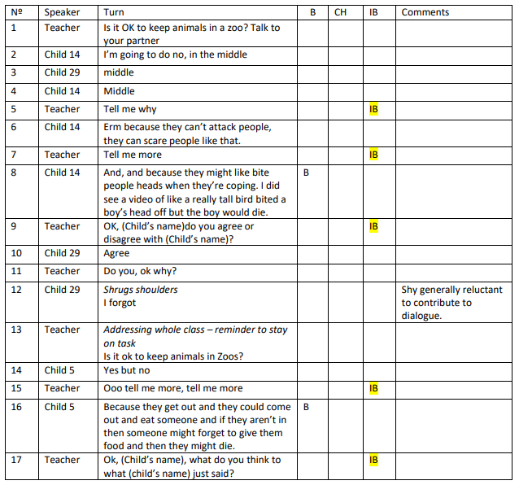

Here is an example of a section of completed transcript from Lucy’s investigation in a primary school.

As you can see, she’s decided to focus on three codes: Build on (B), Challenge (CH) and Invite to Build (IB).

She’s also added a comments section to record any points of note during the dialogue

Decide how long you want your observation windows to be, for example, observe for 1 minute, rest for 1 minute and so on

**2B: Time-sampling coding for groupwork**

‘Time sampling’ is a common technique used by researchers to sample events at regular time intervals during an episode or whole lesson. You don’t note down everything, but it will give you a general picture of what is going on. It also reduces the demand of live coding as your observation windows are short

Guidance notes:

• Observations have an ‘active’ and a ‘resting’ phase. Each active phase is the time window when you note down the codes that you hear

• You can decide how long you want the observation window to be, but they should be short to make sure that the observation isn’t too demanding

• Tick the relevant coding box if the student uses that code during the observation window

• Instead of ticking, you could choose to tally *each time* the student uses the code, but be aware this is harder to do

• You could choose to video the interaction as a ‘back up’ to watch later

**A downloadable time-sampling** **template** is available from our website**.**

On the next page you can see an example of a completed template

|  |  |  |  |  |  |
| --- | --- | --- | --- | --- | --- |
| **Time window** | **Teacher present** | **Student 1:**  **[name]** | | **Student 2:**  **[name]** | |
|  |  | **CH** | **B** | **CH** | **B** |
| 1 |  |  |  |  |  |
| 2 |  |  |  |  |  |
| 3 |  |  |  |  |  |
|  |  |  |  |  |  |
|  |  |  |  |  |  |
|  |  |  |  |  |  |

Write down the name of each student, adding as many columns as you need. Observing 3-6 students in groups is ideal



yCb_-vS_V8SGWBz8OvBnaGag9OflhJKvaBWXL8hax5YqNjQyPioSb5ayfElJ5L6hukRYsbWZLvrTTnuYHfm-8vyoN-lEXjZnorpNTgpZ9Gc9Wwn-Or7XbeGZJH9GOhwmhcxaNKJeLK_pbfb9Rw

Decide which codes you want to focus on: CH and B are given as examples but you can use any one or two codes

If a teacher or teaching assistant interacts with the students during this time put a tick in this box

**Example of completed time-sampling template**

This teacher, Huseyin, had observed and live coded group work with four students. He was looking for Reasoning and Invite Reasoning. He observed for one minute at a time and then rested for 30 seconds., recording when he heard examples of R and IRE. He has also recorded some brief notes of aspects of the dialogue that seemed important.

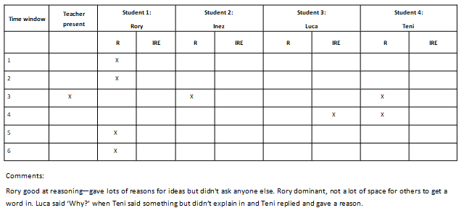

**2C: Checklist for individual students (groupwork)**

This checklist can be used in two ways. Firstly, it can serve as a summary of 2B: you can record the results of students from multiple groups in this checklist, adding a rating of overall participation. Secondly, if it isn’t possible for you to carry out time sampling, you can use this instead: observing dialogue and ticking when you hear the categories you’re interested in. Again, you can give each student an overall rating.

Checklists of this type can’t capture everything, but they’re not designed to. However, it’s a manageable way of paying closer attention to students’ dialogue and identifying trends over time.

**Guidance notes:**

• You can choose one or two categories that you’re interested in

• Tick the code boxes if you hear those codes in a student’s dialogue at any point in their discussion contributions

• If a student participates a lot in the discussion then they will have an overall rating or (3), a medium amount would be (2) an low participation would be a rating of (1)

 **A downloadable** **template** is available from our website**.**

You can give each student an overall participation rating between 1 (low) and 3 (high)

Add as many rows as you need for your students’ names





|  |  |  |  |
| --- | --- | --- | --- |
| **Student’s names** | **CH** | **B** | **Rating of overall participation** |
|  |  |  |  |
|  |  |  |  |
|  |  |  |  |
|  |  |  |  |

Add the dialogue categories into the middle sections, ticking if you hear them

**2D: Group rating (groupwork)**

This group rating tool is slightly different from 2B and 2C because it does not rate individual students’ contributions but the group as a whole. You can select different categories of dialogue to focus on (in this case Coordination of Ideas and Agreement (CA) and Connect ).

**Guidance notes:**

• Use a three-point rating scale for the frequency of each dialogue category within the conversation as a whole: 1 = low, 2 = medium, 3 = high

• Use the ‘Comments’ column to add any relevant information to the rating, such as whether the results are typical, or if they show progress

• You could repeat this to see if groups change their dialogue patterns over time

 **A downloadable** **template** is available from our website**.**

|  |  |  |
| --- | --- | --- |
| **Dialogue code** | **Rating (1-3)** | **Comments** |
| **CA** |  |  |
| **C** |  |  |

• Use the following rating scale:

5 = all the time/as many students as possible

4 = most of the time/most of the students

3 = some of the time/some of the students

2 = occasionally/a few students

1 = never/none of the students

 **A downloadable** **template** is available from our website**.**

**2E: Whole-class participation overview (rating scale)**

This whole-class rating scale extends 2D to focus on whole-class talk. It will allow you to understand more about how students are taking part in dialogue. You can focus on different aspects of student participation such as the length of contributions and how often students are taking part. You can do this during different types of whole class activities to build up a bigger picture of dialogue in your learning setting.

**Guidance notes:**

• Choose one or two categories that you want to focus on for your inquiry

• Decide which types of activity you want to focus your observations on, such as lesson introductions, whole-class discussions or plenaries

|  |  |  |  |  |
| --- | --- | --- | --- | --- |
| **Activity type** | **Category** | **How often are students doing this?** | **How many students are taking part in this?** | **Are the contributions extended or short?** |
| 1) | B |  |  |  |
|  | CH |  |  |  |
| 2) | B |  |  |  |
|  | CH |  |  |  |

**Guidance notes:**

• This tool can be used across whole lessons or for different activities

• You could use it in your own classroom or when observing a colleague

• Read through the descriptors for each category and decide which best applies to the lesson you have just observed

**2F:  Student participation and talk rules rating scales**

This is another tool with which you can measure student participation. It also offers a way of assessing whether or not talk rules are being used.

 **A downloadable** **template** is available from our website**.**

|  |  |  |  |
| --- | --- | --- | --- |
| Dimension | 0: Not Evident | 1: Teacher-led | 2: Teacher-led with student involvement |
| Talk rules | No explicit focus on ground rules for dialogue or dialogic practices is apparent | The teacher introduces, models or reminds students of target dialogic practices, e.g. ground rules to be followed, inclusive turn taking. | Teacher and students or students themselves negotiate target dialogic practices, e.g. ground rules, perhaps along with reminders / modelling.  It may also include students being given or taking responsibility for managing the dialogue, as well as students being involved in evaluating effectiveness of dialogic practices. |
| Student participation | Public exchanges in whole-class situation or group work consist in teacher questioning and succinct students' contributions  or  Students don't have opportunities to discuss their ideas publicly | Students express their ideas publicly at length in whole-class situation and group work, but **they don't engage** with each other’s ideas | Multiple students express their ideas publicly at length in whole-class situation and group work  **AND**  In doing so, they **engage with each other’s ideas,** for example by referring back to their contributions, challenging or building on them (e.g. ‘It’s a bit like what Shootle said but….’, ‘Sam had such a great idea, look [demonstrates]’). This includes spontaneous or teacher-prompted participation. |

**2G: Student group work self-assessment**

**(Older student/adult example)**

 This template is for a group of students to rate their own dialogue. It can help students to understand more about their own participation in dialogue. It can also help you to understand what students are thinking about their own dialogue. You might also find that you have different perceptions of their dialogue and group work than they do.

 **Downloadable** **templates** are available from our website**.**

**Guidance notes:**

• The rating scale is: 1 = Not true; 2 = Partly true and 3 = Very true

• Students can either complete one per group or one each. This can be an interesting activity as different members of the group might have very different perceptions and this can lead to good discussion

• The example on this page is for older students including adults . On the T-SEDA website there is a version for younger children so you can choose the most appropriate

|  |  |
| --- | --- |
| **Criteria** | **Rating** |
| **G1 –  Everyone in the group participated** |  |
| **G2 –  We worked as a single group and didn’t split up** |  |
| **G3 –  Most or all of our talk was about the task we were doing** |  |
| **G4 -  We shared our own ideas and built on each other's** |  |
| **G5 - We listened carefully when others were speaking and took on board what they were saying** |  |
| **G6 – We enjoyed working together in a group** |  |
| **G7 – When we made suggestions or agreed/disagreed with others, we gave reasons** |  |
| **G8 – We challenged or commented each other’s ideas in a respectful and constructive way** |  |
| **G9 – We tried to reach consensus or compromise if there was disagreement** |  |
| **G10 – Our discussions and disagreements helped us learn from each other** |  |