> 3 years experienced candidates

Task 1
Describe the steps for comprehensively testing of a pencil with an eraser on one
end. Cases for all types of testing (such as functional, usability, performance, load,
stress, security, etc.) are expected here.

First, description does only specify that there is an eraser on one end. We don’t know what is expected to be on the other end so we can assume it’s a standard pencil that comes not sharpened.

Functional tests
Purpose of functional tests is to ensure the pencil and eraser work as intended.
Pencil:
- Can you use pencil on different types of surfaces? (paper, glossy paper etc)
- Can pencil write smoothly without breaking?
- When writing a text, is graphite consistent ? (text keeps its quality over time)
Eraser:
- Can it erase writing correctly ? (erased area is cleaned and there are no marks of graphite)
- Does eraser leave smudges on the paper
- Ensure that eraser lasts for specified number of erasings.

Usability tests
Tests focused on user experience with product
- Does the pencil have confortable shape to be used for long period of time?
- Is pencil well balanced? (not too heavy on one side)
- Can it be used by both left handed and right handed people
- Is it easy to sharpen ?
- Is it easy to use eraser ?
- Are labels like hardness visible and clear?

Performance tests
- How long does one pencil lasts?
- How many words can be written ?
- How many time can you erase until eraser runs out?

Load tests
- How many pages can you write before you need to sharpen the pencil?
- What happens when you keep using eraser without a break? (Does it produce heat that can damage paper or the eraser?)

Stress tests
- Check if pencil can brake if you drop it from height
- Can pencil brake easly when you bend it, or press it hard?
- Can pencil deform when high temperature is applied?
- Can eraser harden in low temperature and make it unusable

Security tests
- Is it safe for children? Is there any choking hazards?
- Is the graphite or eraser made of toxic materials?
- Can you easly remove eraser?

Compatibility tests
- Is pencil compatible with different paper types? (Like textures)
- Can eraser handle different types of graphite? (Not only the one from the pencil)
- Is it compatible with most used sharpeners?

Regression tests
- Does new version of the pencil meets previous functionality
- Is new eraser rubber still erasing as well as previous one

Task 2
On the Main page of https://www.hepsiburada.com/ you can see the different
Recommendations section with different products. These sections are also shown on
Product Detail and Cart pages. What are these product suggestions, what is the rule
for listing these products and showing them to the user? Full analysis is expected
here.

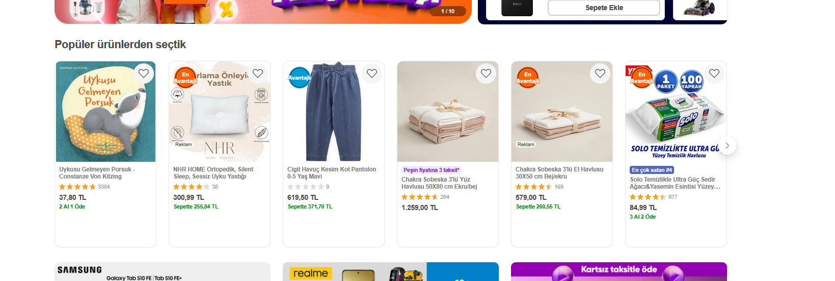
On landing page there are multiple sections with products list.
1. First section shows most popular items. They can be choosen by numner of positive opinions or by number of sold products.
2. Second section good occasion like, low price, or free first installment
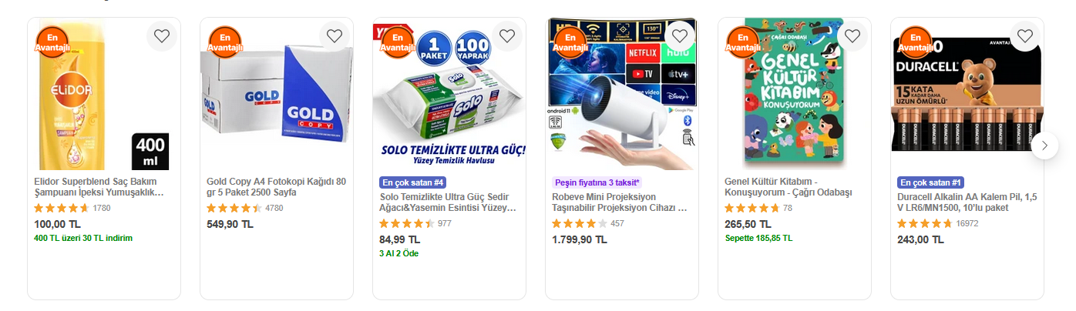

3. Third section are product on discount

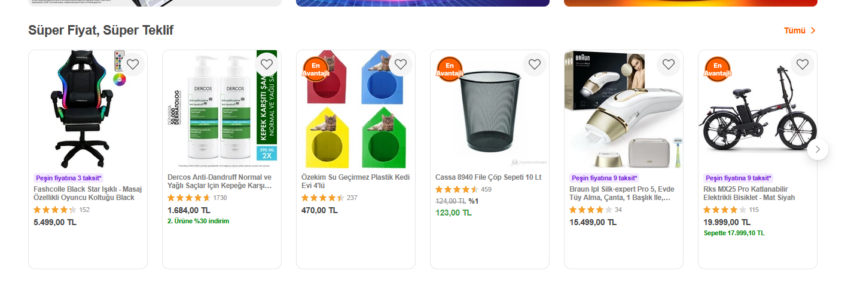
4. Fourth section are products that the user recently viewed
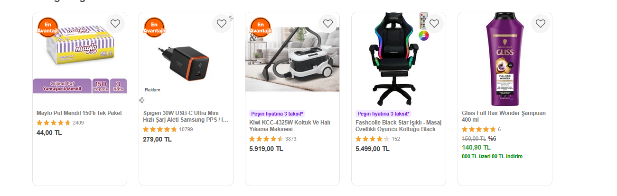
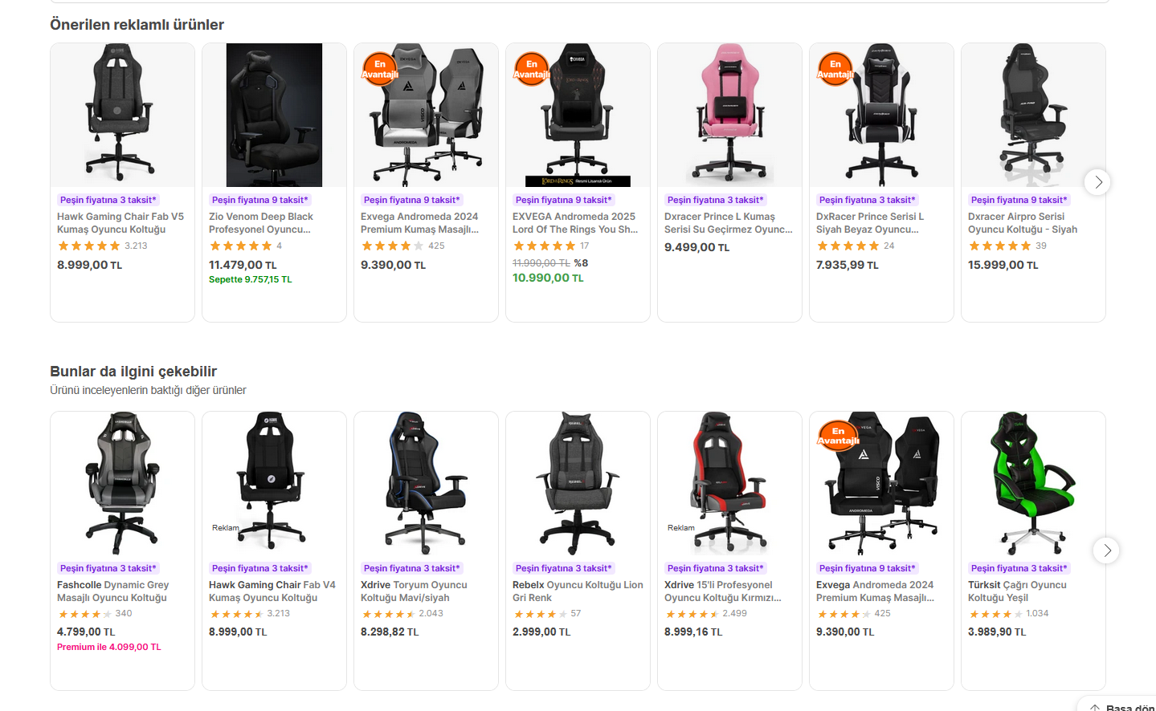
When we open a specific product and scroll down, recommended products seem to be from the same category, for example when I Open gaming chair I can see other gaming chairs recommendations:

The cart recommendations are split into 3 sections:
First one look like items that you recently viewed but you didn’t add to cart.
Second one looks like upsell items that can work well with items you added to the cart
Third section is about items from the same category, different variants of the same item.
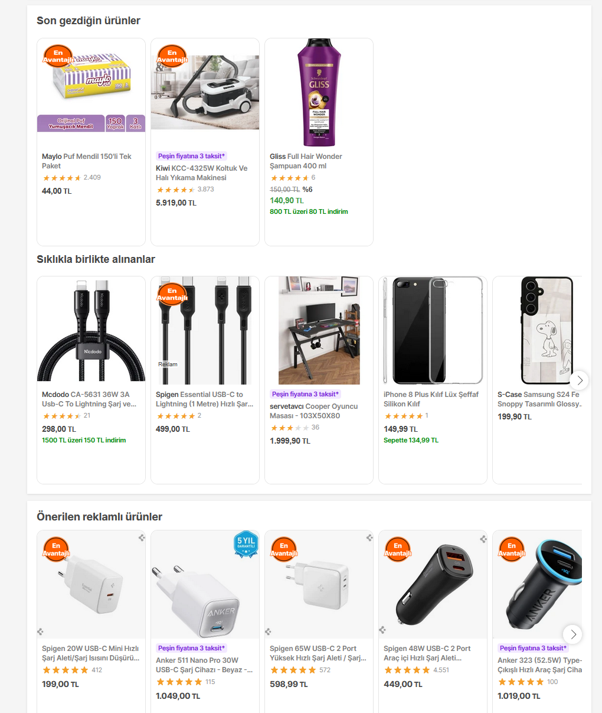

Task 3
Automate the scenario below:
1. Visit https://useinsider.com/ and check Insider home page is opened or not
2. Select “Company” menu in navigation bar, select “Careers” and check Career
page, its Locations, Teams and Life at Insider blocks are opened or not
3. Go to https://useinsider.com/careers/quality-assurance/, click “See all QA
jobs”, filter jobs by Location - Istanbul, Turkey and department - Quality
Assurance, check presence of jobs list
4. Check that all jobs’ Position contains “Quality Assurance”, Department
contains “Quality Assurance”, Location contains “Istanbul, Turkey”
5. Click “View Role” button and check that this action redirects us to Lever
Application form page
- Test case should be written using any programming language and framework
(Python or Java + Selenium would be preferable)
- No BDD(Cucumber, Quantum, Codeception, etc.) frameworks are allowed
- Screenshot should be taken If test fails one of steps
- Test case should be able to run in Chrome and Firefox browsers and ensure
that the browser is parametrically changeable.
- Test code should fully meet POM requirements.

Code for this task can be found in this repository:
https://github.com/MBrylka/insider-qa-tech-task

Description:
There are 2 test scenarios:
1. We check if clicking menu item company > careers opens a careers page correctly and if all sections are visible.
There are 2 pages involved here: home page and careers page.
Many different checks can be done on careers page:
- Are the sections visible
- If you click “See all teams” are more departments loading
- Are arrows working for locations section,
- can you see different time based on what location is hovered

For purpose of this task I only checked visibility of different sections.
Framework uses POM for pages management. There is BasePage main class that provides basic functionality like selecting or interacting with elements + wait mechanism and other pages derrive from that class.
In testconf.py a command line parameter was added “—browser chrome,firefox”. You can specify which browser tests should be executed on. Adding a new browser is straight forward 1 line code in a fixture.
2. We check if careers/quality-assurance page redirects to open-positions page correctly. From there we check filtering and also check if opening a specific job open a new tab with job description.

For test results, report.html file is generated, if a test fails screenshot is added.
Problems: I noticed that website behave diffrently in selenium browser, looks like it has some kind of detection mechanism implemented which result in very flaky tests. Maybe the purpose of this test is to stop bots from scraping the page. To address this issue I would need to consult with the team how it works to fix tests accordingly.

Task 4
Test Automation - API
Using “pet” endpoints from https://petstore.swagger.io/ write CRUD operations API
tests with positive and negative scenarios

Code for this task can be found in this repository:
https://github.com/MBrylka/insider-qa-tech-task

Description:
/pet endpoint have total of 8 endpoints. For this task purpose I only used 4 of them:
- create new pet,
- update pet,
- find pet by id
-remove pet.
Those endpoints fully cover CRUD functionality.
It would be nice to add database requests for creating, updating and removing pets
Problems: This API seem to return random data sometimes so its hard to check changes, for example when I remove a pet, and then try to fetch it by ID, I expect api to return 404 but it returns a different pet.

