SCAN
Soccer Cognitive AI Network
Midterm Progress Report
ROUGH DRAFT OUTLINE

Student | [Your name]
Program / Course | RPI Cognitive Science Co-Terminal M.S. / [Course]
Advisor | Prof. Mei Si
Date | [Midterm submission date]
Purpose of this document: an editable midterm-report outline that captures the current implemented system, preliminary results, limitations, and next steps. Sections can be expanded, shortened, or reordered for the final submission.

1. Project Overview
SCAN (Soccer Cognitive AI Network) is an AI-driven soccer training system designed to analyse individual training repetitions and provide feedback in a cognitively informed way. The project separates computer vision, probabilistic judgement, intervention policy, and language generation so that feedback can be technically grounded without becoming constant or unnecessarily distracting.
[Expand this into a 1-2 paragraph introduction describing the problem, target users, and why adaptive feedback matters.]
Working research question
How can an AI training system combine visual perception, uncertainty-aware judgement, and attention-sensitive coaching policy to provide soccer feedback that is useful, timely, and cognitively appropriate?
Core design claim
SCAN should not simply detect a possible mistake and immediately speak. Instead, perception should provide evidence, Jev should express uncertain judgements, the controller should decide whether intervention is appropriate, and the language layer should communicate only what the evidence supports.

2. Progress at a Glance
Component | Status | Current capability
Video / pose analysis | Implemented | MediaPipe pose pipeline, strike detection, rep metrics, annotated video, CSV/JSON outputs.
Player ROI / calibration | Implemented / refining | Automatic player localisation replaced the original fully manual crop for routine analysis.
Ball tracking | Implemented / refining | YOLO detections combined with motion logic and optical flow; short-horizon prediction used conservatively.
Goal tracking | Implemented | One-time camera calibration, perspective-aware goal region, entry detection, and goal-zone classification.
SituatedState | Implemented | Structured representation of drill context, action phase, body evidence, shot outcome, confidence, and future history hooks.
Jev judgements | Implemented | Probabilistic technique quality, outcome quality, primary issue, and feedback-warranted judgements.
Controller / policy | Prototype / evolving | Priority-based policy for cognitive-load protection, repeated errors, end-of-rep feedback, and future hazard override.
Coaching synthesis | Implemented | Deterministic CoachingReport fallback plus constrained LLM refinement; detailed report separated from short voice cue.
Web / mobile interface | Implemented | Next.js session report, annotated video, metrics, voice toggle, spoken coaching cue.
Phone Live Session v0.1 | Working prototype | Phone camera records a short rep, sends it to the laptop backend, receives analysis, speaks cue, and returns to READY.

3. Current System Architecture
The system is intentionally layered. The perception stack measures what happened; SituatedState packages relevant evidence; Jev converts that evidence into probabilistic judgements; the controller determines whether an intervention is appropriate; and the coaching synthesis layer converts justified conclusions into a detailed report and a short spoken cue. The separation is intended to reduce hallucinated coaching claims and preserve cognitive-load constraints.
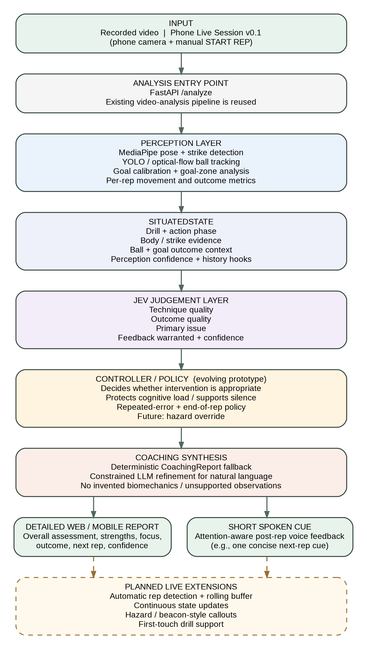
Figure 1. Current SCAN architecture. Solid boxes represent the implemented or active analysis path; the controller is still evolving, and the dashed box shows planned live-session extensions.
[In the final report, add 1-2 paragraphs explaining why each layer is separated and how this supports the Cognitive Science contribution.]

4. Implemented System Components

4.1 Perception: Pose and Shot Analysis
The first working SCAN prototype analysed prerecorded shooting clips with MediaPipe pose estimation and OpenCV. It estimates a probable striking leg and strike frame, extracts body metrics such as torso lean and knee angles, and generates an annotated video plus machine-readable CSV/JSON outputs. Automatic player localisation was added so the system no longer depends on a manually typed crop for normal use.
[Add one screenshot of the annotated pose output and a short note about pose coverage on representative clips.]

4.2 Ball and Goal Tracking
Ball tracking combines detector evidence with temporal tracking. The implementation progressed from detector-only tracking to a more conservative design using optical flow for short visual continuation and brief motion prediction only when direct visual evidence is lost. Goal tracking uses a one-time camera calibration and perspective-aware goal coordinates to classify observed entry location into six goal zones.
[Discuss one difficult clip where the ball is briefly lost and one easier clip where the path remains stable. Keep claims about real-world speed or biomechanics provisional.]

4.3 SituatedState
SituatedState is the structured bridge between perception and reasoning. It captures drill type, task goal, action phase, striking/support leg, pose usability, ball/goal outcome, confidence information, and fields reserved for repetition history. This allows later modules to reason over a compact task-relevant state instead of raw frames.

4.4 Jev Probabilistic Judgements
Jev is used as an uncertainty-aware judgement layer rather than as a policy controller. Current typed questions estimate technique quality, outcome quality, the most likely primary issue, and whether a specific corrective cue is warranted. This supports a key SCAN principle: a successful shot does not automatically imply perfect technique, and a technically imperfect rep does not automatically imply a poor outcome.
[Example to include: on a successful upper-right finish, Jev commonly rated technique as solid, outcome as excellent, selected no specific issue, and assigned low probability to corrective feedback. Replace with the exact values from the final example you choose.]

4.5 Controller / Attention-Aware Policy
The controller is designed to decide whether the system should intervene, independently of the wording layer. The prototype priority structure is: hazard override, cognitive-load protection / silence during action, repeated-error intervention, end-of-rep cue, then default silence. Early controller testing produced a 55% reduction in feedback volume relative to an always-on baseline while preserving all tested hazard-type interventions. These results are preliminary and should be presented as prototype-policy evidence rather than a final user-study result.

4.6 Coaching Synthesis and Voice
SCAN now generates a structured CoachingReport containing an overall assessment, positive evidence, primary focus, shot outcome, next-rep recommendation, spoken cue, and confidence note. A deterministic report is always available as a fallback. When the language model is available, it refines the wording under explicit constraints that prohibit invented biomechanics and unsupported observations. The written UI can provide reflection after the rep, while the spoken cue remains short and attention-focused.

4.7 Phone Live Session v0.1
The newest milestone moves SCAN beyond manual file upload. A phone can now act as the camera, interface, and audio device while the laptop continues to run the heavier analysis. In the current version, the athlete manually starts a rep, the phone records a short clip, the existing /analyze pipeline processes it, and the phone displays the result and speaks the concise cue before returning to a ready state.
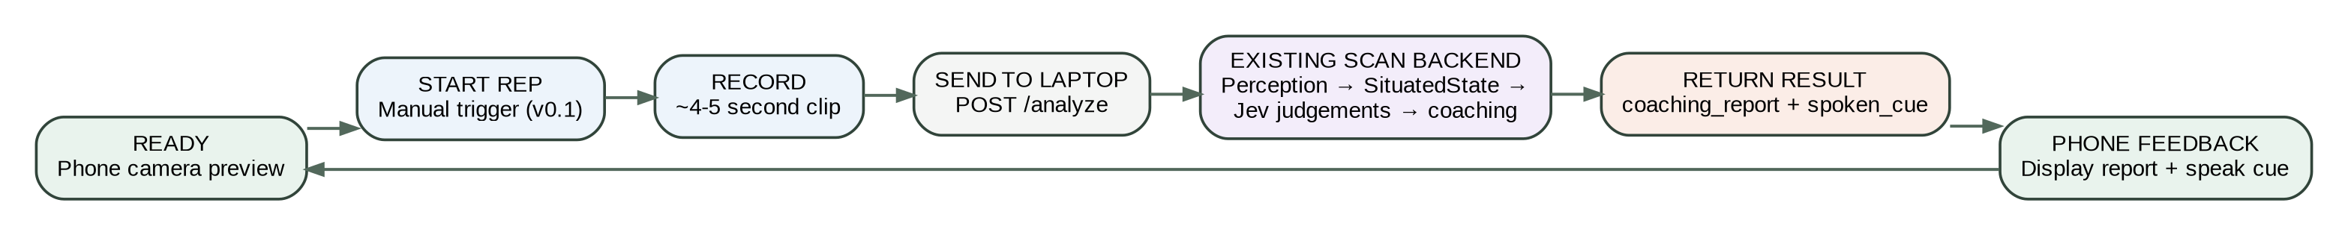
Figure 2. Operational flow of the current phone-based Live Session v0.1. Automatic rep detection is intentionally deferred to a later stage.

5. Preliminary Results and Example Behaviour
The current prototype is best treated as a working systems demonstration rather than a completed validation study. The most important result so far is that the full pipeline can move from a real training clip to structured perception, uncertainty-aware judgement, a constrained coaching report, and spoken feedback on both desktop and phone.
- Early controller experiment: approximately 55% lower feedback volume than an always-on baseline, with no missed tested hazard-type errors.
- Representative Jev behaviour: strong outcome judgements can coexist with only solid technique and low corrective-feedback probability, reducing the tendency to manufacture criticism after every successful rep.
- Failure handling has been tested: if the LLM is unavailable or out of credits, the deterministic CoachingReport still allows the analysis pipeline to complete.
- Phone Live Session v0.1 successfully closes the loop from camera capture to backend analysis to spoken post-rep cue.
[Add one final screenshot of the mobile live-session interface and one example coaching report before submission.]

6. Current Limitations
- Ball visibility remains camera- and clip-dependent; very small or occluded balls can still be lost, especially near the goal/net.
- Current body metrics and technical thresholds are engineering heuristics and are not yet validated soccer-biomechanics measures.
- Goal calibration assumes a stable camera geometry; moving or zooming the camera requires recalibration.
- The current phone mode is near-live rather than fully autonomous: the athlete still manually triggers each rep.
- Multi-rep adaptation is not yet fully integrated, so the system cannot yet make strong claims about consistency trends across a session.
- Hazard detection, Soundscape-inspired beacon/callout behaviour, and first-touch integration remain future work.

7. Planned Work After the Midterm
The next phase should prioritise autonomy and longitudinal adaptation rather than adding more single-rep wording complexity.
1. Multi-rep history: Track patterns across repetitions so SCAN can distinguish a one-off result from a repeatable technique/outcome pattern.
2. Automatic rep detection: Replace the manual START REP trigger with continuous camera monitoring and automatic clip extraction.
3. Live controller integration: Use continuous action phase and state updates so the controller can decide when to speak in real time.
4. Hazard + beacon callouts: Introduce Soundscape-inspired attention-aware live callouts only after the real-time state loop is stable.
5. First-touch drill: Extend the same architecture beyond shooting so the project demonstrates transfer across drill types.
6. Evaluation study: Run structured testing of feedback usefulness, intervention frequency, task performance, and cognitive load (e.g., NASA-TLX).

8. Suggested Midterm Discussion / Framing
The strongest midterm story is not simply that SCAN combines computer vision and an LLM. The contribution is the separation of perception, uncertain judgement, intervention policy, and communication. This makes it possible for the system to remain silent when a correction is not justified, express uncertainty when evidence is weak, and reserve short spoken feedback for moments when it is cognitively appropriate.
[Add 1 paragraph connecting this architecture explicitly to situated cognition, cognitive load, and the Soundscape-inspired attention model.]

9. Rough Conclusion
At the midterm stage, SCAN has progressed from a conceptual attention-aware coaching controller to a working end-to-end prototype. The system can analyse real shooting footage, estimate pose and ball/goal state, construct a situated representation, generate probabilistic judgements, synthesise constrained coaching feedback, and deliver that feedback through a web/mobile interface with spoken cues. The current phone prototype establishes a practical path toward the original goal of a coach that can run alongside training rather than requiring manual post-session video review. The remaining work is therefore less about proving that the pipeline can function and more about increasing autonomy, multi-rep adaptation, and experimental validation.

Appendix A. Editable Diagram Source (Mermaid)
The figure below is included as editable text so the architecture diagram can be regenerated in Mermaid-compatible tools if the system changes before submission.
flowchart TD
A[Recorded Video / Phone Live Session v0.1] --> B[FastAPI /analyze]
B --> C[Perception: Pose + Strike + Ball + Goal + Metrics]
C --> D[SituatedState]
D --> E[Jev Judgements]
E --> F[Controller / Policy]
F --> G[Coaching Synthesis: Deterministic Fallback + LLM Refinement]
G --> H[Detailed Web / Mobile Report]
G --> I[Short Spoken Cue]
H -. Future .-> J[Automatic Rep Detection / Live State / Hazard + Beacon Callouts]
I -. Future .-> J

