<html>

<head>

</head>

<body bgcolor="honeydew">

<center>

<h2>Employee Details</h2>

<form *action*="" *method*="POST">

<table>

<tr>

<td>Employee ID:</td>

<td><input *type*="text" *name*="eid"></td>

</tr>

<tr>

<td>Employee Name:</td>

<td><input *type*="text" *name*="ename"></td>

</tr>

<tr>

<td>Job Name:</td>

<td><input *type*="text" *name*="ejob"></td>

</tr>

<tr>

<td>Manager ID:</td>

<td><input *type*="text" *name*="manid"></td>

</tr>

<tr>

<td>Salary:</td>

<td><input *type*="text" *name*="sal"></td>

</tr>

<tr>

<td>

<input *type*="submit" *name*="btn" *value*="Submit">

</td>

</tr>

</table>

</form>

<form *action*="" *method*="POST">

<table>

<tr>

<td>

    Employees having Salary Greater than 35000 Click&nbsp;&nbsp;<input *type*="submit" *name*="salary_btn" *value*="Here">

</td>

</tr>

</table>

</form>

</center>

</body>

</html>

<?php

*if*(isset($_POST['btn'])){

    $a=$_POST['eid'];

    $b=$_POST['ename'];

    $c=$_POST['ejob'];

    $d=$_POST['manid'];

    $e=$_POST['sal'];

    $connection = mysqli_connect("localhost","root","");

*if*(!$conn){

*die*("Connection failed");

    }

    $db=mysqli_select_db($connection,"webprogram");

*if*(!$db){

*die*("Db failed");

    }

    $in="INSERT INTO employee(emp_id,emp_name,job_name,manager_id,salary) VALUES('$a','$b','$c','$d','$e')";

    $r=mysqli_query($connection,"$in");

*if*(!$r){

*die*("Insert failed");

    }

}

*else* *if*(isset($_POST['salary_btn'])){

    $connection = mysqli_connect("localhost","root","");

*if*(!$connection){

*die*("Connection failed");

    }

    $db=mysqli_select_db($connection,"webprogram");

*if*(!$db){

*die*("Db failed");

    }

    $l=35000;

    $s="SELECT * FROM employee WHERE salary >35000";

    $t=mysqli_query($connection,"$s");

*if*(!$t){

*die*("Insert failed");

    }

*else*{

        echo "<table border='3'>

        <tr>

        <th>Employee ID</th>

        <th>Employee Name</th>

        <th>Job</th>

        <th>Manager ID</th>

        <th>Salary</th>

        </tr>";

*while*($row=mysqli_fetch_assoc($t)){

            echo"<tr><td>".$row['emp_id']."</td><td>".$row['emp_name']."</td><td>".$row['job_name']."</td><td>".$row['manager_id']."</td><td>".$row['salary']."</td></tr>";

        }

        echo "</table>";

    }

}

?>

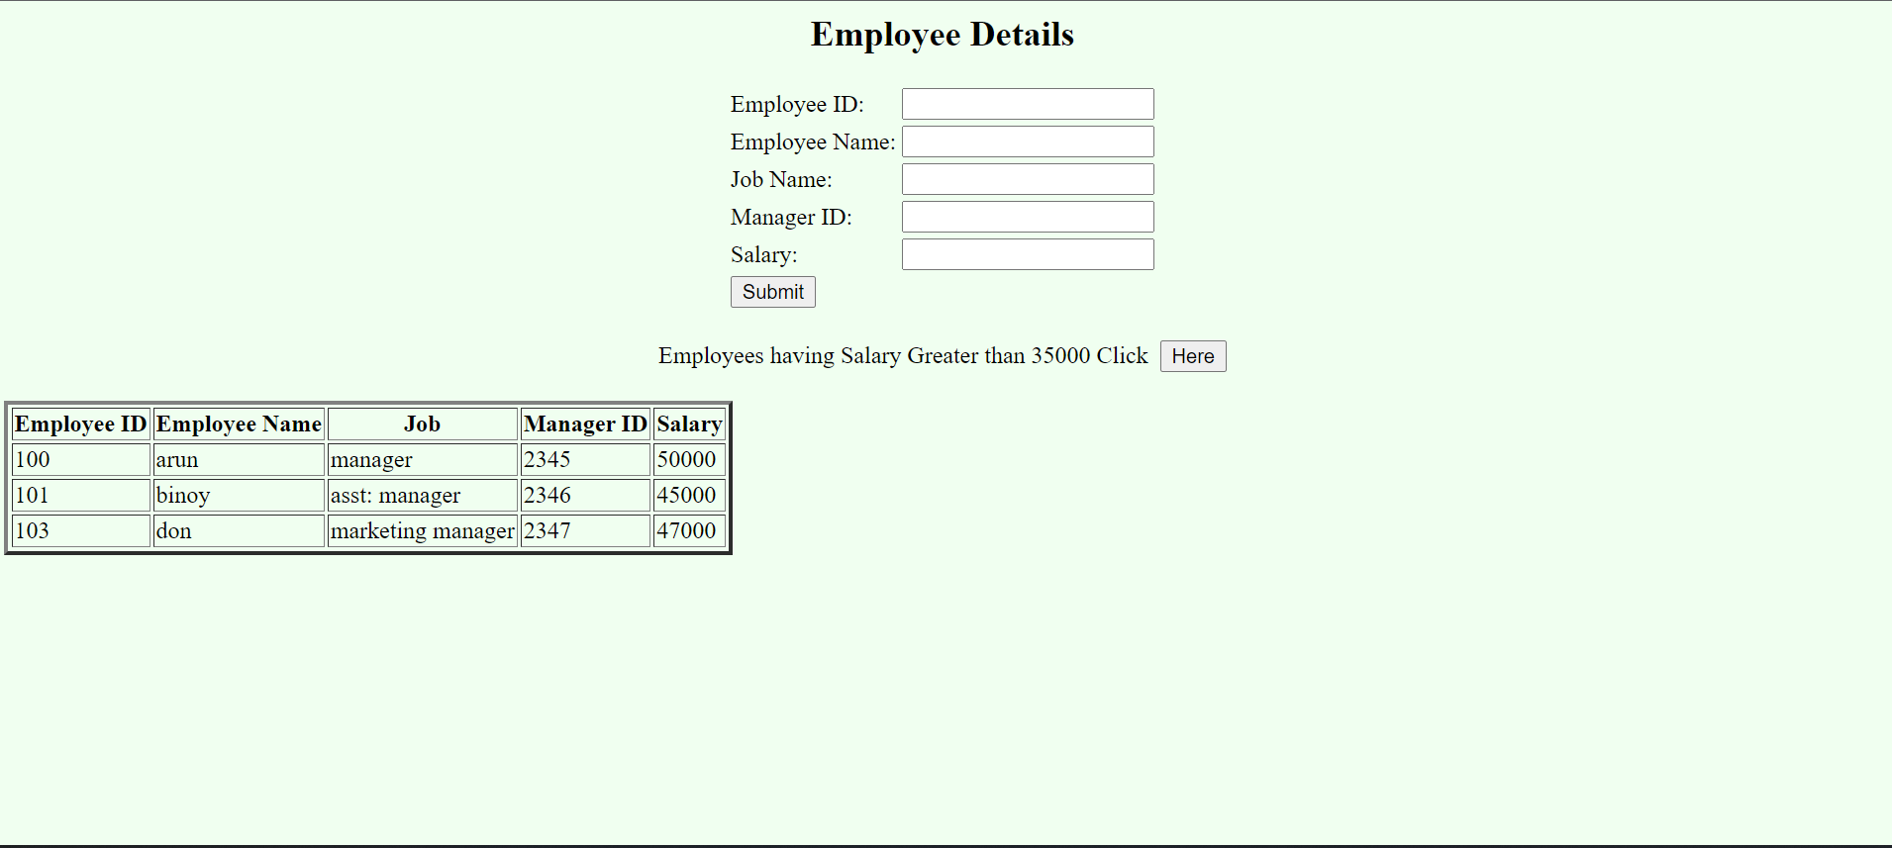OUTPUT