**SEMAPHORE IMPLEMENTATION**

**DINING PHILOSOPHER PROBLEM**

**MOTIVATION: Simulation of shared database.**

**one actors as a class:**

1. **Philosopher either can eat at a time or think but not both at the same time.**

**Constraints**

1. **A philosopher can eat only when he has two chopsticks otherwise not.**
2. **At an instant of time only two philosophers can eat because only five chopsticks are available.**
3. **When any two philosophers are eating then rest of the philosophers have to think.**

**Basic structure of the solution**

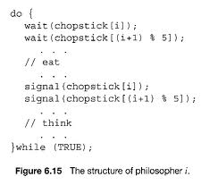

**Language used**

**Visual basic .net**

**Working**

**In this problem there are five philosophers and they are sitting around a round table with five chopsticks and a bowl containing some eatable stuff. Each philosopher has to eat only he has two chopsticks otherwise he has to think.**