Catalog of Lintels
Famagusta, Armenian Church
LIN.1 Lintel, South Portal (Reconstructed) (Fig. 1, Fig. 2)
The lintel block is monolithic and is set on simply-fashioned rounded corbels. The block itself supports only the weight of the ashlar blocks in the tympanum area, while the pointed-arch made with precisely-cut voussoirs blocks above bears the weight of the wall. As can be seen from Enlart's ninetieth-century drawing of the Armenian Church, the south portal was in ruins. The lintel block can be seen at the bottom of the opening as though it had simply fallen when the wall was damaged. This position of the fallen lintel block suggests that the damage to the portal was not aimed at defacing the lintel or its tympanum, but rather an opening was blasted in the south wall in an effort to gain entry.
LIN.2 Lintel, North Portal (Fig. 3)

LIN.3 Lintel, West Portal (Fig. 4, Fig. 5)

Famagusta, Cathedral of St George of the Greeks
LIN.4 Lintel, South Wall Portal (Fig. 6)
The lintel that was originally over the south wall portal is missing, as are the tympanum blocks that would have been above the lintel. The hood molding in the archway is in relatively good shape indicating that the lintel and tympanum blocks were removed intentionally and rather carefully.
LIN.5 Lintel, Frontispiece Center Portal (Fig. 7)
The central portal of the frontispiece differs from the other three portals in the building in that it has no corbels or capitals. Instead, the jamb moldings continue to become the torus moldings of the portal arch. It is not clear whether a lintel existed here, however, it is likely since the fragment of rubble wall behind the arch opening indicates that there was probably a tympanum.
LIN.6 Lintel, Frontispiece, South Portal (Fig. 8, Fig. 9)
Although this lintel has been removed, a marble fragment remains, indicating a more expensive material was used than that found in the elsewhere in the church.
LIN.7 Lintel, Frontispiece, North Portal (Fig. 10)
The right side of the portal is in a ruined state, perhaps destroyed by cannon blasts during the Ottoman siege of 1571. Enugh of the left side remains to indicate there was a lintel in place here. As with the other two portals, the lintel was unsculpted and was relieved of its supporting duties by the shallow pointed arch directly behind.
LIN.8 Lintel, Bema, Chamber Door (Fig. 11)
This lintel, in the doorway to a small chamber between the prothesis and the bema, is of type D. The gap between the lintel and the ashlar blocks above is pronounced and extends several inches beyond the edge of the corbels below the lintel. The importance of this doorway with greater liturgical significance than two other similarly sized doorways would warrant the extra seismic protection.
LIN.9 Lintel, South Wall, Door West (Fig. 12)

LIN.10 Lintel, South Wall, Door North</span> (Fig. 13)
The lintel spanning the door leading from the diaconicon to the exterior (since filled in) is type A. It is not supported by corbels and the stone wall above is directly supported. A large crack in the center of the lintel is beneath the middle of a block above and is part of a large cram that runs up the wall.
LIN.11 Lintel, Diaconicon, Small Chamber Door (Fig. 14)

Famagusta, Church of St Anthony
Famagusta, Church of St. Anne
LIN.12 Lintel, West Portal (Fig. 15)
What appears to be the original limestone lintel is a monolithic block spanning the 1.9 meter opening and with a depth of 0.48 meters and supported on simple curved corbels. A wide gap above separates the block from the next course of blocks which themselves form a straight arch consisting of a wedge-shaped keystone and to adjoining blocks. On the tympanum can be seen one of the rare remains of fresco in Latin cypriot buildings depicting St. Anne flanked by two angels. The lintel block is in good condition without any visible cracks.
LIN.13 Lintel, North Portal (Fig. 16)
The lintel of the north portal is a monolithic block with a vertical depth of 0.44 meters, similar to the lintel in west portal, but spanning a narrower opening of 1.63 meters. As with the west portal, the lintel has a pronounced gap along the top cord separating it from the relatively few tympanum blocks above, the first course of which is a straight arch. The blocks of the straight arch seem jumbled, leaving the gap narrower on one end than the other, giving the impression that the gap was providing a buffer from the movement experienced during seismic shifting. Indeed, the lintel block is in fine condition, showing no cracks. The corbels supporting the lintel are simple quarter circles that are 0.25 meters in radius and extend 0.44 meters from the edge of the main arched portal opening.
Famagusta, Church of St. Mary of Carmel
LIN.14 Lintel, West Portal (Fig. 17)

LIN.15 Lintel, Apse Door, South (Fig. 18)

Famagusta, Church of the Franciscans
Famagusta, Lala Mustafa Pasha Mosque (St Nicholas)
LIN.16 Lintel, North Tower Doorway, East (Fig. 19, Fig. 20)

LIN.17 Lintel, North Tower Doorway, West (Fig. 21, Fig. 22)

LIN.18 Lintel, North Tower Doorway, South (Fig. 23)

LIN.19 Lintel, South Tower Doorway, East (Fig. 24)

LIN.20 Lintel, Western Frontispiece, North Portal (Fig. 25)

Famagusta, Nestorian Church of St. George the Exiler
Famagusta, Sinan Pasha Mosque (Church of St Peter and Paul)
LIN.21 lintel (Fig. 26)

Famagusta, St George of the Latins
LIN.22 Lintel, North Portal (Modern) (Fig. 27, Fig. 28)

LIN.23 Lintel, Apse Chamber Door (Fig. 29)

Famagusta, St. Clare (?)
Famagusta, Twin Churches (Hospiallers and Templars
Famagusta, Unidentified Church 13
Famagusta, Unidentified Church 14
Famagusta, Unidentified Church 15
LIN.24 lintel (Fig. 30, Fig. 31, Fig. 32)

LIN.25 lintel (Fig. 33, Fig. 34)

LIN.26 lintel (Fig. 35)

Famagusta, Unidentified Church 16
Famagusta, Unidentified Church 17
LIN.27 Lintel, Western Portal (Fig. 36, Fig. 37, Fig. 38)

Famagusta, Unidentified Church 18
LIN.28 Lintel, Western Portal (Fig. 39, Fig. 40)

LIN.29 Lintel, Door, North Wall (Fig. 41, Fig. 42)

LIN.30 Lintel, South Wall (Fig. 43)

Figures
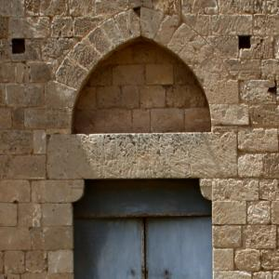
Fig. 1 Lintel, South Portal (Reconstructed)
Famagusta, Armenian Church
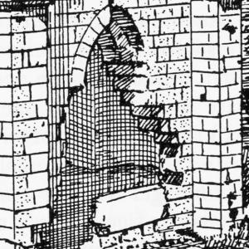
Fig. 2 Lintel, South Portal (Reconstructed)
Famagusta, Armenian Church
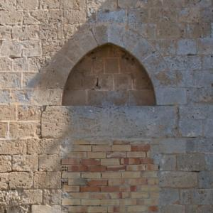
Fig. 3 Lintel, North Portal
Famagusta, Armenian Church
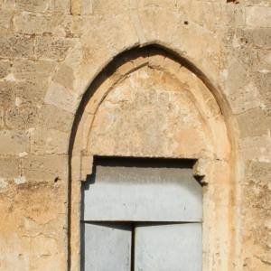
Fig. 4 Lintel, West Portal
Famagusta, Armenian Church
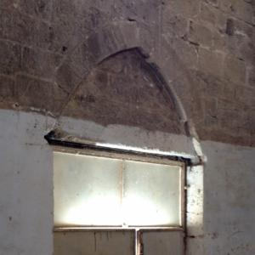
Fig. 5 Lintel, West Portal
Famagusta, Armenian Church
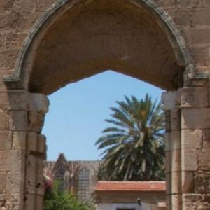
Fig. 6 Lintel, South Wall Portal
Famagusta, Cathedral of St George of the Greeks
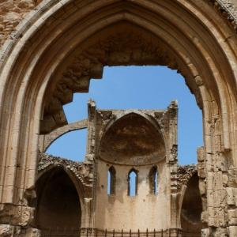
Fig. 7 Lintel, Frontispiece Center Portal
Famagusta, Cathedral of St George of the Greeks
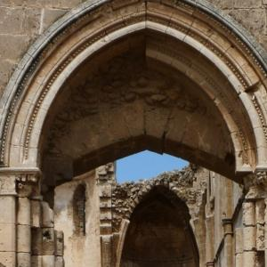
Fig. 8 Lintel, Frontispiece, South Portal
Famagusta, Cathedral of St George of the Greeks
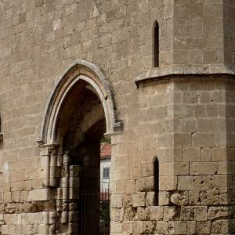
Fig. 9 Lintel, Frontispiece, South Portal
Famagusta, Cathedral of St George of the Greeks
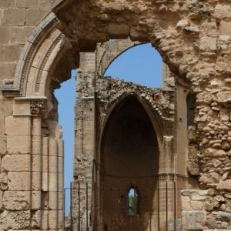
Fig. 10 Lintel, Frontispiece, North Portal
Famagusta, Cathedral of St George of the Greeks
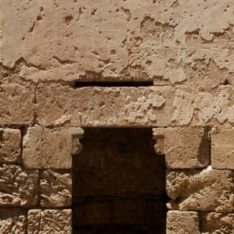
Fig. 11 Lintel, Bema, Chamber Door
Famagusta, Cathedral of St George of the Greeks
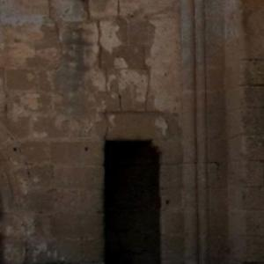
Fig. 12 Lintel, South Wall, Door West
Famagusta, Cathedral of St George of the Greeks
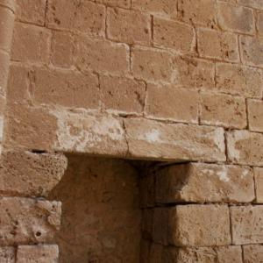
Fig. 13 Lintel, South Wall, Door North</span>
Famagusta, Cathedral of St George of the Greeks
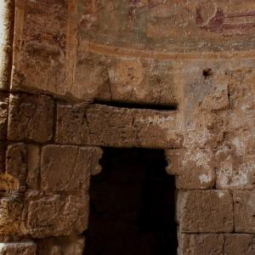
Fig. 14 Lintel, Diaconicon, Small Chamber Door
Famagusta, Cathedral of St George of the Greeks
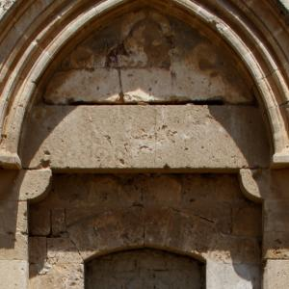
Fig. 15 Lintel, West Portal
Famagusta, Church of St. Anne
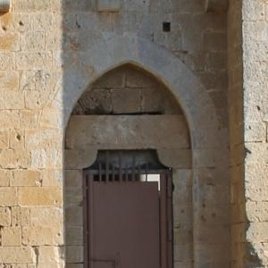
Fig. 16 Lintel, North Portal
Famagusta, Church of St. Anne
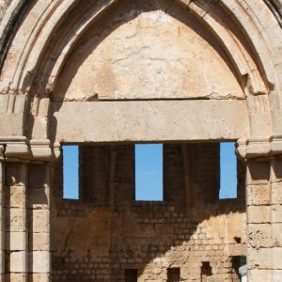
Fig. 17 Lintel, West Portal
Famagusta, Church of St. Mary of Carmel
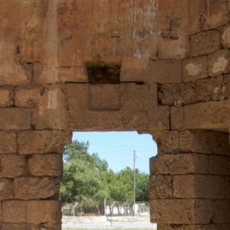
Fig. 18 Lintel, Apse Door, South
Famagusta, Church of St. Mary of Carmel
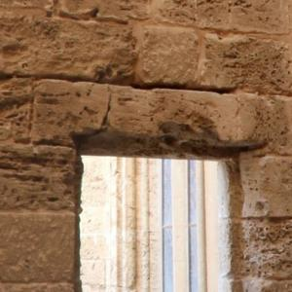
Fig. 19 Lintel, North Tower Doorway, East
Famagusta, Lala Mustafa Pasha Mosque (St Nicholas)
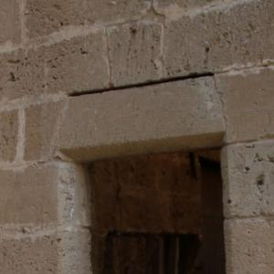
Fig. 20 Lintel, North Tower Doorway, East
Famagusta, Lala Mustafa Pasha Mosque (St Nicholas)
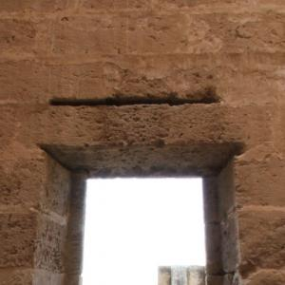
Fig. 21 Lintel, North Tower Doorway, West
Famagusta, Lala Mustafa Pasha Mosque (St Nicholas)
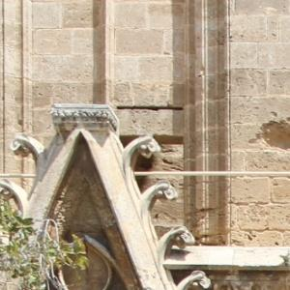
Fig. 22 Lintel, North Tower Doorway, West
Famagusta, Lala Mustafa Pasha Mosque (St Nicholas)
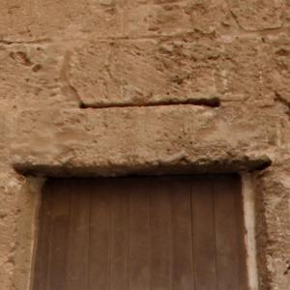
Fig. 23 Lintel, North Tower Doorway, South
Famagusta, Lala Mustafa Pasha Mosque (St Nicholas)
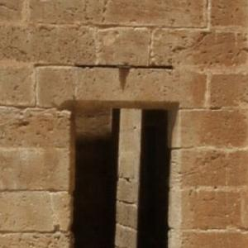
Fig. 24 Lintel, South Tower Doorway, East
Famagusta, Lala Mustafa Pasha Mosque (St Nicholas)
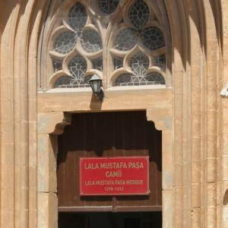
Fig. 25 Lintel, Western Frontispiece, North Portal
Famagusta, Lala Mustafa Pasha Mosque (St Nicholas)
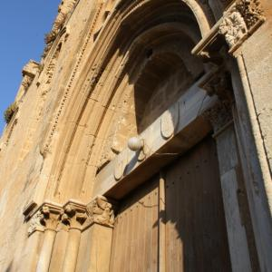
Fig. 26 lintel
Famagusta, Sinan Pasha Mosque (Church of St Peter and Paul)
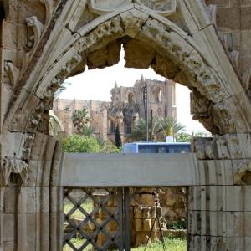
Fig. 27 Lintel, North Portal (Modern)
Famagusta, St George of the Latins
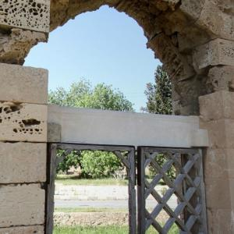
Fig. 28 Lintel, North Portal (Modern)
Famagusta, St George of the Latins
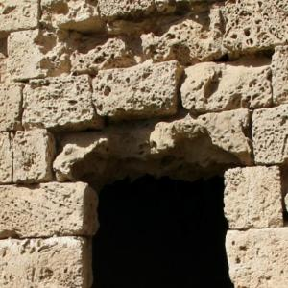
Fig. 29 Lintel, Apse Chamber Door
Famagusta, St George of the Latins
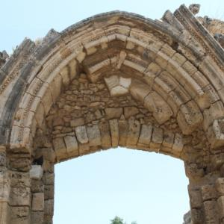
Fig. 30 lintel
Famagusta, Unidentified Church 15
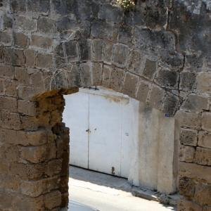
Fig. 31 lintel
Famagusta, Unidentified Church 15
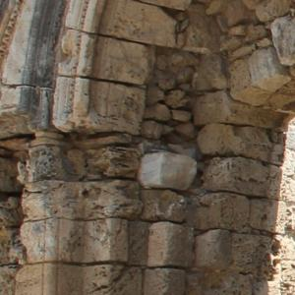
Fig. 32 lintel
Famagusta, Unidentified Church 15
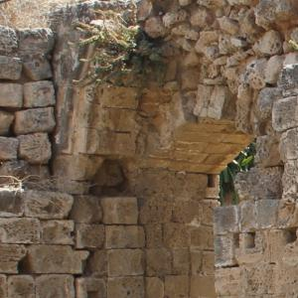
Fig. 33 lintel
Famagusta, Unidentified Church 15
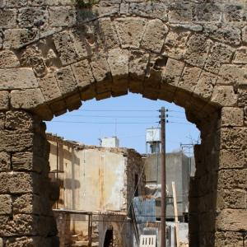
Fig. 34 lintel
Famagusta, Unidentified Church 15
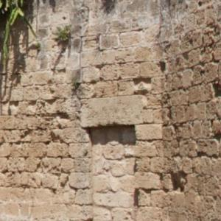
Fig. 35 lintel
Famagusta, Unidentified Church 15
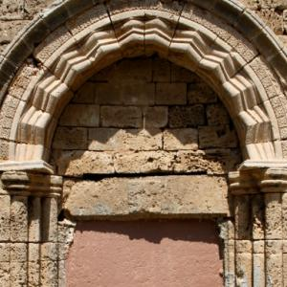
Fig. 36 Lintel, Western Portal
Famagusta, Unidentified Church 17
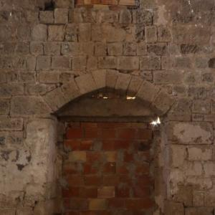
Fig. 37 Lintel, Western Portal
Famagusta, Unidentified Church 17
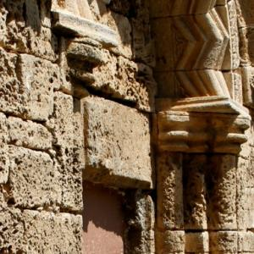
Fig. 38 Lintel, Western Portal
Famagusta, Unidentified Church 17
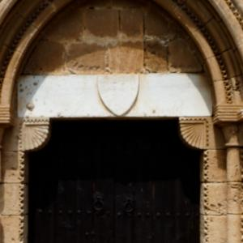
Fig. 39 Lintel, Western Portal
Famagusta, Unidentified Church 18
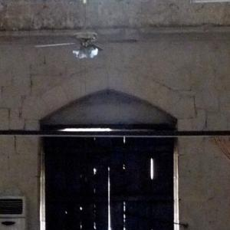
Fig. 40 Lintel, Western Portal
Famagusta, Unidentified Church 18
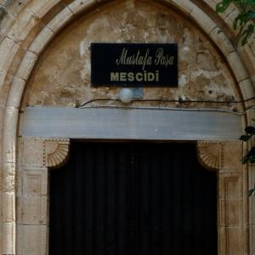
Fig. 41 Lintel, Door, North Wall
Famagusta, Unidentified Church 18
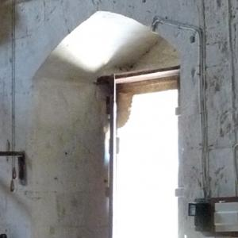
Fig. 42 Lintel, Door, North Wall
Famagusta, Unidentified Church 18
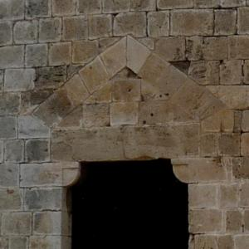
Fig. 43 Lintel, South Wall
Famagusta, Unidentified Church 18

Enlart said that this lintel was made of marble. Enlart, 1898, p.3

