PRogramming for computer games

2-Player Ball Game

Theory Section

Question 1a:

Game engines: Unity and Construct

Advantages of Unity over Construct:

* Free for mobile development
* Over 20 platforms
* Offers choice of scripting languages
* Very good editor

Question 1b:

Programming Languages: Java and C#

Features of C#:

* C# is a simple, modern, object oriented language.
* The classes and data types are common to all of the .NET languages.
* It aims to combine the high productivity of Visual Basic and the raw power of C++.
* We may develop Console application, Windows application, and Web application using C#.

Question 2:

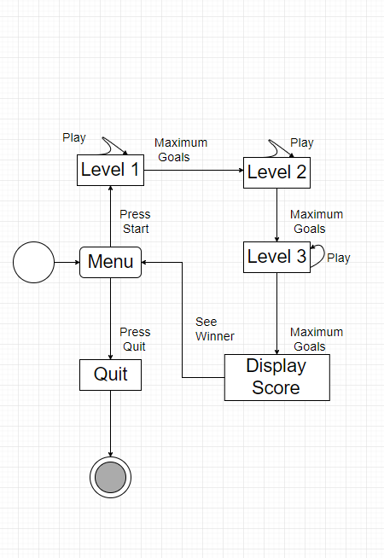

Figure 1: Whole Game State Diagram

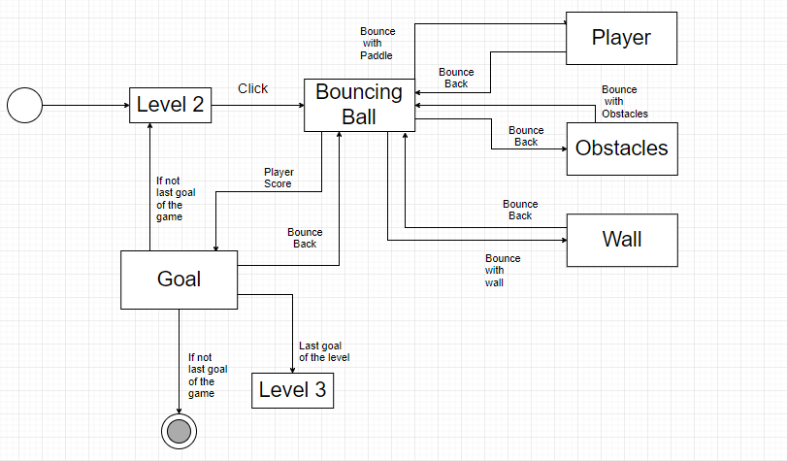

Figure 3: Level 2 State Diagram

Question 3:

Why is File Compression essential?

* File compression is when the size of a file or folder is reduced to save disk space. This helps in many cases because it saves a lot of time while transferring data over network or any other storage devices. Compressing images, videos and audio is ideal because these 3 file types are the most space consuming. Compression of files and folders can serve as security as not all computer systems can read compressed data. Data compression saves energy because every step of file transferring consumes power. Overall file compression helps the machine and the user by saving time and power.

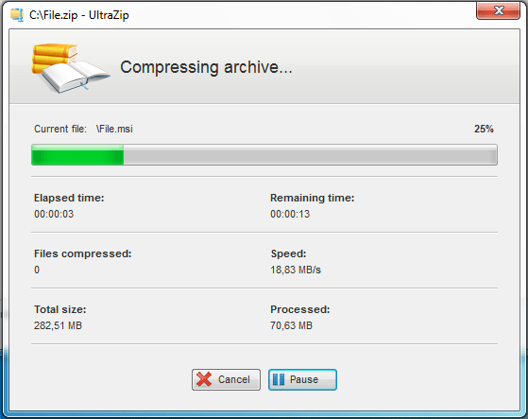

Figure 3: File Compression

References:

https://www.slant.co/versus/1047/1058/~unity_vs_construct-2 – Pros of Unity

http://www.c-sharpcorner.com/article/C-Sharp-and-its-features/ - C# features

https://itstillworks.com/file-compression-important-internet-11806.html, https://www.techopedia.com/definition/892/file-compression - Compression