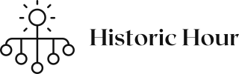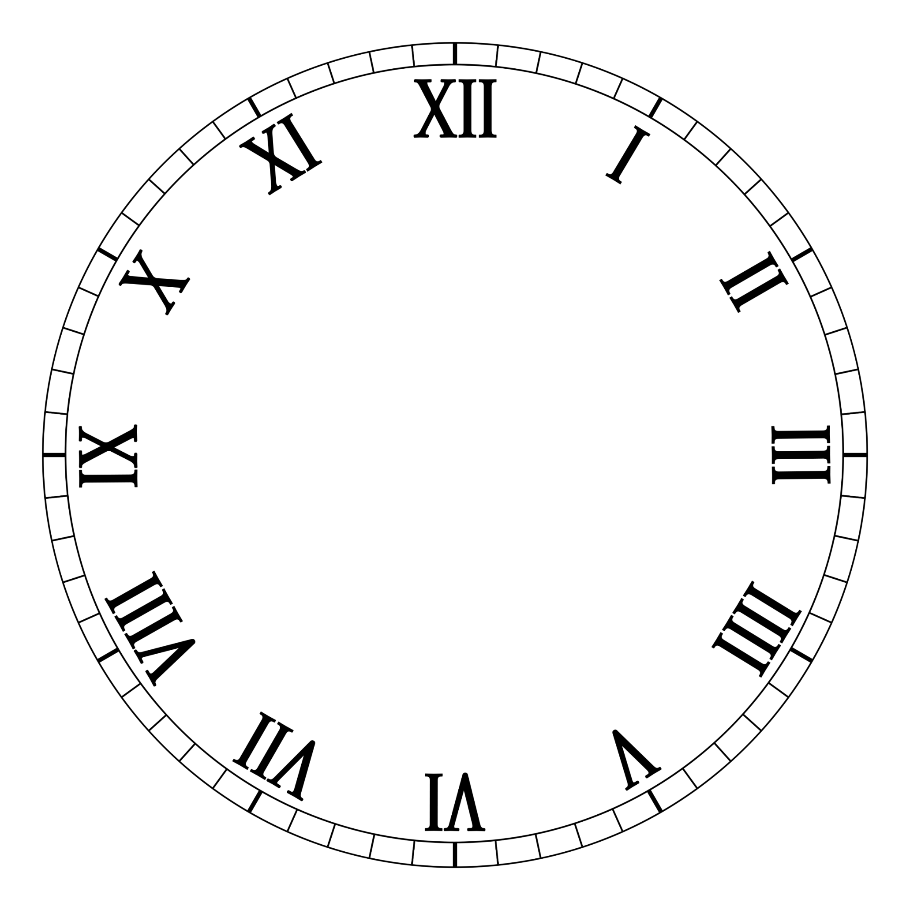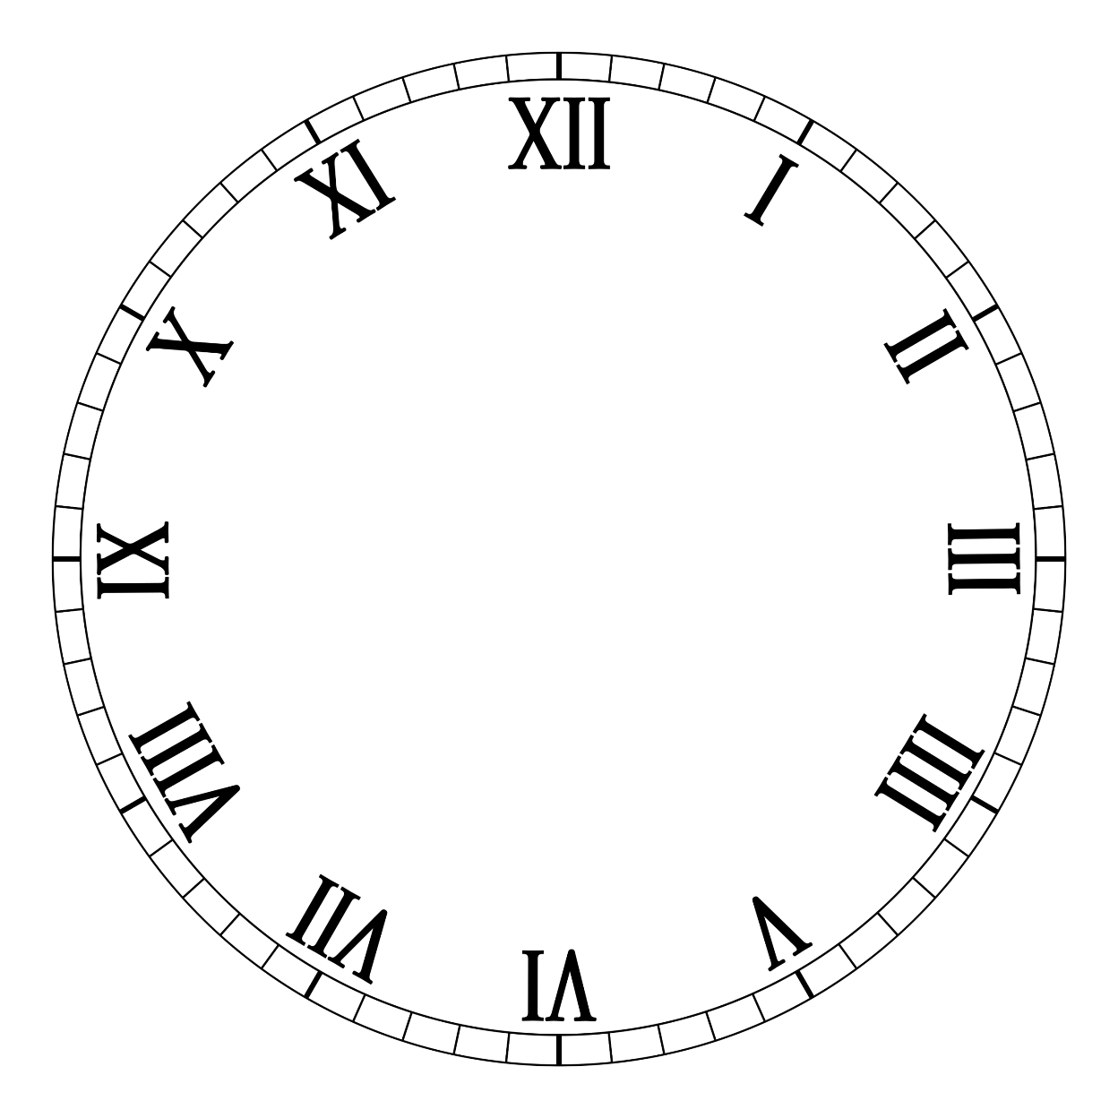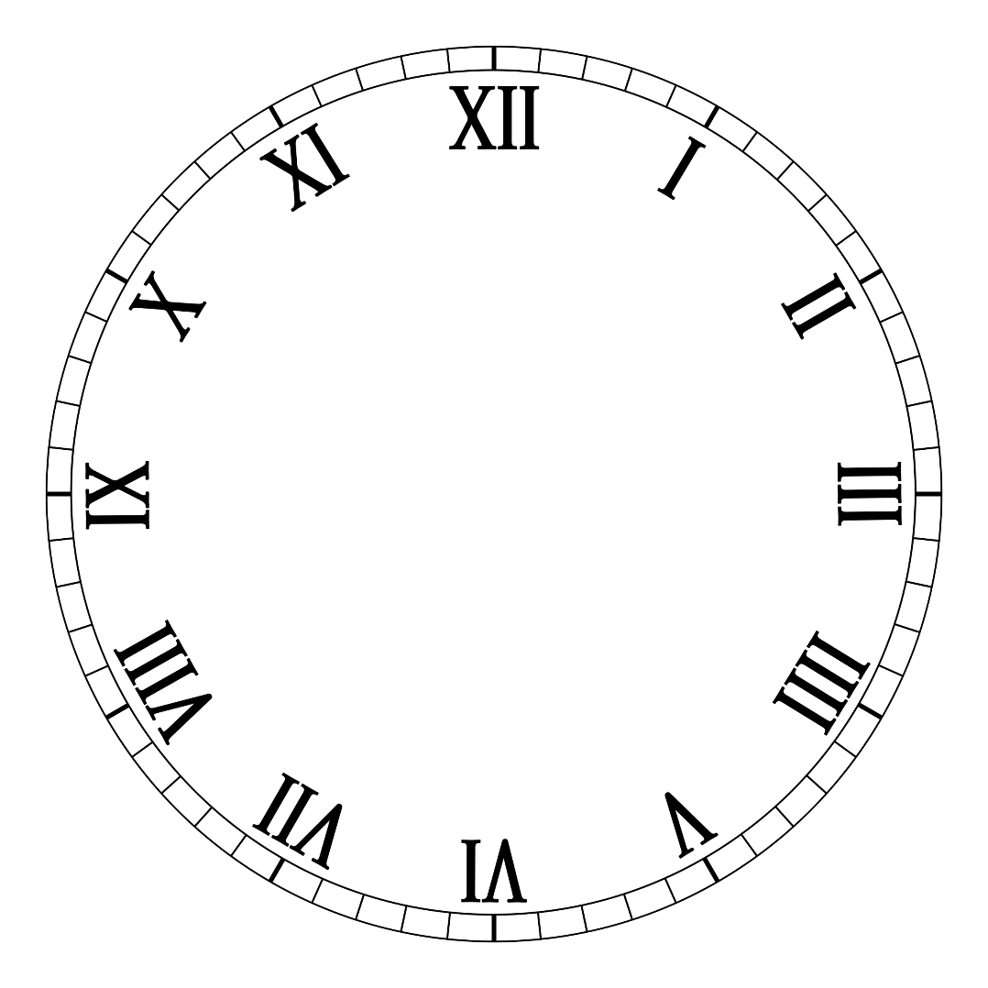

**HISTORIC HOUR**

**2022**

Contents

1. Team 1

2. Used Technologies 1

3. Resume 1

4. Stages of development 2

4.1 Idea 2

4.2 Organisation 2

4.3 Realisation 2

4.4 Testing 2

4.5 Polishing 2

4.6 Presenting 2

5. Diagram 3

# **Team**

* Vanina Teneva (QA Engineer)
* Mario Berberov (Back-End Developer)
* Dimitar Dimitrov (Front-End Developer)
* Ioan Gavrilov (Scrum Trainer)

# **Used Technologies**

* Visual Studio – Application
* Teams – Communication
* GitHub – Organization
* Microsoft Word – Documentation
* Microsoft PowerPoint – Presentation
* Microsoft Excel – QA Documentation
* TestCaseLab.com – QA Documentation

# **Resume**

This is an app made with the help of C++, made for the school project - "Linked Lists". The aim of the app is to create, search and sort out events. The program is associated with history and implemented using linked lists and gray code.

# **Stages of development**

# **4.1 Idea**

After forming a team, we chose everyone’s roles, and we organized the team’s meetings. We talked about our idea and how we were going to fulfill it.

# **4.2 Organisation**

For our organization we used planners in GitHub, where we have 5 different projects for Back-End, Front- End, Algorithms, Documentation and Presentation and Unit Testing. All the tasks were assigned to the team, and we started working on them.

# **4.3 Realisation**

Occasionally we held meetings where we talked about what we were going to do next on the code and we tried to neutralize any mistakes or problems.

# **4.4 Testing**

Our QA Engineer did the necessary tests cases and documentation to check if the program has any problems or mistakes on the code.

# **4.5 Polishing**

We had a meeting for one last time to check everything for any last mistakes and to finish the project

# **4.6 Presenting**

After we finished the presentation, we assigned everyone to different slides. Everyone wrote script for each slide, they were assigned to. We made the presentation automated such as adding each person’s voice to the slide.

# **Diagram**

