Six Card Golf - Socket Project Milestone
Matthew Bulger

Format and Order of Messages
This protocol uses a "request-response" format for communication. There is a single manager with a well-known, static IP address and port (4500 by default) receiving requests, and an arbitrary number of client processes receiving responses to their requests. The manager process listens for incoming messages from any of the clients and responds to them with the responses defined below. No additional acknowledgment messages should be sent back to the manager on receipt of the response; any acknowledgment sent will be incorrectly interpreted as a query to execute.
All requests and responses are strings encoded in the UTF-8 format. If at any point, the command is not recognized, rather than one of the responses below, the response “SYNTAX_ERROR” is returned.
Note that for all of the below requests and responses, double quotes (“”) indicates a message or subset of a message being sent. The quotes are not actually included in the messages.

Register Player
Registers a user with the manager by correlating a username with the network address (IP address and port) they will be listening at.
Request: “register <username> <port>”
<username> must be between 1-15 characters long and unique. <port> must be an integer and unique.
Note the user’s IP address does not need to be specified explicitly in the request, it will be taken from the datagram header. As well, the <port> is the smallest port the user has access to, but each client is actually allocated the next 4 ports as well (total of 5 ports) to be able to open multiple sockets each.
Response 1: “SUCCESS”
A response of “SUCCESS” indicates the username and port were unique, and successfully registered with the manager. The user with a corresponding username/port will be eligible to be assigned to a game.
Response 2: “FAILURE PORT”
This response indicates the manager was unsuccessful at registering the user, as the port has already been registered to another user. The client should re-register with the same username, but different port.
Response 3: “FAILURE USERNAME”
This response indicates the manager was unsuccessful at registering the user because another user already has registered the same username. It is possible the port specified was invalid, but the client should resolve the username issue before the port issue, hence this response takes priority.

Time Space Diagram
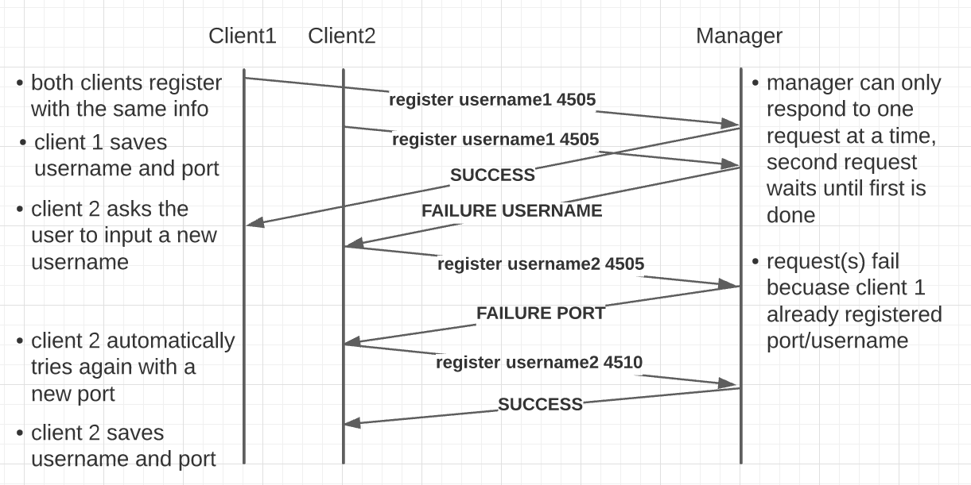Figure 1: Time Space Diagram of the "Register Player" request.

Query Players
Requests the number of players registers with the manager, as well as their user info (username and network addresses).
Request: “query players”
This request has no parameters.
Response: “<num_players><players>”
<num_players> is an integer of how many players are registered with the manager
This is followed by any number of players <players>, which have the format “\n(<username>, <ip_address>, <port>)”. Note the newline at the beginning, meaning each parameter and player will be separated by a single newline.

Time Space Diagram
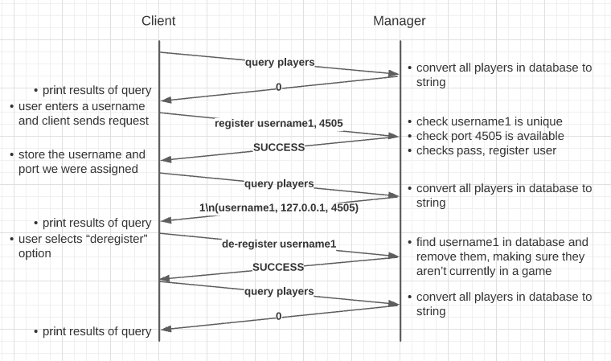Figure 2: Time Space Diagram of the "Query Players" request.

Query Games
Requests the number of games that are currently in progress, and for each game in progress, gets the users involved with that game.
Request: “query games”
This request has no parameters.
Response: “<num_games><games>”
<num_games> is an integer number of games that are currently ongoing, which is followed by the same number of <games>. Each of these games have the format “\n(<game_id>, <dealer_username>, [<players>])”. <players> is a list of each player in the game, including the dealer, each having the format “(<username>, <ip_address>, <port>)”, which each player separated by a comma. <game_id> is a unique integer id assigned to this game.

Time Space Diagram
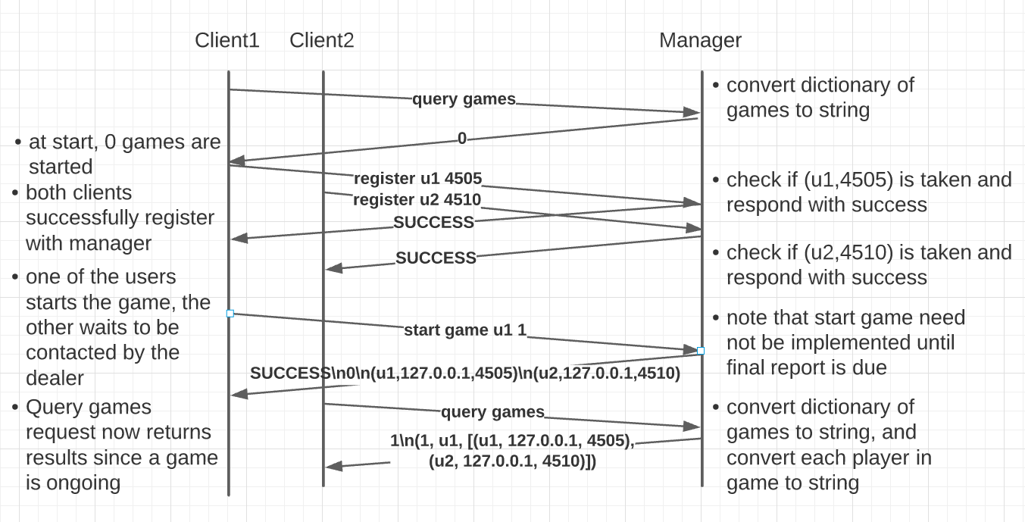Figure 3: Time Space Diagram of the "Query Games" request.

De-Register Player
Stops the manager from assigning a specific user to any new games, and frees the username/port to be used by a new user who joins.
Request: “de-register <username>”
<username> must be the username of a user who has already successfully registered by calling the “Register Player” request.
Response 1: “SUCCESS”
This response indicates the username was found successfully, and that username and port block has been de-allocated. The client should close all of its open sockets and exit to allow another client who joins to use those resources.
Response 2: “FAILURE”
This response indicates the de-registration was not successful. This is usually because you are trying to de-register a username that has not previously been registered with the “Register Player” request above.

Time Space Diagram
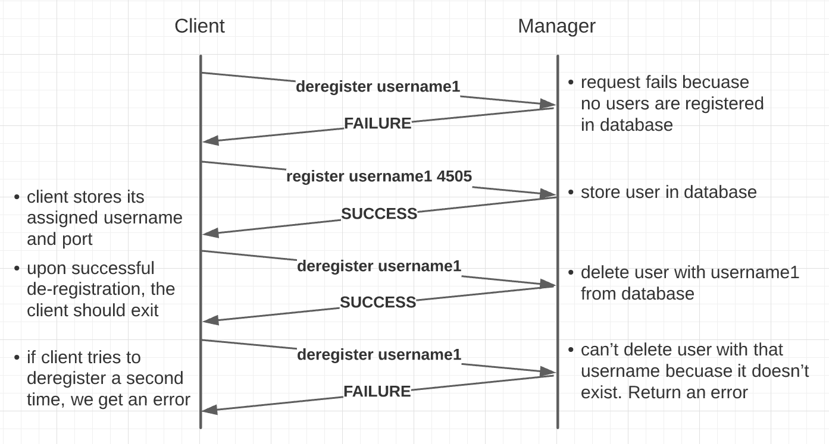Figure 4: Time Space Diagram of the "De-Register Player" request.

Design and Implementation Considerations
The implementation of the manager process and basic client process using UDP sockets was certainly not trivial, but I think my decisions came together to make a suitable prototype for the milestone. First of all, despite C++ socket code being provided to us, I decided early on that Python would be the way to go, as I already have quite a bit of experience with it, and I didn’t want to have to worry about memory management when I would already be struggling with the networking aspects.
Before doing any networking, I setup my Python project to have 3 major files: “main.py”, “client.py”, and “manager.py”. The user only ever needs to invoke the “main.py” file, with its responsibility being to parse the command line arguments you provide, which in turn invoke the manager process (with the “-m” argument) or the client (with no arguments or the “-q” argument for the query console).
My next consideration was what format I would be sending the messages back and forth in. While it would have made parsing easier to use a class or other data structure, I decided to use simple string requests that are encoded in UTF-8, which is the default string encoding in Python. This made it really easy to get some kind of messages sending back and forth, especially since the class textbook provided some simple sample code showing this technique in Python. Since all of the commands for this project are quite simple, with relatively few parameters needing to be sent, I prioritized messages that were quick to create/decipher while debugging, rather than messages that were parsed extremely easily, so I ultimately stuck with this protocol for sending messages.
The biggest design decision I faced for the milestone was deciding how ports were to be allocated among the clients. I was assigned a range of ports from 4500-4999, and since there is only one manager at a time, a naturally decided that it should get the first port, 4500. Since I have a lot of ports to work with, I decided to give it 4500-4504 right off the bat, in case I needed extra ports for something later on- this would allow me to address those extra ports based on an offset from the original port, which is a lot more convenient that needing to store an array of 5 ports. This seemed to work pretty well, so I applied the same technique for assigning ports to each client. When a client makes a request for a username and port, if that port is already taken, rather than moving to the next port, the client actually skips the next 4 ports and tries again. Thus, a manager or client can use 5 ports, but without incurring any additional overhead or complexity in the message format, like needing to manually specify 5 ports and their types for each user.
With basic registration working, I developed a basic “query console”, which is essentially just an infinite loop on the client that sends the raw string request from the console to the manager, and printing out the response that comes back. This was another huge benefit of sending strings instead of data structures; for just getting started, I didn’t have to worry about parsing the requests in code, I just had to formulate the strings myself, which made testing extremely fast. The implementation of the manager was similar quite simple. Rather than getting bogged down with an actual database, I merely used a list to store the registered users, and a dictionary that associates a Game ID with it’s dealer and list of players. This meant that ultimately, implementing the manager was a matter of parsing which query comes in and its parameters (which were just separated by whitespace), and then either appending to the respective list/dictionary or converting it to a string to be sent back as a response of a query. To help with converting to and from strings, I made classes for both games (“game.py”) and players (“player.py”). Each of these classes simply contain the necessary fields, and helper methods to convert those fields into the string format shown in the requests above, or parsing an object from a string that is in that format. As such, both the client and manager processes make use of these helper files. This ultimately allowed me to go from simply transferring strings from client to client, to actually sending structure data, which set me up nicely for sending lists of players for queries like “query players” and “query games”, but also game logic like “start game”.
With these requirements fulfilled, I was actually able to go on and implement a significant portion of the game logic of Six Card Golf on the client, which you will see in my commit history below, but the details of that protocol and the challenges I faced implementing it will be discussed in the upcoming final report.

Version Control
A private GitHub repository was my choice for version control on this project. Please note that I was able to complete a lot more functionality than was required by the milestone before 2/13/22. This additional functionality will be touched upon in the final report.
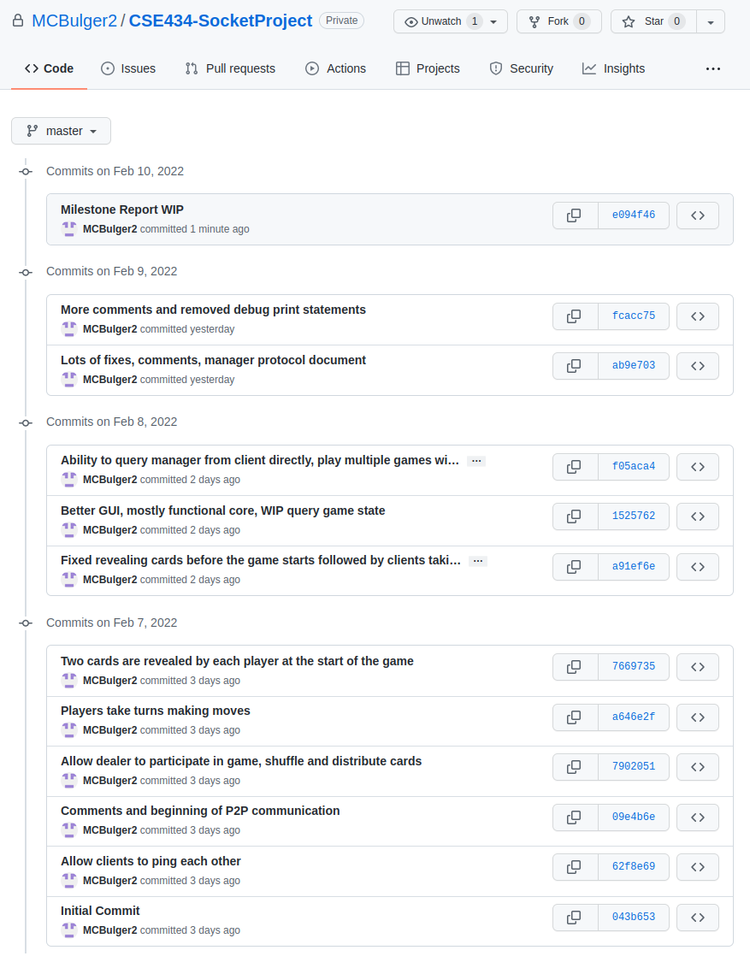

Video Demonstration
Video demo link: https://www.youtube.com/watch?v=v3aOAC23Wdo

Timestamps
- Compile the manager and player programs. - Not applicable since I used Python which is interpreted, not compiled. (0:42)
- Run the freshly compiled programs on at least two distinct end hosts. - I mention that I am running 4 different hosts on GENI at 0:00. At 0:51 I beginning starting up the manager and clients.
- First, start the manager. Then start 3 players and register with the server. - I start the processes from 0:51-1:53, and register the players from 1:53-2:45.
- Have one player issue a query players command. - 2:51
- Have a different player issue a query games command. - 3:10
- Exit the peers using de-register and terminate the server process. - 3:26

