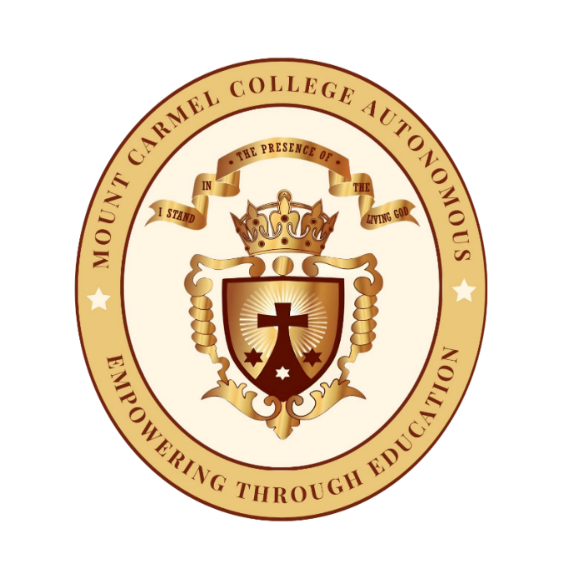
MOUNT CARMEL COLLEGE, AUTONOMOUS
(Affiliated to Bengaluru City University)
#58, PALACE ROAD, BENGALURU – 560052

DEPARTMENT
OF
XXXXX

20XX (XX Semester)

DEPARTMENT OF XXX
BOARD OF STUDIES MEETING

SCHEDULE
Date :
Time:
Venue:

Agenda:

MINUTES OF THE BOARD OF STUDIES MEETING

The Board of Studies of the Department of…… was held on Date at Time in Venue.
The Meeting commenced with reading of the minutes and resolutions of the previous Board of Studies held on Date.
The following agenda were placed by the Chairperson for deliberations by members of the BoS.
Agenda 1: XXXX
Discussion to be recorded

Agenda 2: XXXX
Discussion to be recorded

Resolutions passed by the Board of Studies, Department of XXX, September 2024
The Board of Studies of the Department of XXX resolved to approve the following resolutions:
- The BoS resolved to approve the following proposed courses for the discipline History offered under the triple major BA program – History, Economics, Political Science/ Psychology, History, Sociology from the academic year 2024-25.
- XXX
- YYY
- The BoS resolved to approve the assessment matrix for the UG program as per the SEP guidelines i.e. 20 ( Continuous Internal Assessment) and 80 ( Semester End Examination) for all the courses from the academic year 2024-25

The meeting concluded with the Chairperson thanking the members for their active participation in the deliberations of the meeting.

CHAIRPERSON (BOS)

Sl.No | Name | Signature
External Members
1. | University Nominee - Bengaluru City University
3. | Academic Expert
4. | Industry Expert
5. | Alumni Representative
Internal Members
6. | Dean
7. | Chairperson
8.

