GPU Farm 1.0
Maria Chiara Cecconi
My GitHub directory: https://github.com/MCC04/GPUfarm
Results Summary
The code has been designed to compare performances of different CUDA implementations:
- Future:
the host code spawns K thread, each one of them
- Cuda memory copy H2D
- Launch the kernel
- Cuda memory copy D2H
- Stream:
this technique tries to exploit data transfer time to hide kernel computation times, in this version of stream the code works as follows
For each new non-default stream:
- Cuda memory copy H2D, only a “slice” of the whole input data are transferred to device
- Launch the kernel, working only on the slice assigned to the current stream
- Cuda memory copy D2H
- Stream with managed memory:
This is analogous to the previous implementation, except for the memory management.
In this case we don't need to explicitly transfer data to/from device. The unified memory will do this for us, so we only need to:
- Launch the kernel, working only on the slice assigned to the current stream
- One SM:
This is a classical implementation of a kernel launch, forcing the device to use only one Streaming Multiprocessor. This will be useful, in performances analysis, as lowest parallel degree.

In the table below we give average time measures, w.r.t. number of host iterations

Host iters (#streams) | 4 | 8 | 16 | Kernel iterations
Elem Number | 7168 | 14336 | 28672 | Kernel iterations
Future | 0.966545 | 1.15176875 | 1.565461875 | 500
Future | 1.88885 | 2.21480 | 2.983875 | 1000
Stream | 3.7891675 | 8.69859 | 17.9969875 | 500
Stream | 7.4715925 | 17.1455874999 | 33.2975375 | 1000
Managed stream | 3.8915525 | 8.71605 | 16.68546875 | 500
Managed stream | 7.5729125 | 17.050137499 | 33.15710625 | 1000
One SM | 5908.82 | 13770.85 | 29508.70625 | 500
From those measures we can see that Future seems to have the better performances, in term of device completion time (measured using Events).
Streams and Managed Streams seem to have almost the same behavior: they require more time to complete all device operations w.r.t. Future code; furthermore the streams time doubles as the element number doubles. Future code, instead, seems to grow by a small factor.
Is this behavior due to a bad time sampling (because of some anomaly in events)?
The attempt to understand that is done by comparing event performance, with NvProf performances. Below there's a summary of what we get from NvProf (GPU activities).

FUTURE PROFILING ON 500 KERNEL ITERS:
4 host executions | 7168 elements
Time(%) Time Calls Avg Name
99.30% 4.8866ms 4 1.2217ms cosKernel(int, int, float*, int, int*)
0.35% 17.344us 8 2.1680us [CUDA memcpy DtoH]
0.35% 17.248us 4 4.3120us [CUDA memcpy HtoD]

8 host executions | 14336 elements
Time(%) Time Calls Avg Name
98.64% 9.7824ms 8 1.2228ms cosKernel(int, int, float*, int, int*)
0.75% 73.952us 16 4.6220us [CUDA memcpy DtoH]
0.62% 61.120us 8 7.6400us [CUDA memcpy HtoD]

16 host executions | 28672 elements
Time(%) Time Calls Avg Name
98.56% 23.945ms 16 1.4966ms cosKernel(int, int, float*, int, int*)
0.74% 179.93us 16 11.245us [CUDA memcpy HtoD]
0.70% 169.89us 32 5.3090us [CUDA memcpy DtoH]
The highlighted values are those to compare with event measures, and those are relative to the device time to complete a kernel that works on all N elements.
As we can see, event measures are coherent with those of Nvidia profiler.

STREAMS PROFILING ON 500 KERNEL ITERS:
4 host executions | 7168 elements
Time(%) Time Calls Avg Name
99.62% 17.482ms 16 1.0926ms cosKernel(int, int, float*, int, int*)
0.22% 39.008us 32 1.2190us [CUDA memcpy DtoH]
0.15% 27.072us 16 1.6920us [CUDA memcpy HtoD]

8 host executions | 14336 elements
Time(%) Time Calls Avg Name
99.61% 69.914ms 64 1.0924ms cosKernel(int, int, float*, int, int*)
0.24% 168.03us 128 1.3120us [CUDA memcpy DtoH]
0.15% 107.52us 64 1.6800us [CUDA memcpy HtoD]

16 host executions | 28672 elements
Time(%) Time Calls Avg Name
99.62% 279.72ms 256 1.0926ms cosKernel(int, int, float*, int, int*)
0.23% 638.94us 512 1.2470us [CUDA memcpy DtoH]
0.15% 432.44us 256 1.6890us [CUDA memcpy HtoD]
The event times measures the time needed to complete the computation on all N elements by K streams.
So to compare the above highlighted times to event times, we should divide each by K (number of host executions).
Example: 69.91ms / 4 executions = 17,4775 ms that is the time to complete computation on all N elements by K streams.
So, as we can see from this comparison, event measures are almost good and precise.
Graphic view of measured times

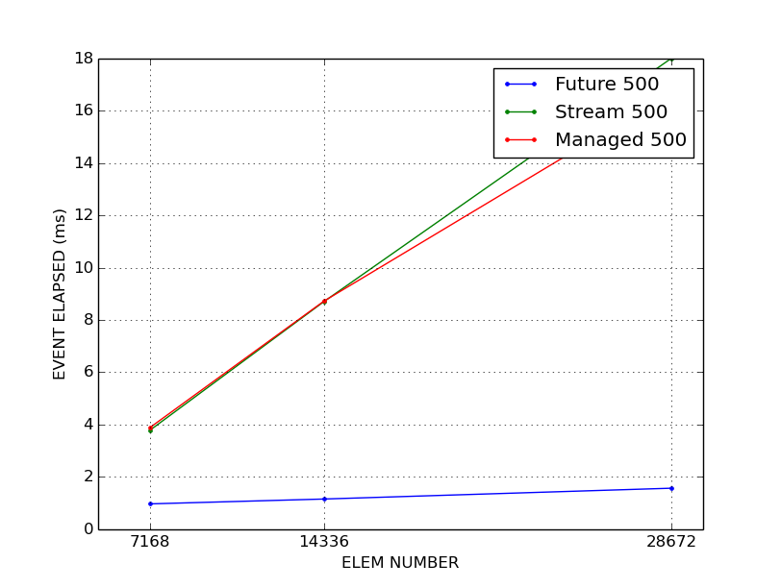

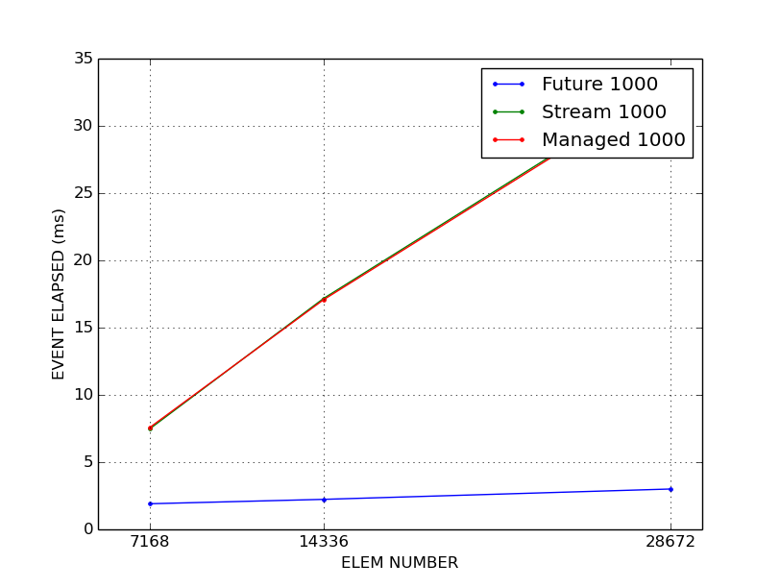

Speedup Estimation

A speedup has been estimated for the 500 kernel iters version.
This has been estimated as follows:

- is the time collected using one SM, in other words we used as <<<GRID, BLOCK>>> dimensions <<<1, 32>>>.
So we considered this as “sequential time”, more precisely time for parallelism degree = 1.
Note that effective degree is
- is the time collected using more SMs, the number of SMs depends on GRID values, that are different for Stream or Future.
This is the time using parallelism degree = n where
-for Future
- for Streams

Par. Degree | 7168 | 14336 | 28672
Future Speedup | 6113.34185165 | 11956.2629217 | 18849.84024284
Stream Speedup | 1559.39794163 | 1583.11289531 | 1639.64698259
Managed Speedup | 518.37088154 | 1579.94160199 | 1768.52725519

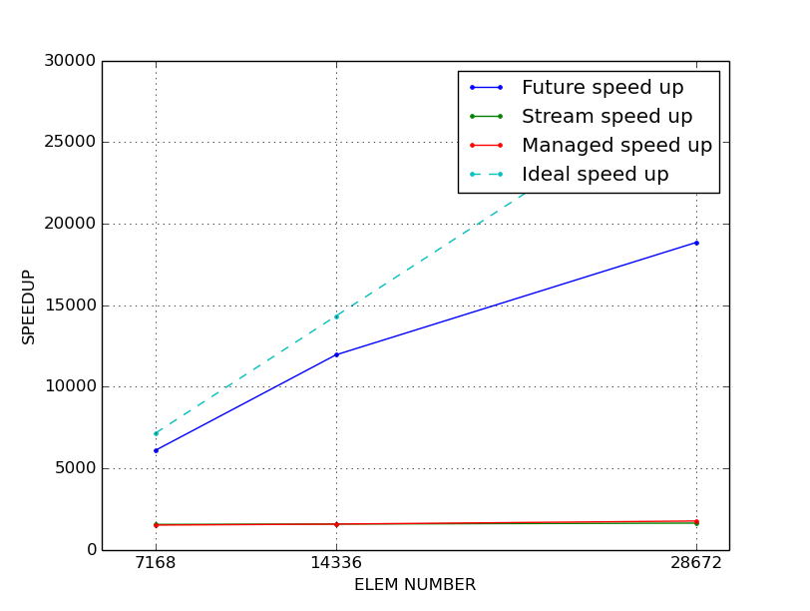
It's clear to see that the achieved speedup by Future is quite good, the speedup by Streams seems to be very bad (as expected from measured times).
Conclusions

It's clear that, currently, streams are not behaving good.
Watching at profiler output streams require to spend more time on memCpy (we copy little slices many times, in future we copy all in one time), this doesn't helps.
But the very increment in device time, between Future and Streams, is in kernel spent in Kernel execution.
I'm trying to discover whether it depends on a bad GRID/BLOCK tuning, or in the increment to kernel launch calls, or a mix of these two reasons.
Things I'm working on:

- Understand why Stream performances are bad, and so if it's possible to get better performances from Streams
- Better understand CUDA clock() to find kernel bottlenecks (useful for problem said above)
- Do tests on more different values of Kernel iterations (M) and number of elements (N)
- Get a more precise estimation on speedup and compute the maximum achievable speedup (Amdahl law, Gustafson's law)
- Understand how and if I can reduce page faults on Stream with unified Memory. Try to improve memory performances (those articles can be the key https://devblogs.nvidia.com/unified-memory-cuda-beginners/
https://devblogs.nvidia.com/how-access-global-memory-efficiently-cuda-c-kernels/ )
- Better understand how to estimate other performance parameters as Bandwidth and GFLOPs (not sure if my effective BW is correctly computed)
- Will be useful to compare device code to pure host code? In other words, compare CPU time to GPU time (I already prepared a host sequential version of the code)

Most important articles I based performance and stream study:
https://devblogs.nvidia.com/how-overlap-data-transfers-cuda-cc/
https://devblogs.nvidia.com/how-implement-performance-metrics-cuda-cc/

Below all times measures (collected in milliseconds) are reported

Stream 500 Times:
- 4 iterations: 5.09091, 5.0513, 5.01446, 5.01296,
- 8 iterations:10.0012, 9.95654, 9.92013, 9.9456, 9.92099, 9.9192, 9.92506, 9.93642,
- 16 iterations: 20.0428, 19.957, 19.8752, 19.8451, 19.847, 19.869, 20.0177, 19.8944, 18.4479, 18.4646, 18.434, 18.4447, 18.4468, 18.2517, 18.1139, 18.1361]

Stream 1000 Times:
- 4 iterations: 9.96909, 9.95946, 9.95782, 9.95507,
- 8 iterations: 19.7634, 19.582, 19.5239, 19.5173, 19.625, 19.5273, 19.6258, 19.6776,
- 16 iterations: 35.6837, 35.6826, 35.6914, 35.6872, 35.6525, 35.541, 35.413, 35.3651, 35.3946, 35.4159, 35.404, 35.3932, 35.4774, 35.4826, 35.4764, 35.4771]

Future 500 Times:
- 4 iterations:1.30346, 1.28454, 1.27818, 1.27613,
- 8 iterations: 1.32042, 1.30128, 1.29888, 1.30099, 1.32947, 1.33325, 1.32986, 1.33034,
- 16 iterations: 1.6375, 1.60406, 1.69434, 1.67328, 1.6768, 1.6824, 1.68803, 1.69325, 1.6761, 1.66931, 1.67392, 1.66758, 1.67104, 1.67104, 1.66874, 1.67901]

Future 1000 Times:
- 4 iterations: 2.5313, 2.51344, 2.51066, 2.51162,
- 8 iterations: 2.52944, 2.51882, 2.51718, 2.52042, 2.53814, 2.54128, 2.55312, 2.54019,
- 16 iterations: 3.14013, 3.10979, 3.17635, 3.17446, 3.20419, 3.20592, 3.17392, 3.19014, 3.19654, 3.19123, 3.19891, 3.18266, 3.18298, 3.2047, 3.21008, 3.21306]

Managed 500 Times:
- 4 iterations: 5.44896, 5.07568, 5.04157, 5.07971,
- 8 iterations: 10.3638, 9.93866, 9.92342, 9.92614, 9.93341, 9.7967, 9.84627, 9.83379,4
- 16 iterations: 18.2522, 17.7132, 17.77, 17.75, 17.7564, 17.7571, 17.7874, 17.7399, 17.7931, 17.7683, 17.7725, 17.7855, 17.7534, 17.7645, 17.804, 17.7973]

Managed 1000 Times:
- 4 iterations:10.2927, 9.99565, 10.0033, 9.93853,
- 8 iterations: 19.7336, 19.4227, 19.4311, 19.4292, 19.4121, 19.4925, 19.4799, 19.4788,
- 16 iterations: 35.7487, 35.3643, 35.4599, 35.4684, 35.4714, 35.4619, 35.4569, 35.4437, 35.4469, 35.2812, 35.1972, 35.2068, 35.2336, 35.1409, 35.1319, 35.1337]

One SM 1000 Times:
- 4 iterations: 7893.6, 7870.84, 7870.84, 7870.83,
- 8 iterations: 15738.0, 15738.1, 15738.2, 15738.1, 15738.2, 15738.2, 15738.0, 15737.9,
- 16 iterations: 31476.2, 31476.1, 31476.2, 31476.1, 31475.9, 31476.0, 31476.1, 31475.8, 31475.8, 31475.9, 31475.9, 31475.8, 31475.8, 31475.8, 31475.9, 31475.9]

