GPU Farm 1.0
Maria Chiara Cecconi
My GitHub directory: https://github.com/MCC04/GPUfarm
Results Summary
In this new version of the project, the code has been slightly modified.
The kernel loads are now balanced between Future, Streams and Managed Memory Streams.
Tests were run for the following input parameters:
- number of elements N = 1792, 3584, 7168, 14336, 28672, 57334
- number of kernel iterations M = 10, 50, 250, 1250, 2500

Below we show some graphs on obtained measures.
N=3584 COMPARISON
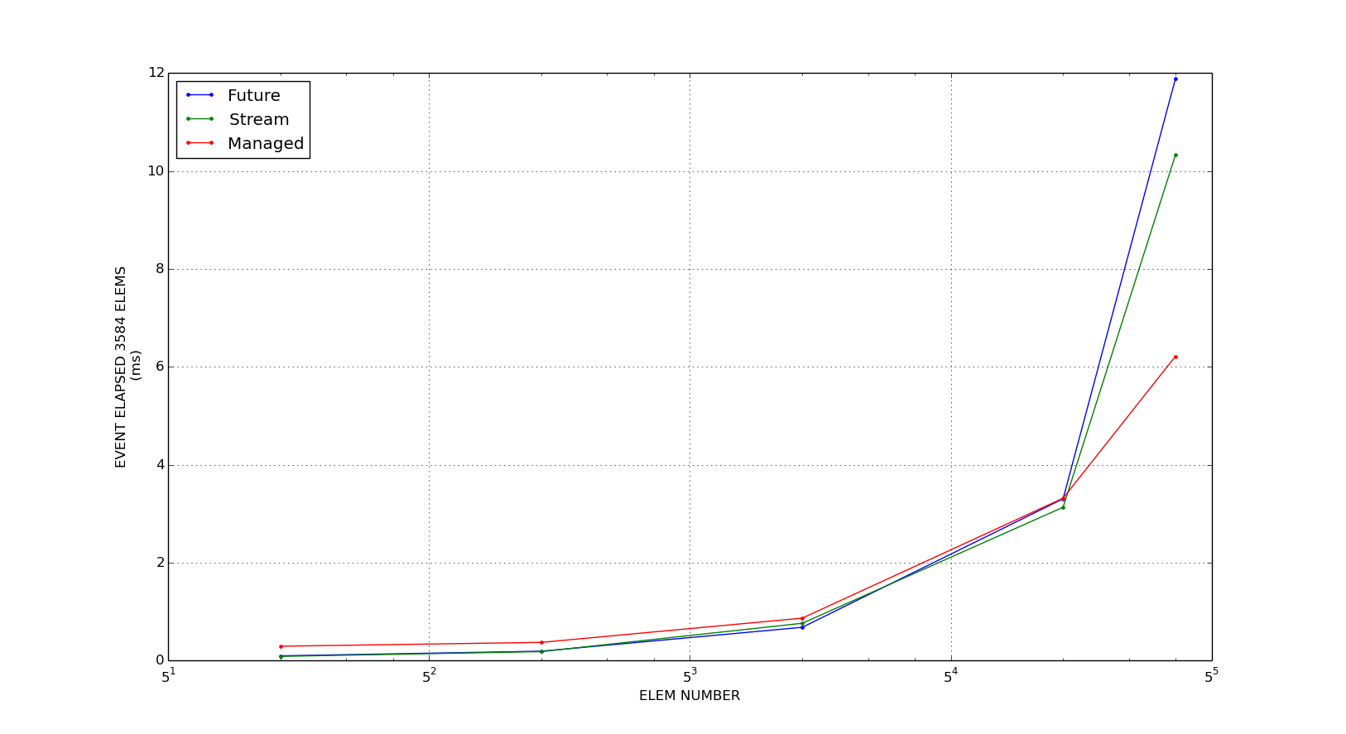
N=14336 COMPARISON
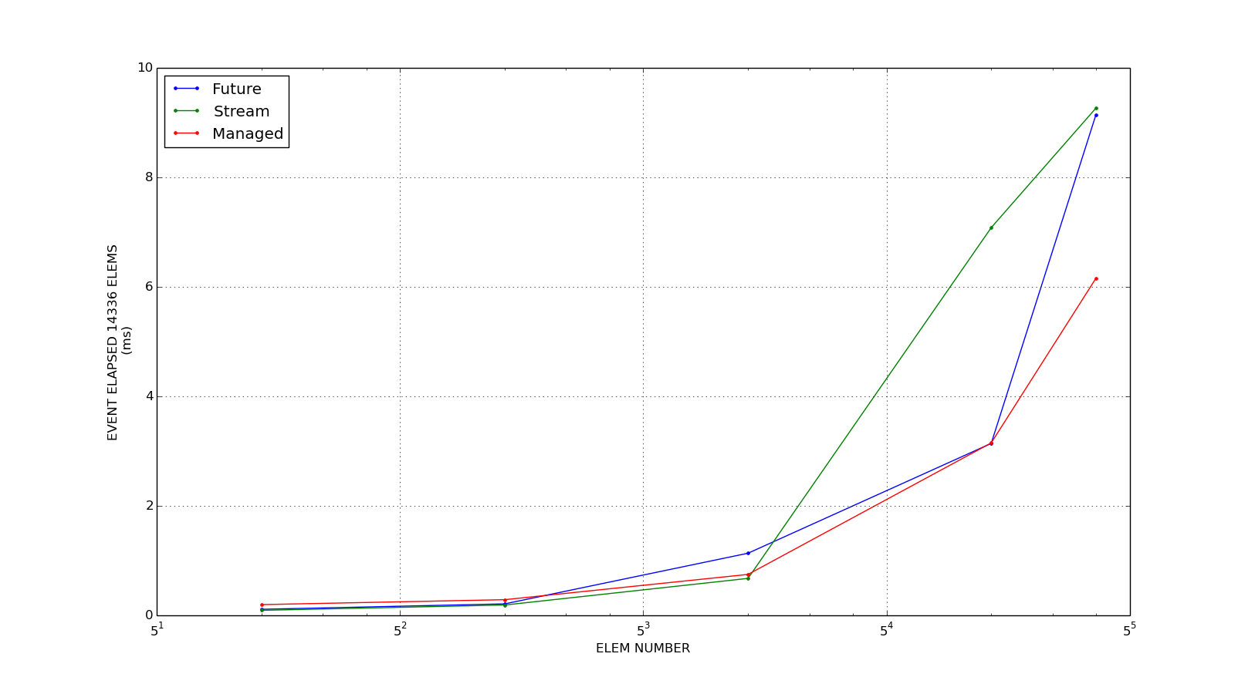
N=57344 COMPARISON
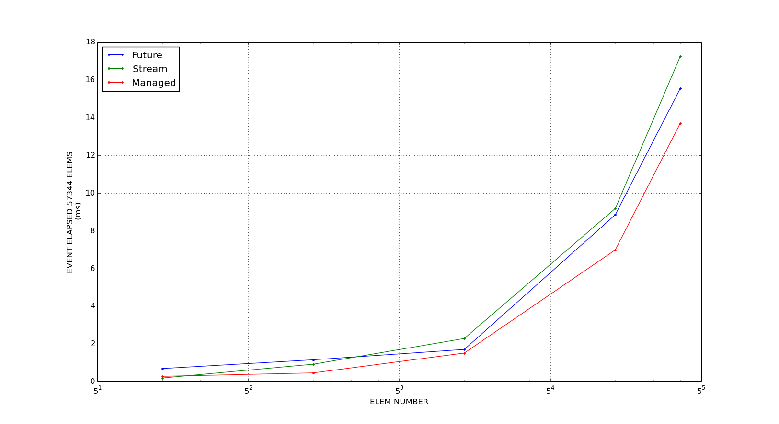
The three graphs above gives us an idea on how the measured times grows as the number of iterations grows, given a specific elements number.
We can see that here the growth is “smooth” as there aren't peaks.
In general Managed Mem Streams seems to have a better behavior as the number of iterations (but also elements number) grows.

M=250 COMPARISON
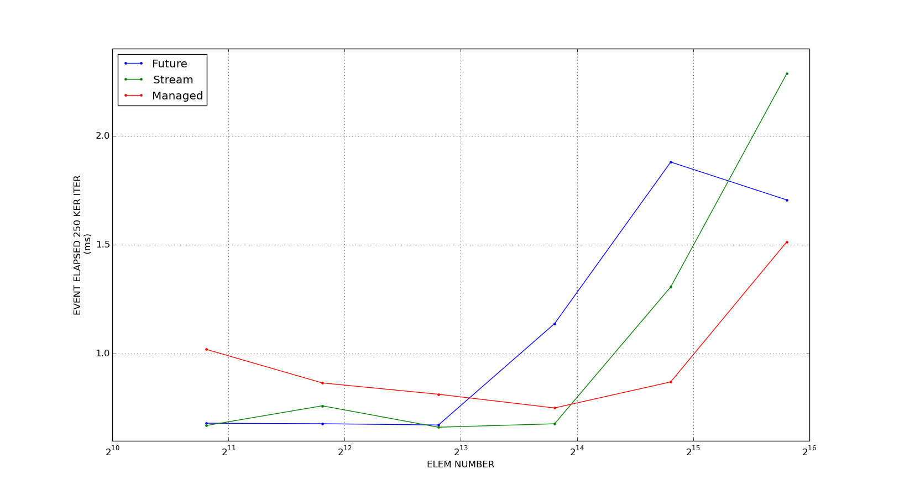

#M=1250 COMPARISON
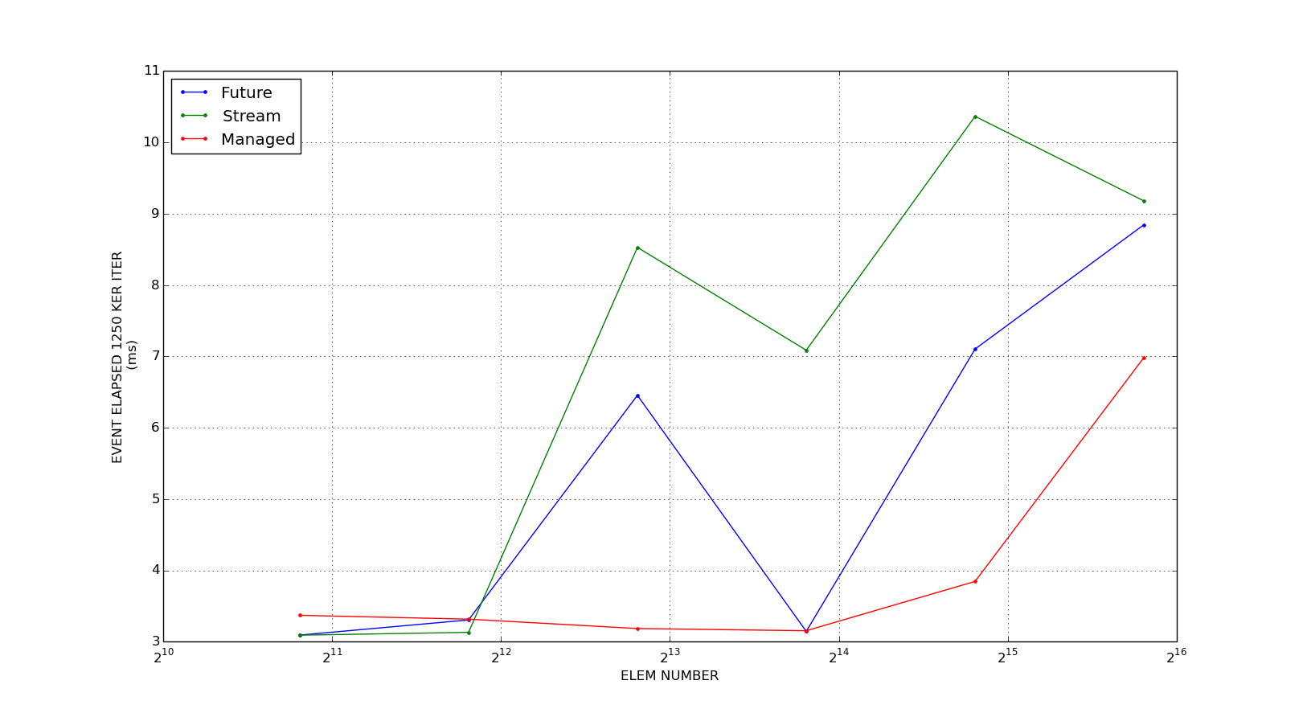

#M=2500 COMPARISON
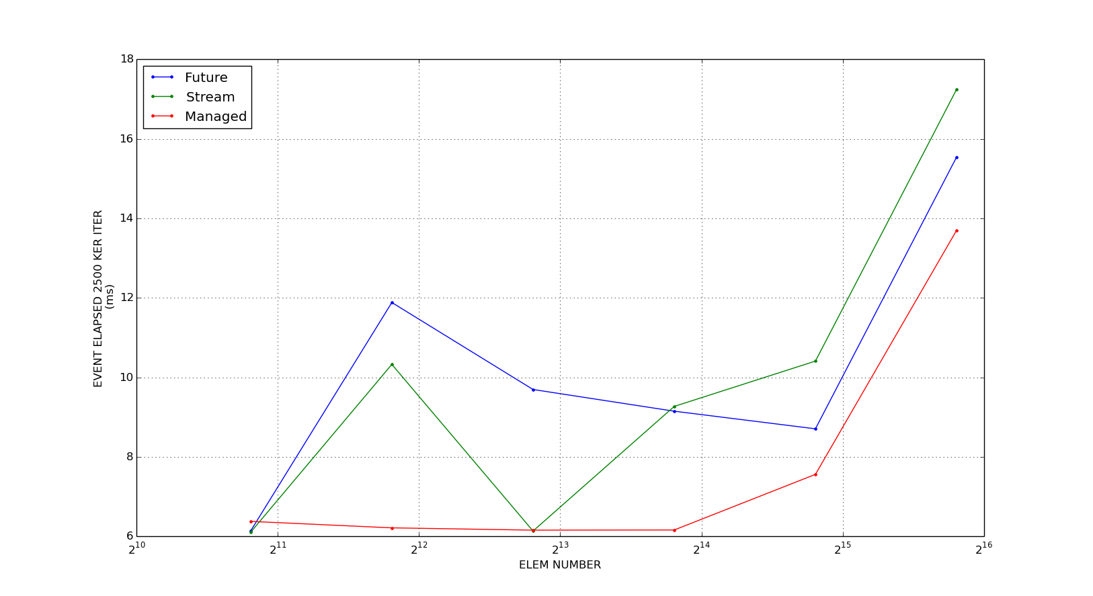
The three graphs above show us how the time grows as the number of elements grows, given a specific kernel iterations number.
As we can see Future and Streams show a strange behavior, we can see some peaks w.r.t. Managed trend.
Comparing this with results, in fact, we can see that some iterations take much more time than the average measures. While all Managed iterations seem to take almost always the same time.

The three graphs above in one:
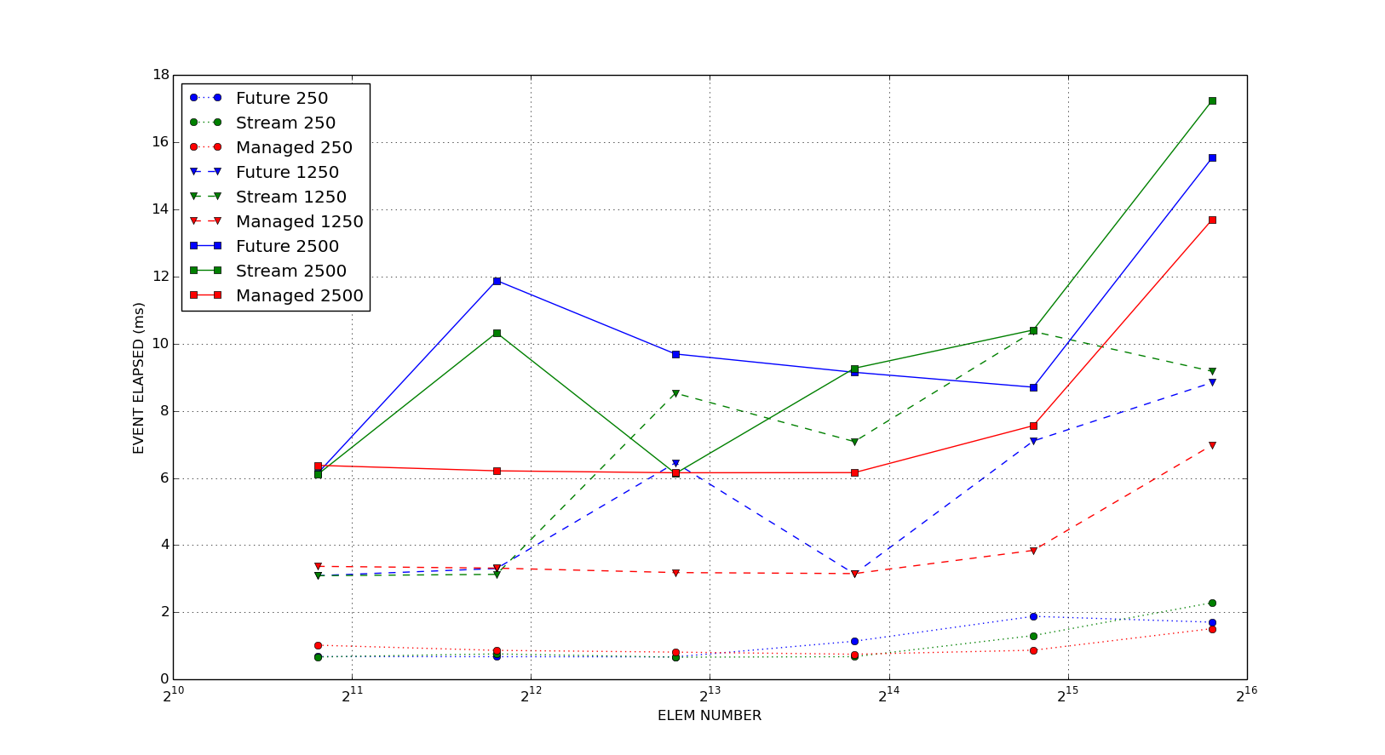

SPEEDUP GRAPHS
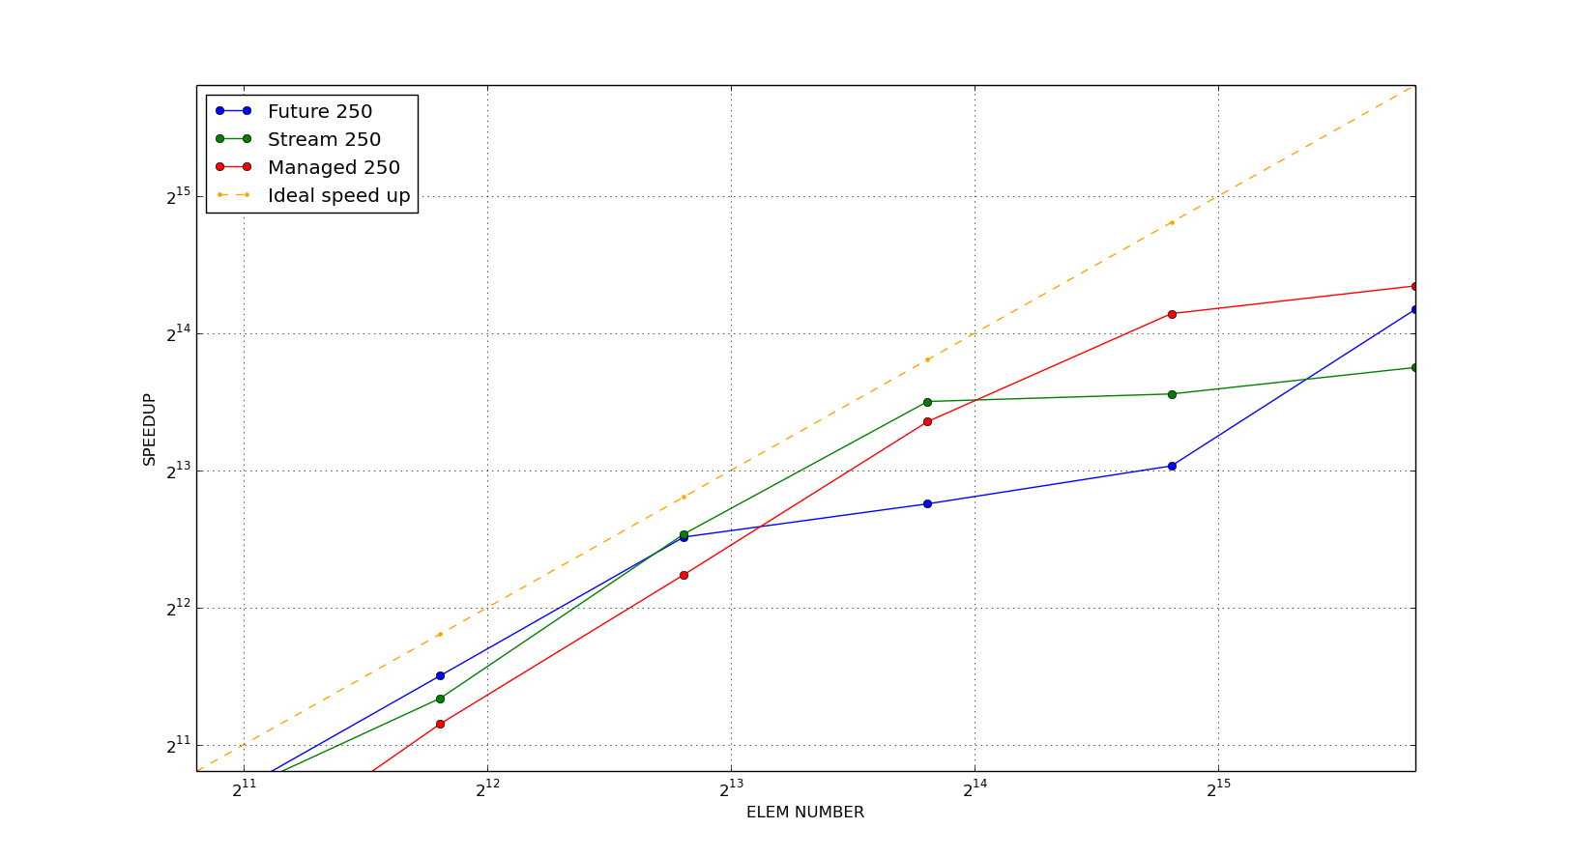

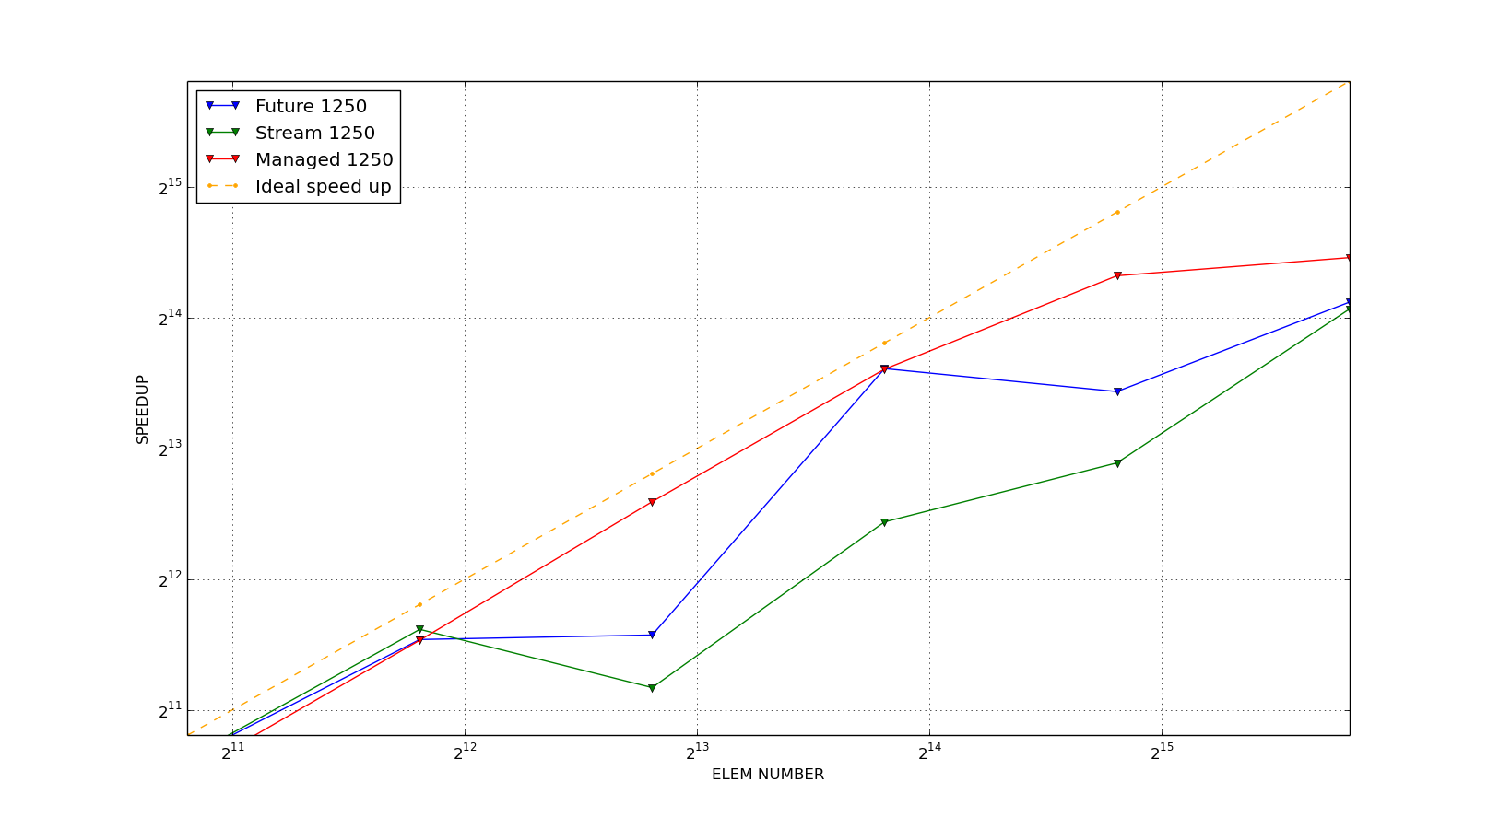

FUTURE
M iterations →  N elements ↓ | 10 | 50 | 250 | 1250 | 2500
1792 | 0.10544 | 0.205536 | 0.6816 | 3.09206 | 6.1368
3584 | 0.096431 | 0.191184 | 0.6791039 | 3.3042249 | 11.88256
7168 | 0.090312 | 0.1859119 | 0.67336 | 6.4529049 | 9.694315
14336 | 0.114452 | 0.213688 | 1.13853625 | 3.144245 | 9.14837125
28672 | 0.196628 | 0.303878 | 1.880057 | 7.1020875 | 8.705446875
57334 | 0.694250625 | 1.15817 | 1.70613625 | 8.84453343 | 15.543275
STREAM
1792 | 0.088608 | 0.187104 | 0.670752 | 3.09101 | 6.10419
3584 | 0.085264 | 0.18296 | 0.761408 | 3.130515 | 10.32562
7168 | 0.081616 | 0.1842639 | 0.6630959 | 8.526845 | 6.13483
14336 | 0.095359 | 0.19268 | 0.678896 | 7.0853375 | 9.26907625
28672 | 0.1172959 | 0.23772 | 1.30698012 | 10.36361749 | 10.408754375
57334 | 0.1947889 | 0.92436024 | 2.286461562 | 9.177777 | 17.24651249
MANAGED
1792 | 0.396704, | 0.451616 | 1.02061 | 3.36941 | 6.37699
3584 | 0.292736 | 0.371312 | 0.866354 | 3.315615 | 6.21437
7168 | 0.2252719 | 0.340296 | 0.8144005 | 3.18403 | 6.15661
14336 | 0.20022 | 0.29026 | 0.751528 | 3.1533525 | 6.160719
28672 | 0.2107059 | 0.32524 | 0.871042 | 3.844489375 | 7.559499375
57334 | 0.282609 | 0.4644649 | 1.514324687 | 6.9831315625 | 13.70058125
ONE SM
1792 | 45.4321 | 214.11 | 984.983 | 4914.09 | 9826.29
3584 | 82.3552 | 396.721 | 1972.495 | 9833.5649 | 19669.55
7168 | 166.5485 | 795.40149 | 3940.19749 | 19669.35 | 39330.675
14336 | 330.486625 | 1587.69249 | 7878.82875 | 39328.6875 | 78638.25
28672 | 661.9558749 | 3176.23624 | 15756.15624 | 78653.80625 | 157272.1875
57334 | 1313.16749 | 6347.33343 | 31507.0875 | 157304.46875 | 314541.875

FUTURE SPEEDUP
 | 10 | 50 | 250 | 1250 | 2500
1792 | 430.8810698 | 1041.715319 | 1445.10416 | 1589.2608811 | 1601.1996421
3584 | 854.02356064 | 2075.074274 | 2904.555119 | 2976.0579258 | 1655.3293229
7168 | 1844.14584994 | 4278.3763285 | 5851.546720 | 3048.1387840 | 4057.0865502
14336 | 887.55657393 | 7429.9562914 | 6920.138686 | 12508.14981 | 8595.874374
28672 | 3366.53922636 | 10452.340248 | 8380.68008 | 11074.744749 | 18065.95224
57334 | 1891.48911461 | 5480.484812 | 18466.92343 | 17785.502181 | 20236.52512

STREAM SPEEDUP
 | 10 | 50 | 250 | 1250 | 2500
1792 | 512.73135609 | 1144.3368394 | 1468.475681 | 1589.8007447 | 1609.7614917
3584 | 965.88478138 | 2168.3482728 | 2590.588751 | 3141.1972151 | 1904.9267743
7168 | 2040.63541462 | 4316.6407979 | 5942.122256 | 2306.7558985 | 6411.04561985
14336 | 3465.6735004 | 8240.0482665 | 11605.354502 | 5550.7147683 | 8483.936034
28672 | 5643.46503717 | 13361.249579 | 12055.39085 | 7589.4161715 | 15109.606955
57334 | 6741.48694228 | 6866.731274 | 13779.84568 | 17139.713193 | 18237.998841

MANAGED SPEEDUP
 | 10 | 50 | 250 | 1250 | 2500
1792 | 114.52392716 | 474.09746333 | 965.0924447 | 1458.4422792 | 1540.8978217
3584 | 281.3292523 | 1068.4303227 | 2276.77716 | 2965.8343927 | 3165.1720126
7168 | 739.32179765 | 2337.3812798 | 4838.157024 | 6177.5014682 | 6388.3655128
14336 | 1650.61744581 | 5469.8976779 | 10483.746114 | 12472.02382 | 12764.457725
28672 | 3141.60904293 | 9765.8229307 | 18088.85937 | 20458.84344 | 20804.57708
57334 | 4646.5876882 | 13665.90257 | 20806.0317 | 22526.35044 | 22958.286897

