**Mission statement**

We will verify that each table respect normalization standards, table by table, we will analyze types of dependencies between entities , and be sure they are 1NF,2NF,3NF

First In this process we will test if our model (entity / relation) meets the following conditions:

• All attributes are present in an entity

• No attribute is redundant

• All tables have a primary key.

• All the attributes are not decomposable and cannot be broken down

**First normal form: The key**

(Statement 1) --- First we make sure that the tables respect the verification rules

Tables should not contain repeating groups of data. If so, it must take out the data group and create another entity that will contain this group of data.

**Second normal form Total Key Dependency**

(Statement 2) An entity or relation is in the second normal form 2FN, if it is:

1. In 1FN./
2. All attributes of the relationship or entity depend on the whole key(notion of composite primary key) and not of part of the key.The second normal form only applies to tables with a primary key .

**Third normal form: And nothing but the key (no transitive dependency.)**

(Statement 3) An entity or relation is in third normal form (3FN) if

1. it is already in 2FNb.
2. All non-key attributes depend only on the key. There is no dependency between two non-key attributes.

**Objectives**

In his book “Database Systems , Design implementation and Management” Carlos Coronel talked about the importance of database design, that no resources will be able to cover the disasters caused by a bad one, in his experience

“*Many database system failures are traceable to poor design and cannot be solved with the help of even the best programmers and managers. Nor is better DBMS software likely to overcome problems created or magnified by poor design. Even the best bricklayers and carpenters can’t create a good building from a bad blueprint*” (Coronel, 2017)

On our work we will use learned skills, and tools to apply the process of normalization on our relational model to achieve our objectives:

**Non-redundancy of data:**

Reduce the risk of inconsistency during updates and inserts and reduce the number of update and insert transactions.

**Data sharing**

This allows sharing database between different applications and different users without fear that concurrent access (sometimes millions of users) will result in corruption of information or race conditions.

**Data consistency and integrity:**

This ensures that the rules are checked especially when modifying data.

**Prevent inaccurate information:**

In a world where only 10-20% of new business ideas succeed[1] (NBCS), inaccurate information could be a killer for the future of a startup

In his publication “Database Design for Mere Mortals” Michael Hernandez talked about impact of such small flaw , he remind companies CEOs and mostly CTOs that "*Inaccurate information is probably the most detrimental result of improper database design—it can adversely affect your organization’s bottom line. In fact, if your database affects the manner in which your business performs its daily operations or if it’s going to influence the future direction of your business*" (Hernandez, 2003)

**Data security:**

Prevent for each use case unauthorized access from unexpected actor.

**Logical independence:**

It means it’s possible to modify an external diagram without changing the conceptual.

This independence ensures access to each set of data through external VIEWs.

**Normalization Process**

**Cabin Cleaning Report**

**Resort ID:** 56 Resort Name: Merrimbula Beach Cabins Resort **Address: 56** The Spike Rd, Merrimbula, 2548

|  |  |  |  |  |  |  |  |  |
| --- | --- | --- | --- | --- | --- | --- | --- | --- |
| **Cabin No** | **Standard Cabin Cleaning Time (mins)** | **Date & Time Cleaned** | **Contract Cleaner Details** | | | | **Actual Cabin Cleaning Time (mins)** | **Cabin**  **Cleaning**  **Charge** |
| **Contractor**  **No** | **First** | **Last** | **Contract Rate** |
| 12 | 60 | 01/05/2021 09:00 | 23 | William | Xui | $20.50 | 60 | $20.50 |
| /13 | 80 | 01/05/2021 10:00 | 23 | William | Xui | $20.50 | 90 | $30.75 |
| 15 | 60 | 01/05/2021 13:00 | 23 | William | Xui | $20.50 | 30 | $10.25 |
| 12 | 60 | 08/05/2021 10:00 | 45 | Mary | Green | $22.00 | 60 | $22.00 |
| 13 | 80 | 08/05/2021 12:00 | 45 | Mary | Green | $22.00 | 85 | $31.17 |
| 12 | 60 | 15/05/2021 10:00 | 23 | William | Xui | $20.50 | 55 | $18.79 |
| 15 | 60 | 15/05/2021 11:00 | 23 | William | Xui | $20.50 | 55 | $18.79 |

**Monash Cabins Cleaning Contractor Rates History**

**Contractor No:** 23 First Name: William Last Name: Xui Postal **address:** PO Box 100 Pambula, 2549 Phone: 0123456789

|  |  |  |  |
| --- | --- | --- | --- |
| **Contract Dates** | | **Contract Hourly Rate** | **Contract Type** |
| **Start Date** | **End Date** |
| 12/07/2019 | 31/12/2019 | $22.00 | Casual |
| 05/01/2020 | 30/12/2020 | $18.50 | Fixed |
| 01/02/2021 | 25/05/2021 | $20.50 | Fixed |
|  |  |  |  |

**Monash Cabins Cleaning Contractor Rates History**

**Contractor No:** 45 **First Name:** Mary **Last Name:** Green Postal **address:** 13 Narrow Lane Merrimbula, 2548 **Phone**: 0789123456

|  |  |  |  |
| --- | --- | --- | --- |
| **Contract Dates** | | **Contract Hourly Rate** | **Contract Type** |
| **Start Date** | **End Date** |
| 01/05/2021 |  | $22.00 | Casual |
|  |  |  |  |
|  |  |  |  |

Normalization of Cleaning History

UNF

**CleaningHistory**

ResortID

ResortName

ResortAdress

CabinNo

StandardCabinCleaningTime

DateTimeCleaned

ContractorNo

First

Last

ContractRate

ActualCabinCleaningTime

CabinCleaningCharge

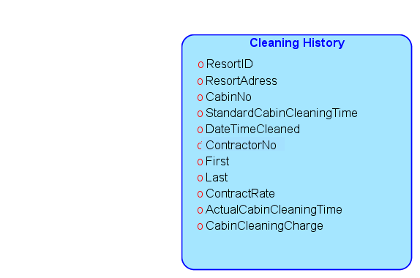

1NF

Tables should not contain repeating groups of data. If so, it must take out the data group and create another entity that will contain this group of data.

**No repeating groups (no multiple values on one column)**

ResortID : will hold one id

ResortName : the name holds one value only

**ResortAdress :** the Adress Has **3** Values

**Street, Town and Postal Code**

CabinNo : will hold one number

StandardCabinCleaningTime : Holds one number represents minutes

DateTimeCleaned : one timestamp, and no more for this column

ContractorNo : Contract No is one value for each attribute

First: the first name is one varchar value

Last : the second name is one varchar value

ContractRate : this column holds one price.

ActualCabinCleaningTime : one number represent minutes passed in cleaning

**Primary key**

**Table CleaningHistory**

ResortID , CabinNo, ContractorNo, DateTimeCleaned

we may chose just (ResortID ,CabinNo,DateTimeCleaned) but we consider the case or two contractors are used for fast cleaning , or if there is different specialty for each contractor.

**CleaningHistory**

**ResortID**

**CabinNo**

**ContractorNo**

**DateTimeCleaned**

(ResortID,CabinNo,ContractorNo,DateTimeCleaned)🡪 ResortName

(ResortID,CabinNo,ContractorNo,DateTimeCleaned) 🡪 ResortAdress

(ResortID,CabinNo,ContractorNo,DateTimeCleaned) 🡪 StandardCabinCleaningTime

(ResortID,CabinNo,ContractorNo,DateTimeCleaned) 🡪 First

(ResortID,CabinNo,ContractorNo,DateTimeCleaned) 🡪 Last

(ResortID,CabinNo,ContractorNo,DateTimeCleaned) 🡪 ContractRate

(ResortID,CabinNo,ContractorNo,DateTimeCleaned) 🡪 ActualCabinCleaningTime

Table ResortAdress

Primary key : ResortID

(ResortID,Street,Town) 🡪 PostalCode

(ResortID,Street,Town) 🡪 Street

(ResortID,Street,Town) 🡪 Town

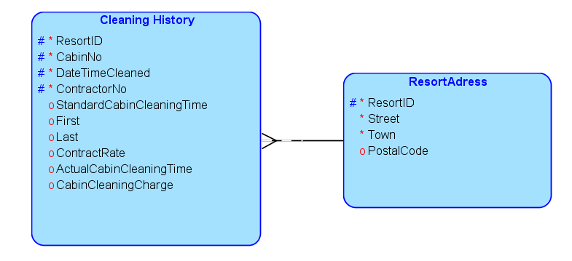

2NF

2NF

|  |  |  |  |  |  |  |
| --- | --- | --- | --- | --- | --- | --- |
|  | **ResortID**  **CabinNo**  **ContractorNo**  **DateTimeCleaned** | **Standad**  **Cabinet**  **Cleaning**  **Time** | **First**  **Last** | **Contract**  **Rate** | **Actual cleaning time** | **cleaning charge** |
| Partial  dependencies | Primary key has no other determinant | **depends on CabinNo** | **Depends on Contractor**  **NO** | **Depends on Contractor**  **NO** | Depends on PK | Depends on PK |
| Dependecies | / | **CabinNo 🡪**  **stdClTime** | **Contractor**  **No 🡪 First/Last** | **Contractor**  **No 🡪 Contract**  **Rate** | PK 🡪  **Actual cleaning time** | PK 🡪 cleaning charge |
| Determinant | NA | CabinNo | Contractor  No | Contractor  No | PK | PK |
| Type of determinant | NA | Partial Key attribute | Partial  Key attribute | Partial  Key a/ttribute | Key attribute | Key attribute |

Standard cleaning time has partial dependency,we move it to new table

First and Last nale, and Contractor Rate have a partial dependency,we move them to new table

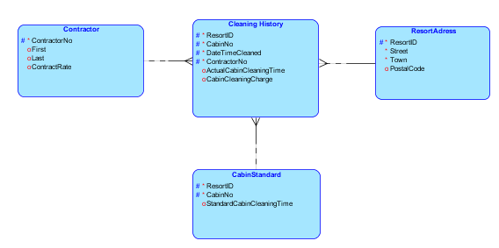

**3NF**

(Statement 3) An entity or relation is in third normal form (3FN) if

1. it is already in 2FNb.
2. All non-key attributes depend only on the key. There is no dependency between two non-key attributes.

|  |  |  |  |
| --- | --- | --- | --- |
|  | **ResortID**  **CabinNo**  **ContractorNo**  **DateTimeCleaned** | **Actual cleaning time** | **cleaning charge** |
| Transitive Dependencies | Primary key has no other determinant | Depends on PK | **Depends on PK through cleaning time** |
| Dependecies | / | PK **🡪 Actual cleaning time** | **actual cleaning time**  **🡪 Cleaning charge** |

we should remove **cleaning charge**

but it’s mostly a calculated attribute from (cleaning time x contractorRate/60)

we created a view for this to get calculations cleaningHistoryChargeView

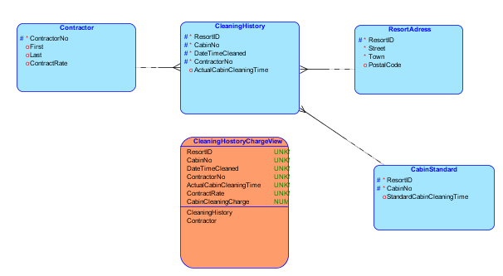

Normalization of Contractor History

UNF

Contractor**History**

ContractorNo:

FirstName:

LastName:

address:

Phone:

Start Date:

End Date :

Contract Hourly Rate :

Contract Type :

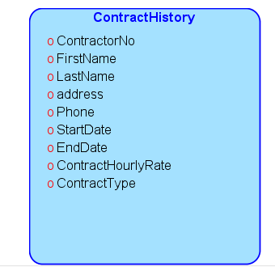

1NF

Tables should not contain repeating groups of data. If so, it must take out the data group and create another entity that will contain this group of data.

**No repeating groups (no multiple values on one column)**

ContractorNo: Contract No is one value for each attribute

FirstName: the first name is one varchar value

LastName: the last name is one varchar value

address: the Adress Has **3** Values

**Street, Town and Postal Code**

Phone: contains just one varchar value

Start Date: contains one date

End Date : contains one date

Contract Hourly Rate : contains one rate

Contract Type : contains one value Casual or Fixed

**Primary key**

**Table ContractorHistory**

ContractorNo, StartDate,EndDate

we may chose just (ResortID ,CabinNo,DateTimeCleaned) but we consider the case or two contractors are used for fast cleaning , or if there is different specialty for each contractor.

**CleaningHistory**

**ResortID**

**CabinNo**

**ContractorNo**

**DateTimeCleaned**

(ResortID,CabinNo,ContractorNo,DateTimeCleaned)🡪 ResortName

(ResortID,CabinNo,ContractorNo,DateTimeCleaned) 🡪 ResortAdress

(ResortID,CabinNo,ContractorNo,DateTimeCleaned) 🡪 StandardCabinCleaningTime

(ResortID,CabinNo,ContractorNo,DateTimeCleaned) 🡪 First

(ResortID,CabinNo,ContractorNo,DateTimeCleaned) 🡪 Last

(ResortID,CabinNo,ContractorNo,DateTimeCleaned) 🡪 ContractRate

(ResortID,CabinNo,ContractorNo,DateTimeCleaned) 🡪 ActualCabinCleaningTime

Table ResortAdress

Primary key : ResortID

(ResortID,Street,Town) 🡪 PostalCode

(ResortID,Street,Town) 🡪 Street

(ResortID,Street,Town) 🡪 Town

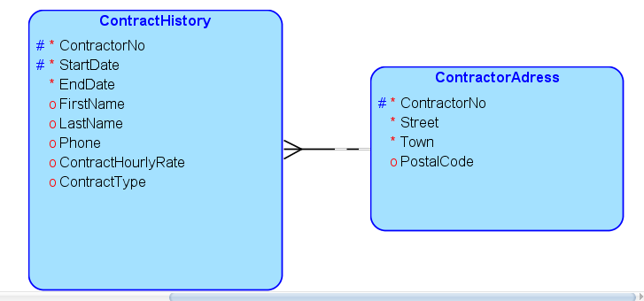

2NF

2NF

|  |  |  |  |  |
| --- | --- | --- | --- | --- |
|  | **ContractorNo**  **Start Date** | **First Name**  **Last Name**  **Phone** | **Contract**  **Rate** | **Contract Type** |
| Partial  dependencies | Primary key has no other determinant | **Depends on Contractor**  **NO** | Contract Type | Depends on PK |
| Dependecies | / | **Contractor**  **No 🡪 First/Last/phone** | **PK 🡪 Contract**  **Rate** | PK 🡪  **Contract type** |
| Determinant | NA | Contractor  No | PK | PK |
| Type of determinant | NA | Partial  Key attribute | Key a/ttribute | Key attribute |

There is attributes with partial dependency,we move them to new table

Contract rate is variable from month to month and it’s not the same contract rate in Contractor table

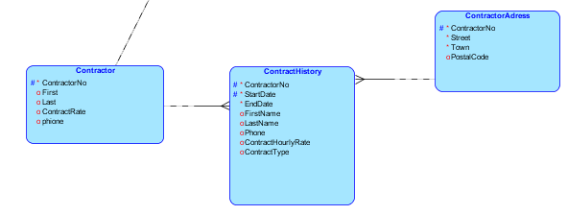

**3NF**

(Statement 3) An entity or relation is in third normal form (3FN) if

1. it is already in 2FNb.
2. All non-key attributes depend only on the key. There is no dependency between two non-key attributes.

|  |  |  |  |
| --- | --- | --- | --- |
|  | **ContractorNo**  **Start Date** | **Contract**  **Rate** | **Contract Type** |
| Transitive Dependencies | Primary key has no other determinant | Depends on PK | Depends on PK |

No transitive dependencies found

**We add surrogate key in contractHistory**

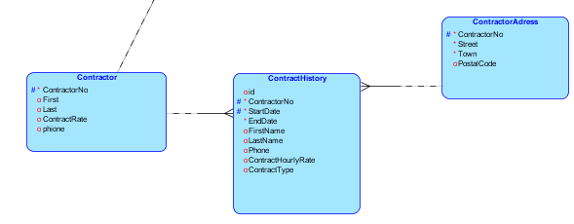

1. National Business Capital and Services. "2019 Small Business Failure Rate: Startup Statistics by Industry