|  |  |
| --- | --- |
| A car parked on the side of a road  Description automatically generated  USER REQUIREMENT SPECIFICATION  Concept version | GROUP A  Kaylee Joy Furst – 3365271  Vincent De Moll – 3636399  Marcello Cardillo – 3774201  Jasper Vos – 3563855  Maya Barakova - 3597261  Mihail Lepadatu – 3793435 |

URS

Contents

**Introduction** **3**

Map editor 3

Simulation 3

Statistics 3

**Agreements and Assumptions** **4**

Data Requirements: 4

Data Output: 5

Wireframes 5

Map Builder Screen 5

Simulation Running Screen 5

Statistics screen 7

Final Design 7

Map Builder Screen 7

Tile configuration form 8

Statistics and Simulation 9

Heatmap 9

Use cases 10

ID: 001 10

ID: 002 11

ID: 003 11

ID: 004 12

ID: 005 12

ID: 006 13

ID: 007 13

ID: 008 14

ID: 009 14

ID: 010 15

ID: 011 15

ID: 012 16

ID: 013 16

**Revision History** **18**

# 

# Introduction

The key objective of this project is to simulate traffic flow on a given street/city area and give accurate data based on the simulation. The simulation will take into consideration planned events, road work.

Functional Requirements

The functional requirements have been divided into 3 parts of the application. The map editor, where the user can create the road they would like to simulate. The simulation itself, and the statistics that will be shown to the user.

## Map editor

|  |  |  |  |
| --- | --- | --- | --- |
| **ID** | **Requirements** | **MoSCoW** | **Use case ID** |
| 01 | User must be able to control the tiles | Must | 004 |
| 02 | User must be able to save boards | Must | 002 |
| 03 | User must be able to load in saved boards | Must | 003 |
| 06 | User could control starting / end point of map for vehicles | Must | 011 |
| 07 | User must be able to control traffic light configuration | Must | 007 |
| 08 | User can select number of lanes | Must | 007 |

## Simulation

|  |  |  |  |
| --- | --- | --- | --- |
| **ID** | **Requirements** | **MoSCoW** | **Use case ID** |
| 09 | User must be able to start the simulation | Must | 001 |
| 10 | User must be able to save a simulation | Must | 002 |
| 11 | User must be able to load a saved simulation | Must | 003 |
| 12 | User must be able to fill in the number of vehicles in the simulation | Must | 009 |
| 13 | Users must be able to choose visible run-time data in the simulation. | Must | 010 |
| 14 | User could be able to pause the simulation | Could | 006 |

## Statistics

|  |  |  |  |
| --- | --- | --- | --- |
| **ID** | **Requirements** | **MoSCoW** | **Use case ID** |
| 15 | User must be able to view the total amount of cars processed | Must | 001 |
| 16 | User must be able to see the average time taken to travel a certain distance | Must | 001 |
| 17 | User must be able to see the current amount of cars that are stopped or are driving | Must | 001 |
| 18 | User must be able to see total distance of cars travelled | Must | 001 |
| 19 | User must be able to see time simulation has been running | Must | 001 |
| 20 | Export/Save the statistics to a specified file | Could | 008 |
| 21 | Smart statistics: Heatmap | Must | 012 |
| 22 | Smart Statistics: Average Road Usage | Must | 001 |
| 23 | Smart Statistics: Inflow & Outflow | Must | 001 |

# Agreements and Assumptions

List of Agreements made in the meetings between the team and the client.

* Agreed that the application first, will be able to simulate a specific crossroad/event without any extra additions like bikers etc.
* Agreed that the User needs to know nothing technical about the application for the User to work with it.
* Agreed that there will always be a meeting every week between the client and the team for further discussion and feedback.
* Agreed that all meetings will be held online, unless discussed otherwise.

List of Assumptions

* Export statistics to a specific file
* Pause in the simulation
* User could move backward and forward in the simulation
* User could be able to change the duration of green/red lights
* User could be able to change intersections

### Data Requirements:

The System should be able to store data:

* Total number of vehicle in the simulation
* Total number of pedestrians in the simulation
* Total number of pedestrians that were involved in the event of a (triggered) accident.
* Total number of accidents
* Total number of vehicles that were involved in the event of a (triggered) accident.
* The Duration of the simulation
* Information about which streets were closed etc.

### Data Output:

The System should display the following after a successful simulation:(for iT1?)

* Total amount of cars that ran through simulation
* Average time taken from start-point to end-point
* Average speed of the vehicles
* How long the simulation was running

## Wireframes

### Map Builder Screen

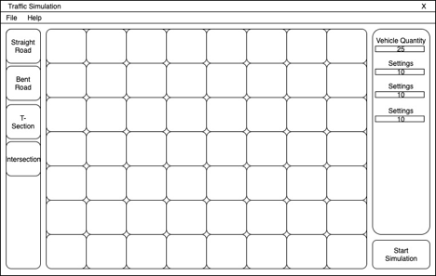

|  |
| --- |
|  |
| As specified previously, the ability to build a map for the simulation to run will only be added in a special case. Regardless our starting screen will look like this, and after the start of the simulation we will load the map.  On the top left you can see “File, Help” - in the Files tab you will be able to import or save your created maps so you can use them as you wish.  The Help tab will include some Q&A’s for commonly asked questions.  On the right there will be a small list of details being displayed during the simulation and most likely after as well.  On the bottom right the start simulation button will be. |

### Simulation Running Screen

|  |
| --- |
|  |
| The screen will immediately be shown after the start simulation button is pressed. The start simulation button is changed to Pause but the functionality will not be implemented in this Iteration. |

### Statistics screen

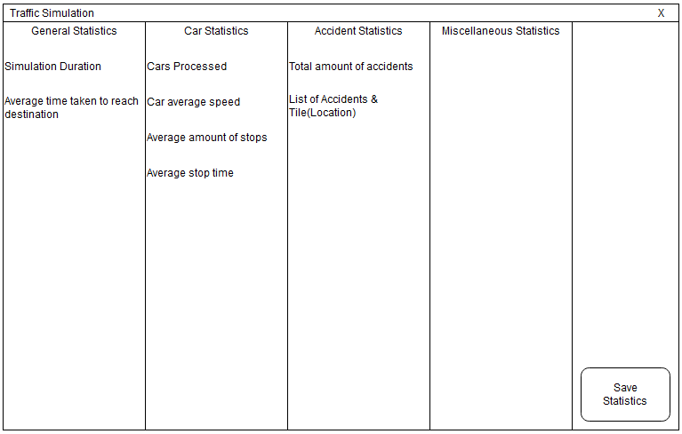

After a successful simulation, the system will display information regarding the simulation.

## Final Design

### Map Builder Screen

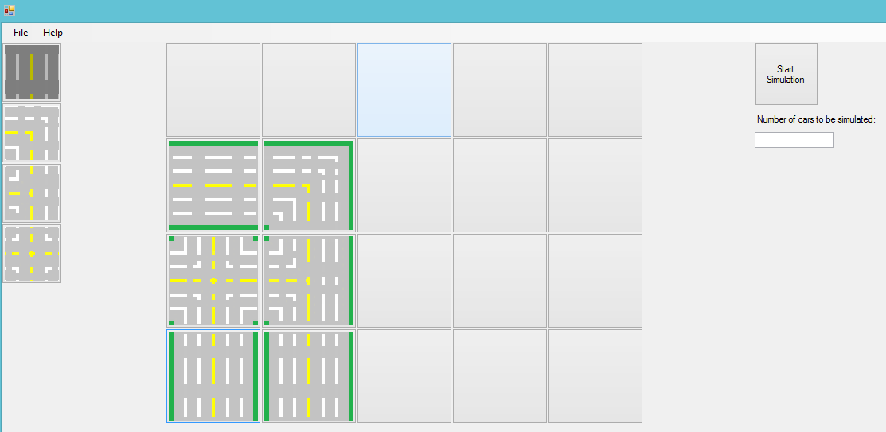

## 

The map builder screen has a very simple intuitive design. It is a collage of buttons that are clickable and input the desired map based on the thumbnail selected on the left.

The start simulation button and Number of cars to be simulated are on the right hand side of the screen.

### Tile configuration form

The tile configuration is one of the right options in the drop down menu after the right click is done on the tiles. It opens with an enlarged image of the tile.

On the right hand side the user can input the number of lanes desired on the tile and on the top the user can select how many traffic lights to initialize and the sequence desired.

Saving it with the button on the bottom applies the changes and cancel would not change anything.

### 

### Statistics and Simulation

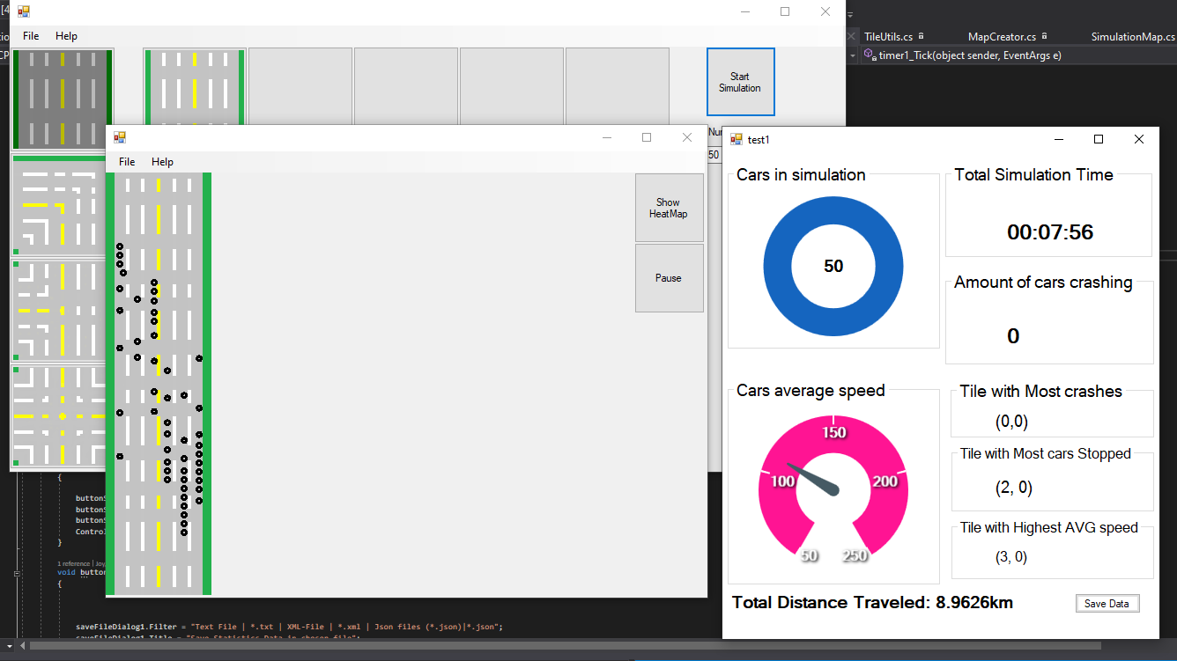

The statistics form on the right open automatically after the simulation is started. They offer several different statistics for live data for the simulation.

The save stats button saves the information to a file on the users pc.

### Heatmap

The heatmap is opened after the user clicks the button on the simulation screen. It shows as more red colors the road positions used the most.

## 

## Use cases

|  |  |
| --- | --- |
| ID: 001 | 001 |
| Goal | Simulate crossroad |
| Description | User wants to simulate a crossroad by creating a map and adjusting the settings to his/her needs. |
| Primary Actor | User |
| Preconditions | Graphical representation of road to be loaded |
| Postconditions | Data statistics to be provided |
| Main Success Scenario | 1. User starts application 2. System displays map builder screen 3. User selects the crossroad tile he/she wants to use. 4. User clicks on the tile the crossroad tile has to be placed on. 5. Selected tile becomes an intersection 6. User presses simulate button. 7. System opens live data for statistics. 8. System starts simulation. 9. System ends simulation after duration expires. 10. System shows data statistics of the simulation. |
| Extensions | 2a, 3a, 4a, 5a, 6a, 8a, 10. User cancels  1. Use case ends  5b. User wants to use another crossroad tile.  1. User opts to undo the choice.  2. System asks for confirmation of change.  3. Use case continues at MSS 4 or at MSS5 depending if the User confirmed the system message.  6b. Selected tile on the map is already occupied with another crossroad tile.  1. System shows appropriate message.  2. System offers the option to change the selected tile with the new choice of crossroad or to keep the old one.  3. Use case continues at MSS 6.  6c. User opts for multiple crossroad tiles to be placed on the map.  1. Use case continues at MSS 4. |

|  |  |
| --- | --- |
| ID: 002 | 002 |
| Goal | Save crossroad map. |
| Description | User wants to save the created crossroad map to a folder. |
| Primary Actor | User |
| Pre-conditions | At least one crossroad tile is placed on the map. |
| Main Success Scenario | 1. User chooses to save the crossroad map. 2. System checks the file status. 3. System offers to save current settings as well. 4. User chooses to save current settings with the roadmap. 5. System saves the file. 6. System offers to continue with the current crossroad map or create new. |
| Extensions | 1a. User cancels.  1. Use case ends.  2a. Crossroad map is already an existing file.  1. Use case continues at MSS 3.  2b. Crossroad map is a new file.  1. System shows the Save File dialog.  2. User chooses a folder.  3. User enters a file name for the new road map.  4. User confirms the new save.  5. Use case continues at MSS 3.  4a. User wants to create a new roadmap.  1. User chooses to start new.  2. Go back to Use Case ID: 001. |

|  |  |
| --- | --- |
| ID: 003 | 003 |
| Goal | Load existing crossroad map/simulation. |
| Description | User wants to load and use an existing crossroad map from a folder (including the settings if it has any). |
| Primary Actor | User |
| Pre-conditions | Possess a map file to be opened |
| Main Success Scenario | 1. User chooses to open an existing crossroad map. 2. System opens Open File Dialog Window. 3. User selects the file to be opened. 4. Systems loads in the selected crossroad map. 5. System displays the selected crossroad map. |
| Extension | 2a, 3a. User cancels  1. Use case ends.  3b. File selected is not a board file or is corrupted  1. System shows appropriate message.  2. System offers to select another file to open or create a new map.  2.1a) User chooses to select another file.  2.2a) Use case continues at MSS 2.  2.1b) User chooses to create a new map.  2.2b) Go to Use Case ID 001. |

|  |  |
| --- | --- |
| ID: 004 | 004 |
| Goal | Control tiles |
| Description | User wants to place and/or rotate the crossroad tiles on the roadmap to create an intersection. |
| Primary Actor | User |
| Pre-conditions | Map builder is loaded. |
| Main Success Scenario | 1. User chooses the tile he/she wants to place on the map. 2. System shows the chosen tile on the map 3. User chooses the tile he/she wants to rotate. 4. System highlights the specific tile. 5. System offers to rotate the tile 90 degrees clockwise or counter clockwise. 6. User chooses the wanted option. 7. System rotates the selected tile. |
| Extensions | 2a, 3a. User cancels  1. Use case ends.  1a. User chose the wrong tile.  1. User cancels.  2. Use case continues at MSS 1.  4a. User chose the wrong option.  2. Use case continues at MSS 1. |

|  |  |
| --- | --- |
| ID: 005 | 005 |
| Goal | Remove tiles on map. |
| Description | User wants to remove already existing tiles on the map. |
| Primary Actor | User |
| Pre-conditions | Map builder is loaded and a Tile has been placed |
| Main Success Scenario | 1. User chooses the tile he/she wants to remove. 2. System highlights the specific tile. 3. System asks for confirmation. 4. User confirms. 5. System removes the chosen tile from the map. |
| Extensions | 2a, 3a. User cancels  1. Use case ends.  2b. User chose the wrong tile.  1. User cancels.  2. Use case continues at MSS 1. |

|  |  |
| --- | --- |
| ID: 006 | 006 |
| Goal | Pause simulation |
| Description | User wants to pause the active simulation. |
| Primary Actor | User |
| Pre-conditions | Simulation to be active |
| Main Success Scenario | 1. User chooses to pause the simulation 2. System pauses the simulation |
| Extensions | 2.a System fails to pause  1. System shows appropriate message.  2. System offers to force stop the simulation or to continue.  2.1.a) User chooses to quit the simulation, Use case ends.  2.1.b) User chooses to continue, Use case end. |

|  |  |
| --- | --- |
| ID: 007 | 007 |
| Goal | Change lanes or traffic light sequence for tile |
| Description | User wants to change the number of lanes in simulation or the traffic light sequence in a tile. |
| Primary Actor | User |
| Pre-conditions | Simulation to be active |
| Main Success Scenario | 1. User selects tile configuration option. 2. System opens the tile configuration form. 3. User inputs number of lanes (limit 3). 4. User inputs the sequence of the traffic lights. 5. User selects the save option. 6. System edits tile as desired |
| Extensions | 3.a User selects more than 3 lanes  1. System auto selects 3 as max.  5.a User selects the cancel option  b all configurations cancelled. |

|  |  |
| --- | --- |
| ID: 008 | 008 |
| Goal | Save after-simulation statistics. |
| Description | User wants to save all the gathered data from the entire simulation. |
| Primary Actor | User |
| Pre-conditions | Statistics to be provided after simulation ends. |
| Main Success Scenario | 1. System displays gathered statistics. 2. User requests to save gathered statistics. 3. System opens a SaveDialogFile window. 4. User selects the wanted saving path. 5. System saves the file. |
| Extensions | 2a,3a,4a. User wants to cancel.  1. Use case ends.  1.a System fails to display statistics.  1. System shows appropriate message, use case ends.  3.b System fails to open SaveDialogFile window  1. System shows appropriate message.  2. Use case continues from MSS2.  4.b User does not define path  1. System shows appropriate message.  2. Use case continues at MSS3  5.a System fails to save fail  1. System shows appropriate message.  2. System offers to save again or cancel.  2.1.a) User wants to try again, go to MSS1  2.1.b) User wants to cancel, use case ends. |

|  |  |
| --- | --- |
| ID: 009 | 009 |
| Goal | Set number of vehicles in simulation |
| Description | User wants to set the number of vehicles for the simulation. |
| Primary Actor | User |
| Pre-conditions | Graphical representation to be loaded |
| Main Success Scenario | 1. User sets the a number to represent the amount of vehicles 2. System loads map with the given number of vehicles. |
| Extensions | 1.a. Number inserted exceeds the maximum vehicles in simulation  1. System shows appropriate message.  2. System offers user to change the number or keep default.  2.1.a) User chooses to change number, Go to MSS1.  2.1.b) User chooses to not change, Use case ends. |

# 

|  |  |
| --- | --- |
| ID: 010 | 010 |
| Goal | Display run-time data |
| Description | User must be able to choose visible run-time data in the simulation. |
| Primary Actor | User |
| Pre-conditions | Graphical representation to be loaded, number of vehicles is specified and tiles are placed |
| Main Success Scenario | 1. User chooses to see run-time data whilst the simulation is running. 2. System shows the run-time data. 3. System continues with the simulation. |
| Extensions | 2a, 3a. User cancels the run-time data.  1. System asks for confirmation.  2. System hides the run-time data, use case ends.  2b. System failed to load run-time data.  1. System shows appropriate message.  2. System offers to load the run-time data again or cancel.  2.1.a) User chooses to load again, Go to MSS1.  2.1.b) User chooses to cancel, use case ends. |

# 

|  |  |
| --- | --- |
| ID: 011 | 011 |
| Goal | Control start/end point. |
| Description | User could control the starting / endpoint of the map for vehicles in the simulation. |
| Primary Actor | User |
| Pre-conditions | Graphical representation to be loaded, number of vehicles is specified and tiles are placed |
| Main Success Scenario | 1. User chooses the starting/endpoint of vehicles. 2. System highlights the new starting/endpoint tiles. 3. User confirms the changes. 4. System loads map with the new starting/endpoint tiles. |
| Extensions | 1a, 2a. User cancels   1. Use case ends.   2b, 3a. User chose the wrong starting/endpoint of vehicles.  1. User cancels the changes  2. System shows appropriate message.  3. System offers to continue or to cancel.  3.1.a) User cancels, use case ends.  3.1.b) User chooses to continue, go to MSS1. |

|  |  |
| --- | --- |
| ID: 012 | 012 |
| Goal | Heatmap |
| Description | User wants to check the heatmap for the current simulation. |
| Primary Actor | System |
| Pre-conditions | Simulation to be active |
| Main Success Scenario | 1. User loads simulation. 2. System loads smart statistics form. 3. System loads a heatmap based on average road position per time. 4. User selects heatmap    1. Heatmap form opens showing heatmap of simulation. |
| Extensions | 1.a) Simulation fails  b) System does not load statistics form. |

# 

# Revision History

|  |  |  |  |
| --- | --- | --- | --- |
| Name | Date | Changes | Minutes spend |
| Maya Barakova | 13-09-2020 | Creating concept version | 60 Min |
| Kaylee Joy Furst | 13-09-2020 | Adding Lifecycle / Data information and changing some information | 15 Min |
| Marcello Cardillo | 13-09-2020 | Added title page, | 40 Min |
| Mihail Lepadatu | 13-09-2020 | use case from  documentation requirement | 60 Min |
| Vincent de Moll | 14-09-2020 | Functional Requirements | 30 Min |
| Maya Barakova | 14-09-2020 | Edited & Added Use cases | 30 Min |
| Kaylee Joy Furst | 20-09-2020 | Edited & Added Use Cases | 15 min |
| Kaylee Joy Furst | 20-09-2020 | Edited & Added Agreements and Assumptions | 15 min |
| Marcello Cardillo | 23-09-2020 | ID’s to Use cases, added wireframes, edited formatting under agreements  added a couple requirements from Iteration 1 plan | 10 Min |
| Vincent de Moll & Mihail | 23-09-2020 | Edit Use cases & Functional Requirements, Agreements and Assumptions, corrected document based on client feedback. | 140 min |
| Jasper | 27-09-2020 | Added to Wireframe of Simulation running screen | 20 Min |
| Kaylee Joy Furst | 28-09-2020 | Redid all the existing Use Cases from scratch. added description  Edited Functional Requirements. | 180 min |
| Maya Barakova | 30-09-2020 | Add use cases, assumptions | 30 Min |
| Kaylee Joy Furst | 04-10-2020 | Edited Use cases and references. Added missing use cases. Editing the references and functional requirements. | 30 min |
| Vincent de Moll | 04-10-2020 | Added Statistics Wireframe | 45 min |
| Marcello Cardillo | 11-10-2020 | Added Couple Requirements | 15 |
| Kaylee Joy Furst | 25 - 10 - 2020 | Changes in Use cases | 10 mins |
| Marcello | 01/08/2020 | edited for final version | 60 mins |