FINAL PROJECT
Solution Design, Deployment and Reflection
AI Productions Solutions —This form completes the Data Preparation and Model Evaluation forms
Field | Details
Project title | Credit Card Fraud Detection and Risk Assessment System
Team members | Juan Franceschi (Team Lead & ML Developer); Mariela Del Rio (ML Developer & Data Analyst); Javier Elizalde Ramirez (Data Analyst & Technical Writer); Jorge Alvarez V (QA Tester & Presentation Lead)
Course / section | CAI2820C Artificial Intelligence Applications Solutions
Instructor | Hebert Metellus
Date submitted | 11/17/2026

1. Problem Framing and Business Value
Item | Your answer
Intended users | Fraud analysts on a credit-card issuer's risk team who review suspicious transactions.
Decision or task supported | Which transactions to review first, and which cards to contact or hold. The model only ranks and flags; the analyst decides.
How it is done today | Fixed rules (for example, flagging large amounts) followed by manual review. On our 2026 test, a rule flagging amounts above $514 (the training 99th percentile) raises 8,384 alerts and catches 1,039 of 2,032 frauds (51%); about 7 of every 8 alerts are false.
Real-world success measure | Catch at least 80% of fraud while keeping alerts under 0.5% of transactions and at least 10% of alerts real. Result on 2026: 1,842 alerts (78% fewer than the amount rule) catching 1,756 frauds (86%), and 95% of alerts were real fraud.

2. Model Selection and Training
Model | Key settings tuned | Validation score (main metric) | Chosen?
Baseline: majority class | n/a (always predicts Legitimate) | F1 0.000 / recall 0.000 | No
Baseline: amount rule | Cutoff = training 99th percentile ($514.19) | F1 0.185 / recall 0.479 | No
Logistic Regression | Class-balanced weights, C = 1.0, liblinear; threshold 0.814 | F1 0.185 / recall 0.676 (target missed) | No
Random Forest | 80 trees, max depth 18, min leaf 3, 60% row sample, balanced weights; threshold 0.671 | F1 0.560 / recall 0.800 | No
Gradient Boosting (transaction only) | 200 iterations, learning rate 0.1, 31 leaves, balanced weights; threshold 0.962 | F1 0.612 / recall 0.800 | No
Gradient Boosting + 17 history features | Same settings plus per-card history features; threshold 0.961 | F1 0.913 / recall 0.877 | Yes

Tuning method: every model was fit on the earliest ~80% of development data (Jan 2019–Nov 9, 2024; 5,034,685 transactions) and compared on the later chronological validation period (Nov 9, 2024–Dec 2025; 1,258,672 transactions), never a random split, so no future transactions leak into training. Each model's decision threshold was tuned on validation: maximum F1 among thresholds with recall ≥ 0.80 and precision ≥ 0.10 (our Part II targets). Hyperparameters were kept at fixed values after an earlier random search (tune.py, 12 trials scored on the last 25% of the training period of the original data) showed Gradient Boosting is insensitive to them (8 of 12 trials within 0.003 average precision). Experiment log: artifacts/expanded_fixed_run1/*/experiment.json and validation_comparison.csv, results/fixed_validation_comparison.csv, IMPROVEMENT_LOG.md and the executed notebook Team_A_Final_Evaluation_2026_ran.ipynb.
Why we chose the final model: Gradient Boosting with history had the best validation F1 (0.913 vs. 0.612 for the next best) with 108 false alerts instead of 1,983, and the same ranking held on the 2026 test. It trains in about 2 minutes and scores 956,022 transactions, including history features, in 88 seconds on one Windows computer's CPU, with no GPU or paid service. It is less transparent than Logistic Regression, so we inspect individual alerts with exploratory feature-replacement sensitivity checks (Section 5); the history features themselves are readable, such as "amount is 13 times this card's average for the category".

3. Deployment Design and Demo
☒ Web app (e.g. Streamlit, Gradio)
☒ API (e.g. FastAPI, Flask)
☒ Notebook interface
☐ Other: ____________

Item | Your answer
How inputs arrive | An analyst loads earlier card history (CSV files, or the server's 2021–2025 files) and then uploads a review batch CSV of new transactions to the local web dashboard. Required columns include time, date of birth, amount, category, gender, state, city population, customer and merchant coordinates, card ID and merchant. Invalid rows are rejected with a clear error, never silently dropped.
How predictions are returned | A review queue sorted by score, showing the fraud score (0–1), a Review flag (score ≥ 0.961) and whether the card had prior history, with a "flagged only" filter. Results download as CSV without names, addresses, birth dates or card IDs. If the batch includes labels, the dashboard also shows precision, recall and confusion counts.
Low-confidence handling | Scores are not calibrated probabilities, so nothing is blocked automatically: every flag goes to an analyst. Transactions just below the threshold stay at the top of the sorted queue for review when time allows. Cards with no earlier history are labeled "No prior history" because their scores were not validated. Planned next step: when a card is flagged, also review its previous 24 hours.
Demo link / location (if applicable) | Presentation address: http://b2518067.eero.online:5100 (external TCP 5100 forwarded to internal TCP 5001). Forwarding is normally off and must be enabled and tested for the presentation. Stop the TTS/STT demo before using the shared port. Run START_DEMO_REMOTE.bat from Part_III_Modeling_Demo; it requests a session password. Local access in remote mode: http://127.0.0.1:5001. Ordinary local mode remains http://127.0.0.1:8766. Remote reachability has not yet been verified.
Architecture diagram | Appendix A
The following monitoring thresholds and actions are proposed operations, not automated facilities in the classroom prototype.

4. Monitoring and Maintenance
What to monitor | Warning sign / threshold | Action
Weekly recall on confirmed fraud (analyst outcomes and chargebacks) | Below 0.80 for two weeks in a row (2026 test: 0.864) | Investigate recent misses; retrain on the latest labeled data
Alert precision and review volume | Precision below 0.80, or alerts above 0.40% of transactions (twice the 0.19% seen on test) | Check data feed and threshold; re-select the threshold on the most recent labeled month
Input data distribution (category, amount and hour mix vs. training) | Population stability index above 0.2 on any key input, or any category with no legitimate purchases | Stop and run data-quality checks before trusting scores (this check caught our generator bug)
Data quality of incoming batches | More than 1% of rows rejected, or more than 1% of cards with no prior history | Fix the upstream feed; route no-history cards to manual review
Recall by gender and age group (monthly) | Gap above 10 percentage points between groups (test gap: 9 points, women 0.820 vs. men 0.910) | Review errors for that group; consider features or a look-back rule for small charges

Proposed responsibility and schedule: the team lead would review confirmed outcomes weekly. Quarterly retraining, or earlier investigation after warnings, is a proposed policy. The prototype does not implement monitoring, analyst outcome recording or automatic retraining. Replacement models and thresholds would be selected on chronological development data and assessed on a separate later test.

5. Responsible AI and Risk
Item | Your answer
Explainability example | Test row 922,960 (Dec 24, 2026, 11:43 p.m., grocery_pos, $345.95) scored 0.9999 and was correctly flagged. Replacing one input at a time with this card's typical value: amount $53.77 instead of $345.95 drops the score to 0.283; category set to the card's usual one drops it to 0.747; 0 instead of 5 high-amount purchases in the previous 72 hours drops it to 0.934. The score was most sensitive to amount in this limited check, with additional sensitivity to recent activity (notebook Section 8b). These are exploratory sensitivity checks, not causal feature attributions. Changing one input while retaining related history ratios can create an inconsistent input combination. Labels define the explanatory reference only; they do not enter deployed predictions.
Fairness check | On the 2026 test, recall is 0.820 for women vs. 0.910 for men; 23.7% of fraud on women's cards is under $50 vs. 15.7% for men, and smaller fraud is associated with more misses. This descriptive comparison does not establish the cause of the group gap. Recall by age is 0.856–0.876. False-alert rates are 0.02% or lower in every gender and age group.
Privacy protection | Names, street, city, ZIP code, job and transaction IDs are never model inputs; date of birth is reduced to age. Card ID only links a card's own history and is not a feature. Downloads omit names, addresses, birth dates and card IDs. Uploads stay in server memory (history expires after one hour) and are not saved; the default server binds to localhost; deliberate remote mode exposes the demo through the presenter's configured network settings. All data are synthetic. Gender and state remain inputs and could act as proxies, which is why group monitoring is proposed and test subgroup results are reported.
Human-in-the-loop | The prototype never blocks a card. It presents flags and a sorted queue for human judgment. In a proposed operational workflow, an analyst would confirm or clear alerts and record outcomes separately for monitoring and retraining. Case assignment, customer contact and outcome recording are not implemented in the demo.
Biggest remaining risk | Missed early or smaller charges remain a risk (276 misses; median missed amount $250.93). Their association with the gender recall gap requires investigation rather than a causal conclusion. Mitigation is proposed group monitoring and a separately validated look-back review rule. The post-test look-back result (0.991 recall, 0.773 precision) measures delayed recovery, not immediate detection. Synthetic-data generalization remains unproven; real labeled-data validation is required.

6. Reproducibility
Item | Your answer
Repository link (if applicable) | https://github.com/MCDR-Code/CAI2820C_FraudShield (branch phase-iii-history-context). Datasets are too large for GitHub: download fraudTrain.csv and fraudTest.csv from kaggle.com/datasets/kartik2112/fraud-detection; synthetic years are regenerated by the pipeline.
Environment and versions | Python 3.12.0; scikit-learn 1.8.0, pandas 3.0.3, NumPy 2.5.4, SciPy 1.16.3, joblib 1.5.3, FastAPI 0.136.1 (requirements-tested.txt). Data generator: Sparkov commit b5eb45c in its own environment (requirements-sparkov.txt) with our fix sparkov_fixes.py.
Random seed(s) | Models: 42. Data generation: 20211027 (2021) and 20221027 (2022–2026), using the same saved file of 999 customers.
How to run end to end | 1) Obtain the Kaggle CSVs and set up the environments described in the repository README. 2) For exact regeneration, obtain the trusted saved 999-customer file from the team; datasets and binaries are not on GitHub. 3) In a clean workspace, run run_fixed_pipeline.ps1 -CustomersFile followed by that file path. Completed output folders must not exist. The script regenerates data, checks coverage, trains models and executes the final evaluation notebook. 4) Start the demo. Existing evaluation records are read rather than repeated.

7. Reflection and Contributions
Biggest challenge and how we solved it: our first model trained with extra synthetic years scored 94% precision and 90% recall on 2026, which looked too good. A subgroup check showed several categories with fraud but no legitimate purchases at all; each generated year had only 4–6 legitimate categories. We traced this to a bug in the open-source Sparkov generator (category was drawn from the same random number as the date), patched it without changing the upstream code, added an automatic category check, regenerated 2021–2026 and retrained every model. The corrected result is 95.3% precision and 86.4% recall.
What we would do differently next time: check generated data against the original Kaggle synthetic data (categories by month, amounts by category) before training; agree on roles, a schedule and a shared software environment at the start; and record training scores and subgroup results from the first run instead of adding them at the end.
Team member | Main contributions | What I learned
Juan Franceschi (Team Lead & ML Developer) | Proposed and built the per-card history features (17 in total) and the Gradient Boosting model (GitHub pull requests #1 and #2); validation error analysis and hyperparameter search. | [Juan: what I learned]
Mariela Del Rio (ML Developer & Data Analyst) | Data preparation pipeline and GitHub repository; synthetic data generation, CSV joining and training runs; found and fixed the generator bug; evaluation notebook, demo dashboard and final forms. | Strong numbers still need checking against the data itself: a simple subgroup table exposed a generator bug the headline metrics hid. Chronological splits and a threshold locked before testing matter more than a higher score.
Javier Elizalde Ramirez (Data Analyst & Technical Writer) | [Javier: main contributions] | [Javier: what I learned]
Jorge Alvarez V (QA Tester & Presentation Lead) | [Jorge: main contributions] | [Jorge: what I learned]

8. Final Presentation and Demo
Item | Your answer
Presentation date and length | 11/17/2026, 10 minutes plus questions
Presentation: Presenter and part | Problem and data: J. Elizalde Ramirez; Models and results: J. Franceschi; Live demo: M. Del Rio; Responsible AI, limitations and Q&A: J. Alvarez V

Pre-Submission Checklist
☐ Every placeholder replaced and every guidance box deleted
☒ At least two models compared against the baseline
☐ Demo link works and architecture diagram is in the appendix
☐ Every team member completed their reflection row
☐ Numbers agree with the Data Preparation and Model Evaluation forms

Appendix A. Architecture Diagram
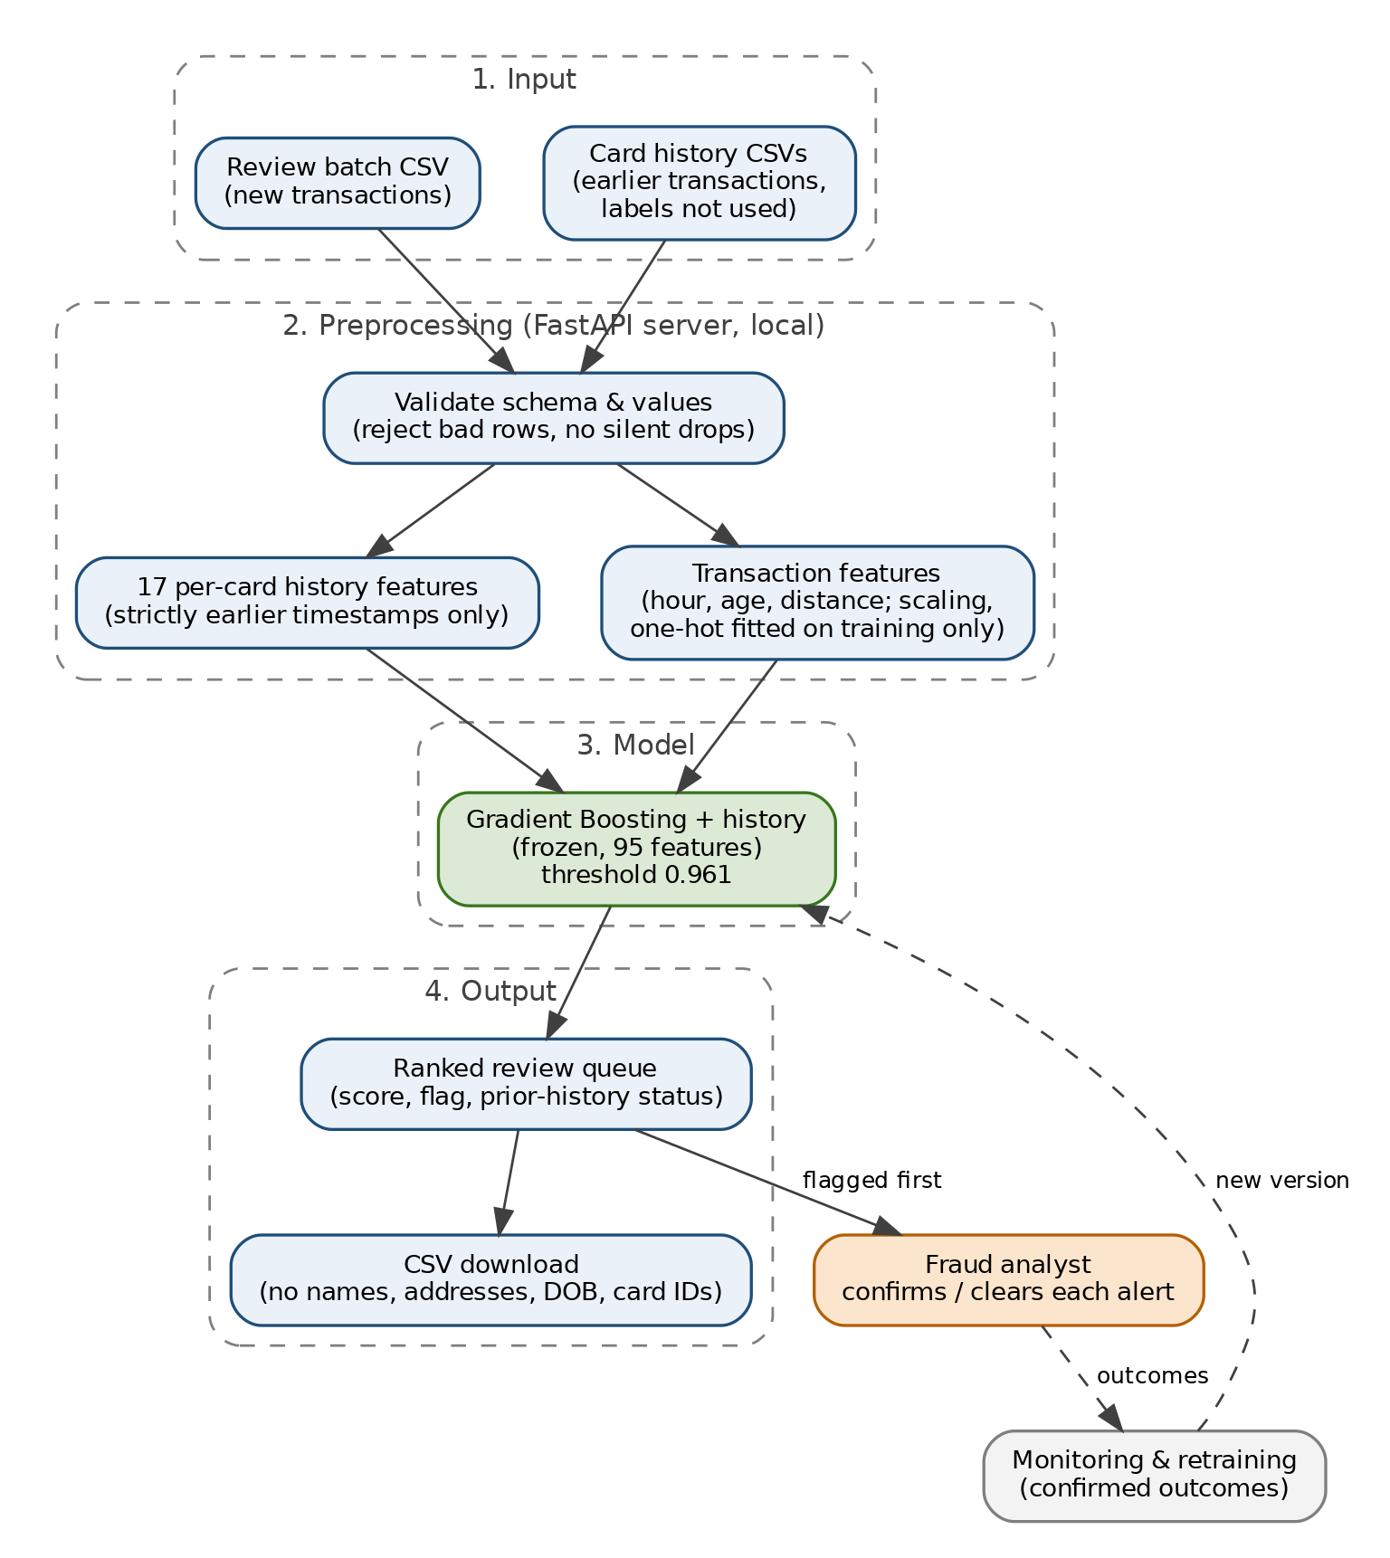
Figure A1. FraudShield flow: input CSVs → validation → transaction and history features → frozen Gradient Boosting model → ranked review queue → analyst decision, with confirmed outcomes feeding monitoring and retraining. Analyst outcome collection, monitoring and retraining are proposed operational extensions, not implemented prototype services.

