Final Project Proposal
Credit Card Fraud Detection Data Preparation and Preprocessing
Field | Details
Project title | Credit Card Fraud Detection and Risk Assessment System
Team members | Jorge Alvarez V; Mariela Del Rio; Javier Elizalde Ramirez; Juan Franceschi
Course / section | CAI2820C Artificial Intelligence Applications Solutions
Instructor | Hebert Metellus
Date submitted | October 23, 2026

Executive Summary
Team A proposes a supervised credit card fraud classifier to help analysts prioritize suspicious transactions for review. We use the Sparkov-generated Kaggle dataset, whose original CSV files contain 1,296,675 development transactions and 555,719 test transactions. This preparation run uses the established 324-card sample: 453,733 development and 194,320 reserved-test records. Inspection found no missing cells, duplicates, invalid labels, invalid dates, or invalid coordinates; 22,662 amounts exceeded the IQR outlier fence but remained valid and were retained. No cleaning rows were removed or added. Derived copies add transaction time features, age, and geographic distance. Training-only scaling and one-hot encoding produce 73 features. The earliest 80% of development rows train the preprocessor; the later 20% support validation. Test labels are not loaded. The data is ready with limitations involving imbalance, simulation, sampling, privacy-like fields, and representation. The final project will use full original files and rerun preparation before modeling.

1. Connection Between the Data and the Problem

1.1 Problem and What the Solution Must Learn
Operational question: Which credit-card transactions should a fraud analyst review first? Financial institutions must find rare fraudulent transactions among many legitimate payments while limiting unnecessary alerts. This continues the Part I problem statement, with Sparkov replacing the earlier proposed ULB dataset after instructor feedback.
Intended users: A simulated fraud analyst or financial risk team reviewing a ranked queue; the classroom prototype will not block real transactions.
The model must learn associations among amount, purchase category, transaction time, and customer/merchant context that distinguish the supplied fraud labels. These structured fields resemble operational transaction inputs, but synthetic examples do not establish real banking performance.

1.2 Input, Output and Target
Element | Description | Example from your data
Input | One transaction with amount, category, timestamp and supported context | 2020-03-06 13:44:38; personal_care; $74.05; Kentucky
Output | Planned fraud score, predicted class and review priority | Not produced in this preparation phase
Target / label column | is_fraud; supplied label, excluded from inputs | 0 for this actual example
Task type | Supervised binary classification | 0 legitimate; 1 fraud

2. Dataset Source and Access

2.1 Dataset Identification
Item | Your answer
Dataset name | Credit Card Transactions Fraud Detection Dataset
Creator / organization | Kartik Shenoy (Kartik2112), distributor; Sparkov synthetic transaction generator
Version or release date | Kaggle version 1; last updated August 5, 2020
Source URL / repository | https://www.kaggle.com/datasets/kartik2112/fraud-detection  Generator: https://github.com/namebrandon/Sparkov_Data_Generation
Date accessed | Source metadata rechecked October 15, 2026. Exact original download date was not recorded; local CSV SHA-256 fingerprints are saved in evidence/sampling_audit.json.

2.2 Collection Method and Relevance
Sparkov simulated customer and merchant profiles, transaction times, amounts, locations, and fraudulent activity. Its generated labels were supplied with the dataset. We downloaded the published CSVs; we did not collect bank transactions or regenerate the simulator. The Kaggle version and local file fingerprints identify the actual inputs used.
The labeled transaction structure supports our proposed fraud-risk classifier and analyst queue. Its relevance is structural rather than proof of realism: generated behavior and historical periods constrain transfer to a present-day financial institution.

3. Dataset Structure and Meaning

3.1 Size, Storage and Subset Used
Item | Your answer
Original number of records / files | 2 CSVs: 1,296,675 development + 555,719 test = 1,852,394 total rows; 23 raw columns each
File format(s) | CSV with header row
Total size | 501,592,535 bytes (501.59 MB, decimal) for both original CSVs
Subset used (if any) | 324 selected cards; 453,733 development rows (34.9920%) and 194,320 test rows (34.9673%). Complete per-card histories verified.
Reason for sampling | Reduce Colab processing time while retaining repeated transactions. This sample is for development; final modeling will use full original files.
Sampling procedure: The existing sample used a recorded seed of 42 and a cumulative test-row target near 35%. The stopping rule limited additional card selection, never a selected card history. The original draw order is not saved; the current exact 324 IDs are now saved in evidence/existing_sample_cards.csv and audited against originals. Filter both original CSVs by those IDs to reproduce the records. The new two-phase reducer instead accepts any percentage of unique test cards, saves the draw and actual row percentages, and writes only when its saved plan is accepted. Its 323-card preview has not replaced this sample. Original files contain 983 training cards, 924 test cards, 908 shared cards, 16 test-only cards, and 75 train-only cards. Selecting from test excludes train-only cards, which is why full originals are planned for final modeling. See Appendix G. Appendix B explains these supporting files and distinguishes the historical sample from new program selections.
Data dictionary (key columns):
Column / field | Data type | Meaning | Example value
Unnamed: 0 | integer | Original file row index; exclude from model | 0
trans_date_trans_time | date string | Transaction date and time; derive hour, weekday, month | 2019-01-01 00:00:18
cc_num | identifier string | Synthetic card ID for sampling and audit; exclude from model | ...89652095
merchant | text | Synthetic merchant name; excluded high-cardinality text | fraud_Rippin, Kub and Mann
category | category | Purchase category; one-hot encoded | misc_net
amt | decimal | Transaction amount in USD; standardized | 4.97
first | text | Synthetic customer first name; exclude | Jennifer
last | text | Synthetic customer last name; exclude | Banks
gender | category | Supplied binary demographic code; one-hot, bias caveat | F
street | text | Synthetic street address; exclude | 561 Perry Cove
city | text | Customer city; exclude redundant text | Moravian Falls
state | category | Customer state; one-hot encoded | NC
zip | integer/code | Postal code; exclude from this representation | 28654
lat | decimal | Customer latitude, degrees; numeric feature | 36.0788
long | decimal | Customer longitude, degrees; numeric feature | -81.1781
city_pop | integer | Customer city population; numeric feature | 3495
job | text | Synthetic occupation; excluded high-cardinality text | Psychologist, counselling
dob | date string | Synthetic date of birth; derive age at transaction | 1988-03-09
trans_num | identifier string | Unique transaction ID; audit only | ...f30655b9
unix_time | integer | Additional time field; excluded to avoid redundant encoding | 1325376018
merch_lat | decimal | Merchant latitude; numeric and distance input | 36.011293
merch_long | decimal | Merchant longitude; numeric and distance input | -82.048315
is_fraud | binary integer | Target: 0 legitimate, 1 fraud; never a predictor | 0

3.4 Labels
Label | Meaning | Assigned by
0 | Legitimate transaction | Existing generator/dataset label
1 | Fraudulent transaction | Existing generator/dataset label
Consistency checks completed: is_fraud contains only 0/1, with no missing labels and no duplicate transaction IDs. We preserved the supplied labels and compared class counts before and after preparation. Semantic correctness beyond the generator labels is not independently verified; manual inspection cannot establish real fraud ground truth.

4. Initial Data Exploration

4.1 Data Distribution
Class / label | Count | Percentage
Legitimate (0) | 451,296 | 99.4629%
Fraud (1) | 2,437 | 0.5371%
Total | 453,733 | 100.0000%
Only about 5.37 in 1,000 development transactions are labeled fraud. The original development file rate is 0.5789%, versus 0.5371% after sampling. A majority-class predictor would achieve 99.46% accuracy but zero fraud recall. Fraud amounts average $514.08 versus $67.88 for legitimate transactions. The highest observed category fraud rates are shopping_net (1.587%), misc_net (1.344%) and grocery_pos (1.314%); hourly rates peak around 22:00-23:00. Prioritize PR-AUC, precision, recall and review workload in later modeling. Appendix D shows these descriptive relationships, not causal effects.

4.2 Representativeness
Missing or underrepresented: fraudulent transactions, customers outside synthetic U.S. profiles, and real contemporary banking patterns. The reduced sample also omits the 75 train-only cards. The source provides only binary gender coding.
Overrepresented: legitimate transactions (99.46%). Repeated customers, frequently used categories and populous locations contribute unequal numbers of rows; the sample contains 46 states and 14 categories rather than a controlled demographic study.
Likely effect: overall metrics can hide missed fraud and uneven subgroup results. Test future transactions chronologically and later report group/category performance where sufficient examples exist. All 324 sampled test cards also occur in the training split, so this run evaluates future activity from known sampled cards, not new-customer generalization. Full data will restore additional coverage.

5. Data Quality Checks

5.1 Quality Issues Found
☐ Missing values - none found; see Appendix E
☐ Duplicate records - none found; see Appendix E
☐ Incorrect data types - none found; see Appendix E
☐ Inconsistent labels - none found; see Appendix E
☒ Unusual values / outliers - 22,662 amounts above the development IQR fence
☐ Corrupted files - none found; see Appendix E
☐ Irrelevant records - none found; see Appendix E
☒ Other - extreme class imbalance and synthetic-data limitations
Issue | Count / % affected | Example from the data | How detected
Missing cells / exact duplicates / duplicate IDs | 0 / 0 / 0 | All 453,733 rows retained | isna, duplicated, trans_num uniqueness
Invalid labels / dates / numeric values / coordinates | 0 for each | Label set 0/1; parseable dates; valid ranges | isin, to_datetime, finite and range checks
Amount upper outliers | 22,662 (4.99%) | IQR fence > $193.325; max $27,119.77 | Q3 + 1.5 x IQR; boxplot in Appendix E
Date strings / identifiers | Date fields loaded as text; card ID kept as string | trans_date_trans_time; cc_num | Schema inspection; expected CSV representation, not corruption

5.2 Most Serious Issues and Their Impact
Highest risk: severe imbalance can reward misleading accuracy and overwhelm analysts with false alerts. Choose metrics and thresholds using validation; do not use test outcomes for tuning.
Second: synthetic behavior, sampling and time drift can overstate transfer to real operations. Retaining high amounts avoids deleting informative extremes. EDA used the full development period, including the later validation part, so validation is development evidence; the official test remains reserved.

6. Cleaning and Preparation Decisions

6.1 Rule for Each Quality Issue
Issue | Rule applied | Justification
Missing, duplicate or invalid records | No removal/imputation; stop if future input fails quality gate | No such defects found in this run; silent deletion would hide changed data
High but valid amounts | Retain, flag for review; do not cap automatically | High value is not evidence of corruption; large legitimate payments exist
Date strings | Parse in derived copies | Required for hour, weekday, month and age; raw CSV remains intact
Index and identifiers | Exclude from model input; retain raw for audit | Avoid direct identity memorization and retain traceability

6.2 Record Counts After Cleaning
Count to report | Number
Original records | 453,733
Records removed in total | 0
Records added (if any) | 0
Usable records after cleaning | 453,733
These counts start from the already selected development subset. Sampling exclusions are not cleaning removals. Overlapping-removal reasons: N/A; no records were removed: 453,733 - 0 + 0 = 453,733.

6.3 Before-and-After Cleaning Example
Before cleaning | After cleaning
2020-03-06 13:44:38; personal_care; $74.05; is_fraud = 0 | 2020-03-06 13:44:38; personal_care; $74.05; is_fraud = 0; unchanged after quality validation
No record-level cleaning was necessary. The actual example remains unchanged; conversion and feature engineering are preprocessing, not evidence that the raw value was wrong. Quality counts in Appendix E justify retaining all records.

6.4 Verifying That Cleaning Did Not Damage Useful Information
Compared record and target counts before/after: 451,296 legitimate and 2,437 fraud in both cases. Original and reduced CSV fingerprints are logged. Derived operations use copies, preserve every row, and test label exclusion is explicit. There are zero shared transaction IDs between development and test. Appendix F contains an actual retained record and its later transformation.

7. Preprocessing for the Proposed Model

7.1 Preprocessing Steps
☐ Text normalization - N/A; not needed for this data
☐ Text feature extraction - N/A; not needed for this data
☐ Image resizing - N/A; not needed for this data
☐ Pixel scaling - N/A; not needed for this data
☒ Category encoding - category, gender and state
☒ Numeric scaling - 11 numeric features
☐ Missing value imputation - N/A; not needed for this data
☒ Other - derive time, age, distance and chronological splits
Step (in order) | Why this step is needed | Completed or planned
1. Derive features in copies | Hour/weekday/month, age at transaction and Haversine distance from supported raw fields | Completed
2. Sort and split development data | Earlier 80% training, later 20% validation; later official test reserved | Completed
3. Fit StandardScaler on training only | Comparable numeric scales for the proposed Logistic Regression baseline | Completed
4. Fit one-hot encoder on training only | Nonordinal category/gender/state indicators; unknown later values ignored | Completed

7.2 What the Model Receives
Each transaction becomes a SciPy CSR sparse row with 73 columns: 11 standardized numeric features plus 62 training-learned one-hot indicators. Matrix dimensions are 362,986 x 73 for training, 90,747 x 73 for validation, and 194,320 x 73 for reserved test inputs. Full matrices remain in memory; evidence and the fitted preprocessor are saved.
This representation fits a proposed Logistic Regression baseline and provides a common comparison input for a later tree model. No classifier is trained here. Numeric time coding is a first pass; cyclical time features and removing demographic/geographic inputs are later validation comparisons. The target, direct identifiers, raw timestamps, job and merchant text are excluded.

7.3 Before-and-After Preprocessing Example
Raw input | After preprocessing (model input)
2020-03-06 13:44:38; personal_care; $74.05; is_fraud = 0; female; KY; population 14,228 | 73-column sparse vector: scaled amount 0.025932; scaled age 0.272091; scaled distance -0.306659; personal_care/F/KY indicators each 1. Appendix F lists all 14 nonzero entries.

8. Data Splitting and Fair Evaluation

8.1 Train / Validation / Test Split
Split | Percentage | Number of records | Purpose
Training | 56.0118% | 362,986 | Fit preprocessing and later model
Validation | 14.0030% | 90,747 | Model/settings/threshold selection
Final test | 29.9852% | 194,320 | Final evaluation after all choices
The percentages above use all 648,053 sampled transactions as the denominator and total 100.0000%. The 80/20 ratio applies only to the 453,733-row development file; test is a separate later period, not part of that 20%.

8.2 How Records Are Assigned to Each Split
Time-based assignment: sort by transaction timestamp, then split at floor(0.80 x development rows). No random split seed is needed; original sample documentation reports seed 42, while new reducer previews save their own seed. Training ends March 6, 2020 at 13:39:47; validation begins 13:44:38 and ends June 21 at 12:13:36; test begins June 21 at 12:14:53 and ends December 31, 2020.
Safeguards: check exact duplicates and transaction IDs before splitting, assert ordered nonoverlapping periods and both development classes, exclude direct identifiers and target from predictors, and fit learned transforms only on training rows. Same customers may appear across periods by design. Test labels are not loaded, and the official test cannot guide feature, model or threshold choices. Development EDA is acknowledged as exploratory exposure.

9. Permissions, Privacy and Responsible Use

9.1 License and Permission
Item | Your answer
License | Kaggle data: CC0 Public Domain, metadata verified October 15, 2026
Free and publicly available? | Yes; Kaggle access/download flow may require an account
Allowed for classroom prototype? | CC0 supports this classroom data use; cite provenance
Allowed for production use? | CC0 does not impose an additional data-use restriction; suitability, policies and operational validation remain separate obligations
Items still to verify | Generator code has its own MIT license if reused. We use the published data, not copied generator code. No claim of production fitness.

9.2 Sensitive Information and Bias
Inspected names, card IDs, street, DOB, postal information and coordinates. They are synthetic but resemble personal records. Card/name/street/transaction IDs are excluded from model inputs; raw DOB becomes age. Coordinates, state and gender are retained first-pass inputs and remain potential identifying/proxy attributes. Shared previews omit direct names/addresses; raw files stay local and outside Git.
Bias concerns: binary gender, synthetic U.S. profiles, age/geographic proxies, rare fraud, unequal category/time coverage, and the 324-card subset. Later compare performance and false alerts by available groups with adequate support, and compare dropping demographic/proxy inputs. These are planned checks, not completed fairness certification; full original files will restore all cards for final modeling.

10. Evidence and Data Readiness

10.1 Evidence Submitted
Evidence item | Location
Dataset preview | Appendix C; main notebook Phase 1
Distribution and feature relationships | Appendix D; notebook Phase 4
Quality, types and outlier inspection | Appendix E; notebook Phase 3
Cleaning and preprocessing examples | Appendix F; notebook Phases 5-7
Notebook and preparation log | Appendix G; Team_A_Data_Exploration_and_Preparation_ran.ipynb

10.2 Reproducibility
Item | Your answer
Raw data location | Local originals: 01_Assignments/fraud/fraudTrain.csv and fraudTest.csv; existing subset in fraud/reduced. Repository readers obtain originals from the README source links.
Prepared data location | Notebook outputs are generated locally: charts, tables, feature list and fitted preprocessor; matrices remain in memory. Required results are included in this report and executed notebook.
Notebook / script and run order | First reconstruct the subset with code/reduce_fraud_by_card.py reproduce; then open the submitted executed notebook and Run All with those CSVs. Preparation functions are embedded; no separate shared module is required. See Appendix B for the program and Appendix G for the preparation log.
Key settings | Existing sample seed 42 (reported); 324 audited IDs; development 80/20 chronological split; StandardScaler; OneHotEncoder(handle_unknown=ignore); environment recorded in the notebook and log
How raw data is preserved | Read source CSVs, derive copies, write outputs separately; source fingerprints are saved. Historical reconstruction reuses exact IDs; new sampling preview does not write replacement datasets.

10.3 Readiness Status
☐ Ready for model training
☒ Ready with limitations
☐ Not yet ready
Submission roadmap: Appendix A identifies the files being submitted and the reading/run order. Appendix B explains the supporting reduction program, the selected-card CSV and the sampling audit. Appendices C-G provide the dataset preview, EDA charts, quality checks, transformation examples and preparation log.
The reduced data and training-fitted preprocessor support classroom modeling. Remaining limits are synthetic behavior, prevalence and subgroup shifts, incomplete original-card coverage, and untested model/threshold choices. Before final modeling, rerun on full originals; compare baselines and candidate models on validation; then evaluate once on the reserved official test period. Full-data counts/results must replace sample counts in that later report.

11. Final Data Preparation Statement
To support a classroom fraud-review assistant, Team A uses the Sparkov-generated Credit Card Transactions Fraud Detection Dataset distributed by Kartik2112 on Kaggle. The two original CSV files contain 1,852,394 transactions with 23 raw columns each, including amount, category, time, customer/merchant context and the binary is_fraud target. This preparation run uses complete histories for 324 selected cards: 453,733 development rows and 194,320 reserved-test rows. Fraud accounts for 2,437 development records, or 0.5371%, compared with 0.5789% in the original development file. Checks found zero missing cells, duplicate rows, duplicate IDs, invalid labels, invalid dates or invalid coordinates. The 22,662 upper-IQR amount outliers remain valid observations, so no records were deleted or imputed. Raw files remain unchanged while derived copies add hour, weekday, month, age and customer-to-merchant distance. An earlier 80% training period fits scaling and one-hot encoding, producing 73 features; the later 20% supports validation. The separate official test outcomes are not loaded, and transaction IDs do not cross development and test. CC0 permits classroom data use; synthetic identity fields are excluded from direct predictors, while retained geographic and demographic features require bias checks. The data is ready with limitations from simulation, imbalance, proxy attributes, sample coverage and development EDA exposure. Next we will rerun preparation using all original cards, compare models and thresholds on validation, and reserve the test period for final evaluation. Appendices and the executed notebook substantiate these decisions.

Appendices: Supporting Evidence

Appendix A: Submission Guide and Reading Order
The hand-in consists of this completed report and one executed preparation notebook. A supporting repository provides the notebook, reduction program, historical selected-card list, sampling audit and its own README explaining the pipeline. The program and selected-card CSV contents are not printed in this document; Appendix B explains what those supporting files mean.
Report: Team_A_Final_Project_Proposal_Data_Preparation.docx. Read Sections 1-11 for the decisions and Appendices B-G for their supporting explanations and evidence.
Notebook: Team_A_Data_Exploration_and_Preparation_ran.ipynb. Contains the executed EDA/preparation steps and results. Its embedded preparation functions allow standalone Colab execution without a separate shared-code upload.
Program: code/reduce_fraud_by_card.py. Supporting Python source for exact historical reconstruction and the revised preview/acceptance process for new selections; see Appendix B.
Selected cards: evidence/existing_sample_cards.csv. A small supporting CSV identifying the exact 324 cards behind this report, not a transaction dataset or a fresh selection; see Appendix B.
Sampling audit: evidence/sampling_audit.json. Supporting machine-readable counts, completeness checks and file fingerprints that connect those cards to the original and reduced CSV files; see Appendix B.
Reading order: report, Appendix B, then the executed notebook. Open the notebook in Colab or Jupyter and run from the first cell using the reconstructed fraudTrain.csv/fraudTest.csv pair. Colab accepts CSV or ZIP uploads without Kaggle credentials. Optional source comparison requires the original pair. The notebook prepares data; it does not redraw cards or train a classifier.
To recover the historical subset, run the program reproduce command with the originals, saved-card CSV, audit and a new output directory. It retains all transactions for the exact saved IDs, without redrawing. Verify 453,733 development and 194,320 test rows. The repository README provides commands; Appendix B explains the method.
The repository README provides dataset URLs, reproduction commands, expected counts and pipeline instructions. The code/ and evidence/ paths above are relative to its Part II folder. Working archives, reference templates and alternate outputs are not additional deliverables. The required plots and tables are included here in Appendices C-F.
Public GitHub repository Part II: https://github.com/MCDR-Code/CAI2820C_FraudShield/tree/main/Part_II_Data_Preparation
The Part_II_Data_Preparation folder version above supports this hand-in. Part_III_Modeling_Demo is separate later-phase work, not part of this deliverable. Submit the report and executed notebook; the link supplies supporting files. Original/reduced transaction datasets, ZIPs, credentials and duplicate versions are excluded. The small card-ID CSV is retained to reconstruct the exact subset.

Appendix B: Reduction Program and Selected Card Files

B1 Reduction program purpose and inputs
The supporting file code/reduce_fraud_by_card.py reduces processing time while preserving complete transaction histories. Its inputs are the separate original fraudTrain.csv and fraudTest.csv files. The cc_num column is a grouping identifier kept as text, not a numerical risk feature. Sampling is based on card IDs and row counts, not fraud outcomes. The source header explains its purpose, phases, outputs and limitations; no source-code listing is included in this appendix.

B2 Preview and acceptance phases
For this report, use reproduce mode with the original train/test files, existing_sample_cards.csv, sampling_audit.json and a new output directory. It verifies source fingerprints and the saved-card totals, then writes all matching transactions without drawing cards again. Original row order and field values are preserved; the same inputs produce deterministic output files. CSV quoting or line endings may differ from an earlier exported file, so byte fingerprints identify exact file versions while transaction IDs, values, counts and complete-history checks establish the reconstructed dataset. The historical seed alone is not used to reconstruct the earlier random draw. The repository README gives the command.
Preview accepts a user-entered percentage of unique TEST cards, rounds it to a whole-card count, randomly selects those cards and saves their exact IDs and random seed. It counts all their transactions in both original files and reports the actual row percentages, which need not equal the requested card percentage. Preview writes selection.json and selected_cards.csv, but no reduced transaction files. The team can review the counts, choose a different percentage or draw again before accepting.
Write accepts the saved selection.json plan. It checks that the input files match the preview fingerprints, retains every transaction for the saved cards in each file, verifies per-card histories and totals, and publishes fraudTrain.csv, fraudTest.csv and sampling_report.json into a new output directory. It does not overwrite originals or existing output directories, truncate histories, combine train/test or train a model. Optional source-path overrides allow moved original files only when their contents still match the saved plan.

B3 Historical selected-card CSV
The evidence/existing_sample_cards.csv file contains one column named cc_num and 324 distinct synthetic card identifiers, one selected card per row. It contains no transaction amounts, timestamps, fraud labels or feature matrix. Use it as an inclusion list against both original files to identify the exact historical sample used throughout this report. Import the column as text; opening and saving long IDs as numbers in a spreadsheet can change their precision.
This historical subset was selected under an earlier cumulative test-row target near 35%, with recorded seed 42. The original random draw order was not saved; the exact surviving IDs were exported and audited afterwards. The revised program selects a percentage of unique test cards instead. Running its preview at 35% with seed 42 therefore does not promise the same 324 cards or reported row totals. Its new selected_cards.csv includes per-file transaction counts and must not be confused with the submitted historical existing_sample_cards.csv. The historical CSV is not a selection.json plan and is not a direct input to the program write phase.

B4 Audit and limitations
The evidence/sampling_audit.json file records original/sample row counts, unique-card counts, retained row percentages, source and sample SHA-256 file fingerprints, and complete-history checks. It verifies that the historical selection retains 453,733 of 1,296,675 development rows (34.9920%) and 194,320 of 555,719 test rows (34.9673%), with the same 324 cards in both reduced files. It documents provenance, not model accuracy or the original shuffle order.
Selecting cards from test excludes the 75 original training-only cards and does not guarantee a representative population or identical train/test row percentages. The sample supports this preparation assignment; the later final modeling phase uses full originals. Card histories are preserved, but this preparation does not yet calculate individual spending baselines or other past-only customer-history features. Such future features would need to exclude future transactions and labels to avoid leakage.

Appendix C: Dataset Preview
Time | Category | USD | Label
2019-01-01 00:00:18 | misc_net | 4.97 | 0
2019-01-01 00:00:51 | entertainment | 220.11 | 0
2019-01-01 00:04:42 | grocery_net | 44.54 | 0
2019-01-01 00:05:08 | gas_transport | 71.65 | 0
2019-01-01 00:05:18 | misc_pos | 4.27 | 0
First five actual development transactions; direct customer identifiers omitted. The notebook also prints the complete 23-column list and identifies is_fraud explicitly.

Appendix D: Distribution Chart / Table
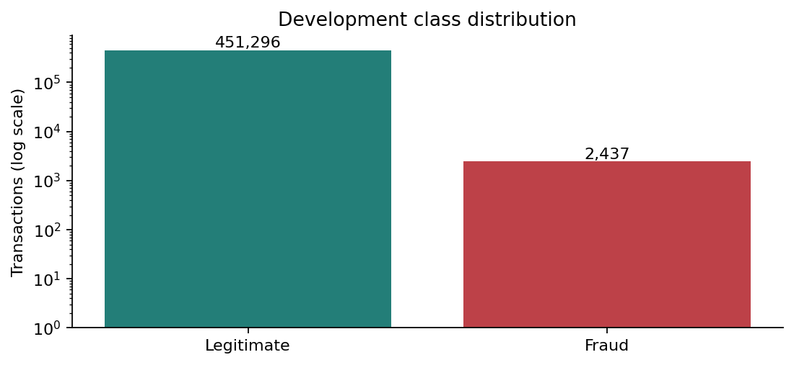
Figure D1. Development class counts on a log scale; legitimate 451,296 versus fraud 2,437.
Label | Mean USD | Median USD | Maximum USD
0 | 67.88 | 48.43 | 27119.77
1 | 514.08 | 353.88 | 1371.81
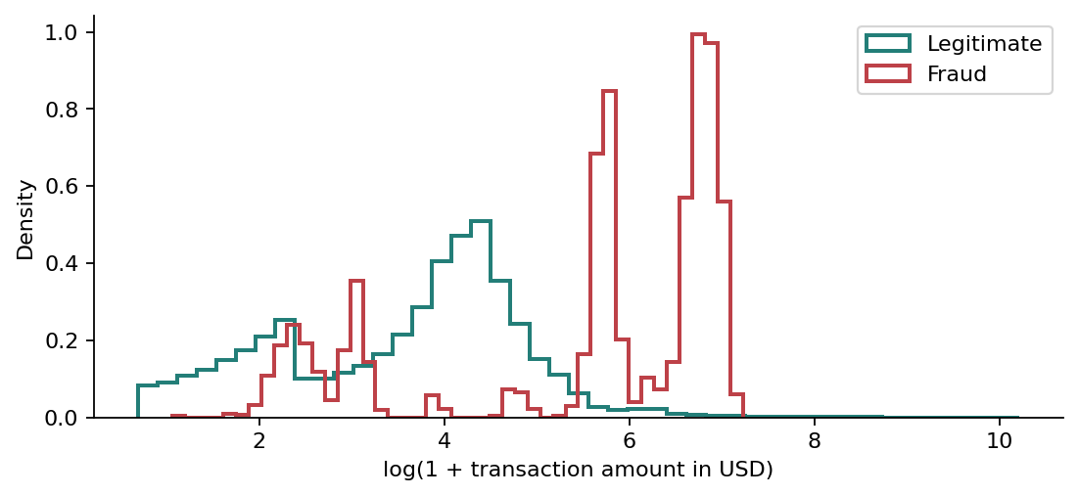
Figure D2. Fraud amounts have mean $514.08 and median $353.88, versus $67.88 and $48.43 for legitimate transactions. Distributions overlap.
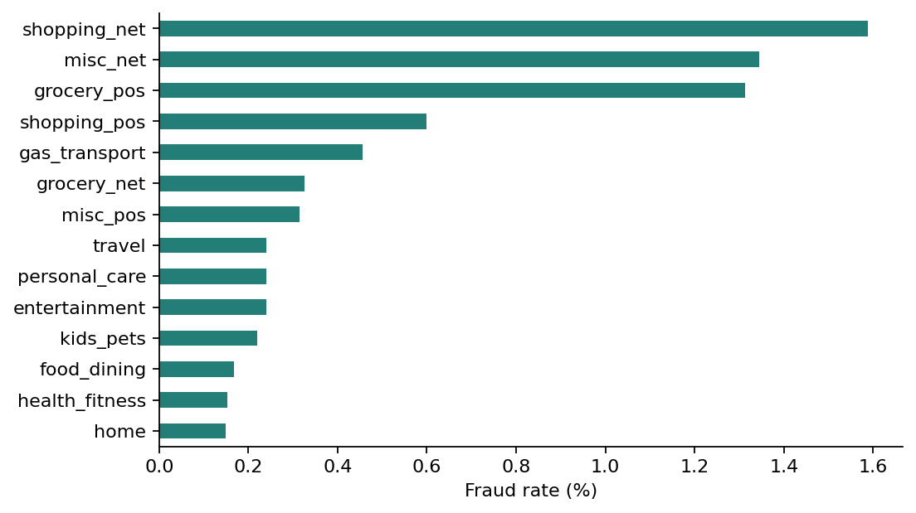
Figure D3. Category fraud rates differ; shopping_net, misc_net and grocery_pos are highest in this development sample.
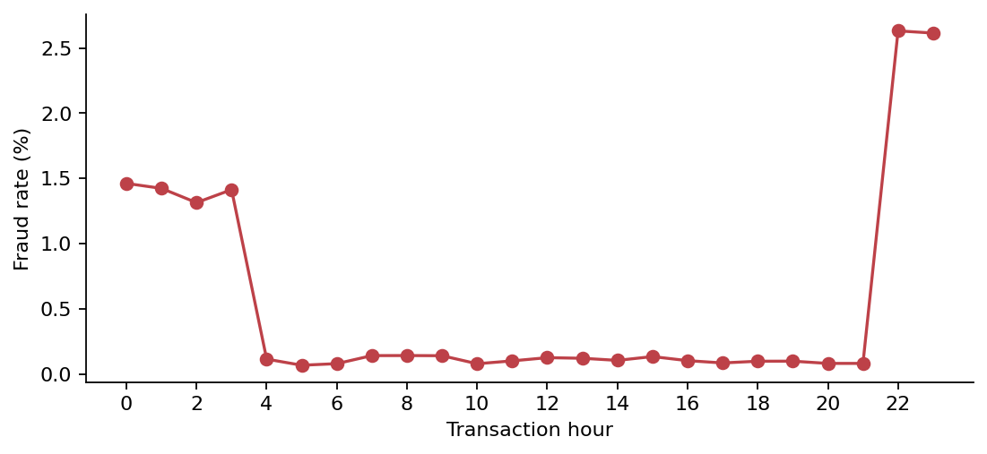
Figure D4. Development fraud rates peak around 22:00-23:00. This descriptive association supports considering transaction hour.

Appendix E: Quality-Check Results
Field | Loaded type | Missing
Unnamed: 0 | int64 | 0
trans_date_trans_time | str | 0
cc_num | string | 0
merchant | str | 0
category | str | 0
amt | float64 | 0
first | str | 0
last | str | 0
gender | str | 0
street | str | 0
city | str | 0
state | str | 0
zip | int64 | 0
lat | float64 | 0
long | float64 | 0
city_pop | int64 | 0
job | str | 0
dob | str | 0
trans_num | str | 0
unix_time | int64 | 0
merch_lat | float64 | 0
merch_long | float64 | 0
is_fraud | int64 | 0
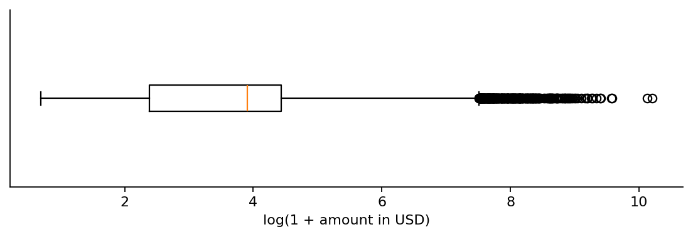
Quality checks evaluated all 453,733 development records. Missing cells, duplicates, invalid labels, date parse failures, nonfinite numeric values, invalid coordinates, negative population and births after transaction all equal zero. The numeric amount range is $1.00 to $27,119.77. Upper-IQR outliers: 22,662 above $193.325; these are retained. The schema table above and the executed notebook contain the supporting types, missing-value counts and quality-check results.

Appendix F: Before-and-After Examples
Cleaning example: the $74.05 personal_care transaction shown in Sections 1.2 and 6.3 remains unchanged. Class totals remain 451,296 legitimate and 2,437 fraud. Preprocessing converts that actual validation row to a 73-column vector; the 14 nonzero values are listed below. Raw timestamp and DOB become derived features; coordinates also remain numeric model inputs. The label remains separate.
Feature | Transformed value
numeric__amt | 0.025932
numeric__city_pop | -0.232292
numeric__lat | 0.102641
numeric__long | 0.488338
numeric__merch_lat | 0.184829
numeric__merch_long | 0.444684
numeric__transaction_hour | 0.026103
numeric__transaction_day_of_week | 0.393876
numeric__transaction_month | -0.968038
numeric__customer_age | 0.272091
numeric__customer_merchant_distance_km | -0.306659
categorical__category_personal_care | 1.000000
categorical__gender_F | 1.000000
categorical__state_KY | 1.000000

Appendix G: Notebook / Preparation Log
Submitted executable evidence: Team_A_Data_Exploration_and_Preparation_ran.ipynb. The notebook contains the shared source snapshot for standalone Colab use. No external code download or Kaggle token is required. The reducer is code/reduce_fraud_by_card.py; its preview/write phases deliberately require separate commands. The exact existing sample IDs are in evidence/existing_sample_cards.csv; source fingerprints and original/sample counts are in evidence/sampling_audit.json. The repository location and submission version are listed in the submission guide.
Preparation log: 1. Load the existing reduced CSVs and exclude test labels. 2. Audit card histories and original/sample row counts. 3. Inspect columns, target, types and quality. 4. Plot class, amount, category and time relationships using development records. 5. Derive time, age and distance in copies. 6. Sort and split chronologically, checking IDs and periods. 7. Fit preprocessing on training only, transform validation/test inputs, and save actual examples/evidence.
Executed environment: python 3.12.0, pandas 3.0.3, numpy 2.5.4, scipy 1.16.3, scikit_learn 1.8.0, matplotlib 3.10.8, joblib 1.5.3. These versions document the execution environment. The notebook requires the selected transaction CSV files to rerun; its saved outputs can be inspected without them. The reduction program uses Python standard-library modules only.

