Figures Report

July 23 , 2020

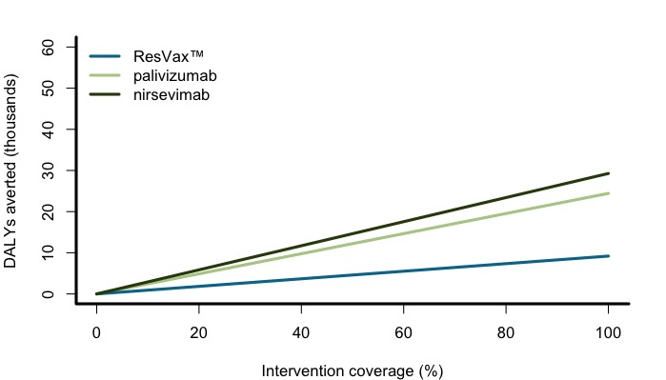

Disability-adjusted life years (DALYs) averted as coverage increases for each intervention.

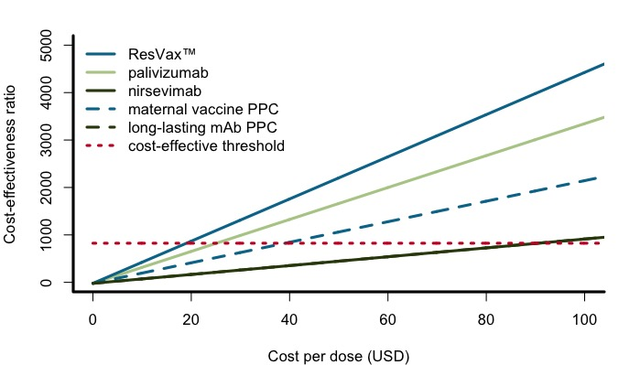

Incremental cost-effectiveness ratio (ICER) as cost per dose increases for each intervention. The red dashed line indicates the cost-effective threshold, equal to the per capita GDP of Mali.

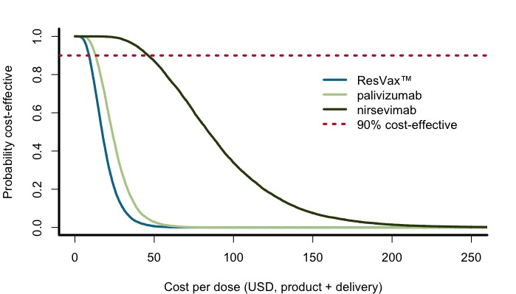

Probability each intervention is cost-effective at a given cost-per dose

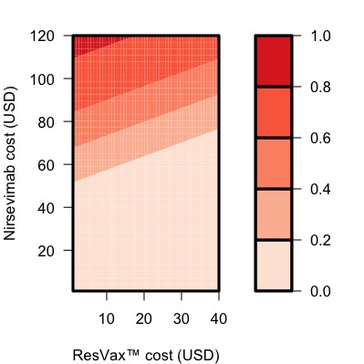

Probability ResVax™ has greater net health benefits than nirsevimab at a given cost per dose (product and delivery) for each intervention