Report: Color maps

Michael Gallaspy and Kevin Kannappan

# Summary

This report assesses the original color scheme choice in our visualization using the Colbis tool for simulating various kinds of color blindness. Our visualization consists of several lines tracking the “goldiness” of countries that participated in the Olympics over time. The color channel is used to encode the country, so that when multiple lines appear overlapping in the plot, a user can still pick out the values specific countries. Moreover by moving the cursor over the plot, one specific line becomes highlighted depending on the cursor position, and the other lines become gray, the intention being to more allow the user to easily assess the goldiness of one country.

The original choice of colors turns out to be problematic for several types of color-blindness, particularly since other lines might become gray during interaction. The highlighting does not function as intended if for instance a red line becomes highlighted and the user is red-blind – the effect is that all lines become gray and indistinguishable from one another. The final section analyzes alternate color schemes.

# Original color scheme

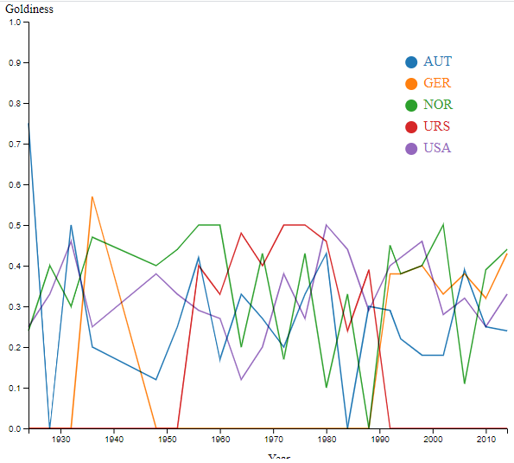  
Figure 2: Original color scheme

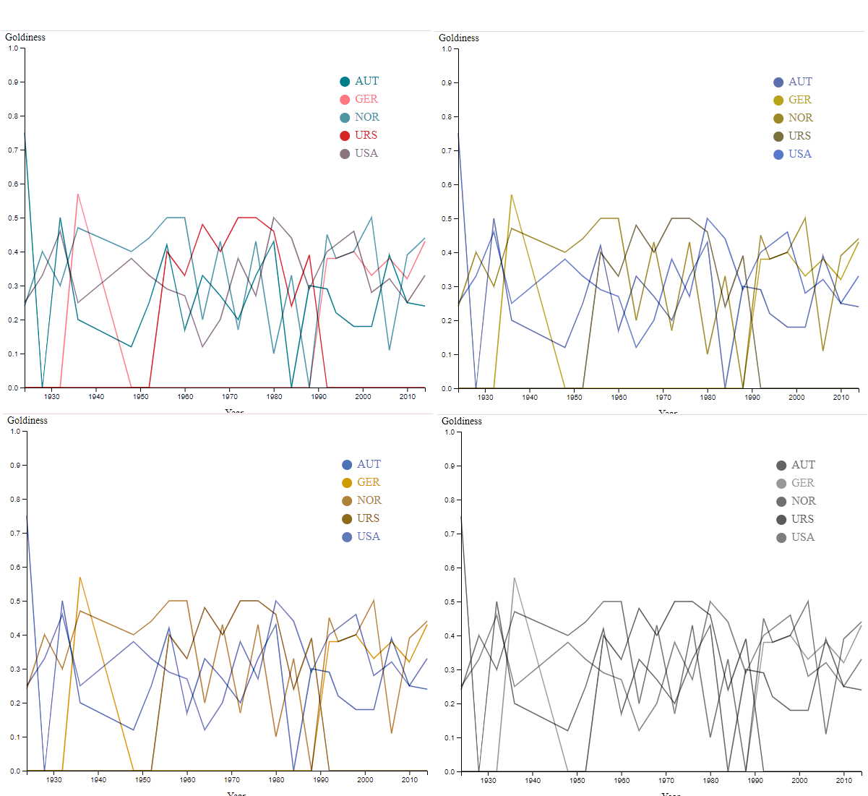  
Figure 1: Original color scheme with simulated color-blindess: blue-blind (top left), red-blind (top right), green-blind (bottom left) and monocrhomacy (bottom right).

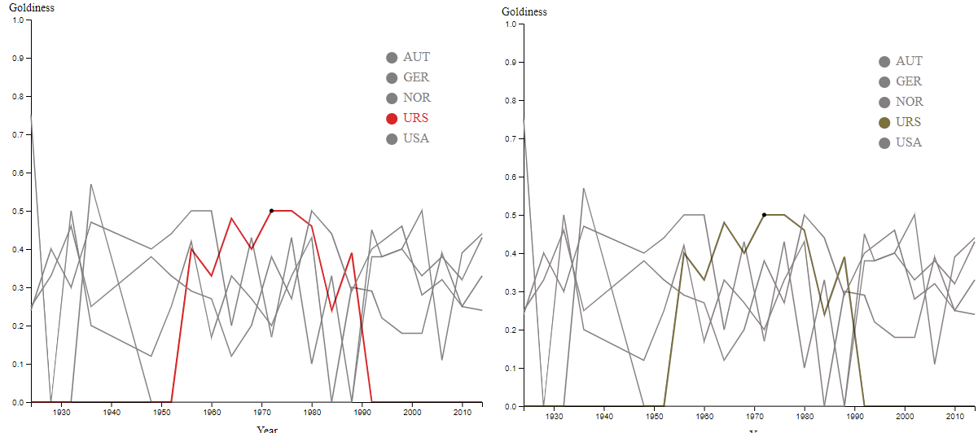  
Figure 4: Original scheme with highlighting (left) and the same with simulated red-blindness (right).

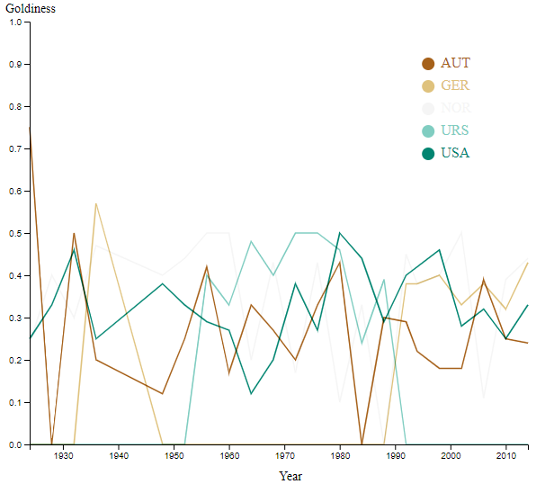  
Figure 3: Visualization with diverging color scheme

The original color scheme (Figure 2) doesn’t hold up well under various kinds of color blindness (Figure 1) as several of the colors become hard to distinguish. The situation is even worse when the other lines are grayed out (Figure 4), as the highlighted line can be nearly indistinguishable.

# Alternate color schemes

An alternate color scheme might be better if it avoided encoding information in the hue, since different hues are harder to distinguish with color blindness. A diverging color scheme seems like a good choice initially, however several of the colorbrewer2 diverging schemes are centered around white, which causes one of the lines to be hard to distinguish even without color blindness (Figure 3). This turns out to be a problem with nearly all of the diverging color schemes built in to d3.

One solution with decent results is to use a diverging color scheme, but darken the background color to achieve better contrast. This shows good results even when a single line is highlighted.

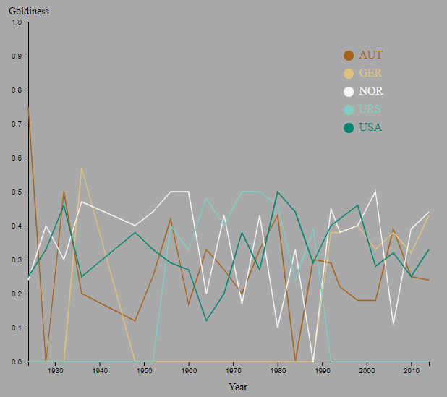  
Figure 7: Diverging color scheme with dark background

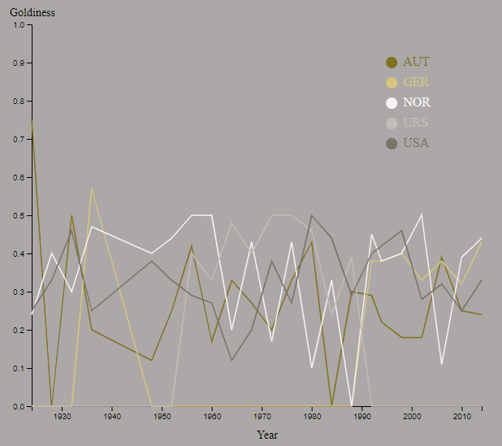  
Figure 8: Diverging color scheme with dark background, simulated red-blindness

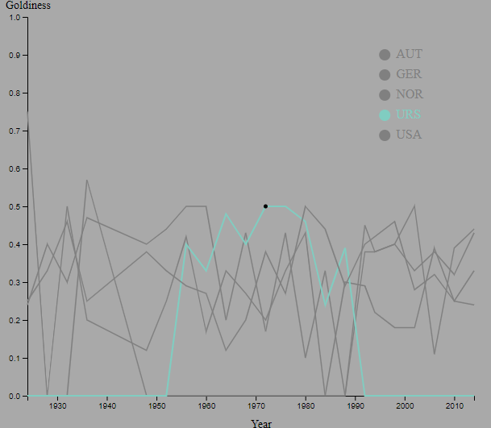  
Figure 5: Diverging color scheme with dark background and highlighted line.

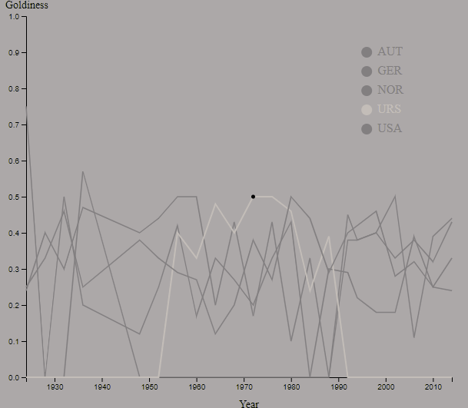  
Figure 6: Diverging color scheme with dark background and highlighted line, simulated red blidness.