SECURITY IN MICROSERVICE SEASON 1

- Core concepts
- Authentication: verifying the user is (login with credentials)
- Authorization: verifying what the user can access(roles, scopes, policies).
- Token-based Authentication:
- Most modern systems use JWTs( Json Web tokens) to carry user identity and roles across services.
- Token removes the need to call the auth service repeatedly.

- Architecture review
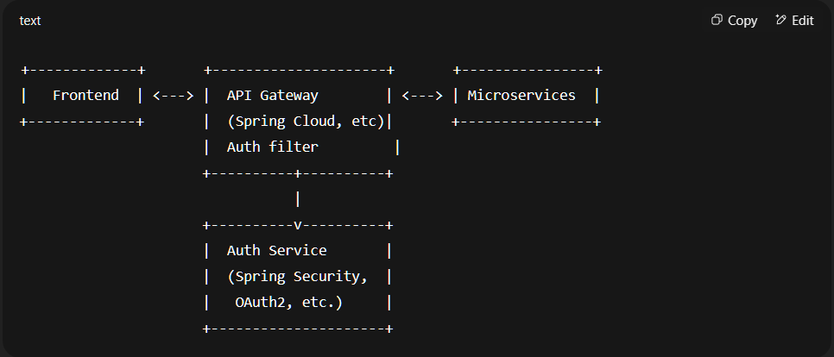

- Security Layers in Microservices
Layer1: Authentication layer (login)
- usually centralized.
- common tools: Spring Security, Keycloak, Auth0, Firebase Auth.
- users authenticate with username/password, OTP, or OAuth2 providers.
- On success: generates a JWT access token ( + sometimes a refresh token).

Layer2: API Gateway / Edge Service
- Handles:
- Token validation(signature, expiration)
- Role/Scope-based access checks.
- Token forwarding to downstream services

- Optional: Rate limiting, IP whitelisting, CSRF filtering.

Layer3: Internal Service-to-service communication
- JWT is passed in Authorization: Bearer <token> header.
- Services validate the token (and optionally decode claims to check roles/scopes).
- No need to hit the auth server again ( JWT is self-contained).

- JWT Token details
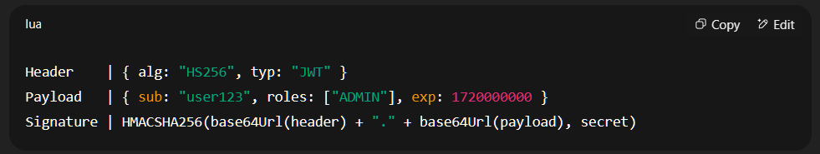

Header: algorithm:”HS256” + type:JWT
Payload: {user data}
Signature: HMACSHA256(base64Url(header) + …..

Claims to include:
. sub - subject ( user ID)
. roles/authorities - Permissions
. exp - expiration time
. iat - issued at
. scope - For Auth2
. custom claims - e.g, orgId, tenantId.

- Token Management
- Access token:
- Valid for ~ 15 minutes
- Sent on every request in headers.
- Stateless (no server DB lookup needed)

- Refresh Token (long lived):
- Store securely(e.g, HTTP-only cookie or encrypted in DB).
- Used to get a new access token after expiry.
- Only sent to the auth server

- Token flow example
1.Login -> user submits credentials to Auth Service
2.Auth Service:
+ Verify credentials.
+ Generate Access Token + Refresh Token.
3.Frontend store token(usually in localStorage or cookies)
4.Frontend sends JWT in every requests to API Gateway.
5.API Gateway verifies the token -> forwards to microservice
6.Microservice processes request, maybe checks roles/claims.
7.If Access Token expires, frontend sends Refresh Token to Auth Service for a new one.

- Tech stack (Spring based)
- Spring Security + JWT:
- Secure endpoints with annotations: @PreAuthorize(“hasRole(‘Admin’)”)
- Use filters to intercept and validate JWT.
- Key libraries:
- spring-securities-oauth2-resource-server
- jjwt
- Nimbus JOSE + JWT
- Spring Cloud Gateway or Zuul (API Gateway).

8. Code snippets ( Spring Security with JWT)

@EnableWebSecurity
public class SecurityConfig {
@Bean
public SecurityFilterChain filterChain(HttpSecurity http) throws Exception {
http
.csrf().disable()
.authorizeRequests()
.antMatchers("/auth/**").permitAll()
.anyRequest().authenticated()
.and()
.oauth2ResourceServer()
.jwt();
return http.build();
}
}

@Bean
public JwtDecoder jwtDecoder() {
return NimbusJwtDecoder.withSecretKey(secretKey).build();
}

9. Best practices
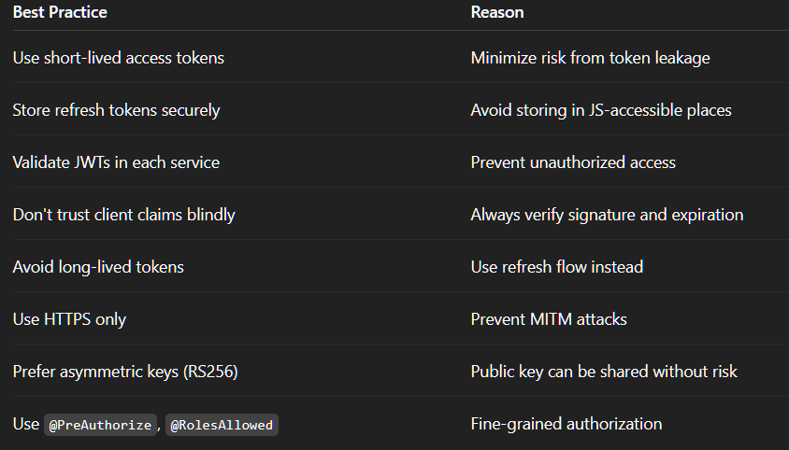
10. Advanced Options
- Service Mesh + mTLS: e.g., Istio can secure service to service traffic.
- OPA (Open Policy Agent): Externalize fin-grained policies.
- Attribute-Based Access Control(ABAC): Use custom attributes in JWT.
- Zero trust: Never trust, always verify - each request, each service.
