Repository for this Assignment: <https://github.com/MCKevmeister/WEB503>

Hosted Site Via GitHub Pages: <https://mckevmeister.github.io/WEB503/index.html>

# Choosing a suitable website to redesign: localbarber.nz

For the WEB503 class assignment 3 I have had to design a website. For the purposes of this assignment I have chosen to redesign an already poorly developed website. I have chosen the localbarber.nz as it is my current hairdresser.

The site is based on a WordPress theme. What is great about it and works well are the pictures and logos. The websites purpose is to advertise the business, and services that are offered.

What doesn’t work well is the page load times, the inconsistent themes/positioning of elements on each of the pages, the lack of consistent style and links that do not work correctly.

## Home Page

When arriving at the homepage <https://www.localbarber.nz/> the user is presented with a full page background image with the logo overlayed. When the user scrolls down the page the menu slides in from the top of the page.

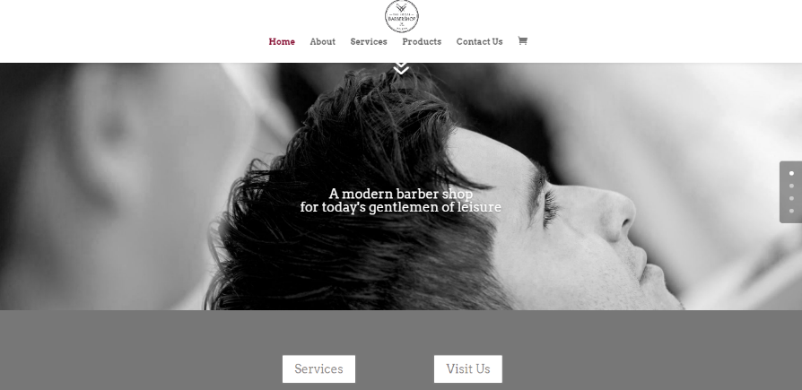

Scrolling down the page, the navigation bar slides in from the top of the page.

Further down the page, there are unclickable images for 2 of the 5 main pages for the website below 2 square buttons for 2 other pages. Additionally, there is a Facebook link that is oddly off to the left of the page. It seems out of place and doesn’t make sense to me why it is there.

At the bottom of the page there is an ugly Contact form that takes up the full width. It seems odd and unecessary.

## About Page

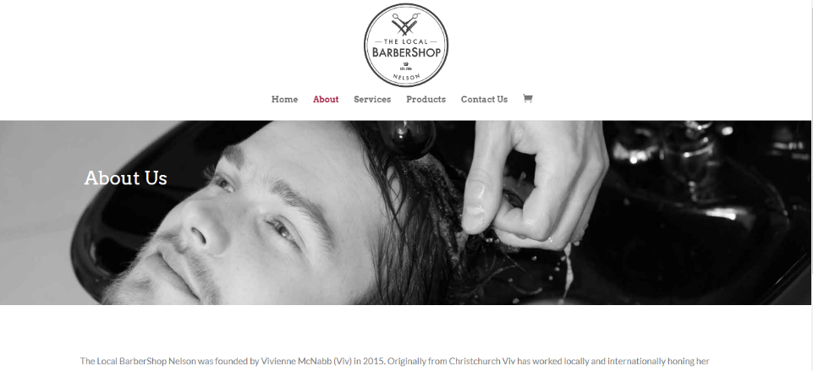The About page notably has a different header than the main page when landing. Also again lower on the page is the same Facebook link that seems an afterthought of the original design. Fortunately, on this page the navigation bar does not change its size or position.

## Service Page

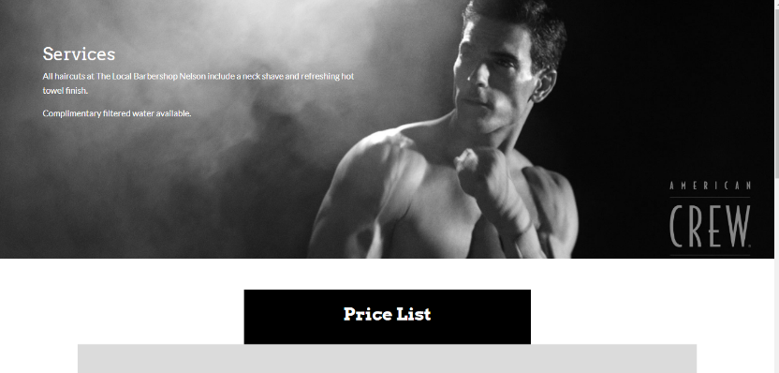

The service page once again seems to be having a bit of a personality crisis with the navigation bar. It isn’t there when you land on the page the user must scroll down to revel it. However, it also disappears when you scroll back to the top of the page. Why?

Oddly on the page the copy state “No appointments taken. Your appointment is when you arrive!” Yet at the bottom of the page there is a button with the label “book now” ?? Huh, very confusing. Many questions.

## Product Page

Once again, the Navigation bar is having a bit of a personality crisis. This time when you land on the page it shows but when you scroll down, the navigation bar shrinks. How is this this inconsistent over all these pages? Its almost as if someone is intentionally messing with the navigation bar settings. Anyway, its something that will be fixed in my redesign.  
  
Further, the “products” listed on the page are nothing more than images. When clicked they lead to an image carousel, not an actual product page. To get to the product page one must click the shopping cart in the navigation bar, then click the “back to shop” button when then takes you to the actual shop. Again, did someone design this so that no one would be able to buy products from the website?

Also, unusual Facebook link again in a weird position.

I could go on about how the contact us page has a google map that doesn’t load correctly and has weird links throughout. But I will ignore that faf for now.

# Wireframes

To develop the new website, I will make some wireframes. The development of the website will be easier as I will be able to refer to the wireframes after I start making the code for the pages.

## Home Page Wireframe



## About Page Wireframe



## Service Page Wireframe



## Shop Page Wireframe



# Setting up GitHub

For version control for this website we were encouraged to use github. It links in very nicely with VS code and made for a seamless development process. Adding new files was very easy in the editor and pushing the commits that I made locally was very easy once I was familiar with how git worked.

I branched my work so that the changes that I was making were going to be done on a “dev” branch so that I could have several versions of the website. Through the development process I reverted a few changes back to where I had previously been, by copying the code from the previous versions off git hub and putting the code back that was functional.

The GitHub repo for this assignment is <https://github.com/MCKevmeister/WEB503>.

# Acquiring Assets

I reached out to the current owner of the website to get her permission to use her images in the redesign and asked her if she would like anything specific done. She didn’t necessarily want anything specifically done however gave me permission to use her images.

I downloaded all the images I thought that I would need (I ended up using more later) from the current website.

My initial design of the website was going to be in vanilla html and css. I started by using an html boilerplate and adding the elements that I wanted based off of the wireframes. q

I have previously used WYSIWYG editors and found that bootstrap studio was something similar to what I have used in the past. I downloaded it and built out the website according to the wireframes that I had built, putting in detail as much as possible for where I could. This process took several hours.

The website wasn’t quite the way I wanted to look and didn’t have all the functionality that I was hoping it would so I exported the assets that bootstrap studio had created to the git repository. A difficultly that I ran into at this point was the file structure and the minified JavaScript and CSS files that bootstrap included. I realised that I would need to make some of my own classes and my own stylesheet in order to stylize the pages as I needed to in order to create the website in the way that I wanted it to be.

I decided to keep the original copy from the website as it was serving the purpose for what it was design for.

# Hosting

Once the html and css was pushed to GitHub, I utilized the hosting feature that GitHub offers to host the website. Setting this up was very easy.

1. Go to settings of the repo
2. Scroll down to GitHub Pages and enable it
3. Select the master branch as the source.

I assume because I named my homepage Index.html that GitHub uses the logic to assume that that is the home page of the website, because I didn’t need to do anything extra along the way in order to make it work.

The site is currently hosted via the url <https://mckevmeister.github.io/WEB503/>. Changes via pushes to the remote repository where quite often instant. However there where a few times when I pushed changes and they didn’t reflect until a few minutes later. I did notice that there was some slight differences initially between the “live server” as hosted by my local machine and GitHub pages. This was primarily in the Parallax of the images that I have discussed below.

# Google Maps

Initially I approached this step entirely the wrong way. I wanted to put a small map on the home page to display the physical location of the shop to a user so that they would be able to quickly find the store. I wonder to if there is some benefit to adding other google products on a page in order to increase page rank on google searches. In any case, I tried and tried to find the work around making an <Iframe> a certain width and height and trying to get its source correct……. All the hard way.

In the end it was quite simple

1. Go to google maps
2. Search for “the localbarber shop”
3. Adjust zoom to an adequate level
4. Click share > Embed a map
5. Select the size of the map (I choose small)
6. Copy the html
7. Paste the html <iframe> in my code where I wanted it.
8. Stylize it as necessary

I didn’t like the exact size of the iframe and wanted to change it. I tried to do this by creating a css class and adding my own css to the stylesheet that I had created. For some reason, I can only assume that the reason is bootstrap, I was unable to adjust the iframe with class selectors. In the end I used inline style to adjust the image. I still would prefer to keep the style out of the html (separation of concerns) as I consider it better coding practice. However for the sake of the exercise I was unable to do so and just wanted it to work so I have settled (a bit begrudgingly) for inline style.

# Google Analytics

After the faffing about that I did with the map I didn’t want to do the same thing with the Analytics that where required for the assignment. The steps for inserting the Analytics were far easier.

1. Go to analytics.google.com
2. Go to settings
3. Make sure that I had a valid tracking ID (I must have already set this up in the past because I already had one)
4. Copy the JavaScript and insert it into all the pages that I want to be tracked by google analytics

Specifically mentioned on the page was to input the JavaScript at the top of the header, assembly so that it loaded before the rest of the page does in order to track everything that will be happening on the page. Far simpler than the map was but in the end just as easy now that I knew how to work with the product.

# User Testing AKA Getting some Feedback from classmates

I wasn’t quite sure how I felt about the website since I had been so close to the site for several weeks. I sent a message away to the current owner of the website and in class asked a few of my fellow class mates what they thought of the website.

The feedback that I received mostly came back to the fact that the page was a bit boring. There wasn’t any really interesting elements that grabbed them as users on each page.

I looked back over the original website and saw that they had implemented a version of parallax images for each page. I though that I would just copy over the same images so that the website had the same feel.

In order to do so I had to try and source where the images where being hosted. After not being able to find the source with inspect element, I had to resort to using a feature in an extension in chrome for advertising blocking. When I attempted to block the image that was the parallax it finally showed me the url source of the image. From there I was able to go to that site and save the image locally in the directory of the git repository on my machine.

The parallax was going to require that the centre logo was white and had a transparent background for all but one page. Luckily the existing website had such a logo so it was a simple task of pointing those images to the new path.

A challenge came when I tried to add the background images to the pages. Locally using Live server in VS code I was able to copy the relative source of the image and paste it as the source for the parallax. However when I uploaded this to GitHub and viewed the site at GitHub pages the parallax images didn’t work and instead didn’t load the image and just showed a blank background.

I could point the path to the remote source and GitHub as well as live server would load the background, however not if I pointed it to the relative path. Once again in an attempt to just finish the work but not have it exactly the way I would have like I settled for not being able to point the path of the image to a “local” source but instead point to a remote host for the images.

# Favicons

Another cute idea from asking around and seeing what else I could do for the website was doing a favicon that shows in the tab of the browser to the left of the page title. It was the cutest little thing that gave me a sense of joy in how easy it was to push to all pages.

# The “Finished” Product

“A work of art is never finished. It is merely abandoned.”

― E. M. Forster

Yes I feel Mr. Forster may be very correct in this statement. I could have spent many more hours fiddling around and changing small things. There are still things that I would like to work on, however the due date for the project as of writing is 2 days away.

The “unfinished” or “unpolished” elements that I can see as of now are

* The Navigation menu could be “prettier”. Maybe rounded edges and hover over effects?
* The Products do not link anywhere. While I mentioned this in the brief its an obvious next step of development.
* The logo in the footer I would really have preferred to point back to the homepage increasing the number of backlinks in the website. When I put the image in an <a> tag it moved the image so that it was overlapping with the other elements in the footer as seen below



It infuriates me that this happens, however I have had to settle for it to not be exactly how I would like for now. I assume that this is an issue with bootstrap.

* In the footer the spacing between the days and the opening hours is done simply by me hitting space. It feels hacky and shows when I resize the browser how poor of an implementation choice this is. Once again, if I had the time I would go through and fix this. I like sleep though so this will have to do.

There are other minor little things that niggle me. The more I look the more I want to change things. I’ve decided that for now it is acceptable.

While I am not entirely happy, I can at least be happy in knowing that the implementation of the website I have done is somewhat …. Better design than the website that I was first basing it from.

Would I change things, sure.

Will I ever be perfectly happy, No.

I can rest well in knowing that.