Create a PHP page that uses cookies to remember what a user has entered into a form, even after they shutdown and startup the browser. When your page loads for the very first time, it should display the following form:

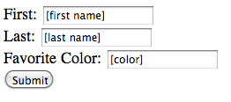

After the user enters information **and clicks on submit**, the form should populate the form fields with the values the user entered:

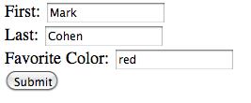

If the user restarts the browser, and the revisits your PHP page, the form should remember what they entered last time (using cookies) and display it:

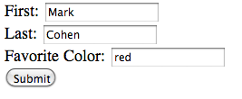

However, if a minute elapses before the user revisits the page, the cookies should timeout and an empty form should be displayed when they visit the page:

