Create a web application that allows you to build a sundae by adding flavors of ice cream. The flavors should be stored in the session.

Anytime your page loads or is refreshed, and the session is empty, it should look like this:

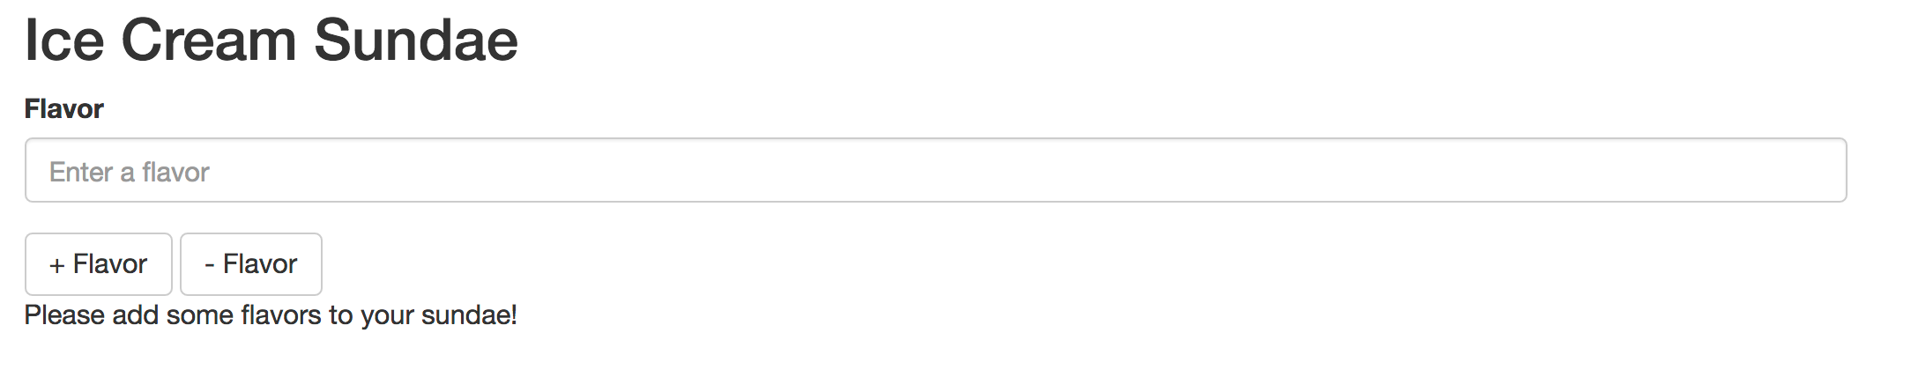

Anytime your page loads or is refreshed and the session contains flavors, the flavors in the session should be displayed like this:

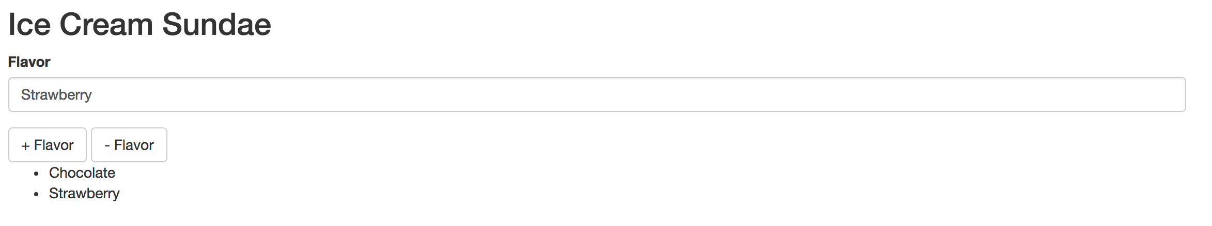

Users should be able to add or delete flavors from the session using the buttons and your page should update to display the flavors. If the user enters a flavor that is already in the sundae the request should be ignored.

When you are done with the exam, please submit the name of the folder on Cloud 9 that contains your solution.