Create a program that prints a seating chart. Green seats are available, red seats are taken, and seats with blue borders are handicap accessible. Here is an example of one possible output:

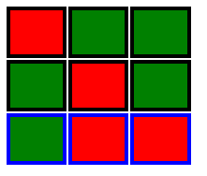

Your program should use a Seat class that has two attributes: $taken and $handicap. In addition, the Seat class should have a method called getTableCell that returns a <td> element that can be displayed in a table row.

Your program should create an array of arrays. The outer array should represent the seating chart, and each array that it contains represents a row of seats.

Write a for loop that generates a table of “seats”. Your table should look something like the picture above.

Enjoy!