For this exercise I would like you to create a program that can add vectors and determine the resulting x component, y component, and magnitude. The design for this program uses the composite design pattern and is shown below using UML:

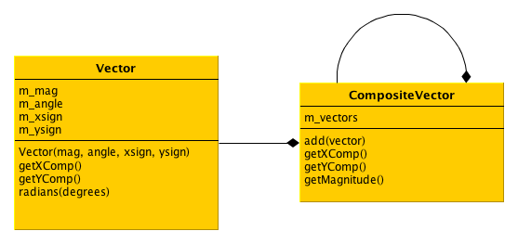

In case you forgot how to add vectors, here is a review:

<http://phys101.blogspot.com/2007/01/vector-addition.html>

I would like you to use the following Main.js file to test your program:

var V = module.require('./Vector.js');

var CV = module.require('./CompositeVector.js');

function main()

{

var v1 = new V.Vector(50, 60, +1, +1);

console.log("X1 ", v1.getXComp());

console.log("Y1 ", v1.getYComp());

var v2 = new V.Vector(60, 40, +1, +1);

console.log("X2 ", v2.getXComp());

console.log("Y2 ", v2.getYComp());

var cv1 = new CV.CompositeVector();

cv1.add(v1);

cv1.add(v2);

console.log("CV1X ", cv1.getXComp());

console.log("CV1Y ", cv1.getYComp());

console.log("CV1Mag ", cv1.getMagnitude());

var cv2 = new CV.CompositeVector();

cv2.add(v1);

cv2.add(v2);

cv2.add(cv1);

console.log("CV2X ", cv2.getXComp());

console.log("CV2Y ", cv2.getYComp());

console.log("CV2Mag ", cv2.getMagnitude());

}

main();

Here is the output generated by the Main.js file above:

X1 25.000000000000007

Y1 43.30127018922193

X2 45.96266658713868

Y2 38.56725658119235

CV1X 70.96266658713868

CV1Y 81.86852677041429

CV1Mag 108.34276960053887

CV2X 141.92533317427737

CV2Y 163.73705354082858

CV2Mag 216.68553920107775