# An optimization algorithm for establishing a Unified Sagittal Plane (USP)

MATLAB version 2017b or higher should be used. The Image Processing, Signal Processing & Statistics toolboxes are required.

## USP function

Run the "USP_Example.m" to test the main function "USP.m". If the open file dialog pops up, select one of the MAT-files in the folder "Data". Comment the different calls of the USP function to test all possible options. Type "help USP" to get a detailed description of the options.

The bone is moved from the coordinate system of the medical imaging system into his centroid. The distal femur has to be positioned according to Table 1 to guarantee a working calculation. This initial transformation depends on the medical imaging system and is stored in the MAT-file as a vector of 3 Euler angles*. Also the side (left or right knee) has to be defined in the MAT-file.

Table 1: Required initial orientation of the distal femur

|  |  |  |  |
| --- | --- | --- | --- |
| Axes | X | Y | Z |
| Negative | Posterior | Distal | Right knee: Medial, Left knee: Lateral |
| Positive | Anterior | Proximal | Right knee: Lateral, Left knee: Medial |

*Three Cardan angles aka Tait-Bryan angles given in degrees using the 'ZYX' convention (global basis aka extrinsic rotations). This means a rotation around the Z-axis is followed by a rotation around the Y-axis is followed by a rotation around the X-axis. But all rotations occur about the axes of the fixed coordinate system. Values between -180° and 180° are valid.

## USP GUI

An additional GUI is "USP_GUI.m". Run the script and a distal femur from the folder "Data" can be loaded. The bone respectively the grey Default Sagittal Plane (DSP) can be adjusted with the six rotate buttons bellow the bone (Figure 1). If there is a variable USPTFM in the MAT-file of the subject, the USP was already calculated and the USPTFM from the previous calculation can be used for the initial transformation of the bone.

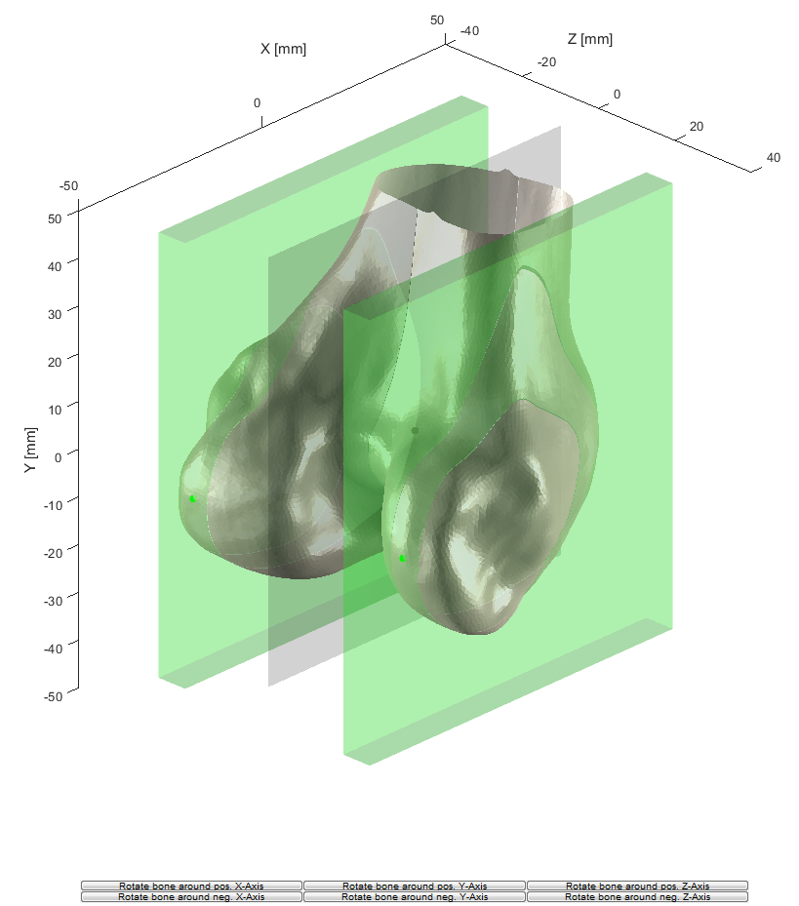

Figure 1: Required initial orientation of a right femur

## The rough/fine iteration method of the USP – How-to

* For a fast calculation the default settings should be used and all plotting options should be disabled.
* For the initial rough search the "-/+ Plane Variation" may be set to **4°** and the step size to **2°** resulting in a quadratic search field of ((4° x 2 / 2°) + 1)² = 25 plane variations (default).
* After the start of the calculation the rough search is repeated as long as the minimum dispersion lies on the boundaries of the search field (4°) (Figure 2). Once the minimum dispersion lies inside the search field a finer search with a step size of 0.5° is performed (Figure 3). The "-/+ Plane Variation" is set to the step size of the rough search minus the step size of the fine search (2° - 0.5° = 1.5°) resulting in a quadratic search field of ((1.5° x 2 / 0.5°) + 1)² = 49 plane variations.
* The results can be saved after the calculation is finished.

After each calculation a table with results for the minimum dispersion is printed in the MATLAB command window.



Figure 2: Three rough iterations and the final fine iteration

## Method

The framework is based on the paper: [Li et al. - Automating Analyses of the Distal Femur Articular Geometry Based on Three-Dimensional Surface Data (2010)](references/Li%20et%20al.%20-%20Automating%20Analyses%20of%20the%20Distal%20Femur%20Articular%20Geometry%20Based%20on%20Three-Dimensional%20Surface%20Data%20(2010).pdf)

The input consists of a triangulated surface of the distal femur, a side indicator and an initial transformation from the coordinate system of the medical imaging system into the default sagittal plane (DSP) (see Table 1). Due to the initial transformation of the bone surface into his centroid, the XY-plane is the DSP.

The initially transformed bone surface is passed to the main function that relates closely to the proposed framework by Li et al. to calculate the unified sagittal plane (USP). Two cutting boxes each filled with eight parallel cutting planes are positioned on the most posterior point of each femur condyle. The orientation of the boxes is varied in an iterative manner (Algorithm 3). For each variation the articulating parts of the contour profiles defined by the cutting planes are determined (Algorithm 1). Ellipses are fitted to the contour parts (Algorithm 2) and the 2D dispersion of the posterior foci of these ellipses is calculated (Algorithm 3). The variation with the smallest dispersion is defined as the USP. Algorithm 3 encloses Algorithm 1 and Algorithm 2 successively.

Improvements have been made to the iteration process of Algorithm 3. First the position of the dispersion minimum is localized by a rough search with a larger step size of the plane variation. Subsequently a fine search with a plane variation of 0.5° is performed around the dispersion minimum of the rough search to improve the position of the USP. For a "-/+ Plane Variation" of 8° the method of Li requires 33² = 1089 plane variations. The rough/fine iteration method requires two initial rough searches and one subsequent fine search, 25 + 25 + 49 = 99 plane variations. The number of iterations is reduced about one-tenth compared with the method of Li et al. In addition parallel computing was implemented for the computationally-intensive parts of the framework to reduce computing time.