JCPOS Native Plant Study
Documentation of the Germination and Survival Analyses
Maggie Gaddis and Mark C. Otto
Colorado Native Plant Society (CoNPS) research grant from Jefferson County Parks & Open Space (JCPOS), 2025
Code and data: github.com/MCOtto/CONPS.JCPOS
Revised from AnalysisNotes.qmd, September 2026

1. Purpose and scope
This document records how the germination and field-survival data from the JCPOS native plant study were prepared and analyzed, so that the analysis can be reviewed, rerun, and extended. It is a companion to the CoNPS JCPOS Research Grant Report (Gaddis, 2025), which describes the study, the field work, and the soil chemistry in full; the design summary below is drawn from that report and from the JCPOS talk slides.
Two analyses are documented: (1) germination in the greenhouse by species and soil type, and (2) survival in the field plots by species, soil type, planting date, and fertilization. Both use binomial generalized linear models (GLMs) fit in R. The grant report also contains an ANOVA with Tukey comparisons of survival rates run separately by student interns; that analysis is not reproduced here. Plant height and stem counts were collected but not analyzed; growth-analysis methods for those data (Hunt et al., 2002; Hunt, 2017) are noted under Further work.

2. Study design

2.1 Species
Eight species native to JCPOS properties were grown: four forbs and four grasses (Table 1). All seed except Pascopyrum smithii was hand-collected on JCPOS properties; P. smithii came from a Boulder County seed increase.
Table 1. Species codes used throughout. The last two columns show which analyses include each species.
Code | Scientific name | Common name | Type | Germination | Survival model
ACMI | Achillea millefolium | common yarrow | Forb | Yes | Yes
SYER | Symphyotrichum ericoides | white heath aster | Forb | Yes | No¹
ARLU | Artemisia ludoviciana | white sage, silver wormwood | Forb | Yes | Yes
HEVI | Heterotheca villosa | hairy goldenaster | Forb | Yes | No²
PASM | Pascopyrum smithii | western wheatgrass | Grass | Yes | Yes
BOGR | Bouteloua gracilis | blue grama | Grass | Yes | Yes
NAVI | Nassella viridula | green needlegrass | Grass | Yes | Yes
HECO | Hesperostipa comata | needle-and-thread | Grass | Yes | No²
¹ Removed from the field study: plants showed multiple leaf and flower forms (keyed to S. falcatum and S. laeve), and wild Symphyotrichum colonized the plots. ² Planted and monitored but excluded from the survival model for low numbers planted (see Section 3.3).

2.2 Germination phase
Seeds were sown 1–2 May 2025, in the Colorado Springs city greenhouses in SC10 trays of 98 cells, one tray per species and soil type (peat and mineral/compost only). Forbs were sown one seed per cell; grasses were sown about ten seeds per cell to produce a plug. All trays were misted twice daily with water carrying 12-6-6 liquid fertilizer, so every seedling was fertilized during germination. Germination was recorded weekly, and final germination was taken on June 1, 2025, scored as presence or absence of a seedling in each cell. For grasses, a cell counts as germinated if any seed in it germinated.

2.3 Field phase
After June 1, we moved the plants outdoors to harden off, and the fertilization treatment began: half the plants received a weekly foliar 12-6-6 application, while the other half received only water. A mid-June heat wave killed many plants. To maintain field numbers, surplus seedlings that had been potted into native garden soil (S3) in 3-inch pots as an "insurance" set were brought into the study, adding S3 as a third soil type. A second, half-size sowing on July 1 supplied the September planting.
Twelve circular common-garden plots (6 ft radius) were laid out at North Table Mountain Park, treated with glyphosate in April 2025, and hand-weeded on each planting day. Each plot received one soil type × fertilization combination and was planted on one of three dates: July 10, August 14, or 11 September 2025. (The grant's executive summary lists July 11; the field data and slides use July 10, which is used here.) Volunteers monitored the plots biweekly through 23 October 2025. The survival analysis uses only the number planted and the number alive at the end of the season, because the grasses were difficult to relocate during intermediate visits.

2.4 Soil types
- Peat: Fertilome Ultimate potting mix (85–95% sphagnum peat, 5–15% perlite), grown in SC10 cells.
- MC (mineral/compost): Cimarron Breeze crushed granite (⅜ in. and smaller) mixed with Colorado Springs municipal horticultural compost, grown in SC10 cells. Labeled "Mineral/Compost" in the germination data.
- S3 (native garden soil): mineral-rich Colorado Springs garden soil mixed with home compost, grown in 3-inch pots. Field phase only.

2.5 Hypotheses and the analyses that address them
The grant states four hypotheses, numbered 1, 2, 4, and 5 (there is no Hypothesis 3; the talk slides renumber them 1–4). The grant phrases Hypotheses 2–5 in terms of plant growth; the analyses here address them using survival (Table 2).
Table 2. Grant hypotheses and where each is tested.
Grant hypothesis | Alternative hypothesis | Tested by
1 | Native seeds have variable germination rates regulated by environmental conditions | Germination model: species and soil terms
2 | Plant growth differs by soil type | Survival model: soil and species × soil terms
4 | Plant growth differs with fertilization | Survival model: fertilization term
5 | Plant growth differs by planting date | Survival model: date and species × date terms

3. Data sources and preparation

3.1 Source files
Field datasheets were digitized into the "JCOS raw data" workbook (one sheet per monitoring visit and recorder). Maggie Gaddis consolidated these into the "JCOS data - MG" workbook, which is the source for both analyses. Copies of both workbooks are in the repository's ori/ folder.
Table 3. Data used in each analysis.
Analysis | Workbook and sheet | Rows used | Variables
Germination | JCOS data - MG, "germination rates" | 16 (8 species × 2 soils) | species, soil type, count of germinated cells (of 98)
Survival | JCOS data - MG, "alldatasimplified" | 84 read; 49 enter the model | plot, soil type, species, planting date, fertilized, planted, survived

3.2 Preparation steps
The following changes were made between the raw datasheets and the model fits, reconstructed from the analysis notes, the R scripts, and the repository history:
- Plot identifiers were simplified to the plot number, and planting dates to a single date per plot and species (the planting date can be recovered from species and plot).
- Planting dates entered with the year 2026 were corrected to 2025 (26 February 2026).
- SYER was dropped from the field data for the reason given in Table 1.
- Species codes in the germination sheet carry the soil type as a suffix (e.g., "ACMI Peat"); the first four characters are used as the species code.
- One survival count is fractional (ACMI, plot 1: 32.5 of 50). R's as.integer() truncates it to 32.
- Three rows with a missing number planted (ACMI in plots 3–5) are dropped. Rows with zero planted carry no information and do not count toward the residual degrees of freedom.
- HEVI and HECO are excluded from the survival model because of low numbers planted and surviving. HECO had 18 plants in total, in only four cells; HEVI had 5–7 plants per soil in September. Their species × soil and species × date terms could not be supported.
Figure 1 shows the germination data as recorded.
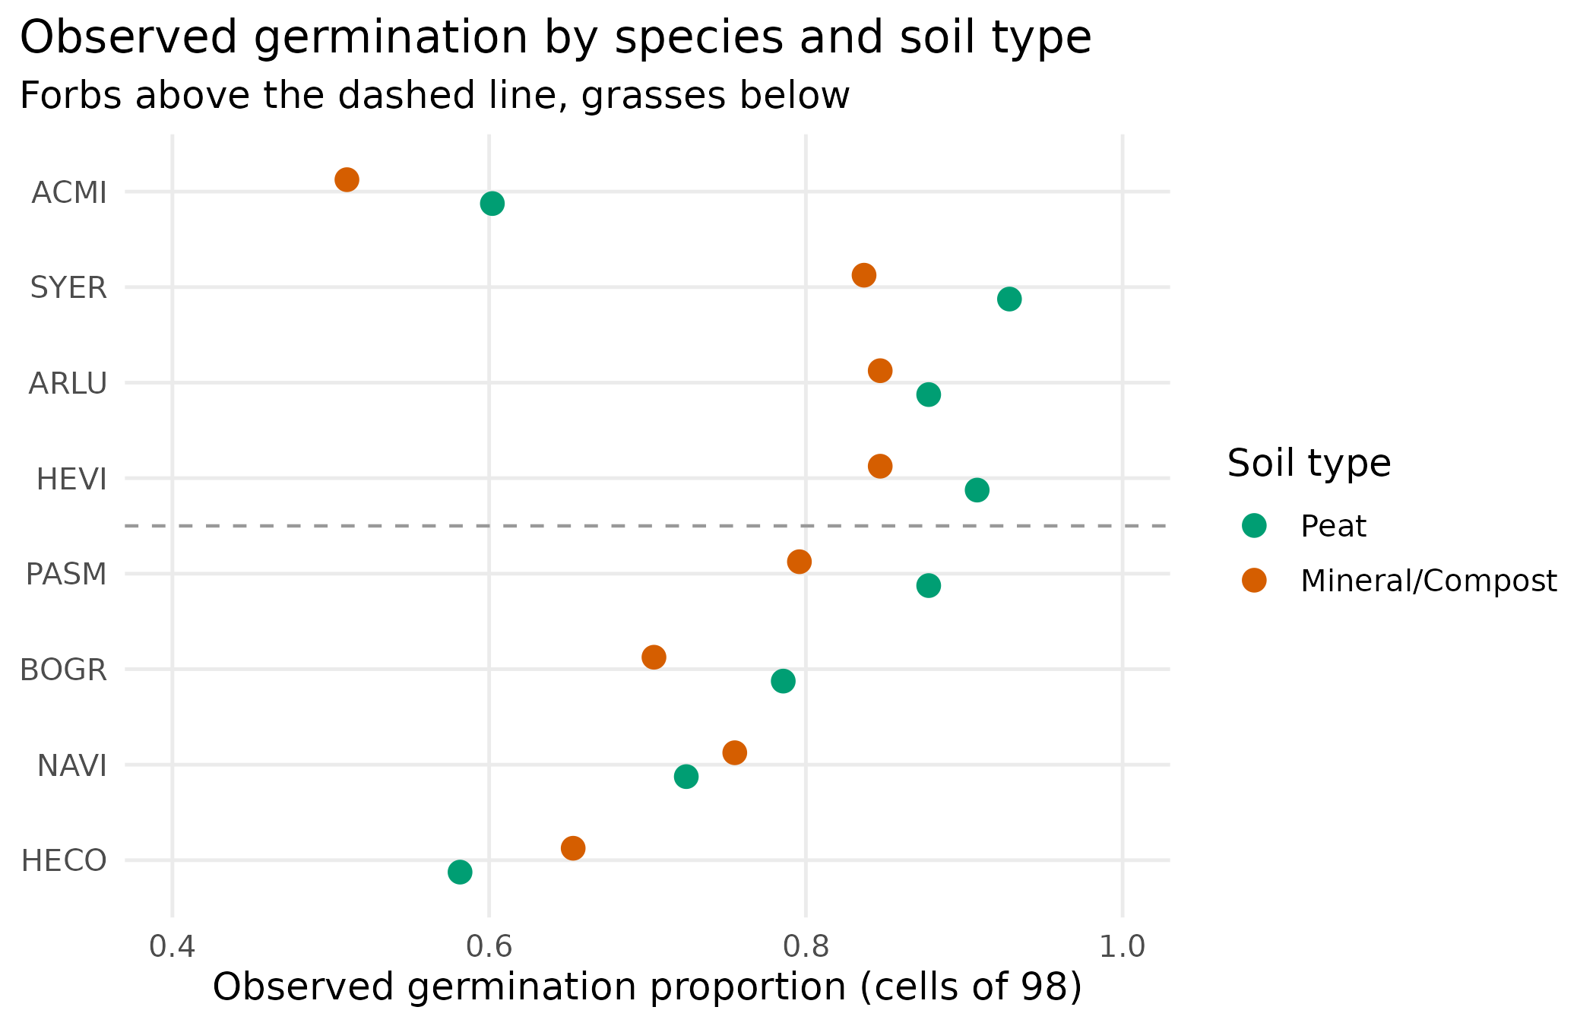
Figure 1. Observed germination: the proportion of the 98 cells in each tray that contained a seedling on June 1, 2025. One tray per species and soil type. Forbs were sown with one seed per cell, and grasses with about ten.

3.3 The field planting layout
Because the S3 soil was added mid-study and plant numbers were limited, the field design is far from a complete factorial. Table 4 shows the number of plants for each species, planting date, and soil type. A dash indicates that no plants of that species were planted in that soil on that date.
Table 4. Plants installed by species, planting date, and soil type (both fertilization levels combined). Last column: survived/planted over the entire stud
 | July 10 |  |  | August 14 |  |  | September 11
Species | MC | Peat | S3 | MC | Peat | S3 | MC | Peat | S3 | Survived / planted
ACMI | – | – | 110 | – | 40 | 50 | 44 | 46 | – | 197/290
ARLU | – | – | 30 | – | – | 38 | 47 | 48 | – | 114/163
HEVI | – | 36 | 30 | – | – | 19 | 7 | 5 | – | 65/97
PASM | – | – | 20 | – | 9 | 15 | 22 | 10 | – | 26/76
BOGR | 32 | 94 | 14 | – | – | 16 | 49 | 49 | – | 202/254
NAVI | – | 18 | 10 | 6 | 6 | 12 | 2 | 11 | – | 15/65
HECO | – | 10 | – | 3 | 5 | – | – | – | – | 7/18
No S3 plots were planted in September. MC was planted in July only for BOGR. Rows for HEVI and HECO are shown for completeness but are not included in the survival model.
Several features of this layout are important for interpretation and are discussed in Section 7: MC is concentrated in September, S3 is absent in September, and the September plants were sown later and monitored for about six weeks rather than about fifteen. Figure 2 shows the observed survival in each cell.
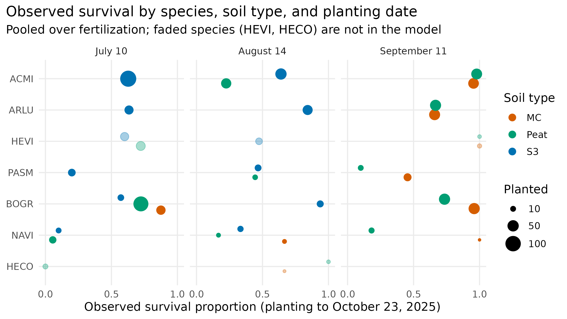
Figure 2. Observed survival from planting to October 23, 2025, by species, soil type, and planting date, pooled over fertilization. Point area is proportional to the number planted. Faded points (HEVI, HECO) are excluded from the survival model.

4. Statistical methods

4.1 Binomial generalized linear models

Both responses are counts of successes out of a known number of trials: germinated cells out of 98 and surviving plants out of the number planted. Each is modeled as binomial, with the probability of success related to the predictors via the logit link:

logit(p) = log[p / (1 − p)] = Xβ,

so effects are additive on the log-odds scale, and every fitted probability stays between 0 and 1. The binomial variance, np(1 − p), is largest near p = 0.5 and shrinks toward the ends; the GLM accounts for this by weighting each observation by its binomial variance during fitting, rather than by transforming the data. Models were fit by maximum likelihood (iteratively reweighted least squares) using R's glm() function. Onofri (2019) and Onofri et al. (2022) recommend time-to-event models when germination or survival is recorded at repeated inspections; because only final counts are analyzed here, the binomial GLM is the appropriate model for these data.4.2 Model selection and tests
Candidate models with different interaction structures were compared by Akaike's information criterion (AIC); the model with the lowest AIC was retained. Terms were tested with sequential (Type I) analysis-of-deviance tables from anova(), which compare the drop in deviance as each term is added, in the order listed, to a chi-square distribution. Because the tests are sequential, a term's p-value depends on which terms precede it. Fit was checked by comparing the residual deviance and the Pearson χ² with their degrees of freedom; a ratio well above 1 indicates overdispersion, meaning more variation than the binomial allows.

4.3 Estimated rates and intervals
Estimated rates for plotting were computed from each model. For a given combination of factors, the fitted probability p̂ and its standard error on the probability scale, SE(p̂) = p̂(1 − p̂) × SE(logit p̂), were obtained with predict(). To keep intervals inside (0, 1), a beta distribution with mean p̂ and standard deviation SE(p̂) was matched to these moments, and its 5th, 50th, and 95th percentiles were taken as the lower limit, point estimate, and upper limit (qbeta2() in the IPMbook package). The figures therefore show medians with 90% intervals. Where SE(p̂) is too large for a beta distribution with that mean to exist, no interval can be computed; where p̂ is very close to 0 or 1, the interval collapses toward the boundary.

4.4 Software
The analyses were run in R using xlsx (data import), here, dplyr, tidyr, stringr, IPMbook, and ggplot2. The scripts are R/Germination.R and R/Survival.R, with shared functions for intervals, marginal rates, colors, and file output in R/Helpers.R. Running the two scripts writes every figure in this document to doc/images/ and the estimated rates to doc/tables/. The model output reproduces the coefficients, standard errors, deviances, and AIC values in the original analysis notes.

5. Germination analysis

5.1 Model
The response is the number of germinated cells per tray out of 98. Three models were compared:
Table 5. Germination candidate models (16 trays).
R object | Model (right-hand side) | Parameters | Residual deviance (df) | AIC
GrmnMdlSS | species + soil.type | 9 | 9.13 (7) | 100.15
GrmnMdlM | soil.type + herb.type / species | 9 | 9.13 (7) | 100.15
GrmnMdlI | herb.type / species + species × soil.type | 16 | 0 (0) | 105.01
GrmnMdlSS and GrmnMdlM are the same fit written two ways: herb.type/species expands to herb.type + herb.type:species, which spans the same eight species means. The interaction model is saturated (one parameter per tray) and has the higher AIC.
GrmnMdlM was retained because nesting species within herb type lets the sequential deviance table separate the forb–grass difference from the variation among species. The fitted model is
glm(cbind(count, 98 - count) ~ soil.type + herb.type/species,
family = binomial(link = "logit"), data = Germination)
Its residual deviance is 9.13 on 7 df (Pearson χ²/df = 1.30), indicating that the binomial variance is adequate and no overdispersion adjustment is needed.

5.2 Coefficients
With R's default treatment contrasts, the reference cell is ACMI in peat. Because species are nested within herb type, the "Grass" coefficient compares the reference grass (HECO) with the reference forb (ACMI), and each remaining species is compared with the reference species of its type. Eight of the nested columns represent empty combinations (e.g., a "grass" SYER) and are reported by R as NA; they are omitted from Table 6.
Table 6. Germination model coefficients (log-odds scale).
Term | Estimate | Std. error | z | p
Intercept (ACMI, peat) | 0.353 | 0.157 | 2.25 | 0.025
Soil: mineral/compost vs. peat | -0.253 | 0.124 | -2.04 | 0.041
Herb type: grass (HECO vs. ACMI) | 0.254 | 0.206 | 1.23 | 0.218
Forb: SYER vs. ACMI | 1.798 | 0.265 | 6.79 | < 0.001
Forb: ARLU vs. ACMI | 1.614 | 0.253 | 6.39 | < 0.001
Forb: HEVI vs. ACMI | 1.749 | 0.261 | 6.69 | < 0.001
Grass: PASM vs. HECO | 1.159 | 0.243 | 4.77 | < 0.001
Grass: BOGR vs. HECO | 0.595 | 0.220 | 2.70 | 0.007
Grass: NAVI vs. HECO | 0.569 | 0.220 | 2.59 | 0.010

With species held fixed, the odds of germination in mineral/compost were exp(−0.253) = 0.78 times those in peat, i.e., about 22% lower (p = 0.041). ACMI and HECO had the lowest germination; SYER, HEVI, and ARLU had the highest.

5.3 Analysis of deviance
Table 7. Sequential analysis of deviance for the germination model.
Term | Df | Deviance | Resid. df | Resid. deviance | p (χ²)
NULL |  |  | 15 | 127.97
soil.type | 1 | 3.86 | 14 | 124.10 | 0.049
herb.type | 1 | 7.87 | 13 | 116.24 | 0.005
herb.type : species | 6 | 107.11 | 7 | 9.13 | < 0.001

Species account for nearly all the explained deviance. Forbs and grasses differ on average (p = 0.005), and soil type has a small effect at the margin of significance (p = 0.049). Relative to Hypothesis 1, germination varies clearly among species; the effect of the growing medium, the one environmental condition varied here, is small.

5.4 Estimated germination rates
Soil-type and herb-type rates in Figure 3 are averages on the log-odds scale: the soil rates average over the eight species, and each herb-type rate averages over its four species at the midpoint between the two soils. Intervals use the full parameter covariance. Species rates in Figure 4 are for mineral/compost; rates in peat are slightly higher for every species by the soil coefficient.
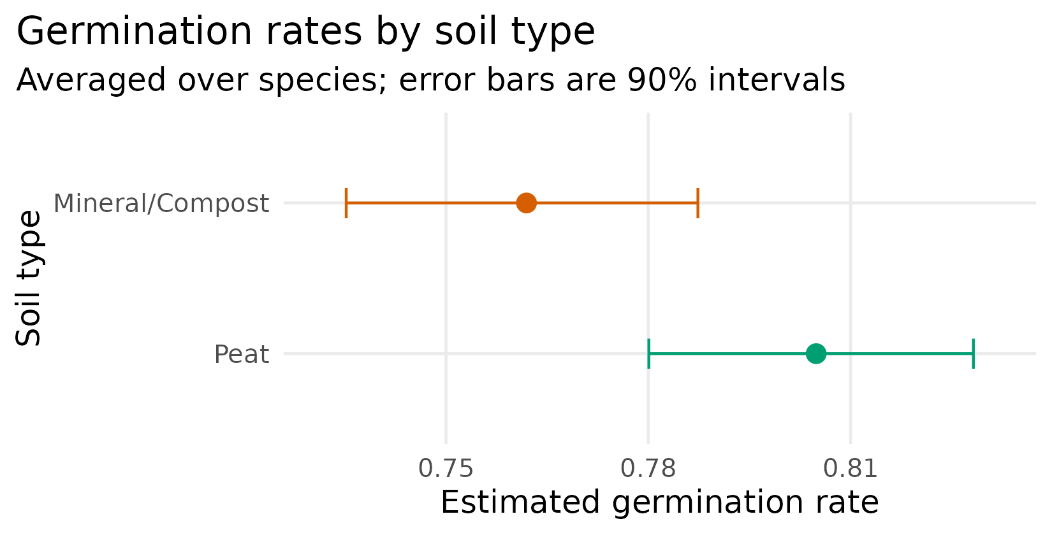
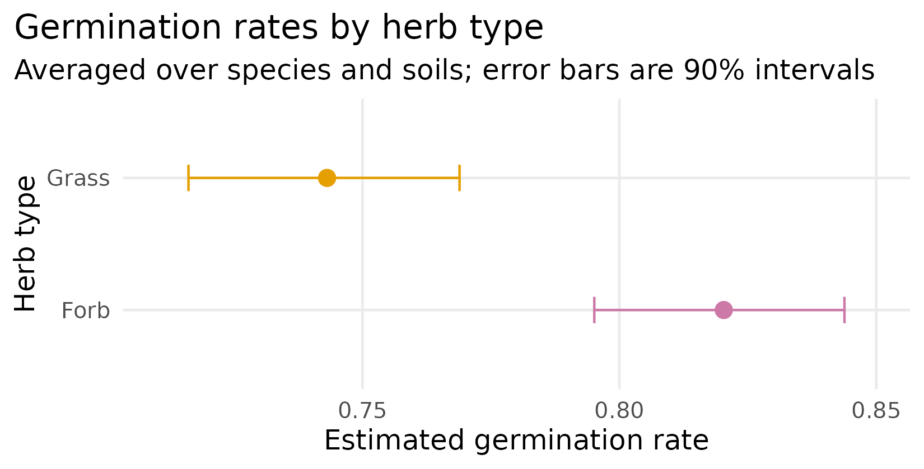
Figure 3. Estimated germination rates by soil type (averaged over species) and by herb type (averaged over species within each type and over soils), with 90% intervals.
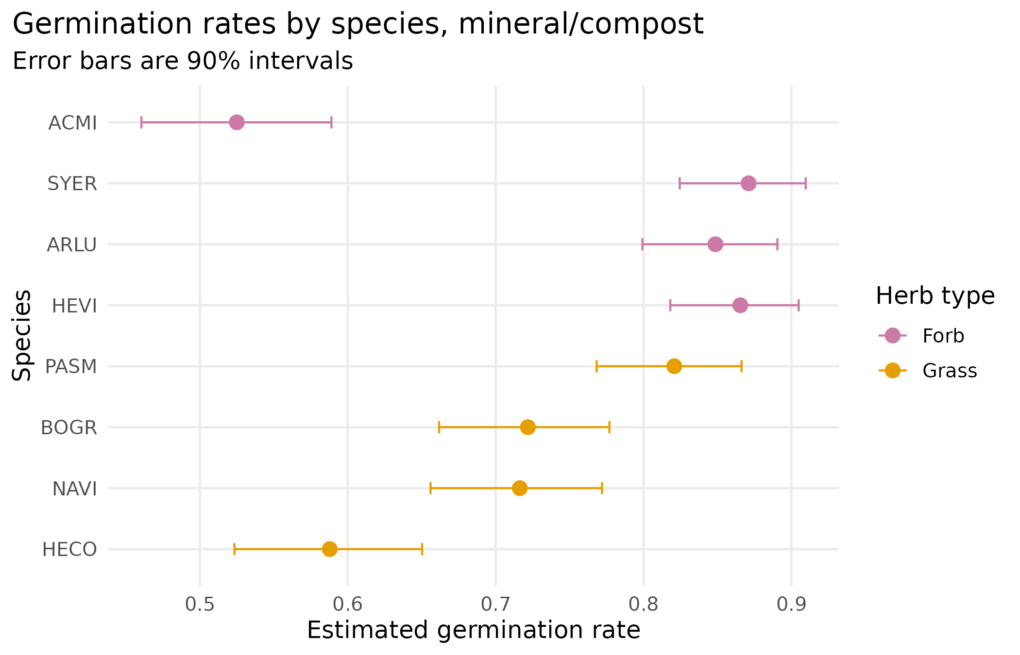
Figure 4. Estimated germination rate for each species in mineral/compost, with 90% intervals.
Table 8. Estimated germination rates plotted in Figures 3 and 4.
Grouping | Level | Estimate (median) | 90% interval
Soil type | Peat | 0.805 | 0.780 – 0.828
Soil type | Mineral/Compost | 0.762 | 0.735 – 0.787
Herb type | Forb | 0.820 | 0.795 – 0.844
Herb type | Grass | 0.743 | 0.716 – 0.769
Species (Mineral/Compost) | ACMI | 0.525 | 0.460 – 0.589
Species (Mineral/Compost) | SYER | 0.871 | 0.824 – 0.910
Species (Mineral/Compost) | ARLU | 0.849 | 0.799 – 0.891
Species (Mineral/Compost) | HEVI | 0.865 | 0.818 – 0.905
Species (Mineral/Compost) | PASM | 0.821 | 0.768 – 0.866
Species (Mineral/Compost) | BOGR | 0.722 | 0.662 – 0.777
Species (Mineral/Compost) | NAVI | 0.716 | 0.656 – 0.772
Species (Mineral/Compost) | HECO | 0.588 | 0.523 – 0.650

6. Survival analysis

6.1 Model
The response is the proportion of plants alive at the end of the 2025 season, relative to the number planted, for each plot × species record. With HEVI and HECO excluded and missing and zero-planted rows removed, 49 records from five species enter the model. Reference levels are ACMI, MC soil, the July 10 planting, and unfertilized (NF). Five models were compared (Table 9).
Table 9. Survival candidate models (49 records). Dispersion is Pearson χ² / residual df.
R object | Model (right-hand side) | Params | Resid. dev. (df) | Dispersion | AIC
SrvlMdlM | species + soil.type × fertilized + plant.date | 12 | 159.4 (37) | 3.81 | 291.2
SrvlMdlSF | species × soil.type × fertilized + plant.date | 31 | 84.4 (18) | 4.29 | 254.1
SrvlMdlnF | species × soil.type + species × plant.date | 24 | 86.3 (25) | 3.15 | 242.1
SrvlMdlF | species × soil.type × plant.date + fertilized | 28 | 75.1 (21) | 3.25 | 238.9
SrvlMdlI | species × soil.type + species × plant.date + fertilized | 25 | 76.9 (24) | 2.91 | 234.7
Parameter counts exclude coefficients R cannot estimate because the corresponding cells are empty. The retained model, SrvlMdlI, is shaded.
The retained model allows the soil and planting-date effects to differ by species, with an additive fertilization effect:
glm(cbind(survived, planted - survived) ~ species * soil.type +
species * plant.date + fertilized,
family = binomial(link = "logit"), data = Survival,
subset = !species %in% c("HEVI", "HECO"))

6.2 Coefficients
Table 10 lists the 25 estimable coefficients. The ARLU × September 11 interaction cannot be estimated: ARLU was planted in only four soil × date combinations (S3 in July and August, MC and peat in September) but has five species-specific parameters, so R reports one as NA. Because the model contains species interactions, the "main effects" of soil and date describe ACMI only; the other species' soil and date effects are the main effect plus the corresponding interaction.
Table 10. Survival model coefficients (log-odds scale). Reference: ACMI, MC soil, planted July 10, unfertilized.
Term | Estimate | Std. error | z | p
Intercept (ACMI, MC, July 10, unfertilized) | -2.568 | 1.360 | -1.89 | 0.059
Species ARLU | -2.423 | 0.789 | -3.07 | 0.002
Species PASM | 2.432 | 2.041 | 1.19 | 0.233
Species BOGR | 4.795 | 1.432 | 3.35 | < 0.001
Species NAVI | 2.375 | 1.815 | 1.31 | 0.191
Soil: peat | 0.751 | 1.245 | 0.60 | 0.546
Soil: S3 | 2.849 | 1.338 | 2.13 | 0.033
Planted Aug 14 | 0.031 | 0.358 | 0.09 | 0.932
Planted Sep 11 | 5.396 | 1.143 | 4.72 | < 0.001
Fertilized | 0.550 | 0.181 | 3.04 | 0.002
ARLU × Peat soil | -0.725 | 1.319 | -0.55 | 0.583
PASM × Peat soil | -2.605 | 1.689 | -1.54 | 0.123
BOGR × Peat soil | -2.424 | 1.332 | -1.82 | 0.069
NAVI × Peat soil | -4.008 | 1.665 | -2.41 | 0.016
ARLU × S3 soil | 2.425 | 0.899 | 2.70 | 0.007
PASM × S3 soil | -4.396 | 1.951 | -2.25 | 0.024
BOGR × S3 soil | -5.057 | 1.520 | -3.33 | < 0.001
NAVI × S3 soil | -4.900 | 1.688 | -2.90 | 0.004
ARLU × Aug 14 | 1.196 | 0.689 | 1.74 | 0.083
PASM × Aug 14 | 1.187 | 0.847 | 1.40 | 0.161
BOGR × Aug 14 | 2.483 | 1.224 | 2.03 | 0.042
NAVI × Aug 14 | 1.136 | 0.990 | 1.15 | 0.251
PASM × Sep 11 | -5.670 | 1.858 | -3.05 | 0.002
BOGR × Sep 11 | -5.099 | 1.199 | -4.25 | < 0.001
NAVI × Sep 11 | -3.664 | 1.610 | -2.28 | 0.023

Fertilization is the one additive effect: fertilized plants had exp(0.550) = 1.73 times the odds of survival of unfertilized plants, for every species, soil, and date (Wald p = 0.002). The large September 11 coefficient (+5.40 for ACMI) is offset for the grasses by their negative September interactions, so the September advantage is concentrated in the forbs.

6.3 Analysis of deviance
Table 11 gives the sequential deviance tests from the notes. The residual deviance is 76.9 on 24 df and the Pearson dispersion is 2.91, so the binomial standard errors and chi-square tests overstate precision. The last column shows the same tests under a quasi-binomial model, which scales the variance by the estimated dispersion and uses F tests; it widens standard errors by a factor of √2.91 = 1.71.
Table 11. Sequential analysis of deviance for the survival model, with quasi-binomial F-test p-values as a sensitivity check.
Term | Df | Deviance | Resid. df | Resid. dev. | p (χ²) | p (quasi F)
NULL |  |  | 48 | 327.27
species | 4 | 106.00 | 44 | 221.28 | < 0.001 | < 0.001
soil.type | 2 | 29.58 | 42 | 191.69 | < 0.001 | 0.014
plant.date | 2 | 19.24 | 40 | 172.46 | < 0.001 | 0.054
fertilized | 1 | 2.85 | 39 | 169.61 | 0.092 | 0.333
species : soil.type | 8 | 31.12 | 31 | 138.50 | < 0.001 | 0.273
species : plant.date | 7 | 61.56 | 24 | 76.94 | < 0.001 | 0.020

Species differences in survival are strong under either test. Soil type and the species × planting-date interaction remain significant after the dispersion adjustment; the planting-date main effect is borderline, and the species × soil interaction is not. Fertilization is not significant in the sequential table when entered after species, soil, and date (p = 0.09), even though its Wald test in Table 10 is (p = 0.002): the sequential test assesses fertilization before the interactions are in the model, whereas the Wald test does so after. Under the quasi-binomial adjustment, the Wald p-value for fertilization becomes 0.087, so the evidence for fertilization is weaker than Table 10 alone suggests.

6.4 Estimated survival rates
Figures 5 and 6 reproduce the two survival figures in the notes: species by soil type for the September 11 planting and species by planting date in MC soil, both for unfertilized plants. Solid points indicate combinations where plants were installed; open points indicate combinations with no plants (Table 4), for which the estimate is produced entirely by the model's additive structure. In Figure 6, nine of the fifteen estimates are of that kind, including ACMI and ARLU in MC in July and August, which the model places near zero, even though neither species was ever planted in MC before September. Appendix A lists the plotted values.
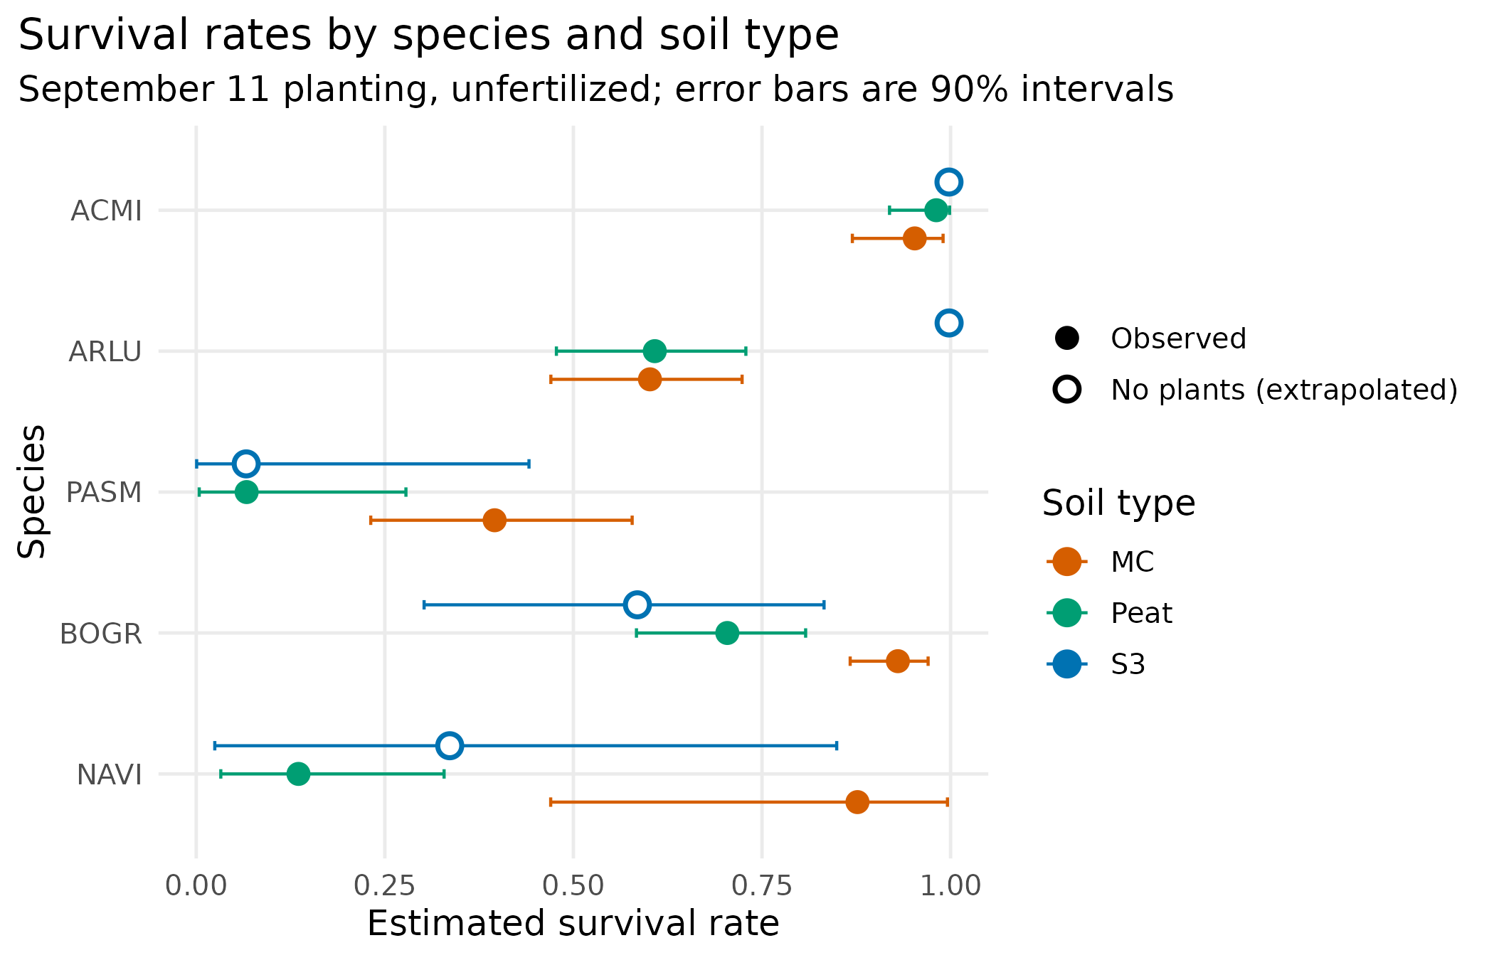
Figure 5. Estimated survival by species and soil type for unfertilized plants installed on September 11, with 90% intervals. No S3 plots were planted in September, so all S3 estimates here are model extrapolations.
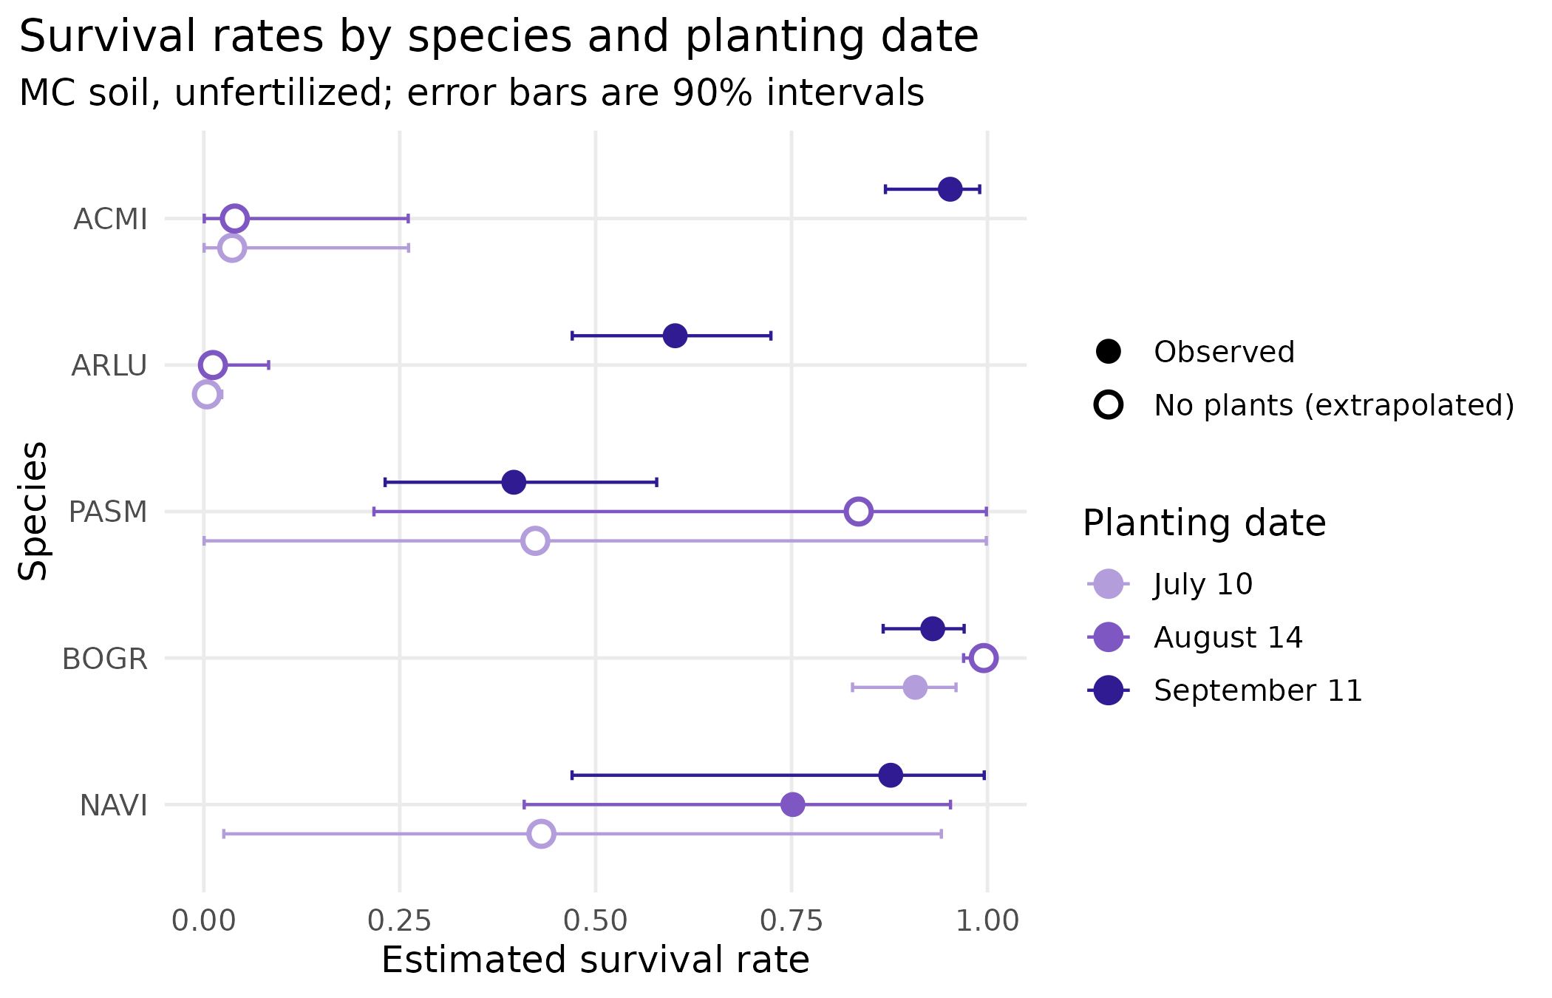
Figure 6. Estimated survival by species and planting date for unfertilized plants in MC soil, with 90% intervals. Open points mark species × date combinations never planted in MC.

7. Cautions for interpretation
The survival results should be read with the following limitations in mind. Most arise from changes forced on the design during the season and are described in the grant report's discussion.
- Planting date is confounded with cohort and exposure time. September plants came from the July 1 sowing and were monitored for about six weeks, compared with about fifteen weeks for the July plants and ten for the August plants. Higher September survival may reflect less time in the field rather than a better planting date. The spring 2026 survey of overwinter survival will separate these.
- Soil type is confounded with container and timing. S3 plants were grown in 3-inch pots rather than in SC10 cells, came from the surplus "insurance" set, and were never planted in September. MC was planted in July only for BOGR and not at all in August, except for small numbers of NAVI and HECO.
- Many plotted combinations were never observed. Estimates for empty cells (open points in Figures 5 and 6) rely on the assumption that effects combine additively on the log-odds scale; they should not be reported as findings.
- Plots are not replicated. Each plot is a unique combination of soil, fertilization, and date, so plot-to-plot variation cannot be separated from treatment effects and appears as overdispersion. A mixed model with a random plot effect (glmmTMB) was attempted but failed due to a non-positive-definite Hessian, which is unsurprising given twelve unreplicated plots. The quasi-binomial column in Table 11 is a partial correction.
- Grass detection. Young grasses were hard to find among Bromus inermis, and we first located some in October. End-of-season counts are the most reliable, but grass survival may still be underestimated.
- Germination trays are not replicated. With one tray per species × soil, differences in misting across the bench are indistinguishable from soil effects. The small soil effect (p = 0.049) should be treated as tentative.

8. Changes from AnalysisNotes.qmd
The following corrections were made in revising the notes; the R scripts have been updated to match.
- Herb-type germination figure. The notes' figure showed grasses germinating better than forbs (0.81 vs. 0.76). It was built from predict(type = "terms") for the herb.type term, which in the nested model is the HECO-versus-ACMI contrast, not the forb–grass average. Averaging over the species in each type reverses the order: forbs 0.82, grasses 0.74, consistent with the raw data (79% vs. 73% of cells). Figure 3 uses the corrected estimates. The soil-type estimates are unchanged; their intervals are slightly wider because they now include the intercept's uncertainty.
- Link function. The notes described a "log-logit link" that stabilizes the variance. The link is the logit; the GLM handles the non-constant binomial variance through its variance function, not through the link.
- Planting date. The notes give July 11, following the grant's executive summary; the data, code, and slides use July 10.
- Figures. The notes referenced doc/imagines/ (a typo for doc/images/) and included the herb-type figure twice. Both scripts now save every figure with ggsave() at 300 dpi and consistent colors; previously, Germination.R drew its plots without saving them and Survival.R saved one figure per run. The germination-by-species title no longer runs off the page, the code comments now say 90% intervals to match the plots, and two figures of the observed data were added (Figures 1 and 2).
- Script corrections. Species comments in Germination.R misnamed HEVI (as Helleborus viridis) and PASM (as Paspalum); they now give the correct names. Survival.R now marks unplanted combinations in its figures, reports the dispersion, and refits the selected model as quasi-binomial (SrvlMdlQ). The ignored height argument to geom_errorbar() was replaced with width.
- Exclusions and data handling. The removal of SYER, HEVI, and HECO, the truncation of the fractional count, and the zero-planted rows are now documented (Section 3.2).

9. Further work
- Add the spring 2026 overwinter survey and refit the survival model to account for monitoring duration, or analyze the biweekly records as interval-censored time-to-event data (Załuski et al., 2018; Onofri et al., 2022). That approach uses every visit rather than just the first and last.
- Analyze plant height and stem counts with classical growth analysis (Hunt et al., 2002; Hunt, 2017).
- In a follow-up study, use replicate plots within each treatment combination and cross fewer factors so that plot variation can be estimated and each factor can be tested against it.

References
Gaddis, M. (2025). CoNPS JCPOS Research Grant Report. Colorado Native Plant Society. (Draft report to Jefferson County Parks & Open Space.)
Hunt, R. (2017). Growth analysis, individual plants. In B. Thomas, B. G. Murray, & D. J. Murphy (Eds.), Encyclopedia of Applied Plant Sciences (2nd ed., pp. 421–429). Academic Press. https://doi.org/10.1016/B978-0-12-394807-6.00226-4
Hunt, R., Causton, D. R., Shipley, B., & Askew, A. P. (2002). A modern tool for classical plant growth analysis. Annals of Botany, 90(4), 485–488. https://doi.org/10.1093/aob/mcf214
Onofri, A. (2019). [Blog post on survival analysis and germination data]. Statforbiology. https://www.statforbiology.com/2019/stat_survival_germination/
Onofri, A., Mesgaran, M. B., & Ritz, C. (2022). A unified framework for the analysis of germination, emergence, and other time-to-event data in weed science. Weed Science, 70, 259–271. https://doi.org/10.1017/wsc.2022.8
Veronesi, F., & Lorenzetti, F. (1983). Productivity and survival of alfalfa hybrid and inbred plants under competitive conditions. Crop Science, 23(3). https://doi.org/10.2135/cropsci1983.0011183X002300030031x
Załuski, D., Mielniczuk, J., Bronowicka-Mielniczuk, U., Stolarski, M. J., Krzyżaniak, M., Szczukowski, S., & Tworkowski, J. (2018). Survival analysis of plants grown in long-term field experiments. Agronomy Journal, 110(5), 1791–1798. https://doi.org/10.2134/agronj2018.01.0062

Appendix A. Plotted survival estimates
Unfertilized plants. Rows for the September 11 planting appear in Figure 5; rows for MC soil appear in Figure 6 (the September MC rows appear in both). "Observed" indicates whether any plants of that species were installed in that soil on that date.
Table 12. Survival estimates plotted in Figures 5 and 6.
Species | Soil | Planted | Estimate (median) | 90% interval | Observed
ACMI | MC | Jul 10 | 0.04 | 0.00 – 0.26 | No
ACMI | MC | Aug 14 | 0.04 | 0.00 – 0.26 | No
ACMI | MC | Sep 11 | 0.95 | 0.87 – 0.99 | Yes
ACMI | Peat | Sep 11 | 0.98 | 0.92 – 1.00 | Yes
ACMI | S3 | Sep 11 | 1.00 | 0.99 – 1.00 | No
ARLU | MC | Jul 10 | 0.00 | 0.00 – 0.02 | No
ARLU | MC | Aug 14 | 0.01 | 0.00 – 0.08 | No
ARLU | MC | Sep 11 | 0.60 | 0.47 – 0.72 | Yes
ARLU | Peat | Sep 11 | 0.61 | 0.48 – 0.73 | Yes
ARLU | S3 | Sep 11 | 1.00 | 0.99 – 1.00 | No
PASM | MC | Jul 10 | 0.42 | 0.00 – 1.00 | No
PASM | MC | Aug 14 | 0.84 | 0.22 – 1.00 | No
PASM | MC | Sep 11 | 0.40 | 0.23 – 0.58 | Yes
PASM | Peat | Sep 11 | 0.07 | 0.00 – 0.28 | Yes
PASM | S3 | Sep 11 | 0.07 | 0.00 – 0.44 | No
BOGR | MC | Jul 10 | 0.91 | 0.83 – 0.96 | Yes
BOGR | MC | Aug 14 | 1.00 | 0.97 – 1.00 | No
BOGR | MC | Sep 11 | 0.93 | 0.87 – 0.97 | Yes
BOGR | Peat | Sep 11 | 0.70 | 0.58 – 0.81 | Yes
BOGR | S3 | Sep 11 | 0.58 | 0.30 – 0.83 | No
NAVI | MC | Jul 10 | 0.43 | 0.03 – 0.94 | No
NAVI | MC | Aug 14 | 0.75 | 0.41 – 0.95 | Yes
NAVI | MC | Sep 11 | 0.88 | 0.47 – 1.00 | Yes
NAVI | Peat | Sep 11 | 0.14 | 0.03 – 0.33 | Yes
NAVI | S3 | Sep 11 | 0.34 | 0.02 – 0.85 | No
Shaded rows are combinations with no plants installed; their estimates are model extrapolations.

Appendix B. Reproducing the analysis
Table 13. Repository contents.
Path | Contents
DESCRIPTION | Project metadata and the R packages the scripts need
ori/ | Files received and not modified: data workbooks, grant report, talk slides
ori/JCOS raw data.xlsx | Digitized field datasheets, one sheet per visit
ori/JCOS data - MG.xlsx | Consolidated data; sheets "germination rates" and "alldatasimplified" feed the models
R/Germination.R | Germination models, estimated rates, and figures
R/Survival.R | Survival models, model comparison, estimated rates, and figures
R/Helpers.R | Shared functions: beta intervals, marginal rates, colors, figure and table output
doc/images/ | Figures written by the R scripts
doc/tables/ | Estimated rates written by the R scripts (CSV)
doc/JCPOS_Germination_Survival_Analysis.docx | This document
doc/AnalysisNotes.qmd | Original analysis notes
ref/ | Bibliography (JCOS.bib) and Hunt et al. (2002)

Open the project in RStudio (or start R in the project folder) and run source("R/Germination.R") and source("R/Survival.R"). File paths are resolved with here::here(), which finds the project root from the DESCRIPTION file.

