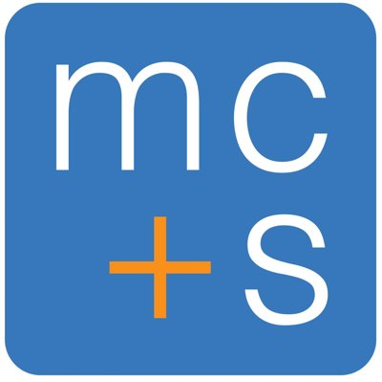 | MC & S PTY LTD | StatementHub Workpaper  Division 7A — UPE Sub-Trust or Repayment Confirmation  Eva-Triggered Evidence Workpaper
Client: {{entity_name}} ABN: {{abn}} Financial Year: {{financial_year}} Period: {{fy_start_date}} to {{fy_end_date}}

A. UPE DETAILS
B. ARRANGEMENT TYPE
C. SUB-TRUST DETAILS (if Option 1)
D. LOAN CONVERSION DETAILS (if Option 2)
E. ACCOUNTANT'S CONCLUSION
Enter conclusion regarding Division 7A compliance for this UPE. Confirm whether the arrangement complies, whether any deemed dividend arises, and whether any remedial action is required before year-end.

SIGN-OFF
Name: {{preparer}}  Signature:  Date: {{date_prepared}} |  | Name: {{reviewer}}  Signature:  Date: {{date_reviewed}}

